Branch :- Computer Sci. & Engg. Class :- IV Year
Subject :- CG Sem :- VII
Teacher Manual
PRACTICAL NO 7

AIM: Write a program to draw a circle using mid-point algorithm

Basic Concept:
Circles have the property of being highly symmetrical, which is handy when it comes to drawing them on a display screen.
- We know that there are 360 degrees in a circle. First we see that a circle is symmetrical about the axis, so only the first 180 degrees need to be calculated.
- Next we see that it's also symmetrical about the y axis, so now we only need to calculate the first 90 degrees.
- Finally we see that the circle is also symmetrical about the 45 degree diagonal axis, so we only need to calculate the first 45 degrees.
- We only need to calculate the values on the border of the circle in the first octant. The other values may be determined by symmetry.

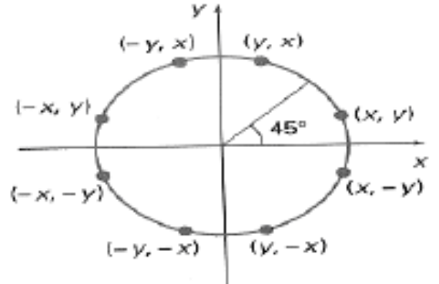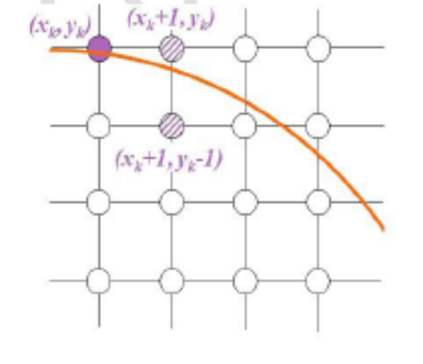

Bresenham's circle algorithm calculates the locations of the pixels in the first 45 degrees. It assumes that the circle is centered on the origin. So for every pixel (x, y) it calculates, we draw a pixel in each of the eight octants of the circle. This is done till when the value of the y coordinate equals the x coordinate. The pixel positions for determining symmetry are given in the below algorithm.

Algorithm :
1. Input radius r and circle centre (xc, yc), then set the coordinates for the first point on the
circumference of a circle centred on the origin as:
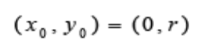
2. Calculate the initial value of the decision parameter as:
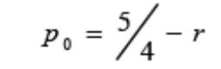
3. Starting with k = 0 at each position xk, perform the following test. If pk < 0, the next point
along the circle centred on (0, 0) is (xk+1, yk) and:
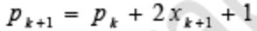
Otherwise the next point along the circle is (xk+1, yk-1) and:
4. Determine symmetry points in the other seven octants
5. Move each calculated pixel position (x, y) onto the circular path centred at (xc, yc) to plot the
coordinate values:
6. Repeat steps 3 to 5 until x >= y
Symmetric pixel positions:
- putpixel(xc+x,yc-y,GREEN); //For pixel (x,y)
- putpixel(xc+y,yc-x, GREEN); //For pixel (y,x)
- putpixel(xc+y,yc+x, GREEN); //For pixel (y,-x)
- putpixel(xc+x,yc+y, GREEN); //For pixel (x,-y)
- putpixel(xc-x,yc+y, GREEN); //For pixel (-x,-y)
- putpixel(xc-y,yc+x, GREEN); //For pixel (-y,-x)
- putpixel(xc-y,yc-x, GREEN); //For pixel (-y,x)
- putpixel(xc-x,yc-y, GREEN); //For pixel (-x,y)

C Program Code:

#include <graphics.h>
#include <stdlib.h>
#include <math.h>
#include <stdio.h>
#include <conio.h>
#include <iostream.h>

class bresen
{
float x, y,a, b, r, p;
public:
void get ();
void cal ();
};
void main ()
{
bresen b;
b.get ();
b.cal ();
getch ();
}
Void bresen :: get ()
{
cout<<"ENTER CENTER AND RADIUS";
cout<< "ENTER (a, b)";
cin>>a>>b;
cout<<"ENTER r";
cin>>r;
}
void bresen ::cal ()
{
/* request auto detection */
int gdriver = DETECT,gmode, errorcode;
int midx, midy, i;
/* initialize graphics and local variables */
initgraph (&gdriver, &gmode, " ");
/* read result of initialization */
errorcode = graphresult ();
if (errorcode ! = grOK) /*an error occurred */
{
printf("Graphics error: %s \n", grapherrormsg (errorcode);
printf ("Press any key to halt:");
getch ();
exit (1); /* terminate with an error code */
}
x=0;
y=r;
putpixel (a, b+r, RED);
putpixel (a, b-r, RED);
putpixel (a-r, b, RED);
putpixel (a+r, b, RED);
p=5/4)-r;
while (x<=y)
{
If (p<0)
p+= (4*x)+6;
else
{
p+=(2*(x-y))+5;
y--;
}
x++;
putpixel (a+x, b+y, RED);
putpixel (a-x, b+y, RED);
putpixel (a+x, b-y, RED);
putpixel (a+x, b-y, RED);
putpixel (a+x, b+y, RED);
putpixel (a+x, b-y, RED);
putpixel (a-x, b+y, RED);
putpixel (a-x, b-y, RED);
}
}
Output:

CONCLUSION:
Thus a program to draw a circle using mid-point algorithm studies and executed.

