**Practical No.1**

**Aim:** Study of various phases of SDLC.

**Theory:**

“SDLC is a process followed for a software project, within a software organization. It consists of a detailed plan describing how to develop, maintain, replace and alter or enhance specific software”

**Need of Software Development Life Cycle**

“SDLC ensure success in process of software development.”

**Phases of Software Development Life Cycle**

* **Initial**
* **Analysis**
* **Design**
* **Coding**
* **Testing**
* **Delivery & Maintenance**

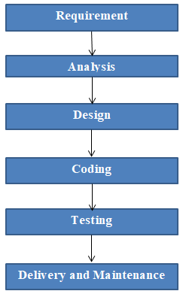

**Figure1: phases of SDLC**

**Initial**

“Business requirements are gathered in this phase. “

This phase is the main focus of the project managers and stake holders. Meetings with managers, stake holders and users are held in order to determine the requirements like;

- Who is going to use the system?

- How will they use the system?

- What data should be input into the system?

- What data should be output by the system?

**Roles Involved:** Business Analyst (BA), System Architects

## Outcome: System Requirement Specification (SRS

**Analysis**

“After requirement gathering these requirements are analyzed for their validity and the possibility of developing the requirements in the system.”

Requirement analysis is the most important and fundamental stage in SDLC. It is performed by both development team and testing team.

**Roles Involved:** Developer & Quality Analysis team, Architects, Project Managers

**Outcome:** Final SRS approved by customer, Technology selection for both Developer & QA

**Design**

“During this part of the design phase, the consultants/architects break down the system into pieces that can be programmed.”

System Design helps in specifying hardware and system requirements and also helps in defining overall

system architecture. The system design specifications serve as input for the next phase of the model.

**Roles Involved:** Architects & Team

**Outcome**: Technical Design Document (TDD)

**Coding**

“The actual development starts and the product is built in coding phase. “

The work is divided in modules/units and actual coding is started in this coding phase and it is the main focus for developer. Coding is one of the longest phase of SDLC.

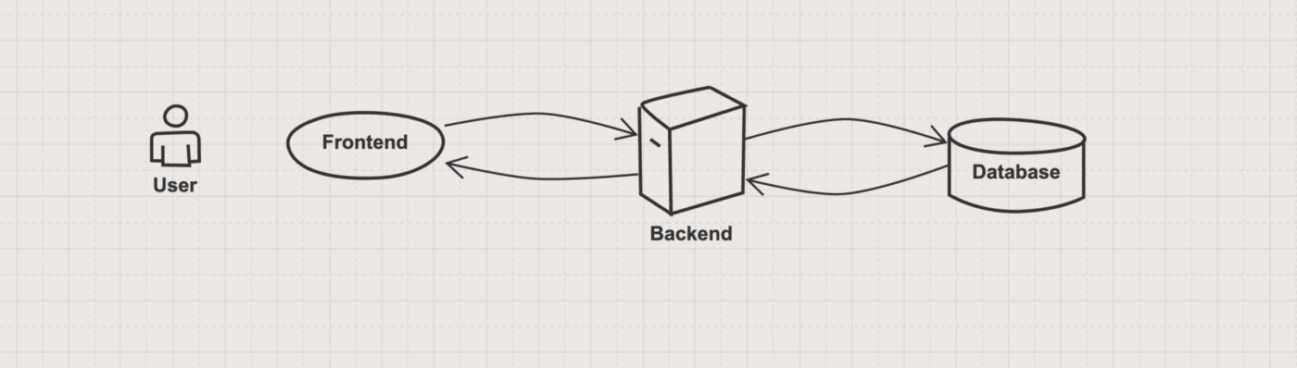

**Figure 2: Connection between Frontend, Backend and Databases**

**Roles involved:** Developers and Architects

**Outcome:** Programs or Application or Module

**Testing**

“In Testing phase testers execute the test cases against the application, report the defects and retested

the fixed defects. “

During this phase unit testing, integration testing, system testing, acceptance testing are done.

**Roles Involved:** Testers, Developers

**Outcome:** Defects, Test Summary Report, Test Plan, Test Case document

**Delivery & Maintenance**

“After successful testing the product is delivered / deployed to the customer.”

During the Delivery phase, customer will perform user acceptance testing (UAT) in a real time environment.

Once when the customers starts using the developed system then the actual problems comes up and needs to be solved from time to time. This process where the care is taken for the developed product is known as maintenance.

**Roles Involved:** Testers, Developers, Customer, Business team, Architects, Project Manager, and Delivery Manager

**Outcome:** Quality Product, Enhancements & Production Issues (Maintenance)

**Conclusion:** Thus, we have studied the SDLC and understand the Roles, Responsibility and outcome of SDLC phases