Technical Seminar

On

HVDC TRANSMISSION

Submitted in partial fulfillment for the award of the degree.

Of
Bachelor of Technology
In
Electrical and Electronics Engineering

Submitted by

17F61A0219 – V. KOUSALYA
Under the esteemed guidance of

MR. V.J. GOWRISENKAR, _{M. TECH}
Assistant professor, Department of EEE


Department of Electrical and Electronics Engineering
SIDDHARTH INSTITUTE OF ENGINEERING & TECHNOLOGY
(Autonomous)
(Approved by AICTE & Affiliated to JNTUA, Anantapur)

(Accredited by NBA, New Delhi, An ISO 9001:2008 Certified Institution)

Siddharth Nagar, Narayanavanam road, PUTTUR-517583, A.P

2021

SIDDHARTH INSTITUTE OF ENGINEERING & TECHNOLOGY
(Approved by AICTE & Affiliated to JNTUA, Anantapur)
(Accredited by NBA, New Delhi, An ISO 9001:2008 Certified Institution)
Siddharth Nagar, Narayanavanam Road, Puttur-517583, A.P

DEPARTMENT OF ELECTRICAL AND ELECTRONICS ENGINEERING

BONAFIDE CERTIFICATE

This is to certify that this project report titled “HVDC TRANSMISSION” that is being submitted by

17F61A0219 – V. KOUSALYA
in partial fulfillment of the requirements for the award of Bachelor of Technology in the Department of Electrical and Electronics Engineering to JNTUA, ANANTAPURAMU. The results embodied in this Technical Seminar.
report have not been submitted to any other University for award of any degree.
Internal Guide Head of the Department
MR. V.J. GOWRISENKAR, MTech Dr. N. RAMESH RAJU, MTech, Ph.D.
Assistant Professor HOD, EEE
Submitted for the Technical Seminar report on __________

CONTENTS

TITLE PAGE NO.

1.ACKNOWLEDGEMENTS 04
2.ABSRACT 05
3.INTRODUCTION 06
4.ADVANTAGES OF HVDC TRANSMISSION 07
5.LIMITATION OF HVDC TRANSMISSION 08
6.HVDC TRANSMISSION SYSTEM 09
7.PRINCIPLES AC/DC CONVERSION 11
8.TRANSMISSION MODES 14
9.PRINCIPLES OF HVDC CONTROL 17
10.HVDC APPLICATIONS 20
11.FUTURE TRENDS 22
12.REFERENCE 23

- ACKNOWLEDGEMENT
I would like to express my profound sense of gratitude to Mr. V.J. GOWRISENKAR of EEE for his valuable guidance and constructive suggestions made at various levels of the work. I am thankful to Dr. N. RAMESH RAJU, MTech., Ph.D.., Professor, HOD, Department of Electrical and Electronics Engineering, for her guidance, constant encouragement and support. I express my gratitude to beloved Principal Dr. K. CHANDRASEKHAR REDDY, MTech., Ph.D., and the Management of SIETK for providing all the facilities in Siddharth Institute of Engineering and Technology, Puttur. completing Seminar course successfully. My heart full thanks to all my teachers in the department of EEE of for their moral support and good wishes. Finally, I would like to express my sincere thanks to our parents, friends, one and all those who guided, inspired and helped me in completion of my Seminar course work.

2. ABSTRACT

An HVDC Transmission system for bulk power transfer over longer distance offers numerous advantages over an alternating current (AC) transmission system, such as direct integration of networks operating at different frequencies, comparatively low line losses on account of constant current and absence of reactance. This paper presents details about HVDC power transmission systems and power converter technologies. Issues concerning integration of electrical power generated by alternate sources into the national grid of Pakistan using HVDC technology are also discussed. Research studies revealed that the energy crisis of countries like Pakistan can be mitigated to a larger extent with the use of HVDC transmission system was less.

___
3.Introduction
The first commercially used HVDC link in the world was built in 1954 between the mainland of Sweden and island of Gotland. Since the technique of power transmission by HVDC has been continuously developed.
In India, the first HVDC line in Rihand-Delhi in 1991 i.e. I 500 KV, 800 Mkl, 1000 KM. In Maharashtra in between Chandrapur & Padaghe at 1500 KV & 1000 MV. Global HVDC transmission capacity has increase from 20 MW in 1954 to 17.9 GW in 1984. Now the growth of DC transmission capacity has reached an average of 2500 MW/year.

4. ADVANTAGES OF hvdc TRANSMISSION
- The cost of D.C. transmission line is less than 3 - phase A.C. line because only two conductors are necessary for D.C. line.
- Tower designs are simple.
- The dielectric strength of cable is high.
- The dielectric loss is low.
- For D.C. overhead transmission lines length is unlimited.
- Power transmission capacity is higher than A.C.
- Corona & radio frequency interference losses are less.
- HVDC link has accurate & quick control of power in the required direction.

5.LIMITATION OF HVDC TRANSMISSION
1. Transformer for step up – step down voltages is not available in case of HVDC.
2. The terminal equipment is costly.
3. Reliable D.C. CKT. Breakers for higher ratings are not available.
4. Earth current may cause some side effects.
5. Reactive MVA cannot be transferred over a HVDC link.
6. Although inverters are used, the wave farm of output A.C. is not exactly sinusoidal and it contains harmonic distention

6.HVDC TRANSMISSION SYSTEM

In case of HVDC transmission, following systems are used: -
(i) Two pole one wire.
(ii) Two pole two wire.
(iii) Three pole two wire.
(iv) Three pole three wire.
The standard voltages used are: -
100, 200, 300, 400, 600 & 800 KV.
The HVDC system is accepted for transmission of power for following reason:
(i) for long-distance high-power transmission.
(ii) for interconnection between two A.C. systems having their own load frequency control.
(iii) for back-to-back a synchronous tie substation.
(iv) for underground or submarine cable transmission over long distance at high voltage.
At present, HVDC links have been installed in the world up to the year 2001, 100 links are expected with a total transfer capacity of 75000 MW. The choice between 400 KV A.C. 705 KV A.C., 1100 KV A.C. and HVDC transmission alternatives is made on the basis technical and economic studies for each line and associated A.C. system although, alternating current system continuous to be used for generation, transmission, distribution & utilization of electrical energy.

7.Principles AC/DC conversion
HVDC transmission consist of two converter stations which are connected to each other by a DC cable or DC line. A typical arrangement of main components of an HVDC transmission is shown in fig.
Two series connected 6 pulse converters (12-pulse bridge) consisting of valves & converters transformer are used. The valves convert AC to DC, and the transformer provide a suitable voltage ratio to achieve the desired direct voltage and galvanic separation of the AC & DC systems. A smoothing reactor in the DC CKT reduces the harmonic currents in the DC line, & possible transient over currents. Filters are used to take care of harmonics generated at the conversion. Thus, we see that in an HVDC in an HVDC transmission, power is taken from one point in an AC network, where it is converted to DC in a converter station (rectifier), transmitted to another converter station (inverter) via line or cable and injected into an ac system.
By varying the firing angle & (point on the voltage wave when the gating pulse is applied & conduction starts) the DC output voltage can be controlled between two limits, positive and negative. When a is varied, we get,
maximum DC voltage when ∝ = 0⁰.
Rectifier operation when 0< ∝ < 90⁰
Inverter operation When 90⁰< ∝ < 180⁰
While discussion inverter operation, it is common to define extinction angle γ = 180⁰ - ∝.

Shunt capacitors |SVS| other reactive equipments e.g. such condenser
AC Bus

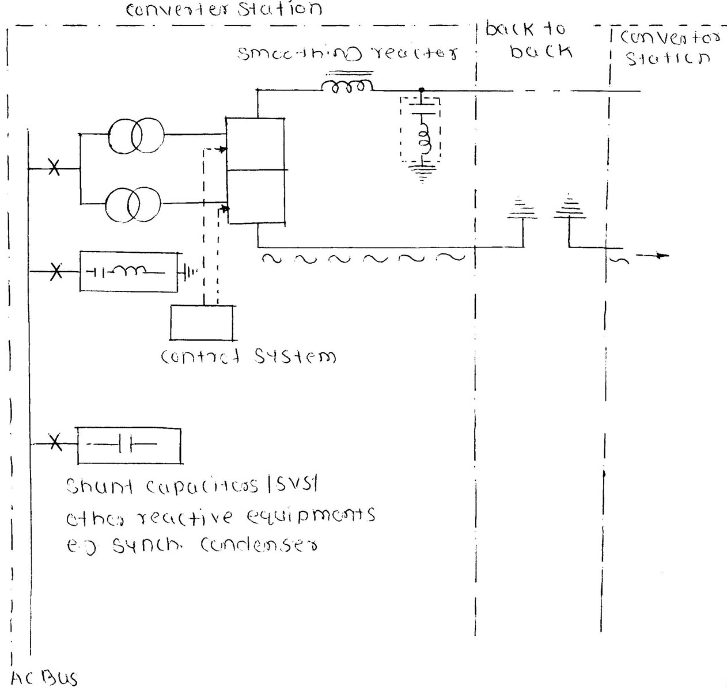

Fig. Main components of a HVDC transmission a typical arrangement

8.Transmission Modes
There are three different transmission modes.
1. Mono polar
2. Bipolar
3. Homo polar
1. Mono polar :-
In case of mono polar arrangement one pole is used at a D.C. voltage level and ground is the permanent return path. Mono polar arrangement is used for long submarine/underground cables.
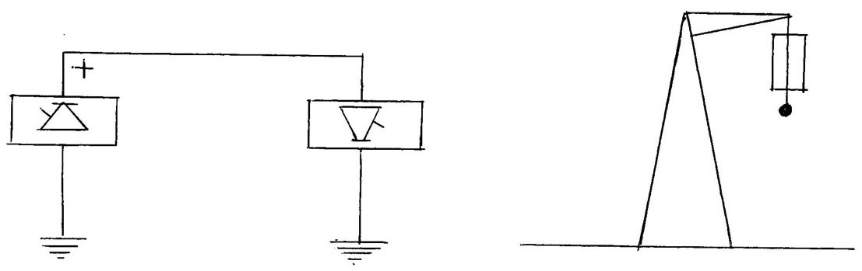

Fig. Monopolar Line
2. Bi-polar :-
The bipolar arrangement uses two poles, one positive pole and other negative pole at each conversion substation, the mid-points point of converter are earthed, the current carried by the ground, is However less if one of the poles is out of service, the bipolar arrangement can be used as a mono polar arrangement. Although it is used at a reduced rating. Bipolar arrangement is universally used for bulk power HVDC overhead transmission linear and for overhead lines for interconnection.
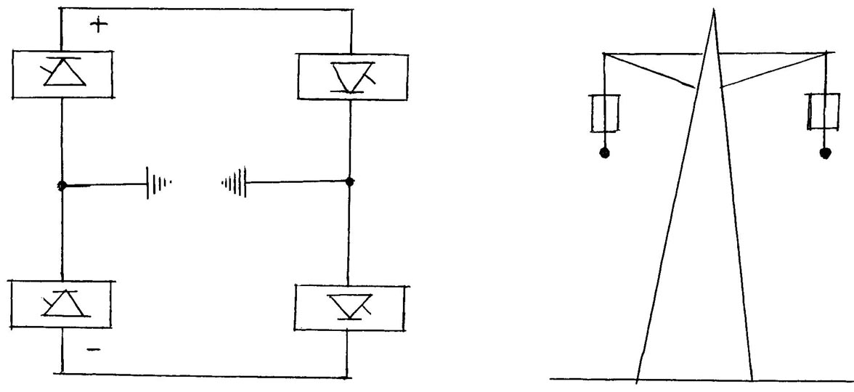

Fig. Bipolar line

3. Homo polar :-
A Homo polar arrangement consist of two conductors of same polarity on the same tower. In fact, it is a mono polar system having two conductor/pole. The ground is used as a return path. Homo polar system is used for the overhead D.C. line feeding into the D.C. cable.

9. PRINCIPLES OF HVDC CONTROL
One of the most important aspects or HVDC systems is its fast and stable controllability. In DC transmission, the transmitted power can be rapidly controlled by changing the DC voltages. The current in the system can only flow in one direction for a given setting power is transported from rectifies to inverter and by altering voltages, the power flow direction is reversed.
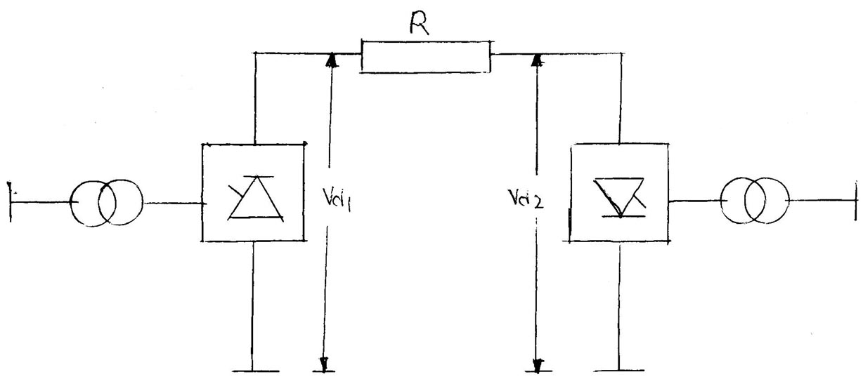
Rectifier
(Sending )
Inverter
(Receiving )

In HVDC transmission, one of the converter stations, generally the inverter station, is so controlled that the direct voltage of the system is fixed & has rigid relation to the voltage on the AC side. Tap changers take care of the slow variations on the AC side the other terminal station (rectifier) adjusts the direct voltage on its terminal so that the current is controlled to the desired transmitted power.
In fig.
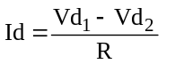 (L – 1)
Where R is the Resistance of link & includes loop transmission resistance (if any), and resistance smoothing reactors and converter valves the power received is, therefore, given as
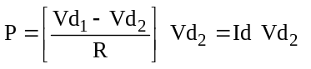 (L – 2)
The rectifier and inverter voltages are given by.
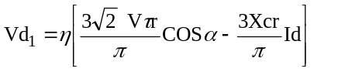 (L – 3)
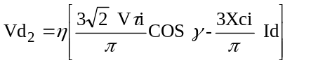 (L – 4)
Where,
: - number of series connected bridges.
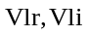 : - line to line AC Voltages at the rectifier and inverter bridges, respectively.
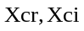: - Commutation reactance at the rectifier and inverter, respectively.
From equation (L-2). The DC power per pole is controlled by relative control of DC terminal voltages, 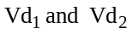 control on DC voltage is exercised by the converter control angles 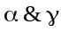as given by
Equations (L – 3) and (L – 6). Normal operating range of control angles is:
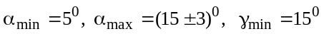
The prime considerations in HVDC transmission are to minimize reactive power requirement at the terminals and to reduce the system losses. For this DC voltage should be as high as possible and should be as low as possible.

10.HVDC APPLICATIONS
1. Inter connection of systems of the same frequency through a zero length DC link (back-to-back connection).
This does not require and dc transmission line and AC lines for minute on the rectifier and inverter which are connected back-to-back. A typical example is the Eel River scheme is Canada connecting the Quebec hydro system with that of New Brunswick. This helps in interconnecting two AC systems without increasing their fault levels. In India, a 400 KV, 500 MW Singrauli to Vindhychal back-to-back link is being commission at Vindhychal.
2. Transmission of power through underground or submarine cables.
3. A.C. & D.C. lines in parallel.
4. Connection of D.C. transmission A.C.
5. Frequency conversion.
6. Transmission of power over a long distance.

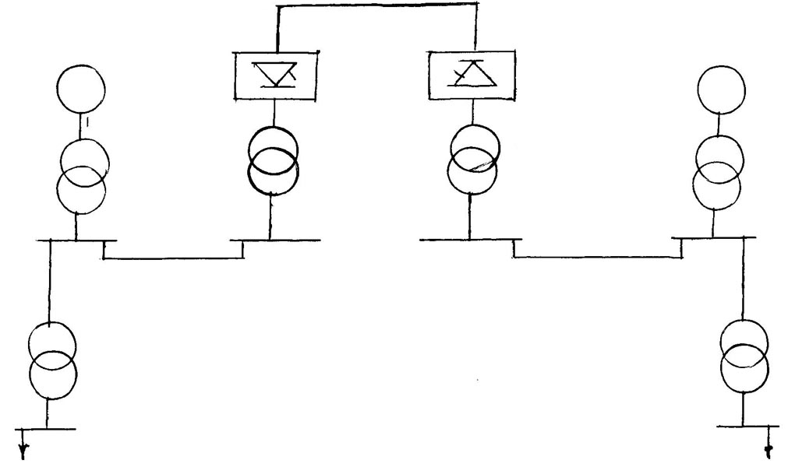

Fig. Back-to-Back Connection

11.FUTURE TRENDS
Considerable research and development work is under way to provide a better understanding of the performance of HVDC links to achieve more efficient and economic designs of thyristor valves and related equipment and to justify the use of Alternatives AC/DC system configurations.
Future power systems would include a transmission mix of AC & DC. Future controllers would be more & more Microprocessor based, which can be modified or upgraded without requiring Hardware changes.
It is by now clear that HVDC transmission is already a reliable, efficient & cost-effective alternative to HVAC for many applications.

12.REFERENCE
Power System Engineering.
I. J. Nagarnath
D.P. Kothari
M. V. Deshpande.

