* Let’s create a restController:

1. Configure the project at spring initializer
2. Download the zip file
3. Unzip the file
4. Import the project in IDE
5. Run the application

* WhitelabelErrorPage

We have not added any real code to our project that’s why we are getting this page.

1. Create a package -> rest
2. Create a class FunRestController
3. Add @RestController Annotation on class
4. Create a method which will return a string (“Hello Team!!”)
5. Annotate it with @GetMapping(“/”)
6. Run the main application

package com.flynaut.springboot.demo.primaryApp.rest;  
  
import org.springframework.web.bind.annotation.GetMapping;  
import org.springframework.web.bind.annotation.RestController;  
  
import java.time.LocalDate;  
  
@RestController  
public class FunRestController {  
  
 //expose endpoint - "/hello" that returns "Hello Team"  
 @GetMapping("/")  
 public String sayHello(){  
 return "Hello Team!!";  
 }  
 //This method will handle GET request at "hello" endpoint  
  
 @GetMapping("/date")  
 public LocalDate date(){  
 LocalDate localDate = LocalDate.*now*();  
 return localDate;  
 }  
  
 // return yesterdays date  
}

URL – Uniform Resource Locator

<http://localhost:8080>

<http://www.abc.com:8080/college>

http : Application Layer Protocol (Hypertext Transfer Protocol)

www.abc.com : DNS qualified hostname/IP address (used to resolve the host problem)

8080: TCP port(used to identify the port)

/college: URI (Uniform resource identifier) or path

MAVEN:

* Project build tool
* Used for build management and dependencies

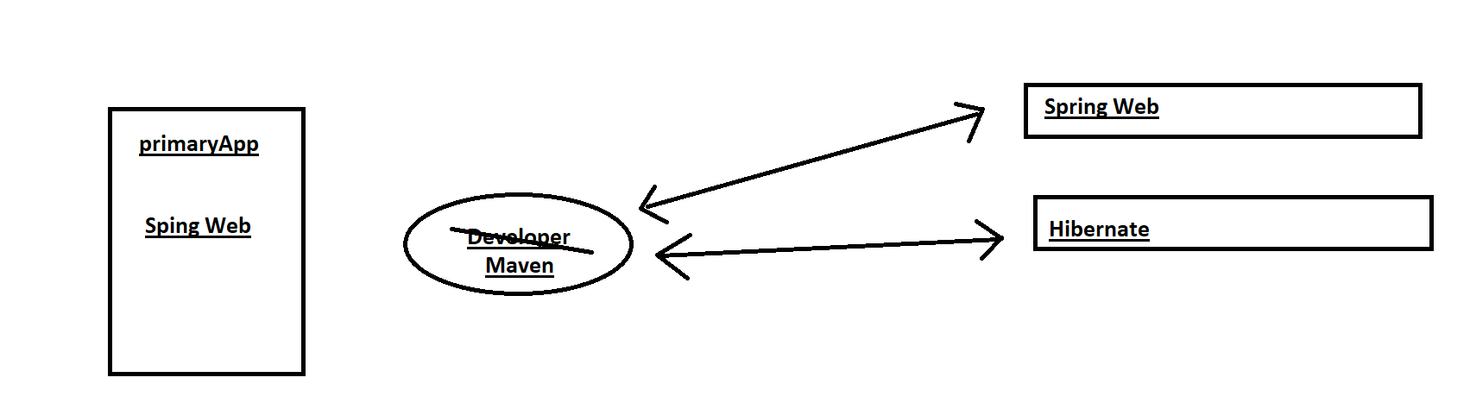

* Tell maven the projects we are going to work on(dependencies)
* Go out and download the jar files for us
* Maven Project Structure

Maven uses standard directory structure

|  |  |
| --- | --- |
| Directory | Description |
| src/main/java | Our source code |
| Src/main/resources | Properties/ configuration files used by our app |
| src/test | Unit testing code and properties |
| target | The destination directory for compiled code(Automatically created by maven) |
| pom.xml | Maven Configuration File |

POM.xml

Project Object Model File

* Configuration File for our project
* Shopping List
* Located at root of project

POM file Structure

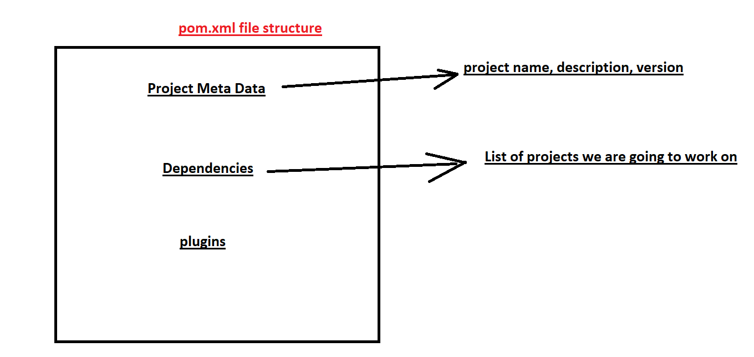

Maven flow:

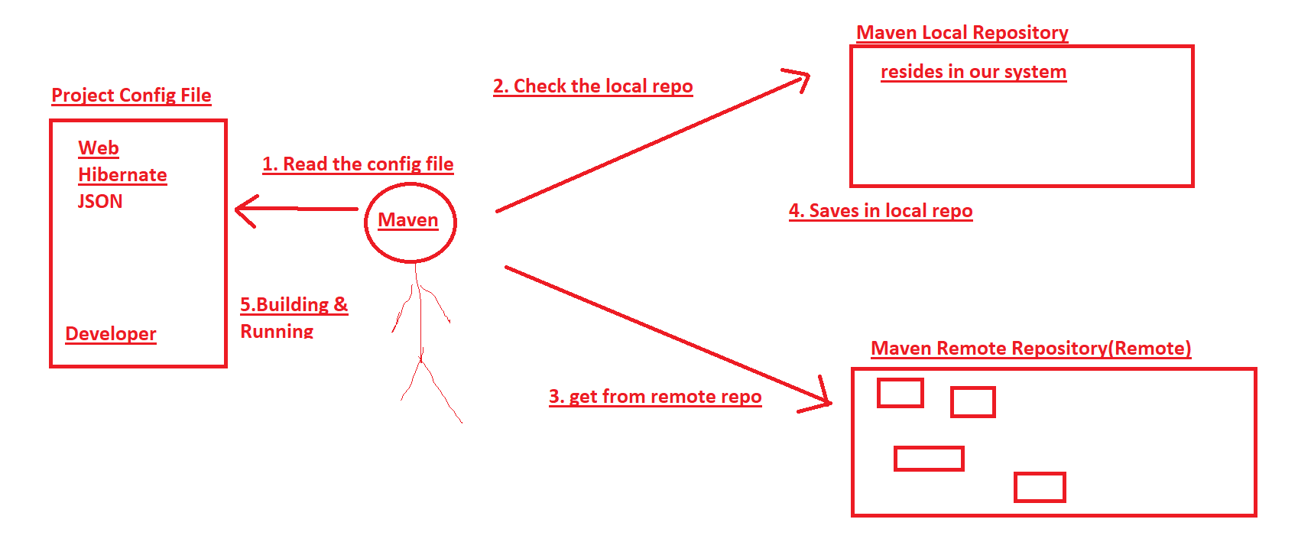

[Maven Central](https://central.sonatype.com/) – Remote Repository

Project Coordinates:

* To uniquely identify a project
* Similar to GPS coordinates for home- longitude/latitude
* Precise address of our home(city, street, home no.)

<groupId>org.springframework.boot</groupId> <City>  
<artifactId>spring-boot-starter-parent</artifactId> <Street>  
<version>3.4.2</version> <Home No.>

GroupId: Name of company, group, organization

ArtifactId: Name of our project : primaryApp

Version

If we want to manually add the dependencies, we need GAV

Maven Wrapper Files:

mvnw

mvnw.cmd/ mvnw.sh

* mvnw allows us to run a maven project
* No need to have maven installed in our path

Mvnw.cmd = for windows

Mvnw.sh = for mac/linux

Application.properties file

By default, SB loads properties from this file

* Created by spring initializer
* It is empty at beginning

We can add properties in this file:

Server.port=7070

To add our own custom properties

Task ->

Why Starters?

<dependency>  
 <groupId>org.springframework.boot</groupId>  
 <artifactId>spring-boot-starter-web</artifactId>  
</dependency>