CommandLineRunner:

* It is a functional interface which is provided by SB
* It allows us to execute the code after the SB application has started
* It has @Bean annotation it registers the CLR as Spring Bean.
* Creating db tables from java code

Previously we created db tables by running a SQL script.

JPA/Hibernate provides an option to create db tables automatically.

Configurations:

Application.properties:

Spring.jpa.hibernate.ddl-auto = create

When we run our application, JPA/Hib will drop tables then create them for us

NOTE: When database tables are dropped, all data is erased.

Spring.jpa.hibernate.ddl-auto = update

If we want to create table once and then keep the data

What are REST services?

REpresentational State Transfer

* Used for building web services which interact over HTTP.

Uses of HTTP Methods:

1. GET: retrieve data
2. POST: create new data
3. PUT: update the existing data
4. DELETE: Delete data

What is data format: JSON

/students -> represents all the students

/student/{id} -> Represents a single student by id

Business Problem?

* Build a client application that can provide the weather report for a city
* To get this I have to have an external service

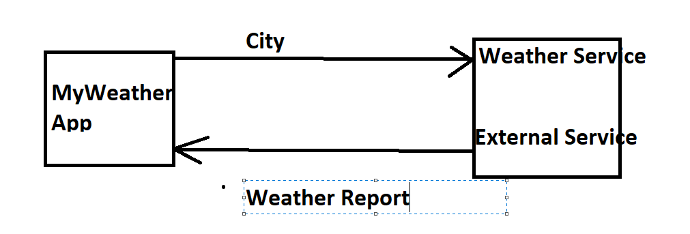

1. How we are going to connect to weather service?

* We can make REST API calls over HTTP
* Representational State Transfer
* Lightweight approach for communicating between applications.

1. Which programming language we are going to use?

* REST is language independent
* The client and server application can use any programming language.

1. What will be the data format?

* Rest can use any data format
* Commonly used is XML or JSON
* JSON is most popular

JavaScript Object Notation

Respose – Weather report

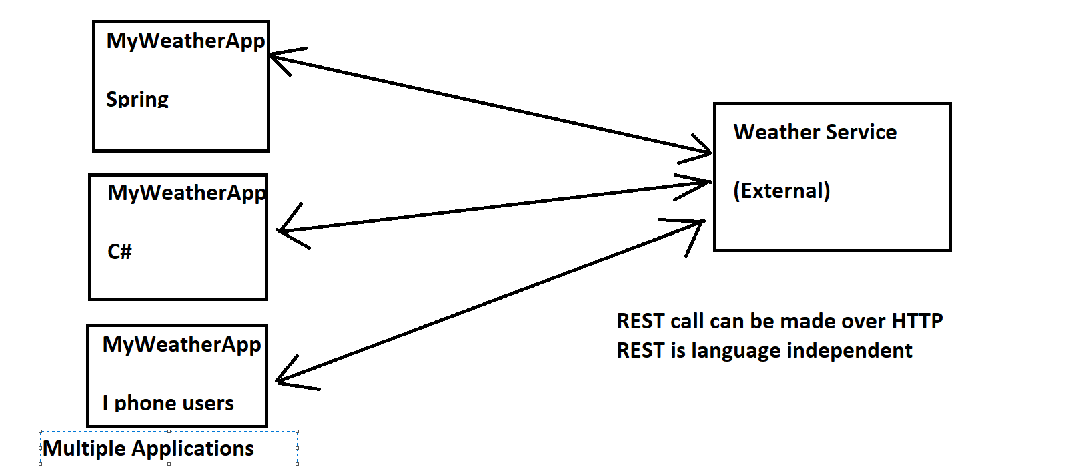

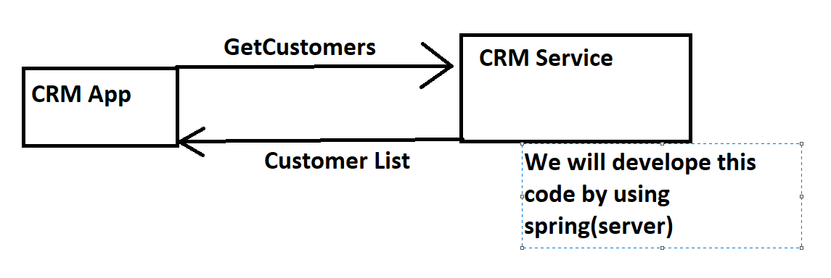CRM application

What is JSON?  
- lightweight data format for storing and exchanging the data

* Language independent….not only for javascript
* Nothing but a plain text data

Example:

{

“Id” : 1,

“firstName”: “Krishna”,

“lastName” : “Yadav”,

}

Curly braces define the object is JSON

Object Members are name/value pairs

REST HTTP Methods:

POST: create a new entity

GET: Read a list of entity or list of entity

PUT: update an existing entity

DELETE: delete existing entity

* HTTP Message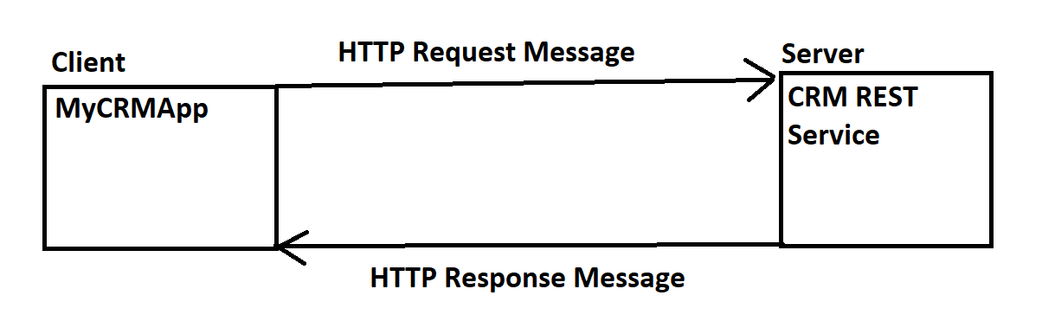

HTTP Request Message:

It has 3 parts

1. Request Line: the HTTP command
2. Header variables: request metadata
3. Message Body: (actual payload) contents of message

HTTP Response Message:

It has 3 parts

1. Response line: status code
2. Header variables: response metadata
3. Message body: contents of message

HTTP Response Status Codes

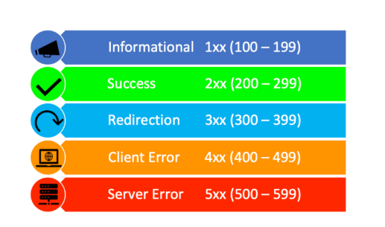

Client Tool:

We need client tool to send HTTP requests to REST WEB service/ API : Curl, Postman

Web Browser Vs Postman:

* For simple REST testing for GET requests

WebBrowser and postman act the same

* For advanced REST testing : POST, PUT,etc