package com.flynaut.exploration1.rest;  
  
import org.springframework.web.bind.annotation.GetMapping;  
import org.springframework.web.bind.annotation.RestController;  
  
import java.time.LocalDate;  
  
@RestController  
public class FunRestController {  
  
 //exposing an endpoint - "/name" which is returning name  
 @GetMapping("/name")  
 public String sayName(){  
 return "PrasadJain";  
 }  
  
 //To return today's date  
 //@RequestMapping(value = "/date",method = RequestMethod.GET)  
 @GetMapping("/date")  
 public LocalDate date(){  
 LocalDate localDate = LocalDate.*now*();  
 return localDate;  
 }  
  
 //To return yesterday's date  
}

MAVEN:

* Project Build Tool
* Used for managing dependencies and build management

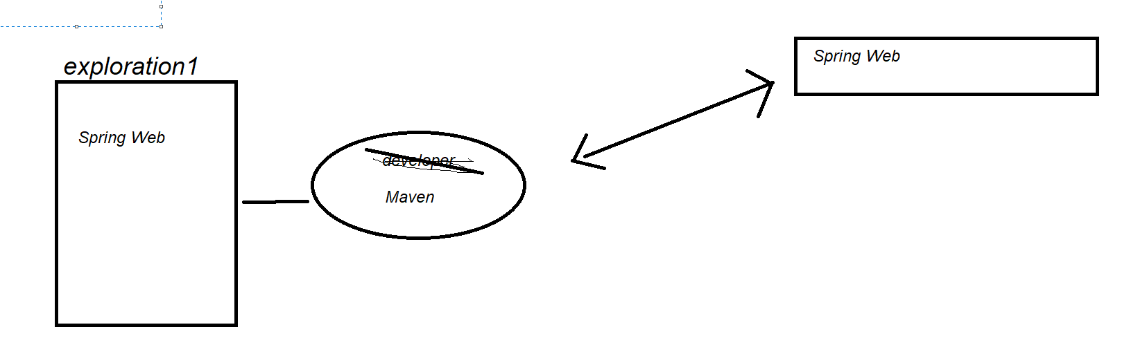

* Tell maven the projects we are going to work on(dependencies)
* Go out and download the JAR for us.

Project Structure

|  |  |
| --- | --- |
| Directory | Description |
| src/main/java | Our Source code |
| src/main/resources | Properties / configuration files used by our application |
| Src/test | Unit testing code and properties |
| target | The destination directory for compiled code(automatically created by maven) |
| Pom.xml | Maven Configuration file |
|  |  |

pom.xml

Project Object Model file

* Configuration file for our project
* Shopping List ☺
* Located at the root of the project

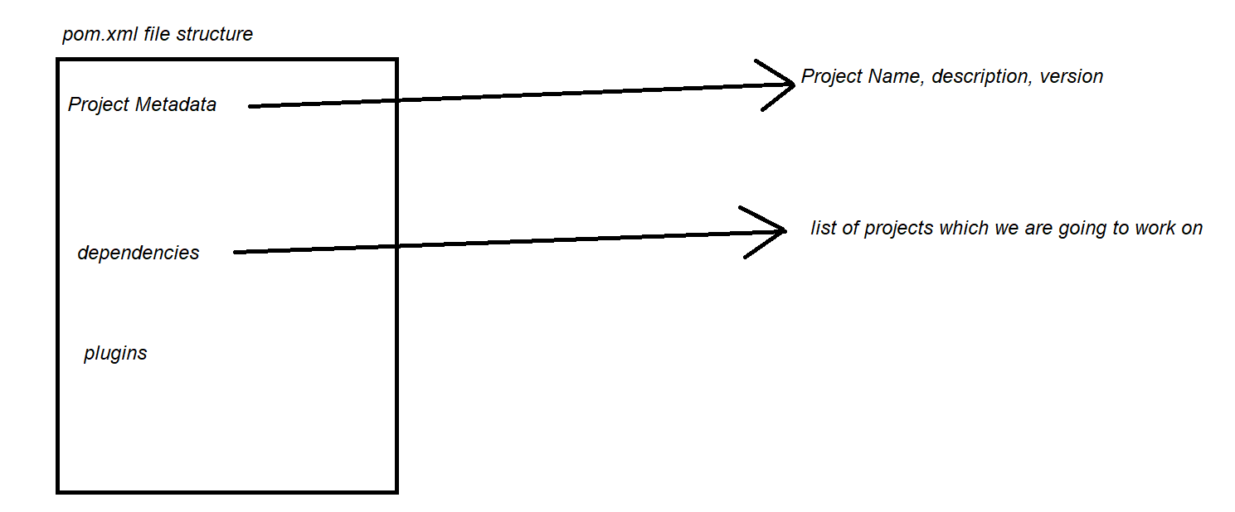

MAVEN FLOW:  
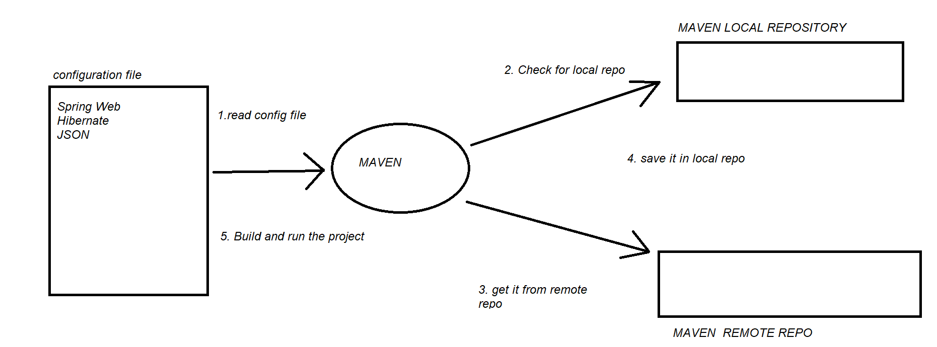

Project Coordinates:

* To uniquely identify a project
* Similar to google coordinate

<groupId>com.flynaut</groupId>  
<artifactId>exploration1</artifactId>  
<version>0.0.1-SNAPSHOT</version>

GroupId: Name of company, group, org

ArtifactId: name of project

Version

If I want to add dependencies manually I will need GAV

Maven Wrapper Files

Mvnw

Mvnw.cmd (for windows)

Mvnw.sh (for linux/mac)

application.properties

By default, SB loads properties from this file

* Created by spring initializer
* It is empty at the beginning

We can add properties in this file

server.port = 9090;  
  
We can add custom properties

spring-boot-starters

A collection of maven dependencies with the compatible version.

spring-boot-starter-web

- Spring-web

- Spring-webmvc

- Tomcat

- JSON  
  
  
Building Spring application is tedious.

Why?

It will be great if there is a list of maven dependencies collected as a group of dependencies which will be a one stop solution

If we have one stop solution we don’t need to search for dependency

Solution- SB Starters

* A curated list of maven dependencies
* It reduces the configuration part

Ex.spring-boot-starter-security

Spring-boot-starter-jpa

SB DEV TOOLS:

The Problem:

When we are running the SB application

And if we are making any changes in the source code. Then manually we have to stop application and restart the application☹  
  
The Solution: SB dev tools

Automatically restarts the application when we make any changes in the source code.

How?

Step1:Simply by adding dependency in the pom.xml

<dependency>  
 <groupId>org.springframework.boot</groupId>  
 <artifactId>spring-boot-devtools</artifactId>  
 <scope>runtime</scope>  
 <optional>true</optional>  
</dependency>

Step2:

File -> Settings -> build,execution,deployment -> compiler -> check the box(build project automatically ) -> apply -> ok

Step3:

Settings -> advanced settings -> check the box(allow automate…….)-> apply -> ok