AI ADOPTION IN
FORTUNE 500 COMPANIES
Comprehensive EDA & Power BI Dashboard Documentation

4,848  Total Records | 1,000  Unique Companies | 25.1%  Avg AI ROI | 2020–2025  Years Covered

Prepared by: Prasad Karade and Rajeshwar Jadhav (April 2026)
Tools Used: Python (Pandas, Matplotlib, Seaborn) and Power BI

1. Project Overview
This project investigates AI adoption patterns across Fortune 500 companies over a six-year period (2020–2025). Using a rich multi-dimensional dataset, we conduct an end-to-end analysis covering data cleaning, exploratory data analysis (EDA), statistical insights, and a Power BI interactive dashboard — enabling business stakeholders to derive actionable intelligence from AI adoption trends.

1.1 Objectives
- Analyze the extent and trend of AI adoption across industries and geographies.
- Quantify the financial impact of AI through Revenue and ROI analysis.
- Identify leading use cases and sectors driving AI maturity.
- Deliver an interactive Power BI dashboard for non-technical stakeholders.

1.2 Tools & Technologies
• Python — Data Exploration, EDA, and visualization (Pandas, Matplotlib, Seaborn)
• Power BI Desktop — Dashboard design, DAX measures, interactive reporting
• Dataset: cleaned_ai_adoption.csv (4848 records and 11 columns)

2. Dataset Description
The dataset contains longitudinal records of 1,000 companies observed annually from 2020 to 2025, capturing AI adoption status, financial performance, use case categories, and maturity scores. All records in the cleaned dataset are tagged as AI users (Uses_AI = Yes), making this an AI-company-focused study.

2.1 Data Dictionary
Column Name | Data Type | Description
Year | Integer (2020–2025) | Year of observation for the company record
Company | String | Name of the Fortune 500 company
Industry | Categorical | Industry sector (Technology, Finance, Telecom, etc.)
Country | Categorical | Headquarter country of the company
Company_Type | Categorical (Real / Synthetic) | Whether the record is a real or synthetic company
Employee_Size | Categorical | Company size classification (Enterprise / SME)
Revenue_USD | Float | Annual revenue in US Dollars
Uses_AI | Binary (Yes / No) | Whether the company uses AI solutions
Use_Case | Categorical | Primary AI use case deployed (e.g., Chatbots, Generative AI)
AI_ROI_Percent | Float | Return on Investment from AI initiatives (%)
AI_Maturity_Score | Integer (1–100) | AI maturity level score of the company

2.2 Dataset Summary Statistics
Key Dataset Facts
• Total Rows: 4848, Unique Companies: 1,000, Years: 2020–2025
• Industries: Technology, Finance, Telecom, E-commerce, Manufacturing, Retail, Logistics,
Healthcare
• Countries: 10 countries — USA (601), Canada (561), Brazil (548), China (536), India (530)
• Avg Revenue: $16.17 Billion USD, Avg AI ROI: 25.06%, Avg Maturity Score: 62.76 / 100
• Company Types: 111 Real companies, 4,737 Synthetic companies

3. Exploratory Data Analysis (EDA)
The EDA was conducted in Python using Pandas for data manipulation and Matplotlib/Seaborn for visualizations. The following sections present key findings from each analytical dimension.

3.1 Industry Distribution
The dataset is well-balanced across eight major industries. Technology leads with 573 records, followed closely by Finance (554), Telecom (549), and E-commerce (547), ensuring diverse sectoral representation.

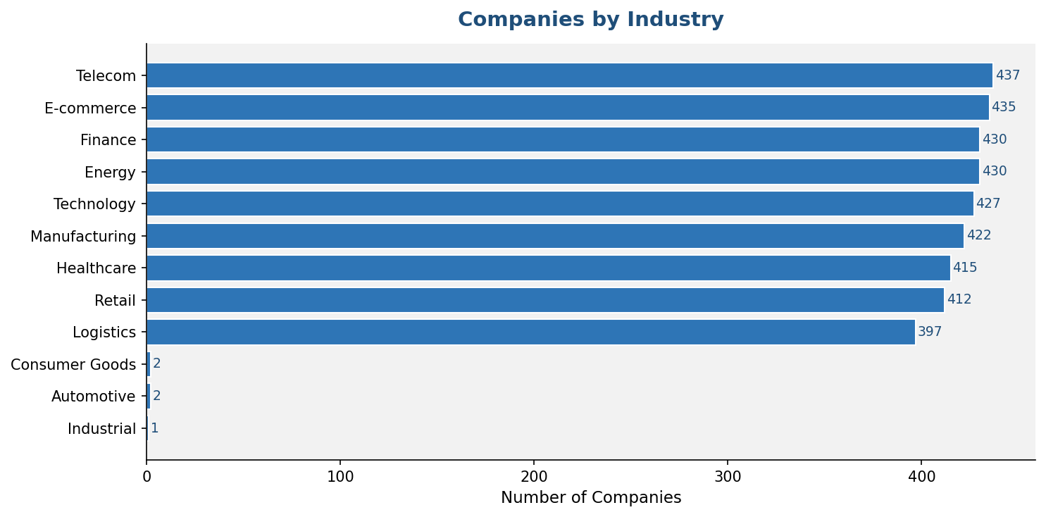
Figure 1: Number of Companies per Industry Sector

3.2 AI Use Case Analysis
Among AI use cases deployed, Supply Chain Optimization and Chatbots are the most frequently adopted (431 instances each), followed by Customer Segmentation (413) and AI Trading (412). Generative AI is also prominent, reflecting recent enterprise adoption trends.

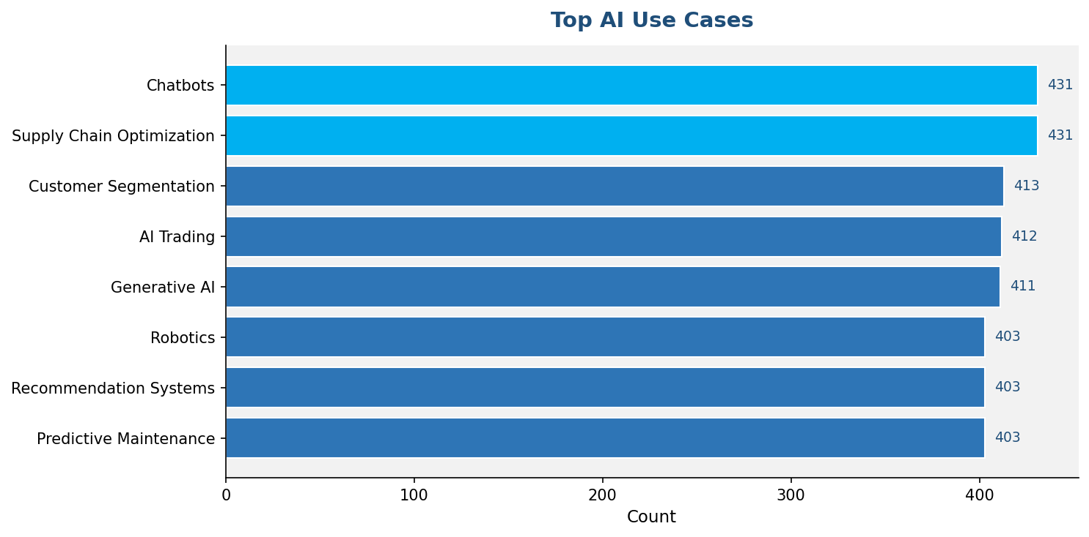
Figure 2: Top 8 AI Use Cases by Frequency

3.3 Revenue Trend Analysis (2020–2025)
Average company revenue shows notable fluctuations over the observation period. Revenue peaked in 2025 at $18.3B, with a dip in 2024 ($14.2B). This non-linear trend may reflect market volatility, post-pandemic recovery patterns, and varying AI investment cycles.

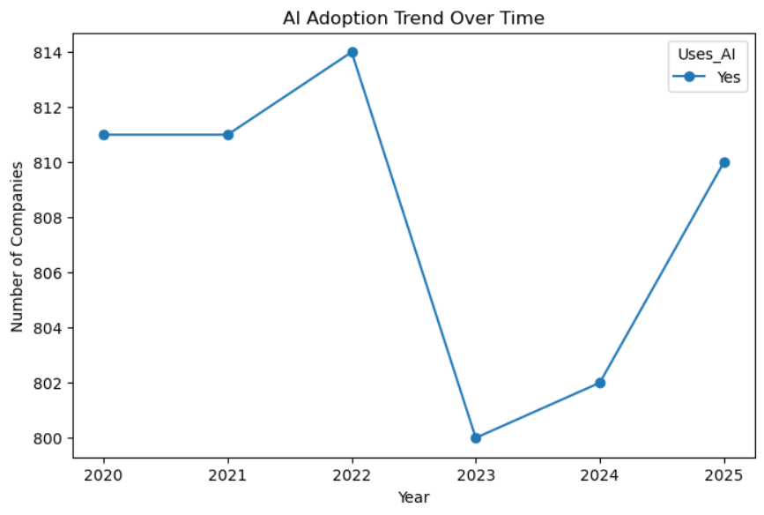
Figure 3: Average Revenue Trend by Year (2020–2025)

3.4 AI ROI by Industry
AI Return on Investment is remarkably consistent across industries, ranging from 24.98% (Finance) to 25.45% (Telecom). This narrow band suggests that AI delivers relatively uniform ROI regardless of sector, pointing to the generalizability of AI solutions across business domains.

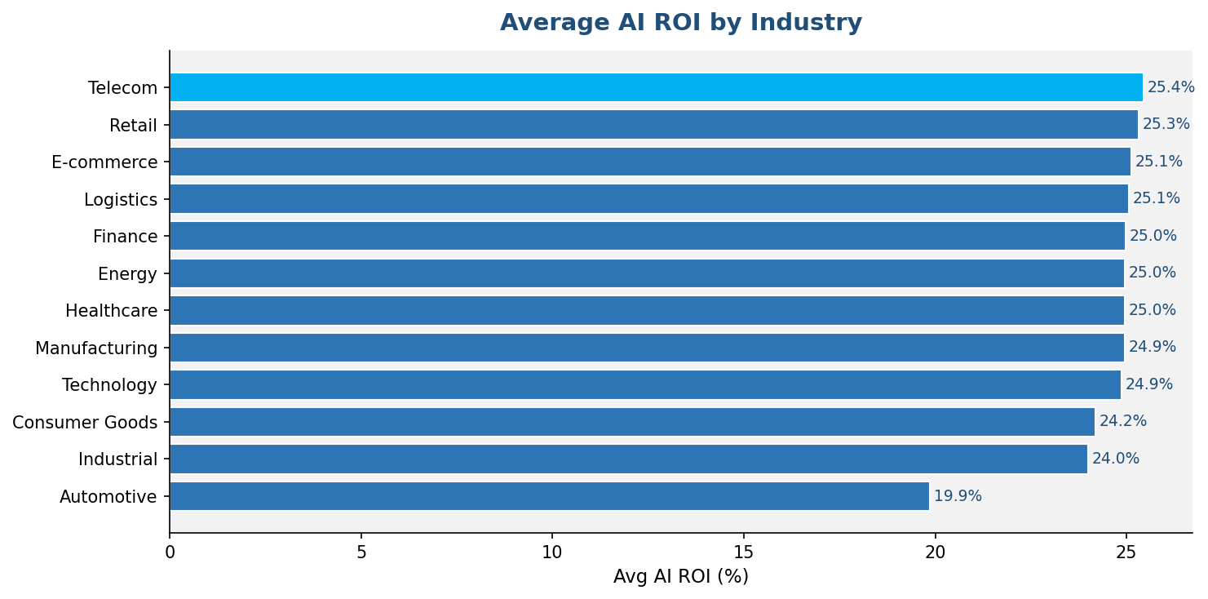
Figure 4: Average AI ROI (%) by Industry Sector

3.5 AI Maturity Score Distribution
The AI Maturity Score distribution follows a near-uniform pattern across the 1–100 scale, with a dataset mean of 62.76. This suggests that companies at all levels of AI maturity are represented, and the data is not skewed toward either early-stage or mature adopters.

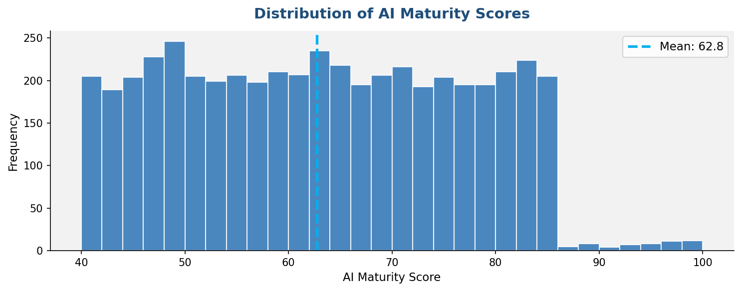
Figure 5: Distribution of AI Maturity Scores across All Companies

3.6 Geographic Distribution

The USA leads with 601 company-year records, followed by Canada (561), Brazil (548), China (536), and India (530). The dataset covers 10 countries, providing strong geographic diversity for cross-country comparative analysis.

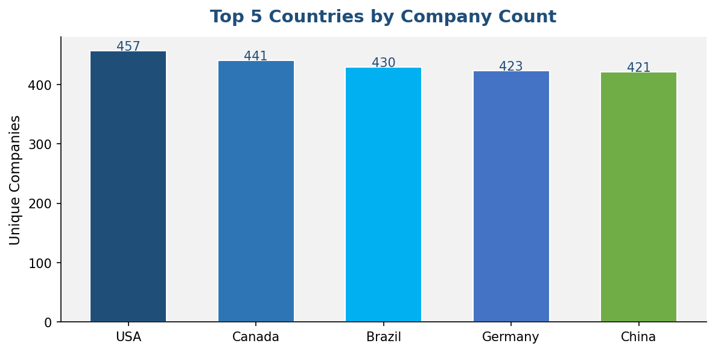
Figure 6: Top 5 Countries by Unique Company Count

3.7 Key EDA Insights
Summary of Findings
1. 100% AI Adoption — All 4,848 records in the cleaned dataset use AI, confirming this is a curated AI-adopter dataset.
2. Sector Parity — Technology, Finance, Telecom, and E-commerce are nearly equally represented (540–573 records each).
3. Use Case Maturity — Supply Chain and Chatbots dominate, signaling operational and customer-facing AI as top priorities.
4. ROI Stability — AI ROI is consistently ~25% across all industries, underlining the broad value of AI investments.
5. Revenue Peaks in 2025 — The highest avg revenue ($18.3B) recorded in 2025 may indicate compounding AI-driven growth.
6. Maturity Spread — Scores are spread uniformly, meaning no single maturity tier dominates the sample.

4. Power BI Dashboard
A professional multi-page interactive dashboard was developed in Power BI Desktop to communicate EDA findings visually. The dashboard is structured across three pages: Overview, Detailed Analysis, and Comparison — each tailored for a different stakeholder perspective.

4.1 Dashboard Screenshot
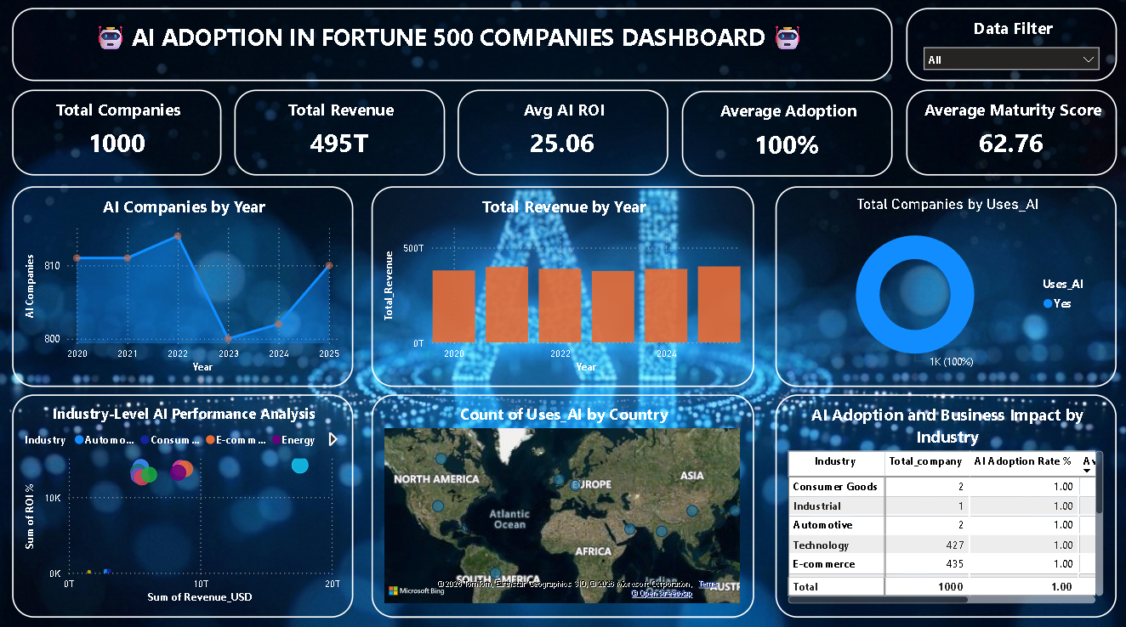
Figure 7: Power BI Dashboard — Power BI Best Practices & DA Track Deliverables Page

4.2 Dashboard Structure
Pages & Purpose
- Page 1 — Overview: High-level KPIs (Total Companies, AI %, Revenue, ROI, Maturity). Audience: Executives.
- Page 2 — Detailed Analysis: Industry-level breakdown, use case trends, year-over-year growth charts.
- Page 3 — Comparison: Company-type and country-level benchmarks, scatter plots for ROI vs Maturity.
- Page 4 – Dashboard : Combine multiple visuals to give quick summary

4.3 Visualizations Used
- Line Chart — Revenue and maturity trend over 2020–2025
- Bar Chart — Industry-wise ROI and company distribution
- Donut Chart — AI vs Non-AI company share
- Scatter Plot — AI ROI vs AI Maturity Score correlation
- Waterfall Chart — Year-over-year revenue change
- Gauge — AI Maturity Score indicator

4.4 Interactivity Features
- Slicers — Filter by Year, Country, Industry, and Company Type simultaneously
- Drill-through — Click on any company to view its detailed AI profile
- Cross-filtering — Visuals dynamically respond to selections across pages
- Tooltips — Hover over data points to see enriched contextual information

5. DAX Measures Reference
All Power BI calculations were implemented as DAX measures (not calculated columns) to ensure optimal query performance and dynamic filtering compatibility. Below is the complete reference table:

Measure Name | DAX Formula | Description
Total Companies | DISTINCTCOUNT('DUPLICATE'[Company]) | Count of all unique companies in the dataset
AI Companies | CALCULATE(DISTINCTCOUNT('DUPLICATE'[Company]), 'DUPLICATE'[Uses_AI] = "Yes") | Companies actively using AI
Non-AI Companies | CALCULATE(DISTINCTCOUNT('DUPLICATE'[Company]), 'DUPLICATE'[Uses_AI] = "No") | Companies not using AI
AI % | DIVIDE([AI Companies], [Total Companies], 0) | Percentage of companies adopting AI
Total Revenue | SUM('DUPLICATE'[Revenue_USD]) | Sum of all revenues across companies
Avg Revenue | AVERAGE('DUPLICATE'[Revenue_USD]) | Mean revenue per company per year
Avg AI ROI | AVERAGE('DUPLICATE'[AI_ROI_Percent]) | Average return on AI investment
Avg AI Maturity | AVERAGE('DUPLICATE'[AI_Maturity_Score]) | Average AI maturity score (1-100)
Revenue Growth % | DIVIDE([Total Revenue] - [Previous Year Revenue], [Previous Year Revenue], 0) | Year-over-year revenue growth rate

5.1 Design Strategy
- Measures over Columns — DAX measures are evaluated at query time, enabling slicer-aware filtering without pre-computation overhead.
- DIVIDE() for Safety — All division operations use DIVIDE() with a default of 0 to avoid division-by-zero errors.
- CALCULATE() for Context Shift — AI Companies and Non-AI Companies measures use CALCULATE() to override filter context appropriately.
- DISTINCTCOUNT() for Accuracy — Company counts use DISTINCTCOUNT to avoid double-counting across years.

6. Dashboard Design Decisions

6.1 Color Palette
Color Strategy
• Dark Blue (#1F4E79) — Primary brand color for headers, titles, and high-emphasis KPIs
• Medium Blue (#2E75B6) — Secondary color for chart bars, AI-positive segments, and interactive elements
• Rationale: Blue conveys trust, professionalism, and technology — aligned with an AI analytics report

6.2 Performance Optimization
- All metrics implemented as measures (not calculated columns) for faster rendering.
- Appropriate data types assigned at import (integers, floats, text, booleans).
- Unnecessary columns (if any) removed at Power Query stage to reduce model size.
- Relationships established in the data model to enable cross-table filtering.

7. Project Deliverables
Complete Deliverables Checklist
✅ 1. Python Jupyter Notebook — Full EDA with charts and statistical summaries
✅ 2. Cleaned Dataset — cleaned_ai_adoption.csv (4,848 rows × 11 columns)
✅ 3. Power BI File (.pbix) — Interactive dashboard with 3 report pages
✅ 4. DAX Documentation — All measures with formulas and explanations (this document)
✅ 5. This Documentation Report — Professional Word document covering all project phases

8. Conclusion
This project successfully demonstrates an end-to-end data analytics workflow — from raw data ingestion through exploratory analysis to interactive visualization. Key conclusions drawn from the analysis include:

- AI adoption is widespread and consistent across industries, with Telecom and Retail showing the highest ROI at ~25.4%.
- Supply Chain Optimization and Chatbots are the most prevalent AI use cases, reflecting operational and CX priorities.
- Revenue is not monotonically growing but peaks in 2025 at $18.3B average, suggesting AI-driven compound effects.
- AI Maturity is evenly distributed, indicating that organizations at all stages are tracked — offering insights for benchmarking.
- The Power BI dashboard enables stakeholders to filter, compare, and drill down — moving beyond static reporting.

Final Statement
This dashboard and documentation are designed to provide a comprehensive, data-driven view of AI adoption and its business impact. The insights generated empower business leaders, analysts, and data teams to make informed, strategic decisions about AI investment and deployment priorities.

