1.What are the two values of the Boolean data type? How do you write them?

**Ans**: True and False are two values of the boolen data types. We have to use capital T and F and with the rest of the word in lowercase

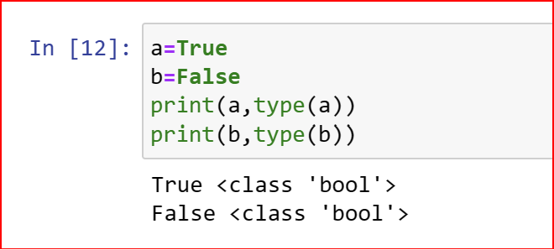

2. What are the three different types of Boolean operators?

**Ans**: The three differnt types of Boolean operators in python are: or and not

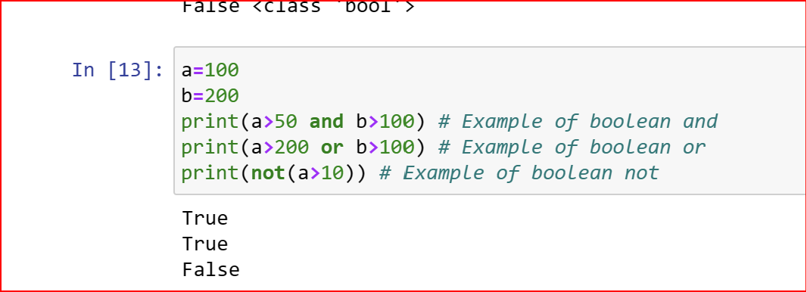

3. Make a list of each Boolean operator's truth tables (i.e. every possible combination of Boolean values for the operator and what it evaluate ).

**Ans:** The Truth tables for the boolean tables are as follows:

* **Truth Table for and operaotor**  
  True and True is TrueTrue and False is FalseFalse and True is FalseFalse and False is False
* **Truth Table for or operaotor**  
  True or True is TrueTrue or False is TrueFalse or True is TrueFalse or False is False

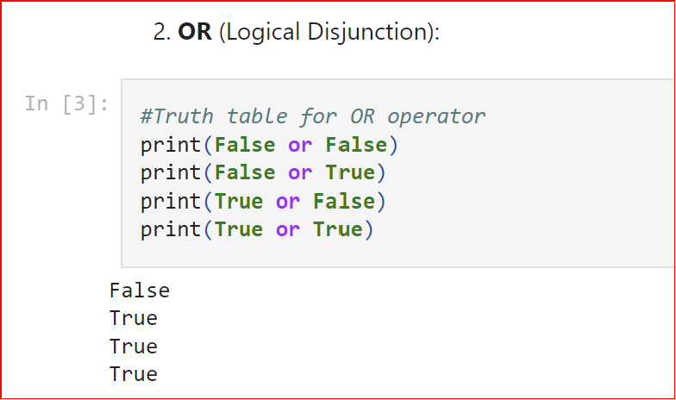

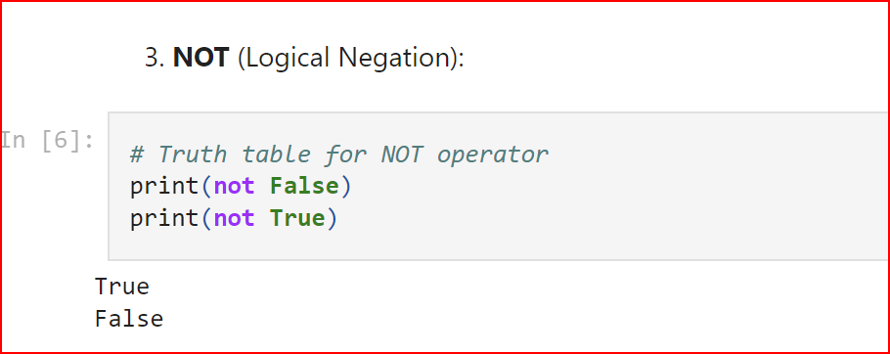

4. What are the values of the following expressions?

* (5 > 4) and (3 == 5)
* not (5 > 4)
* (5 > 4) or (3 == 5)
* not ((5 > 4) or (3 == 5))
* (True and True) and (True == False)
* (not False) or (not True)

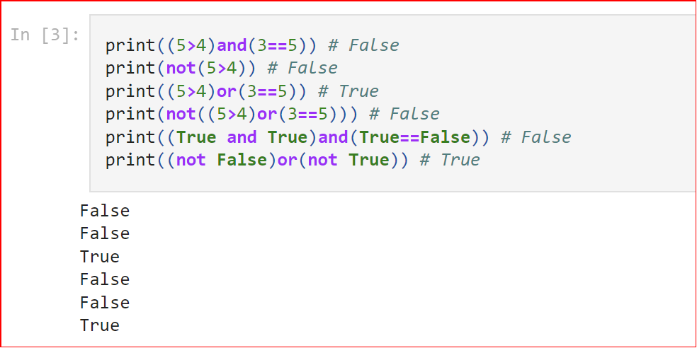

5. What are the six comparison operators?

**Ans:** The Six comparision operators available in python are:  
== , != , < , > , <= , =>

6. How do you tell the difference between the equal to and assignment operators?Describe a condition and when you would use one.

**Ans:** == is the equal to operator that compares two values and evaluates to a Boolean, while = is that assignment operator that stores a value in a variable..

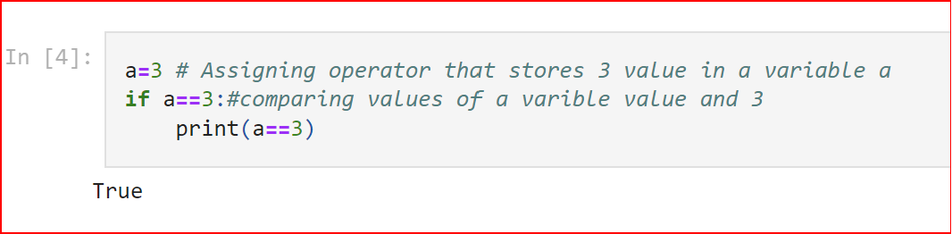

7. Identify the three blocks in this code:

spam = 0

if spam == 10:

print('eggs')

if spam > 5:

print('bacon')

else:

print('ham')

print('spam')

print('spam')

**Ans**: In Python, code block refers to a collection of code that is in the same block or indent. This is most commonly found in classes, functions, and loops.

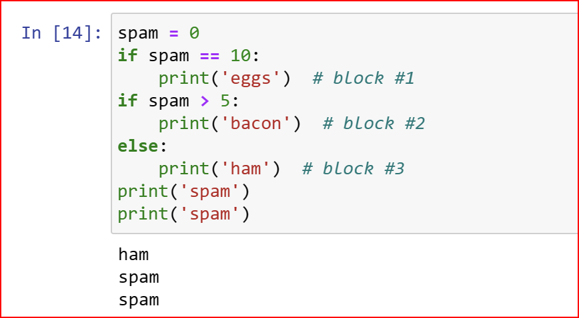

8. Write code that prints Hello if 1 is stored in spam, prints Howdy if 2 is stored in spam, and prints Greetings! if anything else is stored in spam.

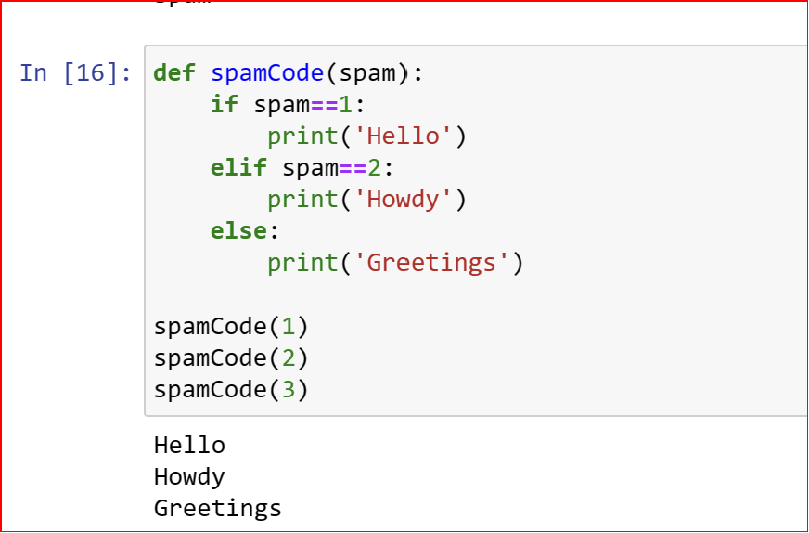

9.If your programme is stuck in an endless loop, what keys you’ll press?

**Ans:** Press Ctrl-c to stop a program stuck in an infinite loop

10. How can you tell the difference between break and continue?

**Ans:** The break statement will move the execution outside the loop if break condtion is satisfied. Whereas the continue statement will move the execution to the start of the loop

11. In a for loop, what is the difference between range(10), range(0, 10), and range(0, 10, 1)?

**Ans:** The Differences are as follows:

1. The ***range(10)*** call range from 0 to 9 (but not include 10)
2. The ***range (0,10)*** explicitly tells the loop to start at 0
3. The ***range(0,10,1)*** explicitly tells the loop to increase the variable by 1 on each iteration

12. Write a short program that prints the numbers 1 to 10 using a for loop. Then write an equivalent program that prints the numbers 1 to 10 using a while loop.

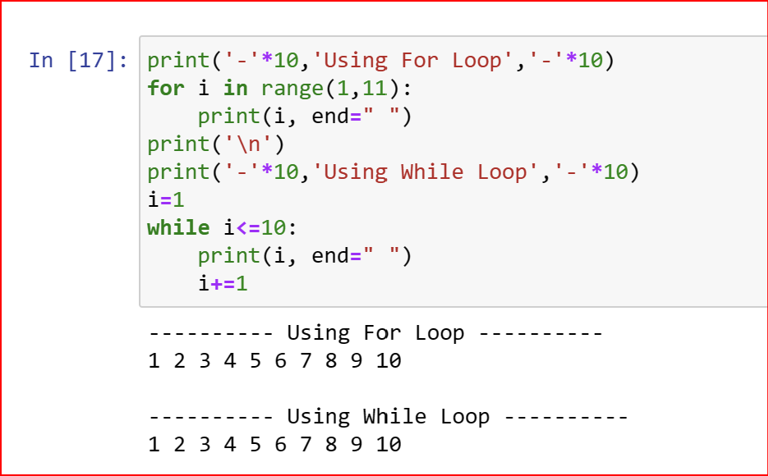

13. If you had a function named bacon() inside a module named spam, how would you call it after importing spam?

**Ans:** This function can be called with spam.bacon()