

**Software Engineer, Full Stack Web Developer**

**Mahadevaprasad M**

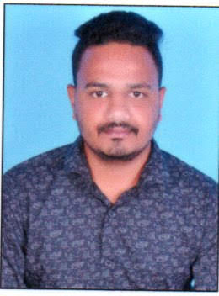Fill shape with photo as a square ratio

Mob: 8610705959 | Email: mmprasad2244@gmail.com

**Summary**

* Experienced Full-Stack Java Developer adept at utilizing Spring Boot, Angular, and MySQL to deliver robust backend and user-friendly frontend solutions.
* Committed to driving company growth and continuously expanding skills through ongoing learning and development. Passionate about leveraging expertise to contribute to the success of the organization.

**Education**

* Master of computer applications

**Technical Expertise**

* Java Full Stack
* SAP ABAP

**Professional Experience**

* Over 1.3 years of experience in full stack web development. - Proficient in both front-end (HTML, CSS, JavaScript) and back-end (Java, Spring boot ) technologies.
* Experienced in designing and implementing responsive web applications and RESTful APIs.
* Strong problem-solving skills, attention to detail, and a commitment to delivering clean and maintainable code.
* Excellent communication skills and ability to work collaboratively in agile development teams.
* Trained in SAP (ABAP) for 2 months.

**Technical Skills**

* **Front-end Technologies:** HTML5, JavaScript, Angular
* **Back-end Technologies:** Java, Databases, Spring boot.
* **Database Management:** MySQL. Version Control: Git, GitHub.
* **API Development:** RESTful.
* **Programming Languages:** Java
* **Other Tools:** Visual Studio Code, Eclipse
* **SAP (ABAP)** : Function Module, Reports, OOPS ABAP

```

**Professional Experience**

Project 1

## Data Table

* Develop interactive method for managing and displaying data in tables.
* Leverage Angular and Angular Material for Data Table project.
* Create data-rich tables for visually appealing presentation.
* Implement interactivity, sorting, and filtering features.
* Ensure seamless data manipulation.
* Develop using HTML, CSS, and TypeScript.
* Result in a user-friendly web application.

Project 2

**Sports Event Management System**

* Created a sports management system using Spring Boot for API development.
* Implemented CRUD operations for player registration, event scheduling, and sports management.
* Utilized MySQL for backend operations and Angular for frontend development.
* Designed a user-friendly web interface with HTML,CSS, and Typescript.
* Collaborated with the team throughout the project, addressing errors and ensuring seamless functionality.
* Included product management features for easy addition, update, listing, and deletion of products.

Project 3

## BMI Calculator

A BMI (Body Mass Index) calculator is a tool used to assess an individual's body composition based on their weight and height. It is a widely used method to determine if a person's weight falls within a healthy range.

* Used Java, Spring Boot (STS), Angular and MySQL to develop this application.
* Integrated the frontend using Angular framework.
* Created four different types of calculators like scientific calculator, bmr calculator, Home affordability calculator, and student loan calculator so that user can use the calculator of his interest.
* Used Java, Spring Boot (STS), Angular and MySQL
* Explored and resolved few errors.
* Collaborated with the team and involved in every phase of this project.