Patient Management (OPD & IPD) - Hospital Management System

# 1. Introduction

The Hospital Management System (HMS) is designed to streamline hospital operations and improve patient care. This module focuses on Patient Management, covering OPD (Outpatient Department) bookings and IPD (Inpatient Department) admissions. It allows patients to register, book appointments, and track their medical journey while enabling hospital staff (receptionists and doctors) to manage schedules, admissions, and records efficiently.

# 2. Objectives

- Simplify patient registration and appointment booking.  
- Automate OPD scheduling based on doctor availability.  
- Provide a structured flow for IPD admission (ward/room allocation).  
- Ensure seamless communication between patients, doctors, and receptionists.  
- Maintain secure and centralized patient records.

# 3. Scope

This module will handle:  
- Patient Registration/Login  
- OPD Booking (Doctor selection, appointment date/time booking, Receptionist confirmation/rejection)  
- IPD Admission (Admission request by doctor/receptionist, Ward/room/bed allocation, Admission record maintenance)  
- Patient Dashboard for tracking appointment/admission status

# 4. Workflow Description

## 4.1 Registration & Login

- New Patient: Enters personal details (Name, DOB, Gender, Contact, Email, Password).  
- Existing Patient: Logs in using credentials.  
- Patient data stored in Patients Table.

## 4.2 OPD Booking

1. Patient selects specialization/doctor.  
2. Chooses appointment date & time (based on availability).  
3. Provides reason for visit/disease name.  
4. Request saved in Appointments Table (status: Pending).  
5. Receptionist reviews request → confirms/rejects.  
6. Patient notified of status.

## 4.3 IPD Admission

1. Doctor recommends admission.  
2. Receptionist creates IPD record with room/bed allocation.  
3. Admission details stored in IPD Table.  
4. Patient notified of admission confirmation.

## 4.4 Patient Dashboard

- View OPD booking history.  
- Check appointment status (Confirmed / Pending / Rejected).  
- View IPD admission details.

# 5. Actors

- Patient → Registers, books appointments, views status.  
- Receptionist → Approves/rejects OPD bookings, manages IPD admissions.  
- Doctor → Provides availability schedule, recommends IPD admission.

# 6. Database Design (Basic)

- Patients (patient_id, name, dob, gender, contact, email, password, address)  
- Doctors (doctor_id, name, specialization, availability)  
- Appointments (appointment_id, patient_id, doctor_id, disease, date, time, status)  
- Receptionists (receptionist_id, name, contact, login_credentials)  
- IPD (ipd_id, patient_id, doctor_id, room_no, bed_no, admission_date, discharge_date, status)

# 7. Workflow (Activity Diagram)

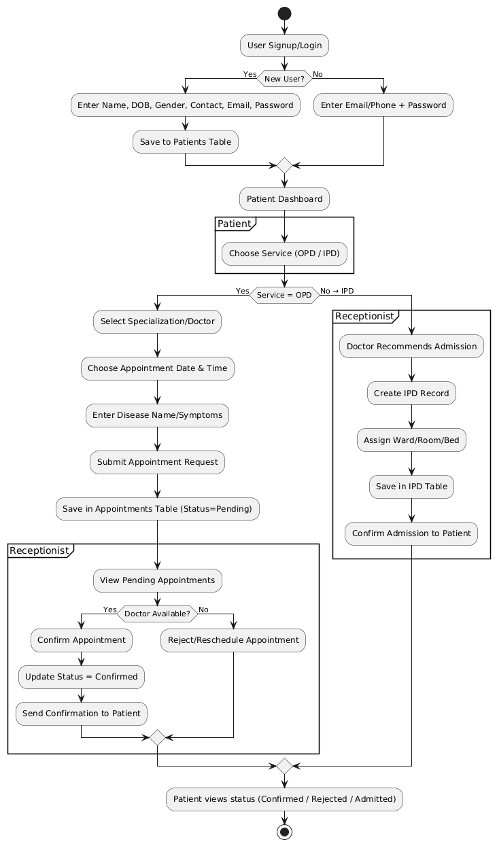

# 8. Benefits

- Reduces manual paperwork.  
- Avoids double-booking of doctors.  
- Provides transparency to patients.  
- Helps hospital staff manage patients efficiently.