Project for the Bachelor of Information and Technology
Expenses Management System


Submitted By:
Anish Thapa (321003)
Prasan Poudel (321022)
Raj Khadka (321027)
KIST College of Information Technology(KIST)
Faculty of Science and Technology
Purbanchal University, Nepal

Acknowledgement
We take this opportunity to express our profound appreciation and regards to the Information Technology (IT) department for this commendable guidance, monitoring and constant encouragement throughout the course of this project. The help and guidance given by shall carry us a long way, in the journey on which we are about to embark.

We also take this opportunity to express a deep sense of gratefulness to our coordinator Mr. Deepak Khadka for his amiable support, valuable information and guidance, which helped us in completing this task throughout its various stages by giving us his precious time. We are also indebted to all members of KIST College, for the valuable suggestions and help provided by then in their respective fields. We are grateful for their cooperation during the period of our project.

Finally, we would also like to express lots of thanks to PURBANCHAL UNIVERSITY for designing such a wonderful course structure. It will help us to get more knowledge in the field of Information Technology & help us to have a bright future in the field of technology. We hope our University will accept this attempt as a successful project.

Examiner’s Certification
This is to certify that the project entitled “Expenses Management System” has been successfully completed by Mr. Anish Thapa, Mr. Prasan Poudel, and Mr. Raj Khadka in partial fulfillment of Degree of Bachelor of Information Technology of Purbanchal University during the academic year 2024 under the guidance of our coordinator and subject teacher Mr. Deepak Khadka.

__________________________________

Department of Science and Technology
PURBANCHAL UNIVERSITY

Student Declaration
Our project titled “Expenses Management System” is a consequence of our own work and indebtedness to other work publication and references have been wholly acknowledged. If we have been found guilty of copying any other report or information and showing as our original work, we shall be punishable by University, which may include failing in examination or any other punishment that Purbanchal University decide, which we understand very nicely so, it is a pure effort of our own.

We further certify that this project is submitted in fulfillment of requirement for the project marks of Bachelor in Information Technology(BIT) 2nd Semester. So, it is our original work and has not been submitted for award of any other degree or title.

S.N | NAME | Reg. No. | Symbol No. | Signature
1. | Anish Thapa | 058-3-2-02412-2023 | 321003
2. | Prasan Poudel | 058-3-2-02440-2023 | 321022
3. | Raj Khadka | 058-3-2-02437-2023 | 321027

CERTIFICATE
This project entitled “Expenses Management System” prepared and submitted by Anish Thapa, Prasan Poudel and Raj Khadka has been examined by us and is accepted by the degree of Bachelor’s of Information Technology by Purbanchal University.

Sailendra Basnet Signature Date: 14th February,2025
Assoc. Prof.

Deepak Khadka Signature Date: 14th February,2025
Supervisor

Deepak Khadka Signature Date: 14th February,2025
Coordinator of BIT

ABSTRACT
The Expenses Management System is a software application developed using C++ to provide users with an efficient and user-friendly platform for managing their financial transactions. This system aims to simplify the process of tracking and analyzing daily expenses to ensure better financial planning and decision-making.
The project utilizes C++'s capabilities, including object-oriented programming principles, to design a structured and scalable solution. Key features of the system include:
Expense Tracking: Allows users to record, categorize, and store expenses in predefined or user-customized categories.
View Expenses: Provides summarized reports of expenditures for specific periods, enabling users to analyze spending patterns.
Budget Management: Enables users to set budgets for categories and receive notifications when they exceed them.
Currency Conversion: Helps users to easily convert Nepalese Rupees in currency of different countries within just a click.
This system emphasizes usability and reliability, leveraging C++'s performance to handle computations and file management efficiently. The solution is ideal for individuals or small-scale users seeking a lightweight application for expense management. Future enhancements may include integration with graphical user interfaces (GUI's), multi-user support, and cloud-based data storage for broader applicability.

Table of Content
Chapter 1: Introduction 8
1.1 Introduction 8
1.2 Problem Statement 8
1.3 Objectives 8
1.4 Future of the Project 9
1.5 User View 9

Chapter 2: Acknowledgement 10

Chapter 3: Algorithm 11

Chapter 4: Flowchart 13

Chapter 5: Console Design 16

Chapter 6: Conclusion 20

Chapter 7: Reference 21
1. Guidance from: 21
2. Websites: 21

Chapter 1: Introduction
  - Introduction

In today's fast-paced world, managing personal or organizational expenses efficiently is crucial for financial stability and growth. An Expenses Management System is a software solution designed to help individuals or businesses track, categorize, and analyze their expenses. This project aims to develop a C++-based Expenses Management System that provides a user-friendly interface for recording and managing expenses. The system will allow users to add, view, edit, and delete expenses, generate reports, and analyze spending patterns.
  - Problem Statement
Many individuals and small businesses still rely on manual methods (e.g., spreadsheets or pen-and-paper) to track expenses, which is time-consuming and prone to errors. Storing and retrieving expense data in an organized manner is challenging without a dedicated system. Without proper tools, users struggle to analyze their spending patterns and make informed financial decisions.
  - Objectives
Create a console-based for easy interaction with the system. Allow users to add, edit, and delete expense entries with details such as category, amount, and description. Implement file handling to store expense data persistently (e.g., using text files ). Design the system to handle a large number of expense entries efficiently. Provide features to generate reports and categorize expenses.
  - Future of the Project
- Transition from a console-based interface to a GUI for a more better user experience.
- Enable synchronization of expense data across multiple devices using cloud storage.
- Develop a companion mobile app for expense tracking.
- Extend the system to support multiple users with role-based access control (e.g., admin, user).
- Automatically fetch and categorize transactions from bank accounts.
- SMS Alert direct to phone.
- User’s data can be handled more securely using encryption and decryption.
  - User View
- Add Expenses: Users can input details such as category (e.g., food, transportation, utilities), amount.
- View Expenses: Users can view all recorded expenses in a tabular format.
- Edit/Delete Expenses: Users can modify or remove existing expense entries.

Chapter 2: Acknowledgement
We take this opportunity to express our profound appreciation and regards to the Information Technology (IT) department for this commendable guidance, monitoring and constant encouragement throughout the course of this project. The help and guidance given by shall carry us a long way, in the journey on which we are about to embark.

We also take this opportunity to express a deep sense of gratefulness to our coordinator Mr. Deepak Khadka for his amiable support, valuable information and guidance, which helped us in completing this task throughout its various stages by giving us his precious time. We are also indebted to all members of KIST College, for the valuable suggestions and help provided by then in their respective fields. We are grateful for their cooperation during the period of our project.

Finally, we would also like to express lots of thanks to PURBANCHAL UNIVERSITY for designing such a wonderful course structure. It will help us to get more knowledge in the field of Information Technology & help us to have a bright future in the field of technology. We hope our University will accept this attempt as a successful project.

Chapter 3: Algorithm
Step 1: START
Step 2: Include standard libraries such as <iostream>, <cstring>, <windows.h>, <fstream>, <sstream>, <map>, <conio.h>, and <iomanip> for required functionalities.
Step 3: Change the console text color for better UI.
Step 4: Displays authentication options: Login, Sign Up, Forgot Password, and Exit, based on user input, calls respective functions.
Step 5: For Login: Takes username and password input securely using “_getch()”.
Step 6: Reads authenticationdb.txt to validate credentials.
Step 7: If correct, grants access; otherwise, prompts for password recovery.
Step 8: For Sign up: Collects user details including name, date of birth, phone number, and password.
Step 9: Stores credentials securely in authenticationdb.txt.
Step 10: Ensures password confirmation before storing.
Step 11: For Forget Password: Validates user identity via phone number.
Step 12: Allows the user to reset and update the password in authenticationdb.txt.
Step 13: Implement Currency Converter in addItem Class.
Step 14: Converts NPR (Nepalese Rupees) into multiple currencies.
Step 15: Implement expenses viewing system in view class.
Step 16: Displays a Yes/No choice prompt and returns user selection.
Step 17: Displays structured bill headers and footers.
Step 18: Requests user to enter a registered phone number.
Step 19: Reads and displays stored expenses from a corresponding file.
Step 20: Asks for phone number and prepares a filename for expense storage.
Step 21: Asks the user to enter income details.
Step 22: Allows deduction for monthly installments.
Step 23: Stores income in the expense file.
Step 24: Displays options to select an expense category.
Step 25: Calls addExpense() for adding expenses.
Step 26: Takes expense amount and category as input and stores the expense in a file.
Step 27: Displays main options: Add Expenses, View Expenses, Edit/Delete Expenses, Currency Converter, Exit and calls respective functions based on user selection.
Step 28: Reads stored expenses and allows the user to edit or delete a specific category.
Step 29: Writes updated expenses back to the respective file.
Step 30: · Create objects of necessary classes.
Step 31: Call authenticate() to verify user credentials.
Step 32: Call imp() to start the main menu for expense tracking.
Step 33: STOP.

Chapter 4: Flowchart

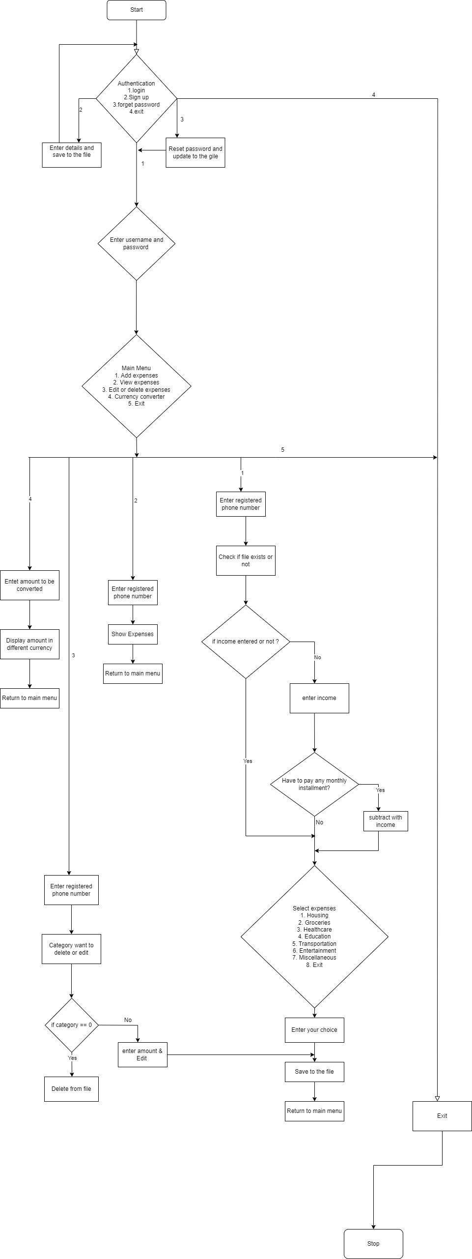

Chapter 5: Console Design
Screenshots:
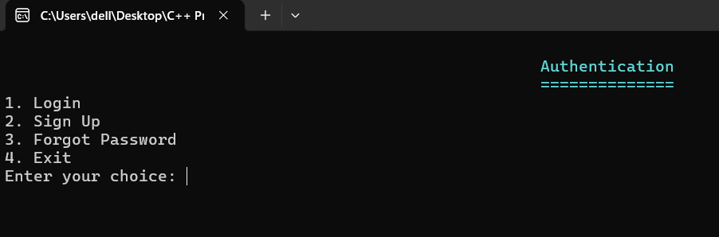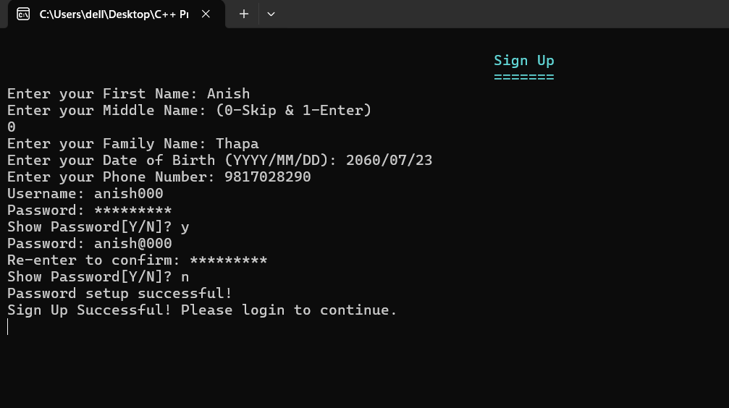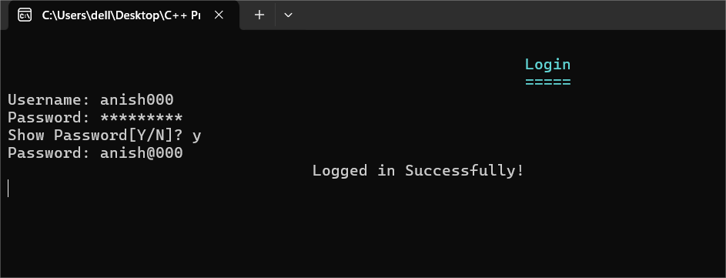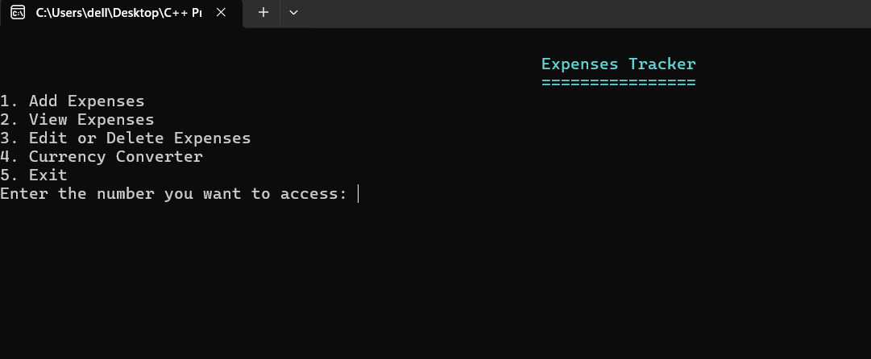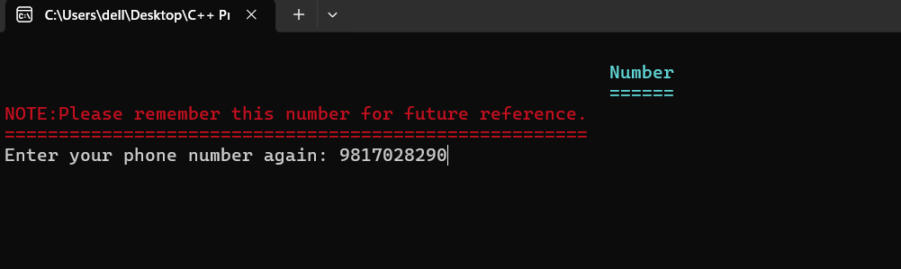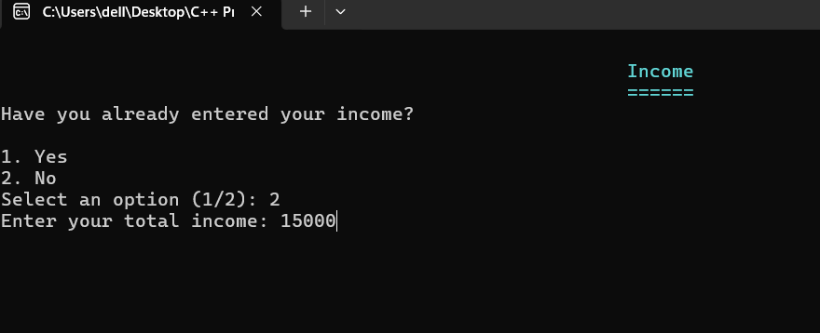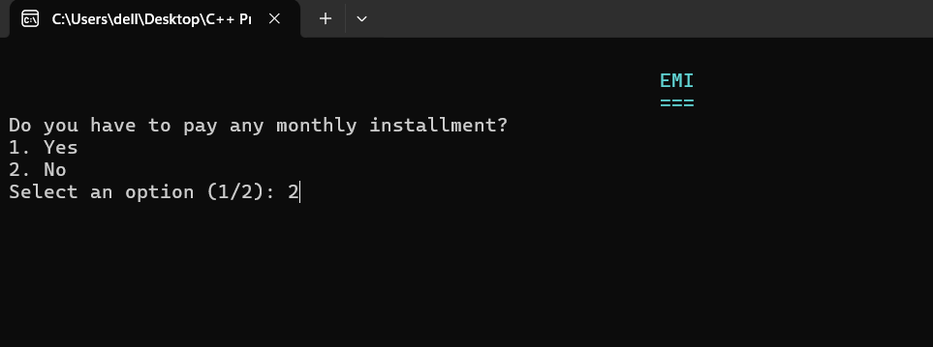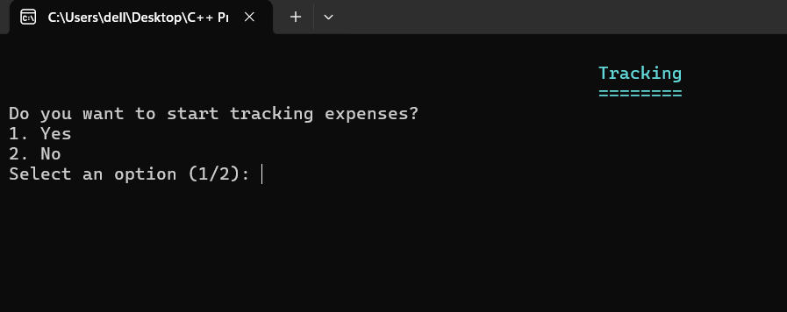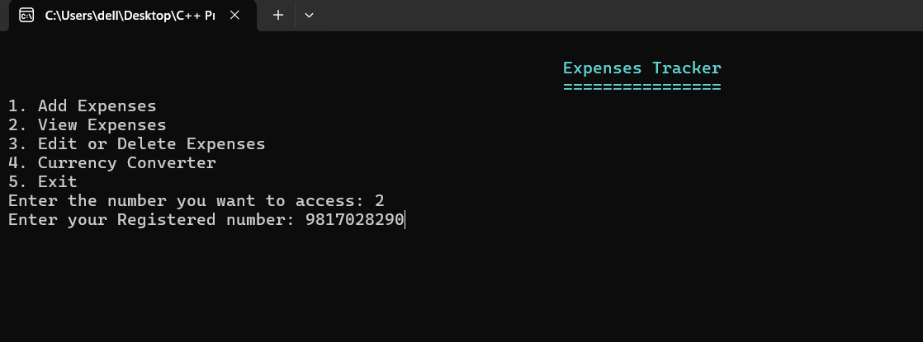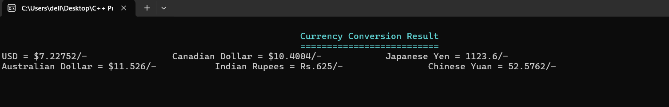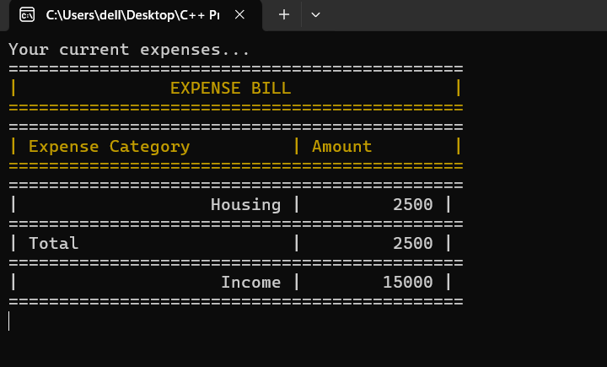

Chapter 6: Conclusion
The provided C++ program is a Personal Finance and Expense Tracking System that integrates authentication, currency conversion, and financial tracking functionalities. The program is structured using multiple classes, ensuring modularity and ease of use. Users can Sign Up, Log In, and Reset Password. Passwords are masked for security, and user credentials are stored. Users can input their income and categorize expenses under predefined sections like Housing, Groceries, Healthcare, Education, etc. The program colors text for better readability. Utilizes file handling to store user credentials and financial records. Implements password verification & recovery mechanisms.
This program serves as an efficient personal finance manager, allowing users to track their expenses, convert currencies, and manage finances securely. It provides a structured and interactive interface, making financial tracking simple and accessible for users.
To sum up, we are confident that our system will significantly improve efficiency, convenience, and customer satisfaction in the real time use with a seamless and hassle-free experience.

Chapter 7: Reference
To develop this system certain helps are taken from different websites and also from our coordinator also our project teacher.

- Guidance from:
Deepak Khadka.
9851184846.
BIT Coordinator, Kist College of Information and Technology.
- Websites:
https://www.stackoverflow.com
https://www.geeksforgeeks.com
https://www.w3schools.com
https://www.programiz.com

