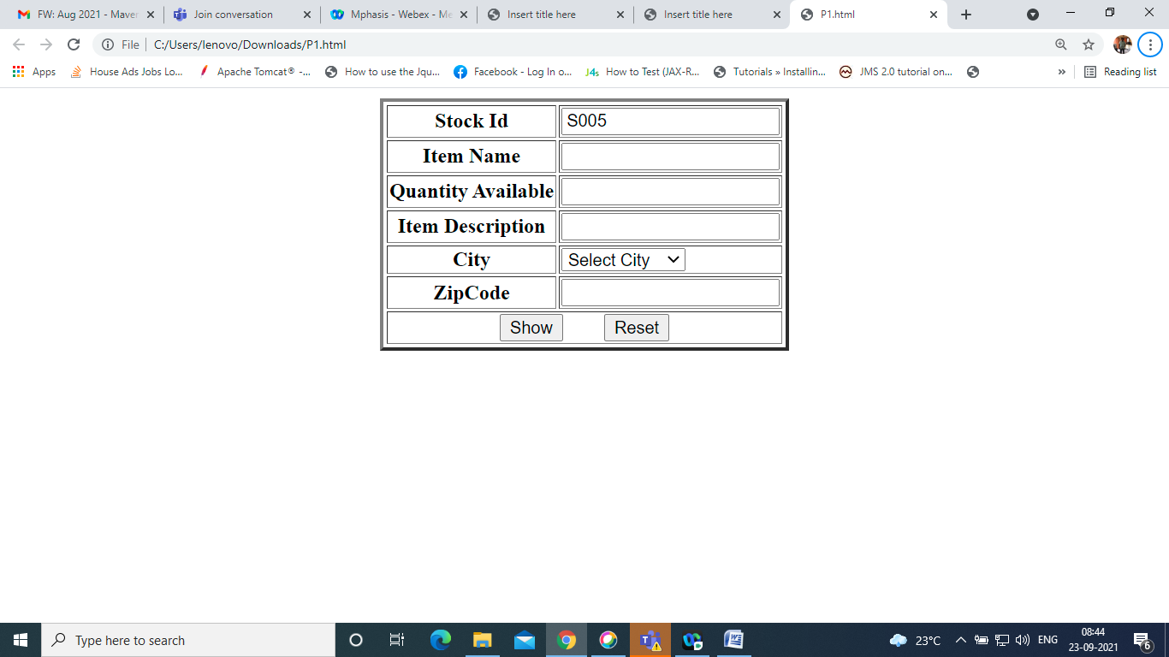

Create above form and print the values in <span> tag.

StockId to be generated automatically as S001, S002,S003 etc…

Take in array and print

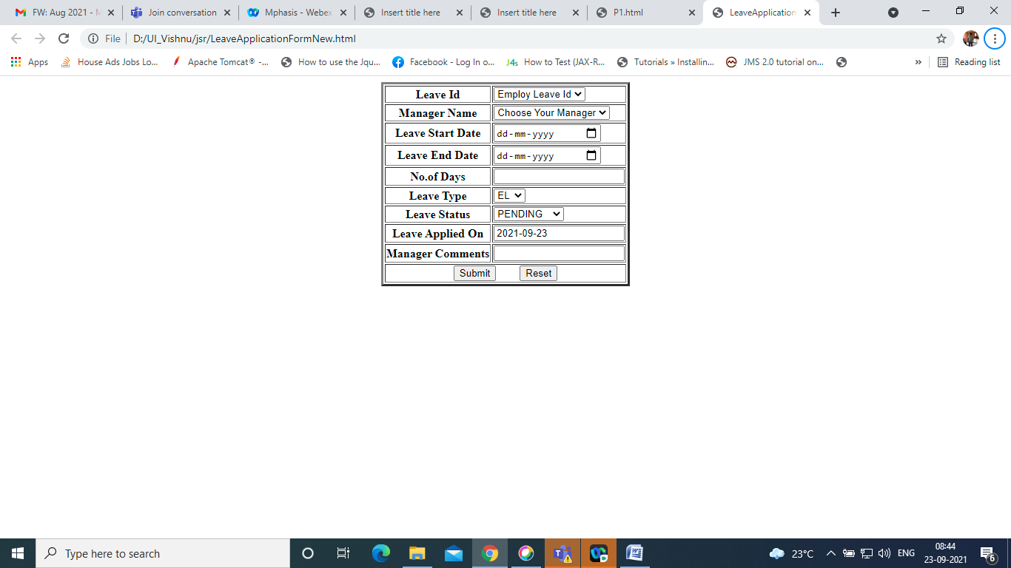

Create the above form and perform validations as

1. LeaveStartDate cannot be yesterday’s date
2. LeaveEndDate cannot be yesterday’s date
3. No.of Days to be calculated
4. LeaveStartDate cannot be less than leave end date
5. LeaveAppliedOn default today’s date

Print the Result in <span>

All validation errors to be printed in <span> with red color.

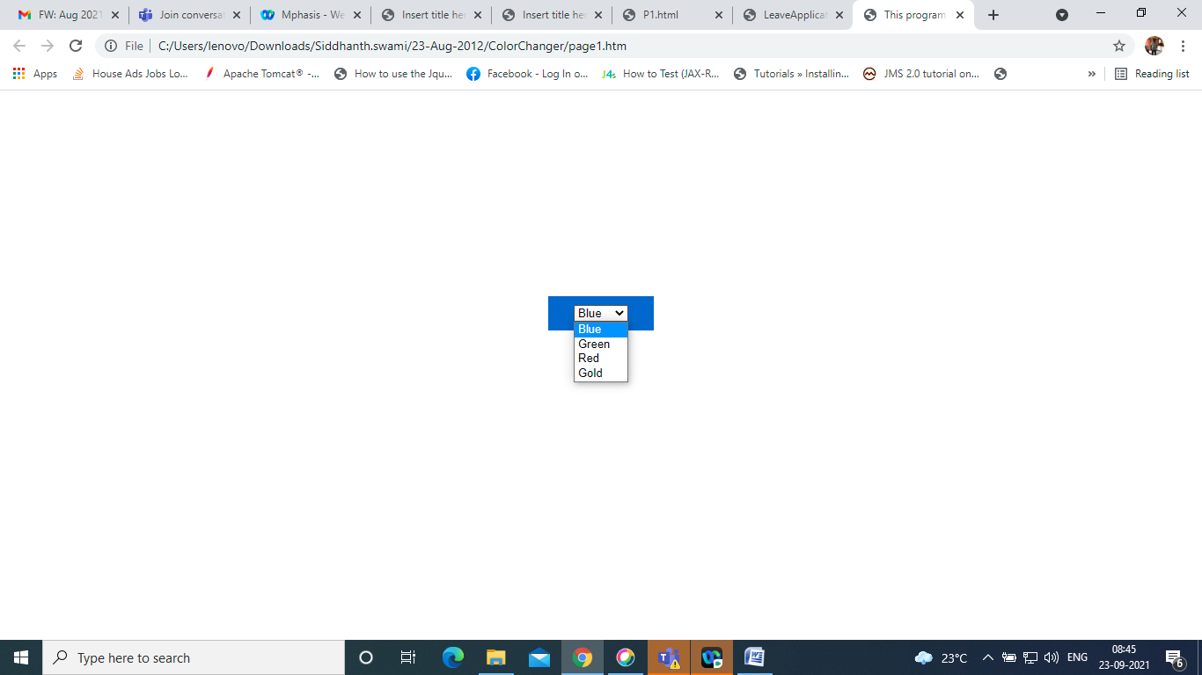

Design this page and change the background color.

a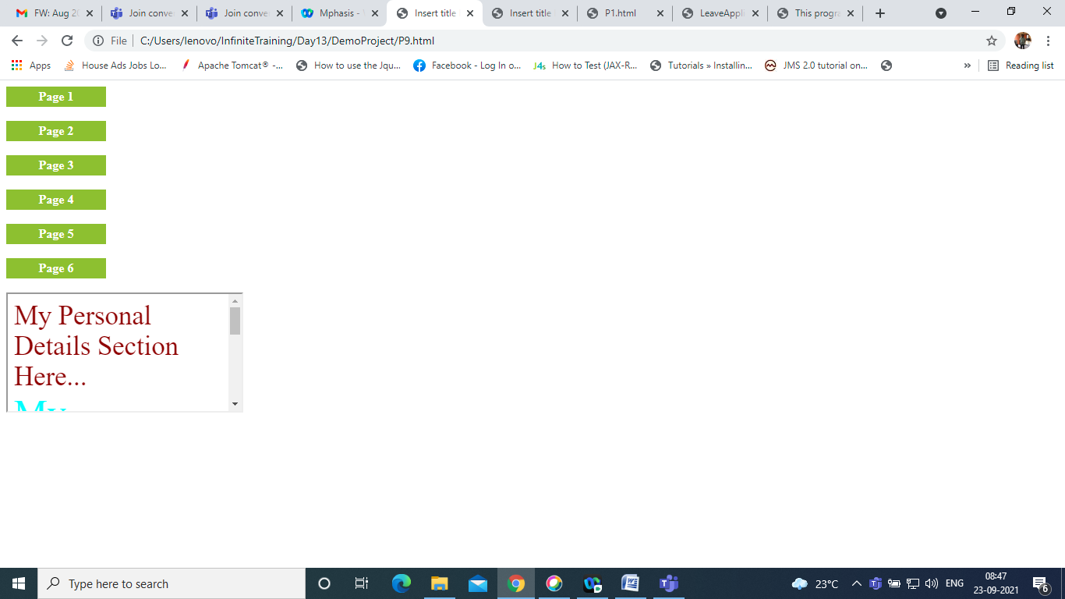

Create page with actions.

Create the above page, and once you click on link, page to be printed on the division specified

Same page division to be printed.