**Step 1 :**

**Create a .NET Console Application**

**Step 2 :**

You Need to add Reference of System.Configuration

Right-Click on Project -> Add Reference -> Assemblies -> System.Configuration

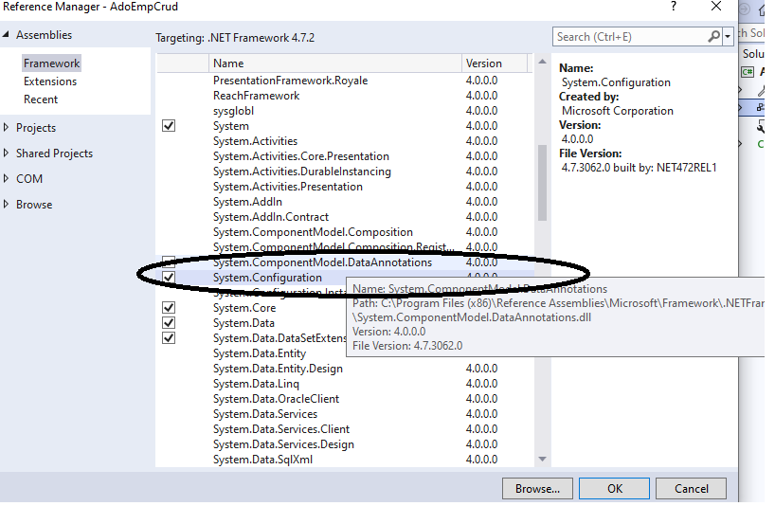

**Step 3 :**

You need to write connectionString information in app.config file

Write the connectionString specified as Below

<?xml version="1.0" encoding="utf-8" ?>

<configuration>

<connectionStrings>

<add name="sqlpracticeconn" connectionString="integrated security=true;data source=DESKTOP-1P9MIR5;initial catalog=sqlpractice;"/>

</connectionStrings>

<startup>

<supportedRuntime version="v4.0" sku=".NETFramework,Version=v4.7.2" />

</startup>

</configuration>

Above code you need to edit Data Source as your system Sql Server instance name.

Edit data soure name as

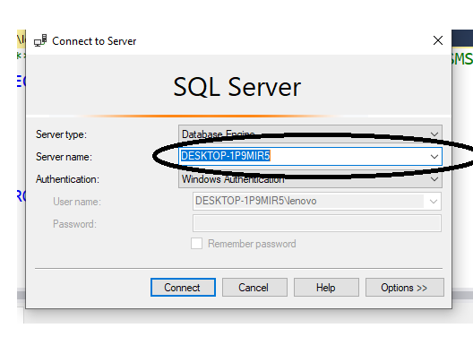

Step 4 :

using System.Configuration;

using System.Data;

using System.Data.SqlClient;

Add the above statements in Program.cs file (Main File).

Next Challenge, how to get ConnectionString from app.config file.

*** We write connectionString there, because every file no need rewrite, as we can reuse in multiple class files of same solultion ***

string strcon = ConfigurationManager.ConnectionStrings["sqlpracticeconn"].ConnectionString;

As app.config file may have lot of ConnectionStings, from that I am getting connectionString with key name as “sqlpracticeconn”

So, write the below code in Main()

string strcon = ConfigurationManager.ConnectionStrings["sqlpracticeconn"].ConnectionString;

SqlConnection connection = new SqlConnection(strcon);

Step 6 :

To retrieve data from Database table Emp, add the below lines to the code

static void Main(string[] args)

{

string strcon = ConfigurationManager.ConnectionStrings["sqlpracticeconn"].ConnectionString;

SqlConnection connection = new SqlConnection(strcon);

SqlDataAdapter ad = new SqlDataAdapter("select * from Emp", connection);

DataSet ds = new DataSet();

ad.Fill(ds, "EmpDummy");

}

DataRow : Contains the information about each row in dataset

SqlCommandBuilder cmd = new SqlCommandBuilder(ad)

This is most important command to be used when you are using DML operations as INSERT/UPDATE/DELETE. As

Database commands are not understandable to Sql Server and Sql Server commands are not understandable to .NET, we need an intermediatory, that which allows you to generate sql commands for .NET code we are writing, that can be done by commandBuilder.

In above command, we are passing adapter as an object, as adapter contains Insert Code of .NET, then Insert command generated by CommandBuilder in background and sent to database.