DBMS ASSIGNMENT – 2

Select all rows & columns from tables
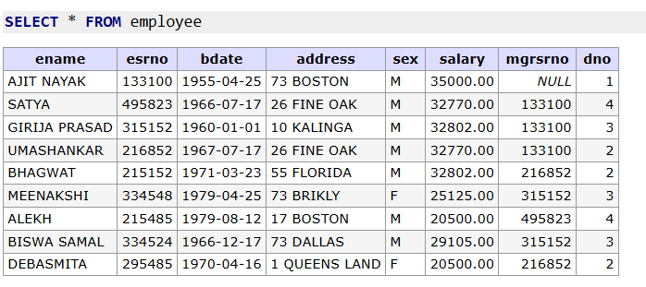
- List all employees with their complete details from employee table.

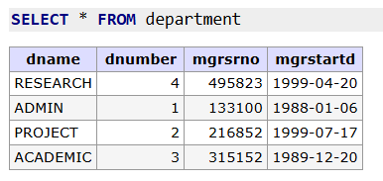
- List all departments with their complete details from department table.

- List all projects with their complete details from project table.
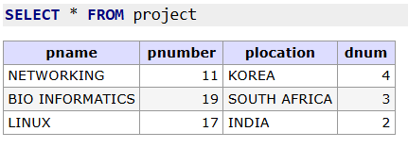

- List all working details from works_on table.
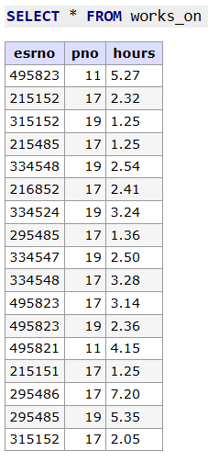
Select particular columns
- List the salary of all the employee.
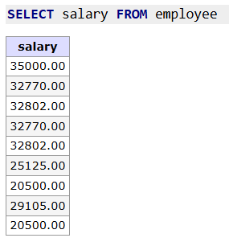
- List the department number, department name of all the departments.
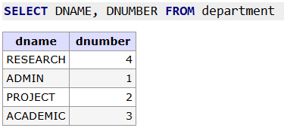
- List employee number, name, birth date & salary from the employee table.
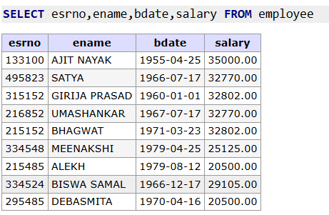

- List employee number and name of employee table with the headings as NUMBER and Name.
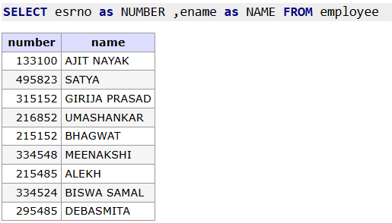
9. List dnum, pnumber, plocation from project table with the headings as
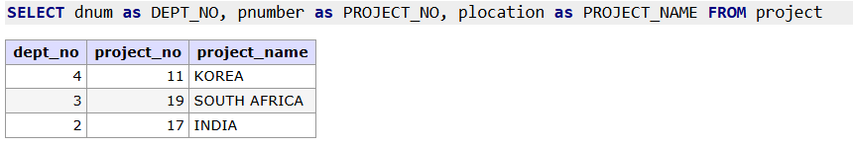
DEPT_NO, PROJECT_NO, and PROJECT_NAME.

10. List ESRNO, PNO & HOURs from the works_on table with the headings as
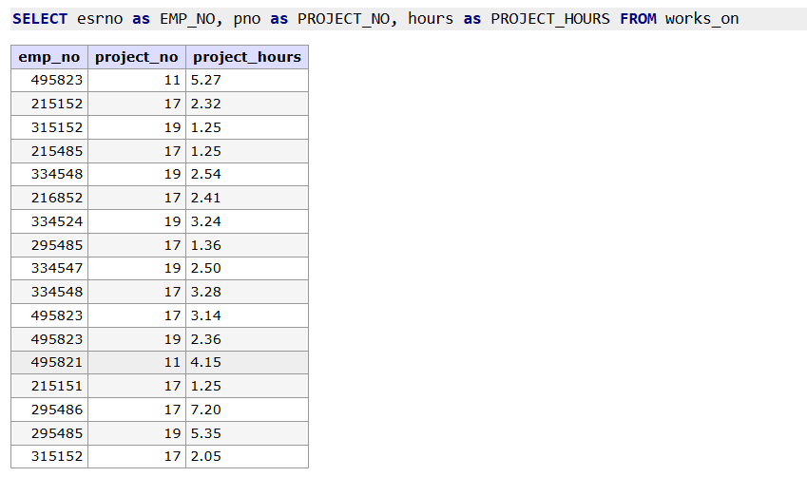
EMP_NO, PROJECT_NO, and PROJECT_HOURS.

Conditional select
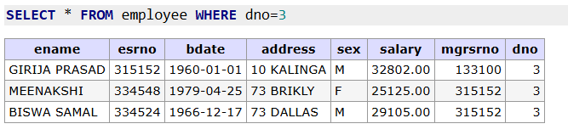
11. List the employees working in department 3.

12. List the departments with number greater than 2.
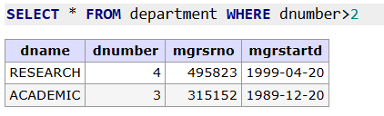
13. List the employees of department 2 and 3.
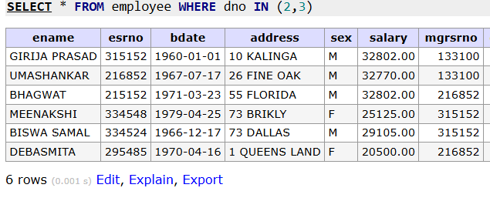
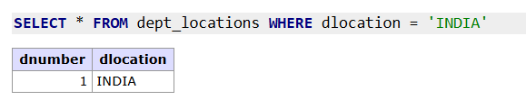
14. List the projects with location as ‘INDIA’.

15. List the employees who have worked less than 3 hours (from works_on
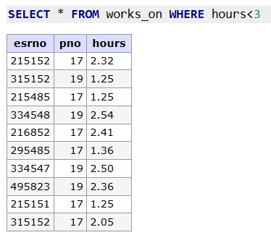
table).
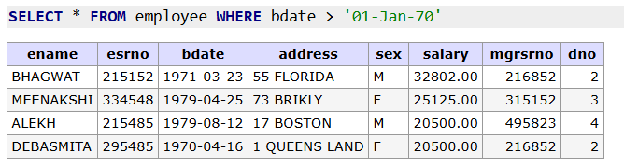
16. List the employees with birth date after 01-Jan-70 ( BDate > ’01-Jan-70’)

17. List the employees of dept 2 with salary more than 25000.
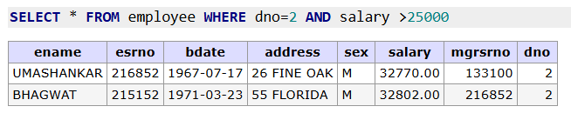

18. List all male employees with salary between 28000 and 36000.
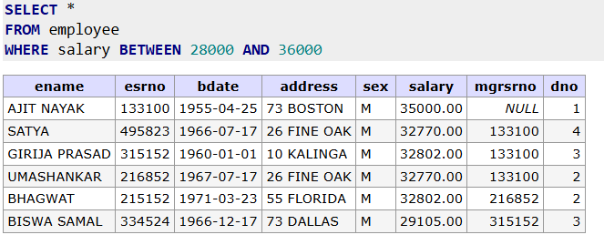

19. List all male employees who do not work in departments 1, 3 and 4.
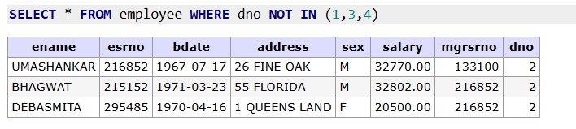
20. List all the departments whose manager start dates lie between ’01-jan-89’ &
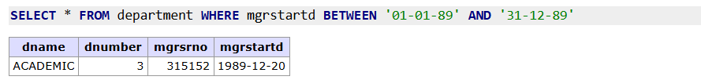
’31-dec-89’.

21. Find hours from works_on table where pno is 19 or 17.
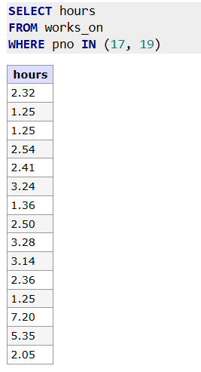
22. List all the employees except Satya and Alekh.
