**Password based authentication thorugh SSH connection**

**Instances:**

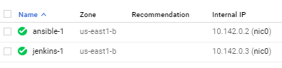

User creation in the first server: (ansible server instance)

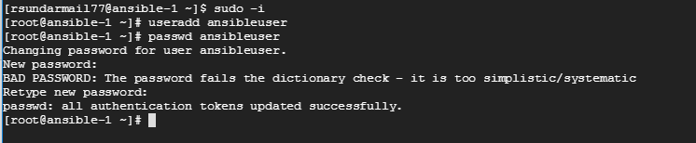

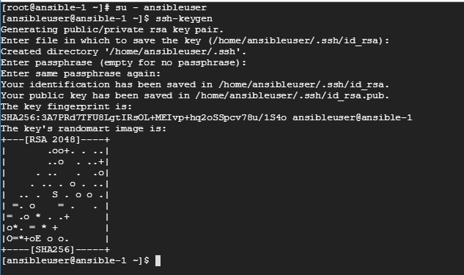

Same user should be created in the other server as well to establish the SSH connection: (Jenkins server)

Login into the new user: su – ansibleuser

Type: ssh-keygen in Jenkins server and it will create a default directory.

Come back to ansible server and type this command to copy the ssh keys into the Jenkins server:

ssh-copy id <<IP_address>>

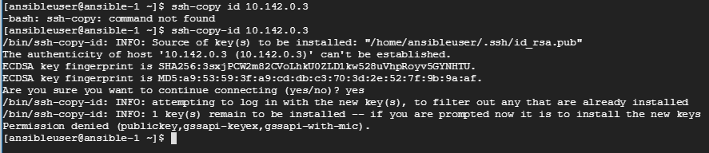

Try to login into Jenkins server from ansible server:

ssh <<internal_ip_address>>



If the above error exists, then do the following configuration in the ansible server:

sudo –i

vi /etc/ssh/sshd_config

PasswordAuthentication yes - Try to change the password authentication as yes in this file.

To make reflect this configuration just type the below command and it should restart the service.

service sshd restart

Above configuration should be done in Jenkins server as well so that the password authentication should be done smoothly without having any issues.

Now try to connect the Jenkins server from ansible as below using the internal IP:

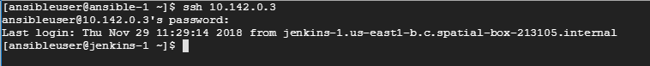

**Brief summary**:

Steps for creating the new user and SSH connection establishment using password authentication: (**Marked in green color are commands**)

* Creating user in Ansible server – This is just an example and you can create users as you wish. Below is the command to be executed in the Ansible server.
  + useradd ansibleuser
  + visudo - add the username in the file ( Ex: ansibleuser ALL=(ALL) NOPASSWD: ALL ) (to be added in Allow root to run any command section)
  + passwd ansibleuser
  + su – ansibleuser (login into the new user)
  + ssh-keygen (generation of public/private key in the server) (Keep press enter until command prompt appears and no need to change the default location path)
  + ssh-copy-id <<Jenkins_server_Private_IP_address>>
  + ssh <<Jenkins_server_Private_IP_address>> ( try to connect the Jenkins server from Ansible server using SSH)