**THE INDIAN PERIOPERATIVE NURSES ASSOCIATION**

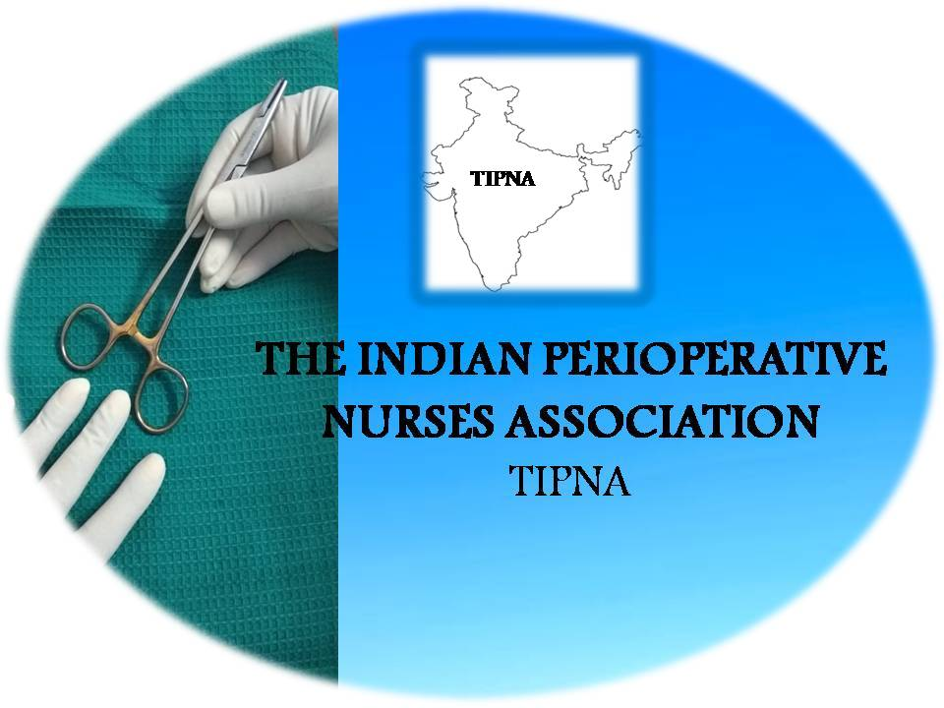 

**Membership Form**

Kindly enroll me as a “Member” of The Indian Perioperative nurses association

Type of membership : Annual / Life

Name: Professor/Dr./Mr./Mrs./Ms.

(First) (Middle) (Surname)

Highest Academic Qualification:



DOB:  Blood Group: 

Designation: 

Institution/Affiliation:



Perioperative Area working in: ENT/ General Surgery/ Orthopedics/ Urology/

Neurology/ Cardiothoracic/ Emergency/ Obstetrics & Gynecology/ Pediatrics/

Daycare/ PACU

Years of Experience (OR): <1 year 1-5 years 6-10 years

 11-15 years 16-20 years 20-25 years

 >25 years

Signature of the candidate

**\*Memberships Fee: Annual - Rs 250/person, Life - Rs 2500/person**