**STAMPED.IO REVIEWS & UGC**

Step 1- Visit the Shopify admin console, click on Apps & ‘Visit the Shopify App Store’ as shown below.

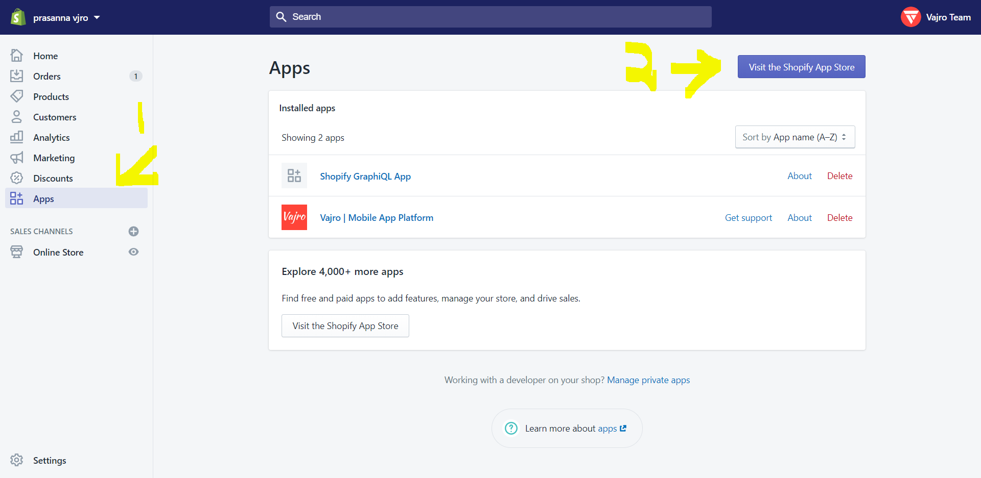

Step 2- In the Shopify App Store, search for ‘stamped.io’. The results page will look similar to the picture given below. Click on ‘Stamped.io Product Reviews UGC’.

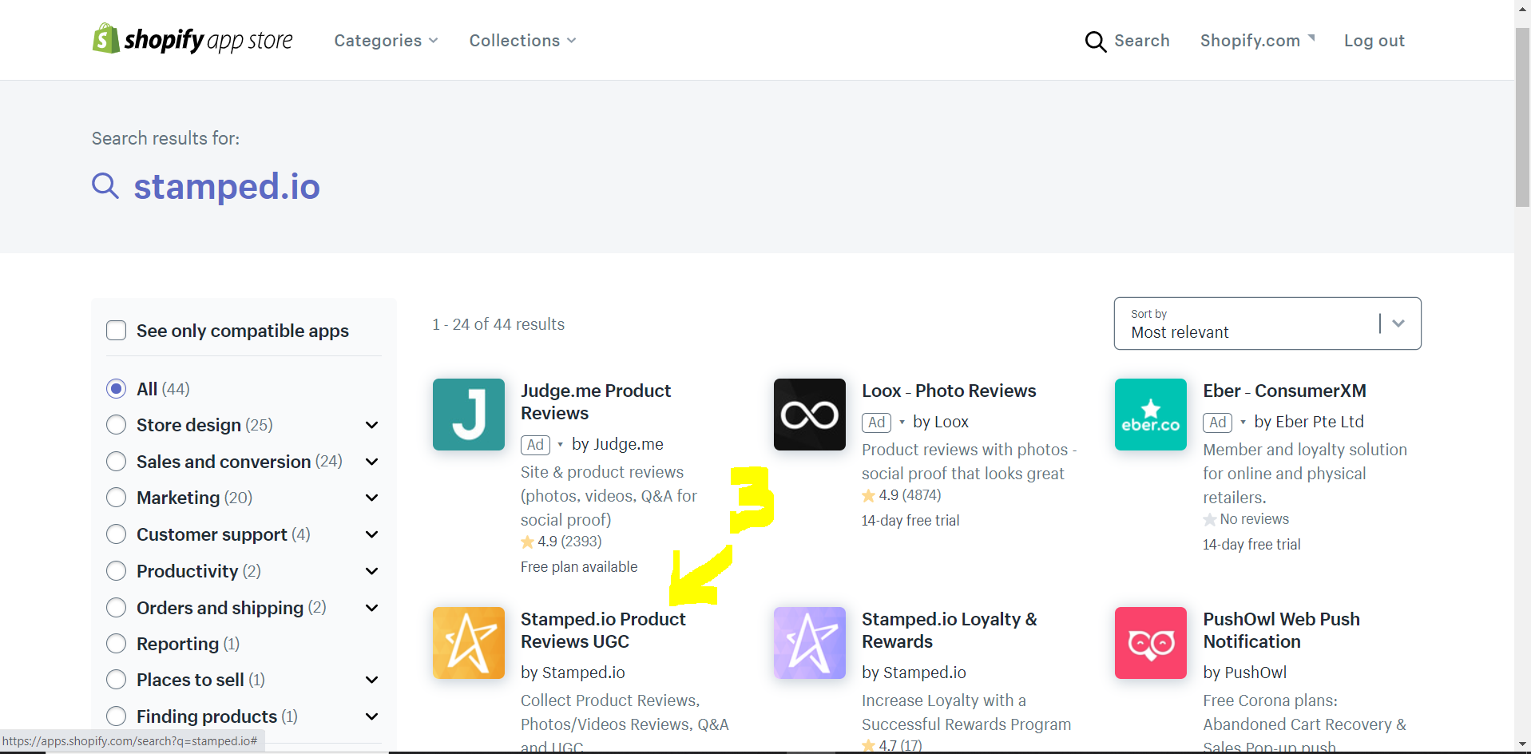

Step 3- Click on ‘Add app’ & ‘Install App’ in the resulting page.

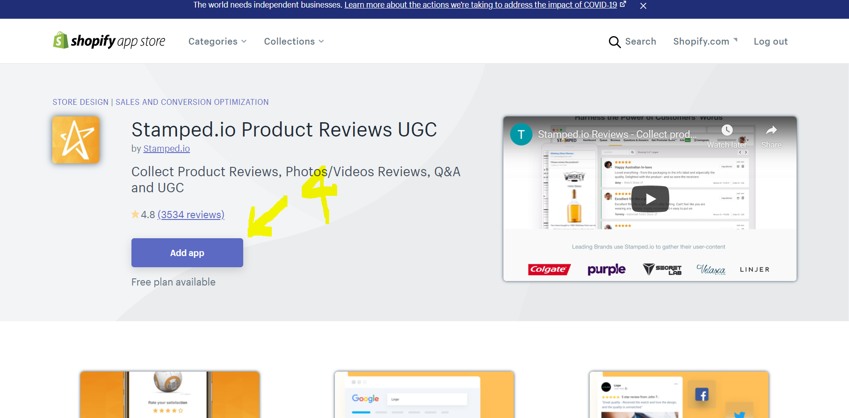

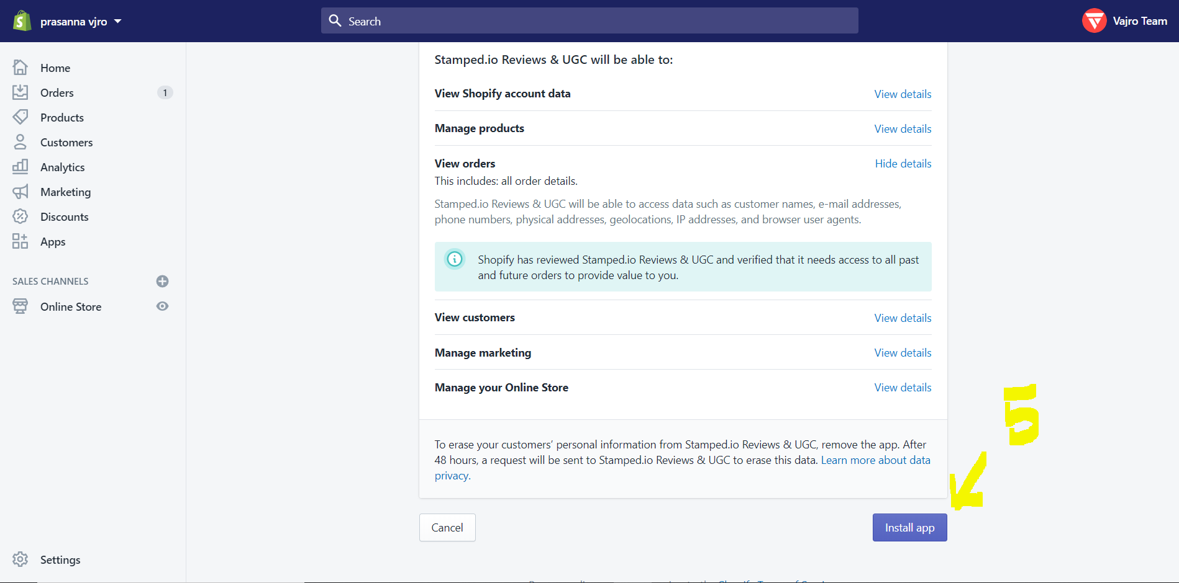

Step 4- Now you can see ‘Stamped.io Reviews & UGC’ in your installed Apps in Shopify console. Click on it to view the Stamped.io Reviews App as shown below.

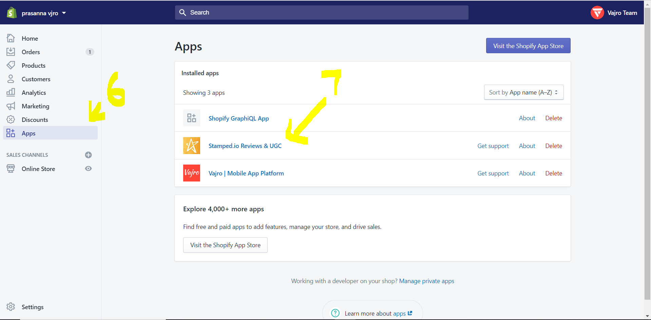

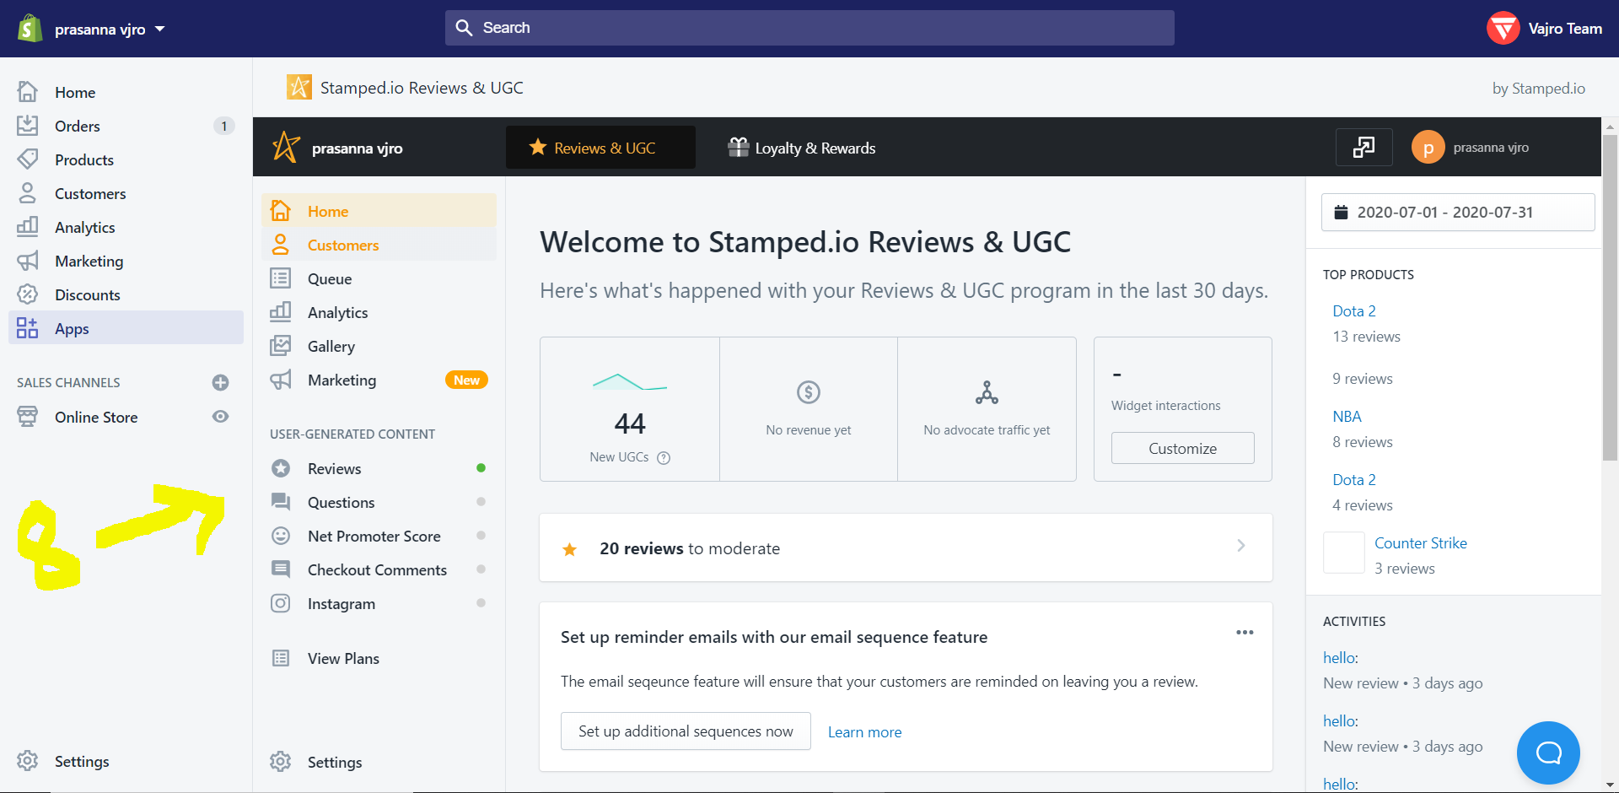

Step 5- To retrieve the API keys and store hash, Click on Settings in ‘Stamped.io reviews & UGC’ app.

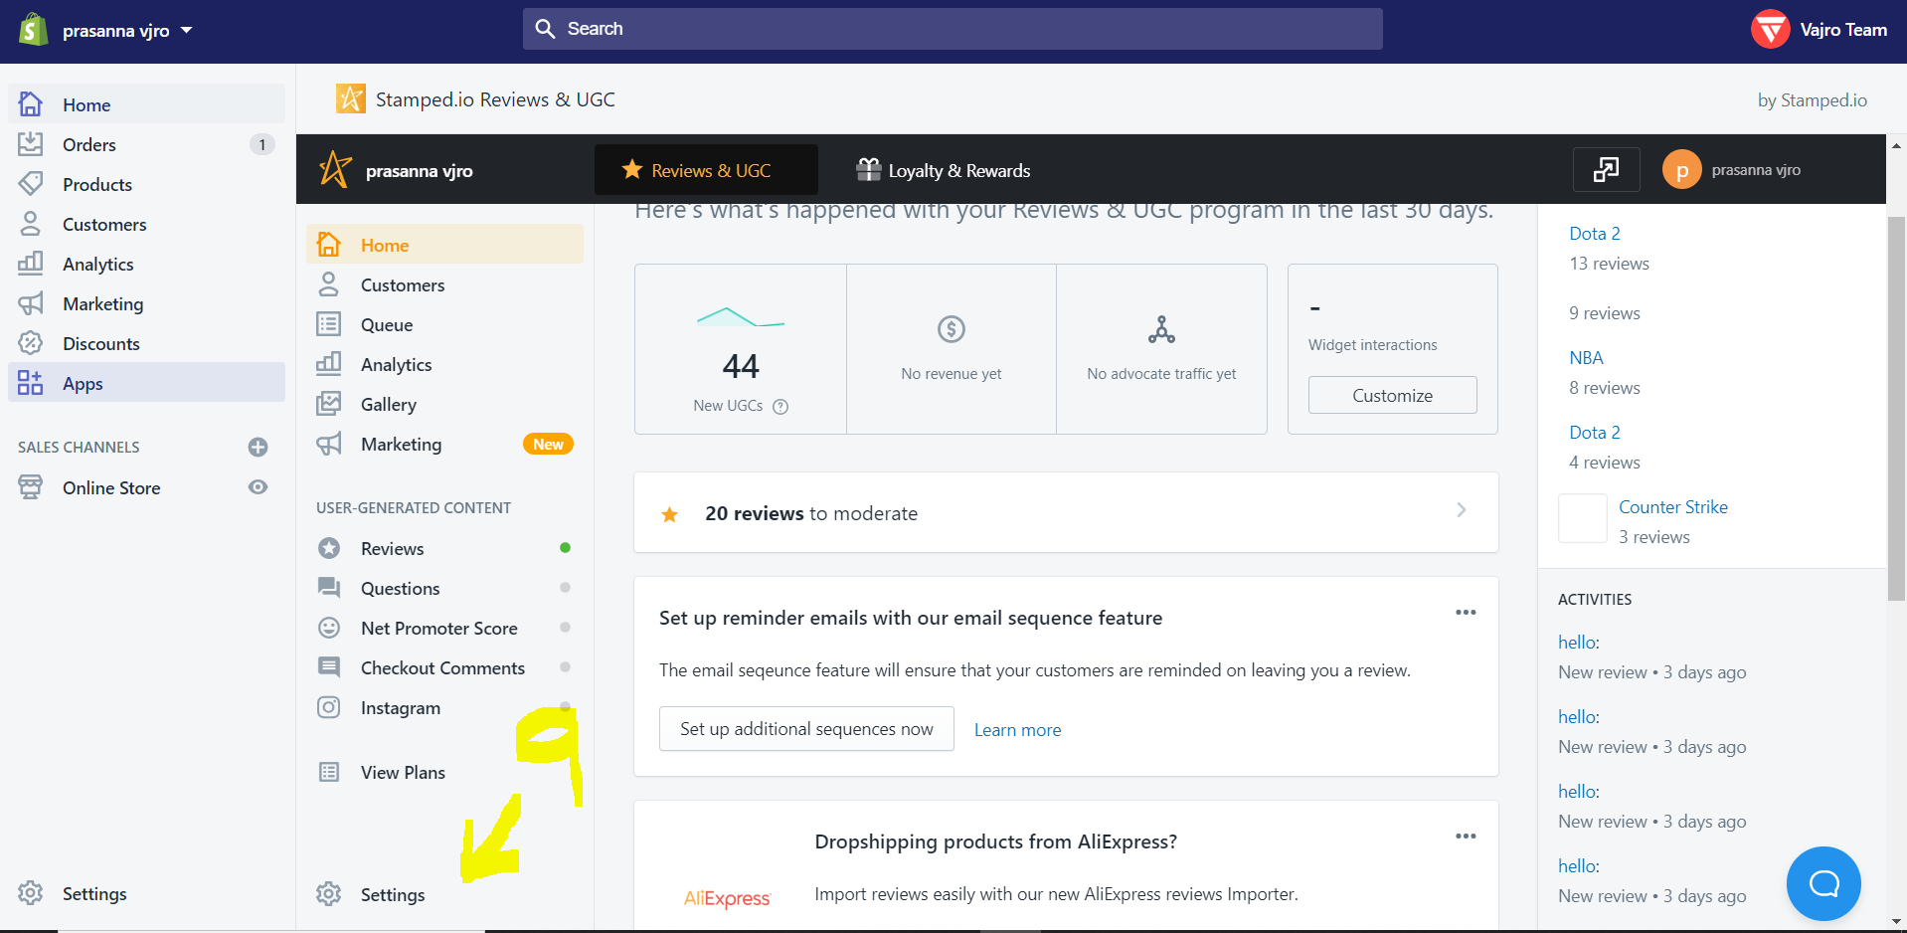

Step 6- In the Settings page, click on API keys, the Public & Private API keys along with the Store hash will be displayed as shown in pictures below.

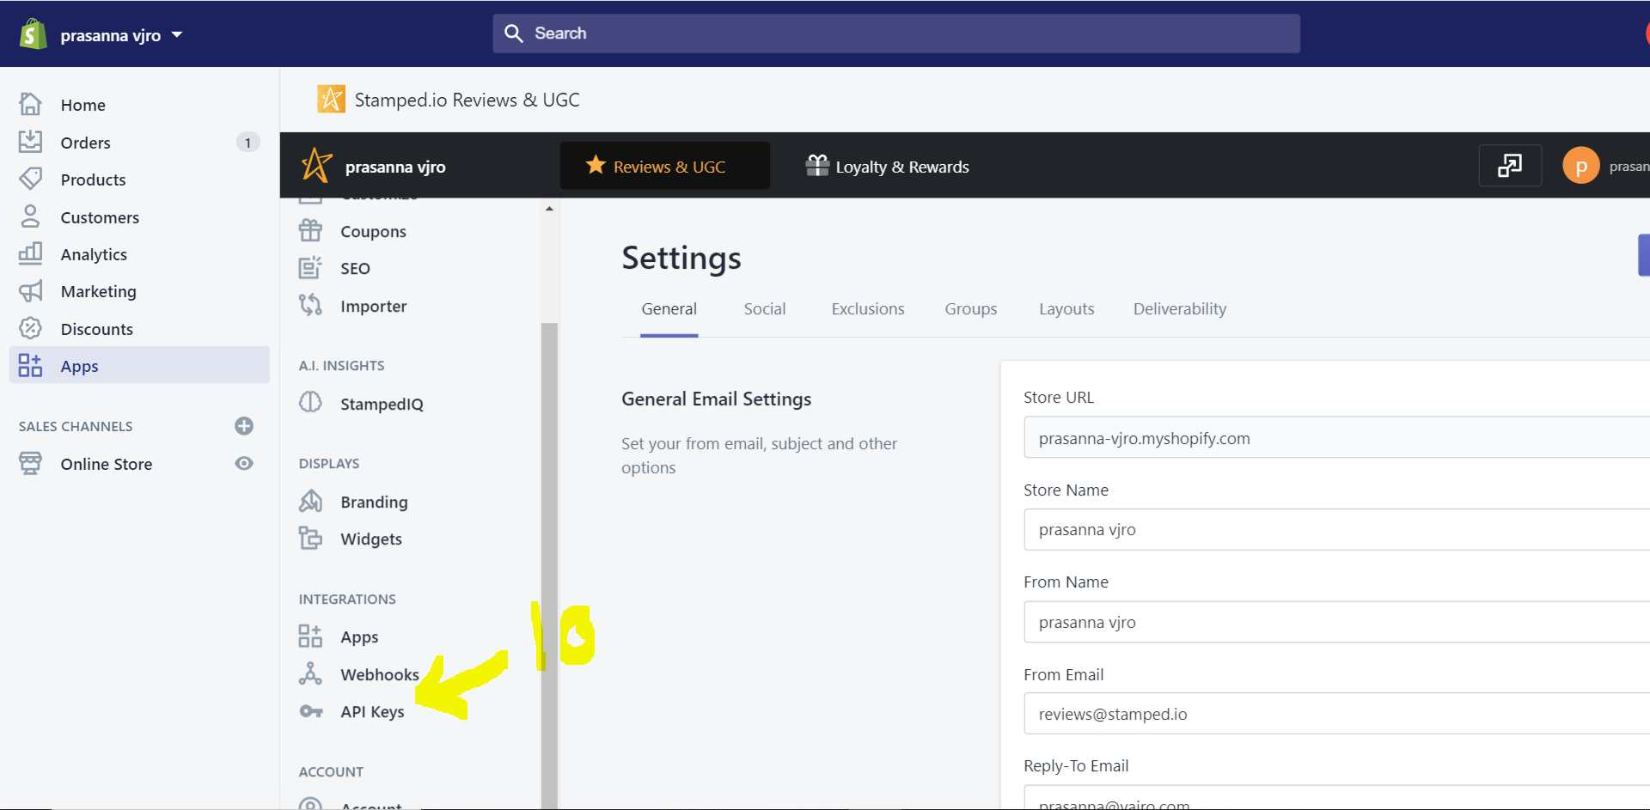

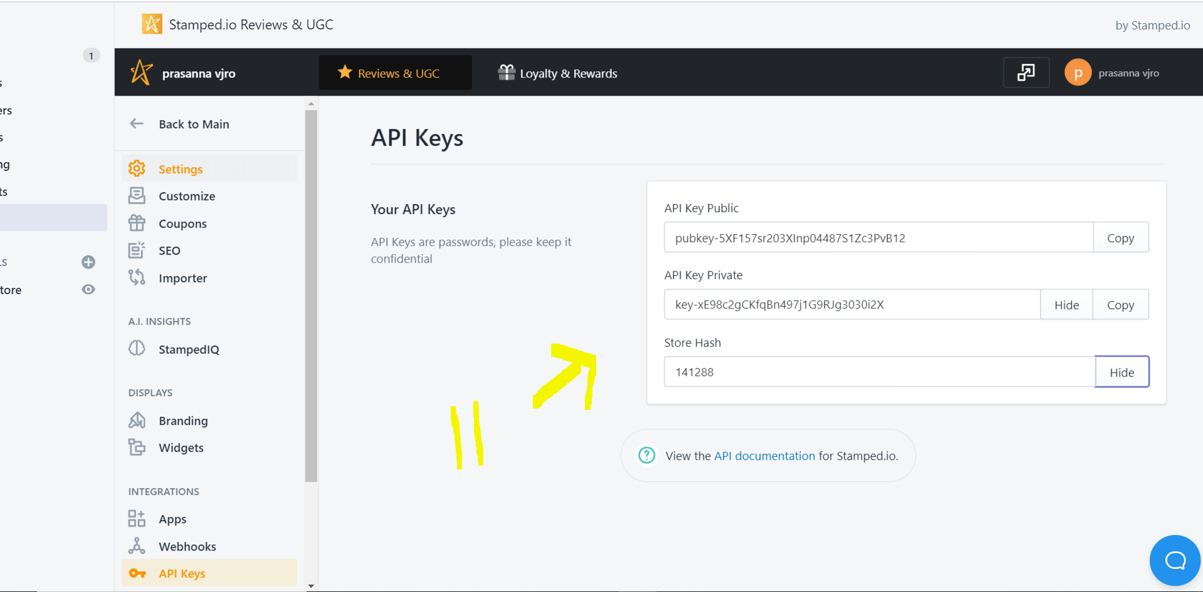

Step 7- Go to <https://staging.vajro.com/app/integration-two> , click on ‘Integrations’ and then click on ‘Stamped.io reviews & UGC’ as mentioned below.

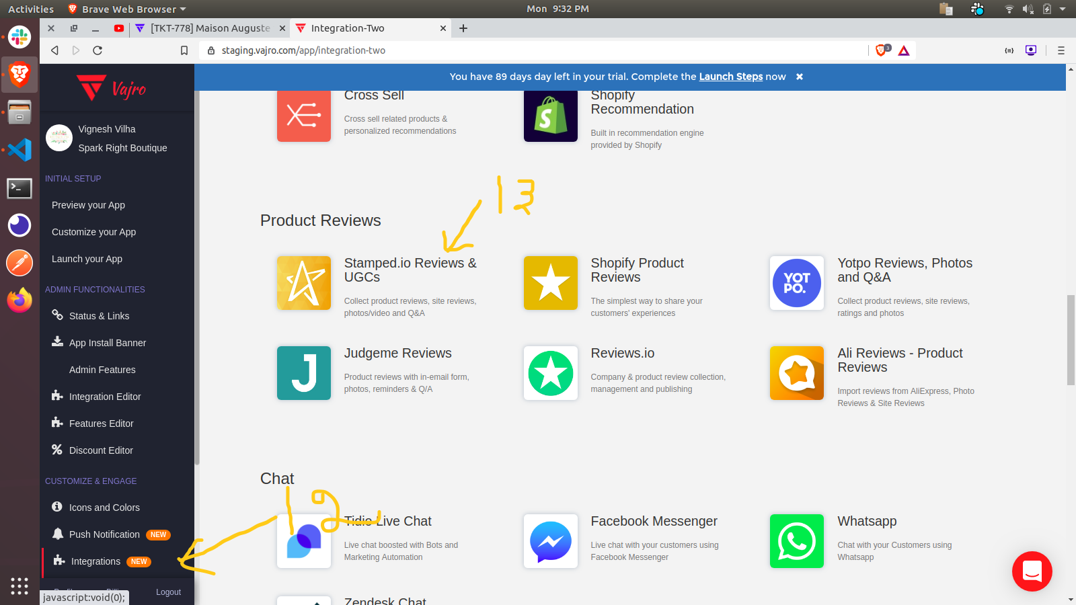

Step 8- Fill the API keys and store hash obtained from step 6 and click on ‘Save Changes’.

