🛡️ Machine Learning-Based Lightweight Intrusion Detection System for IoT Networks

📌 Project Overview
The rapid adoption of Internet of Things (IoT) devices has introduced significant security challenges due to the increasing number of cyberattacks targeting connected environments. This project presents a lightweight and intelligent Intrusion Detection System (IDS) that leverages Machine Learning and Deep Learning techniques to detect malicious network activities in IoT environments.
The system analyzes network traffic features and classifies them into normal or attack categories, enabling proactive threat detection for smart homes, industrial IoT systems, healthcare devices, and other connected infrastructures.

🎯 Objectives
- Detect malicious activities in IoT network traffic.
- Improve cybersecurity through intelligent intrusion detection.
- Handle class imbalance using advanced balancing techniques.
- Compare multiple machine learning models.
- Build a lightweight IDS suitable for real-world IoT deployment.

📊 Dataset

RT-IoT2022 / CICIoT Dataset
The project utilizes a real-world IoT network traffic dataset containing various attack scenarios and legitimate traffic patterns.
Dataset Characteristics
- Approximately 123,000+ network records
- 80+ traffic-related features
- Multi-class classification problem
- Real IoT traffic captured from actual devices
- Includes modern IoT attack categories

Attack Categories
- DDoS Attacks
- DoS Attacks
- Reconnaissance Attacks
- Theft Attacks
- Network Scanning
- Normal Traffic

🏗️ System Architecture
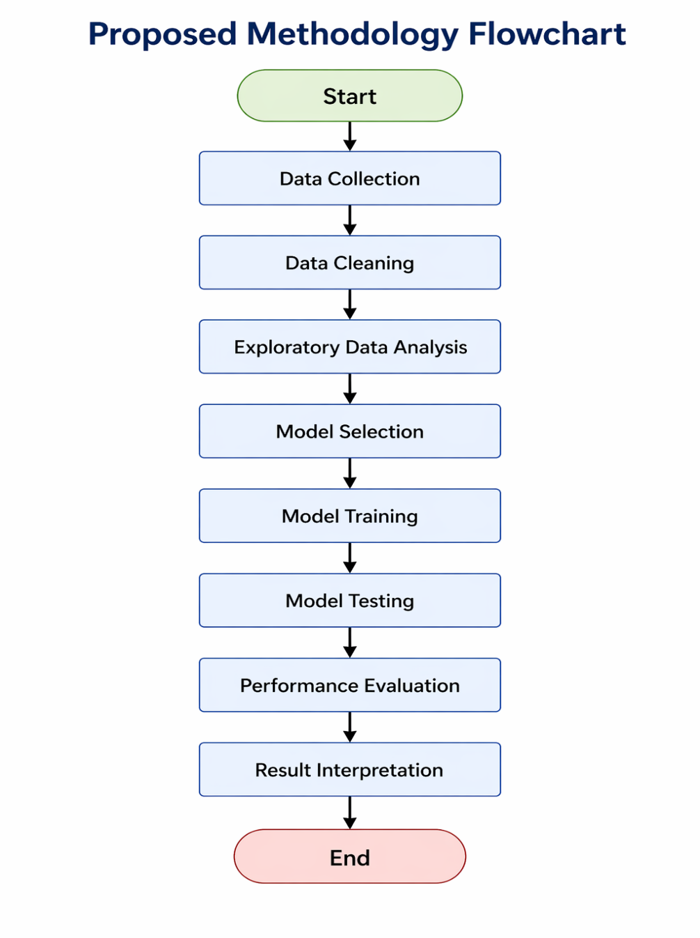

⚙️ Technologies Used

Programming Language
- Python

Libraries
- Pandas
- NumPy
- Scikit-Learn
- TensorFlow / Keras
- LightGBM
- XGBoost
- CatBoost
- Matplotlib
- Seaborn
- Joblib

Development Environment
- Jupyter Notebook
- VS Code

🔄 Data Preprocessing
The following preprocessing techniques were applied:

Data Cleaning
- Missing value handling
- Duplicate record removal
- Data consistency verification

Feature Engineering
- Categorical feature encoding
- Feature selection
- Data normalization
- Standard scaling

Class Balancing
To address class imbalance:
- Equal class sampling
- Minority class augmentation
- Controlled oversampling
- Majority class reduction
This improves model fairness and detection performance across all attack categories.

🤖 Machine Learning Models

1. Deep Neural Network (DNN)
A fully connected neural network trained to learn complex traffic patterns and attack signatures.

2. LightGBM
Gradient boosting framework optimized for speed and performance on tabular datasets.

3. XGBoost
Highly efficient boosting algorithm known for superior predictive accuracy.

4. CatBoost
Boosting algorithm capable of effectively handling categorical features.

5. Ensemble Learning
Predictions from multiple models are combined to improve overall intrusion detection accuracy and robustness.

📈 Evaluation Metrics
Model performance is evaluated using:

Accuracy
Accuracy = (TP + TN) / (TP + TN + FP + FN)

Precision
Precision = TP / (TP + FP)

Recall
Recall = TP / (TP + FN)

F1-Score
F1 = 2 × (Precision × Recall) / (Precision + Recall)

Additional Metrics
- Confusion Matrix
- Classification Report
- Class-wise Performance Analysis

🚀 Key Features
✅ Multi-class Intrusion Detection
✅ Machine Learning + Deep Learning Hybrid Architecture
✅ Class Imbalance Handling
✅ Automated Feature Processing
✅ Lightweight Deployment Architecture
✅ Real IoT Network Traffic Analysis
✅ Ensemble-Based Prediction System

📷 Project Outputs

Confusion Matrix
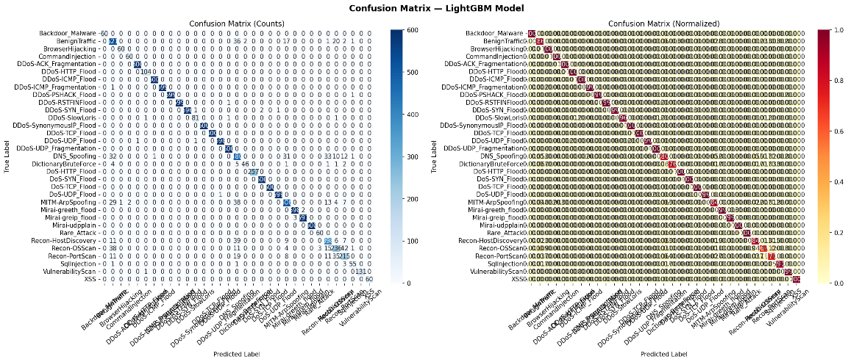

Attack Classification Results
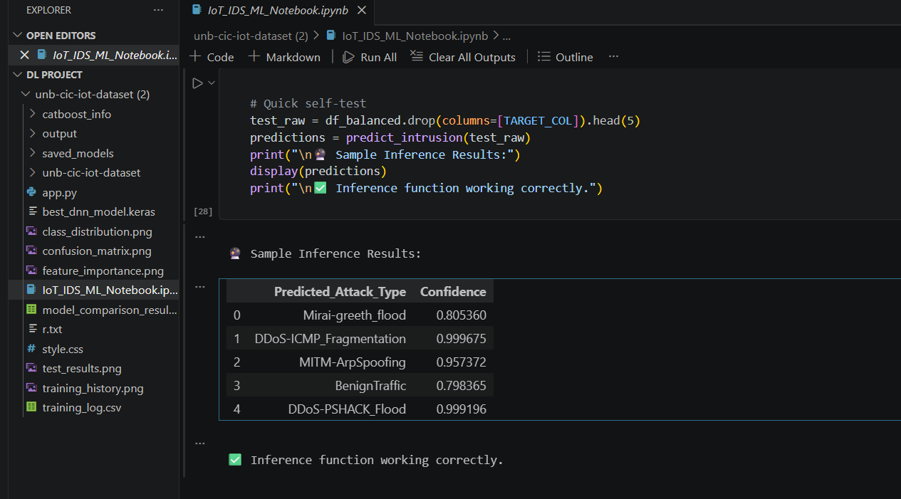

Model Performance Comparison
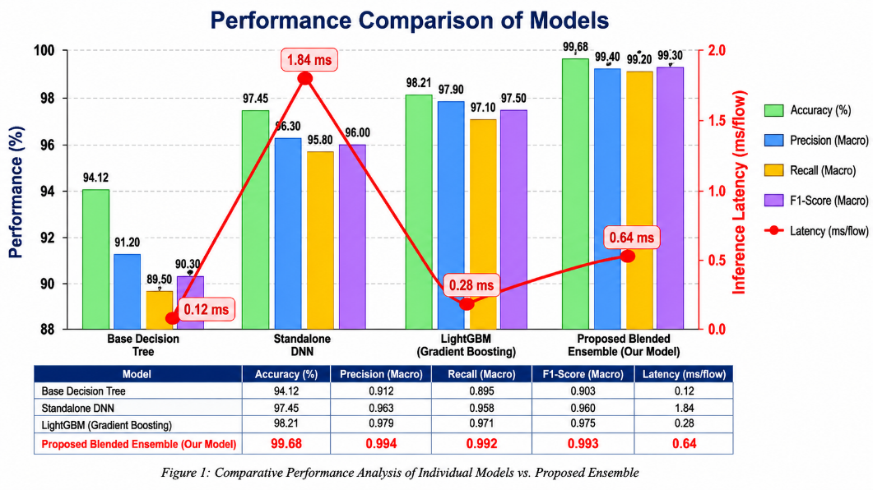

Class Distribution Analysis
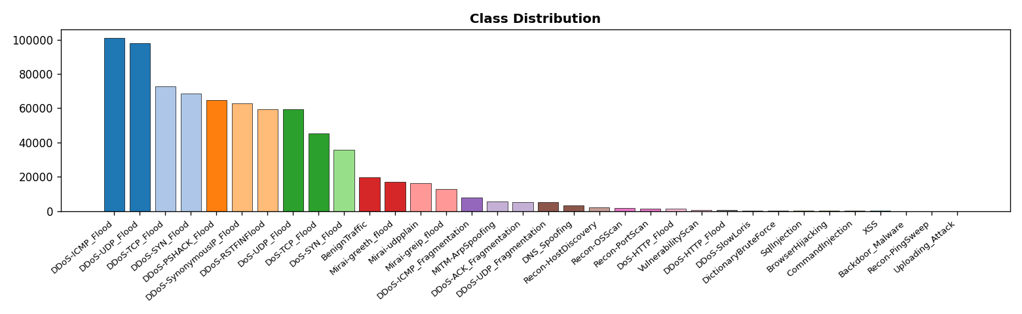

📂 Repository Structure
IoT-Lightweight-IDS/
├── notebooks/
├── dataset/
├── models/
├── outputs/
│ ├── confusion_matrix.png
│ ├── model_comparison.png
│ └── predictions.png
├── presentation/
├── report/
├── requirements.txt
└── README.md

💡 Applications
- Smart Home Security
- Industrial IoT Protection
- Healthcare Device Security
- Critical Infrastructure Monitoring
- Enterprise Network Monitoring
- Edge-Based Intrusion Detection

🔮 Future Enhancements
- Real-Time IDS Deployment
- Edge Computing Integration
- Explainable AI (XAI)
- Federated Learning for IoT Security
- Cloud-Based Threat Monitoring
- Zero-Day Attack Detection

👩‍💻 Author
M V SAI PRASANNA LAKSHMI ATHULURI
Final Year of MCA Student
Cybersecurity | Machine Learning | IoT Security Enthusiast
LinkedIn: [www.linkedin.com/in/prasanna-lakshmi-athuluri-551437369]
GitHub: [www.linkedin.com/in/prasanna-lakshmi-athuluri-551437369]

📜 Conclusion
This project demonstrates how Machine Learning and Deep Learning can be effectively utilized to build a lightweight Intrusion Detection System for IoT environments. By combining advanced preprocessing, class balancing, ensemble learning, and neural networks, the system achieves accurate detection of malicious network activities while remaining efficient enough for practical deployment.

