23CSE304 Embedded Systems — Case Study Report
Department of CSE, Amrita School of Computing, Amrita Vishwa Vidyapeetham
Edge Acoustic and Vibration Condition Monitoring System using STM32F411CEU6

Team (Name – Roll No.):
1. Prasanna B - [CB.SC.U4CSE24537]
2. Nitharshan CK – [CB.SC.U4CSE24532]
3. Parthiv Surya – [CB.SC.U4CSE24535]
4. Awaaz – [CB.SC.U4CSE24562]

Faculty: Dr. A. Baskar

1. Problem Statement
Faults in small rotating machines show up as changes in vibration and sound long before a breakdown. Checking this by ear or with a handheld meter is subjective and needs an expert, while industrial monitors are costly. This project builds a low-cost, STM32F411CEU6-based edge monitor for a small 6 V/12 V DC motor. An MPU6050 senses vibration and an INMP441 digital microphone senses sound. The microcontroller records a healthy baseline, extracts RMS, peak and FFT features locally, and raises an alert (OLED, LEDs, buzzer, UART/Bluetooth) when the motor deviates from that baseline, for example due to rotor imbalance, loose mounting or load change.
2. Objectives (what we are doing)
- Measure the vibration of a small DC motor with the MPU6050 accelerometer (I2C).
- Capture the motor sound with the INMP441 digital MEMS microphone (I2S + DMA); no ADC is needed because it replaces the analog MAX9814.
- Acquire both signals reliably using timers, DMA and NVIC interrupts.
- Compute features: RMS, peak, peak-to-peak and dominant frequency (FFT).
- Build a healthy baseline (mean and standard deviation) from normal operation.
- Detect abnormal behaviour caused by controlled imbalance, loose mounting or load change.
- Show the condition on a 0.96" SSD1306 OLED and indicate it with red/green LEDs and a buzzer.
- Send measurements to a PC over USB-UART (and optionally to a phone over HC-05); start/stop by KEY button (EXTI) or Bluetooth command (UART).
- Control the motor safely through the TB6612FNG driver, and keep the design ready for a later TinyML classifier.
3. Hardware Components Used
No. | Component (qty) | Key specification | Usage in this project
1 | STM32F411CEU6 Black Pill (1) | ARM Cortex-M4F with FPU, up to 100 MHz, 512 KB Flash, 128 KB RAM, 3.3 V logic, 25 MHz crystal, USB-C 5 V in; on-board KEY (PA0), LED (PC13) | Main controller: acquisition, DSP, decision logic, motor control, display and telemetry
2 | ST-Link V2 (1) | SWD programmer/debugger | Flashing and debugging from Keil
3 | DC motor 6 V / 12 V (1) | Small brushed DC motor | Machine under observation
4 | MPU6050 (1) | 3-axis accelerometer + gyro, 16-bit, ±2/4/8/16 g, I2C up to 400 kHz, address 0x68, 3.3 V | Vibration (X, Y, Z acceleration)
5 | INMP441 (1) | MEMS microphone, 24-bit I2S output, 3.3 V, 1.8–3.3 V supply | Acoustic signal (replaces MAX9814)
6 | 0.96" SSD1306 OLED (1) | 128×64 pixels, I2C address 0x3C | Condition and feature display
7 | TB6612FNG driver (1) | Dual H-bridge, VM 4.5–13.5 V, 1.2 A per channel, logic 2.7–5.5 V (L298N also works) | Drives the motor from PWM/GPIO signals
8 | 5 V active buzzer (1) | Built-in oscillator; driven by BC547 + 1 kΩ transistor stage | Audible abnormal-condition alert
9 | Red + Green LEDs (1 each) | With 330 Ω series resistors | Visual status (normal / abnormal)
10 | USB-to-UART adapter (1) | 3.3 V logic, 115200 baud | Telemetry/debug log to PC
11 | HC-05 Bluetooth (1, optional) | Bluetooth 2.0 SPP, ~10 m, 3.6–6 V supply, 3.3 V logic, 9600 baud | Wireless telemetry; receives commands
12 | Power supply | 5 V regulated for electronics + suitable 6/12 V motor supply, common GND | Powers electronics and motor separately
13 | Breadboard, jumper wires | Full-size breadboard; male-male and male-female wires | Prototype wiring

4. Pin Specifications, Connections, Inputs and Outputs
(a) Interface network — each sensor/actuator path uses dedicated MCU pins
Interface | STM32 pins | Peripheral / alternate function | Role
I2C bus (shared) | PB8 (SCL), PB9 (SDA) | I2C1, AF4, 400 kHz | MPU6050 (0x68) and OLED (0x3C) on one bus
I2S audio | PB12 (WS), PB13 (CK), PB15 (SD) | I2S2 receive, AF5, DMA1 | INMP441 samples at 16 kHz (24-bit in 32-bit slot)
Motor driver | PA8 (PWMA), PB0 (AIN1), PB1 (AIN2), PB5 (STBY) | TIM1_CH1 PWM (AF1) + GPIO | Speed by duty cycle; direction and enable by GPIO
USB-UART | PA2 (TX), PA3 (RX) | USART2, AF7, 115200 baud | CSV telemetry and debug to PC
Bluetooth | PA9 (TX), PA10 (RX) | USART1, AF7, 9600 baud | Result to phone; commands B / M / S
Alerts | PA6 (Green), PA7 (Red), PA5 (Buzzer) | GPIO output | Status LEDs and buzzer drive
User / debug | PA0 (KEY), PC13 (LED), PA13/PA14 | EXTI0, GPIO, SWD | Start/stop button, heartbeat LED, ST-Link
The motor is switched by the TB6612FNG from a separate supply, so no motor current flows through a GPIO pin. The pin map is a proposed plan; confirm alternate functions against your board schematic before final wiring.
(b) Module pin details
Module | Pin | Specification | STM32 pin
MPU6050 | VCC / GND | 3.3 V supply | 3V3 / GND
 | SCL / SDA | I2C1, open-drain, 400 kHz, 4.7 kΩ pull-ups | PB8 / PB9
 | AD0 / INT | AD0 to GND selects address 0x68; INT not used | GND / not used
INMP441 | VDD / GND | 3.3 V supply | 3V3 / GND
 | SCK | Bit clock = 16 kHz × 64 = 1.024 MHz | PB13 (I2S2_CK)
 | WS | Word select = sample rate, 16 kHz | PB12 (I2S2_WS)
 | SD | Serial data out, 24-bit MSB first | PB15 (I2S2_SD)
 | L/R | Tied to GND = left channel | GND
SSD1306 OLED | VCC / GND, SCL / SDA | 3.3 V, I2C address 0x3C, shares the I2C1 bus | 3V3 / GND, PB8 / PB9
TB6612FNG | VM / VCC / GND | VM = 6/12 V motor supply, VCC = 3.3 V logic, common GND | Ext. supply / 3V3 / GND
 | PWMA, AIN1, AIN2, STBY | PWM 10 kHz; direction inputs; STBY high = enabled | PA8, PB0, PB1, PB5
 | AO1 / AO2 | Motor outputs (BIN/PWMB unused, tied low) | DC motor
Buzzer / LEDs | Signal pins | Buzzer via 1 kΩ + BC547; LEDs via 330 Ω, active-high | PA5; PA6 (G), PA7 (R)
HC-05 | VCC / GND | 5 V supply (3.6–6 V) | 5V / GND
 | RXD / TXD | UART, 3.3 V logic, 9600 baud | PA9 (TX) / PA10 (RX)
 | STATE, EN | Link status; AT-mode select | Not used
USB-UART | RXD / TXD / GND | UART, 3.3 V logic, 115200 baud | PA2 (TX) / PA3 (RX) / GND
ST-Link V2 | SWDIO / SWCLK / GND | Serial Wire Debug | PA13 / PA14 / GND
KEY / LED (board) | button / LED | KEY: to GND, internal pull-up, EXTI0; LED: active-low | PA0 / PC13
(c) Inputs and outputs of the device
Signal | I/O | Type / interface | Range or format
Vibration X, Y, Z | In | I2C1, MPU6050, sampled by TIM3 at 1 kHz | ±4 g range, 16-bit (8192 LSB/g)
Motor audio | In | I2S2 + DMA circular buffer, INMP441 | 16 kHz, 24-bit signed samples
KEY button | In | Digital, PA0, EXTI0 | Active-low, falling edge
Bluetooth command | In | USART1, 9600 baud | 'B' = baseline, 'M' = monitor, 'S' = stop
Motor drive | Out | TIM1 PWM + GPIO to TB6612FNG | 10 kHz PWM, duty 0–100 %
OLED text | Out | I2C1, 128×64 pixels | State, vibration RMS, frequency, audio RMS
LEDs and buzzer | Out | GPIO PA6, PA7, PA5 | Green = normal; red + buzzer = abnormal
Telemetry | Out | USART2 115200 / USART1 9600 | CSV: Time,Vib_RMS,Audio_RMS,Freq,Status

(d) Pin diagram — STM32F411CEU6 Black Pill (black = pin used)
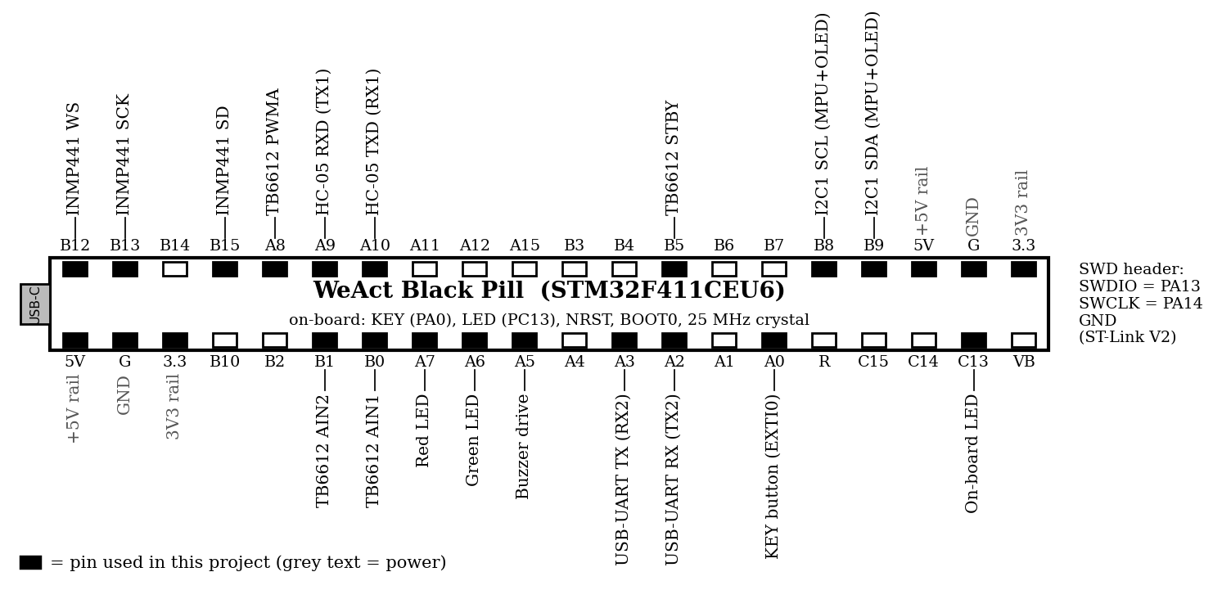
Figure 1. Black Pill pin diagram with project connections
5. Architecture Diagram (Block Diagram)
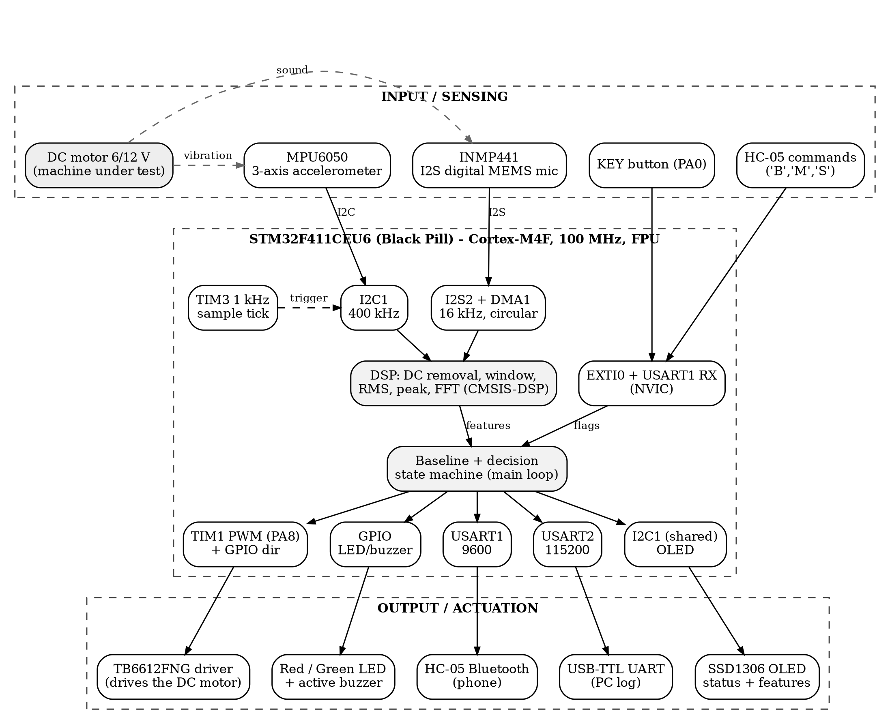
Figure 2. Block diagram of the monitoring system
Input blocks: DC motor (vibration and sound source), MPU6050, INMP441, KEY button, HC-05 commands, USB-C power, ST-Link. Processing block: STM32F411 acquires data (I2C, I2S + DMA, timers), runs DSP (DC removal, windowing, RMS, FFT), builds the baseline and decides the condition. Output blocks: TB6612FNG motor driver, OLED, LEDs and buzzer, USB-UART (PC log), HC-05 (phone).

6. System Design
6.1 Circuit Schematic Diagram (Connection Diagram)
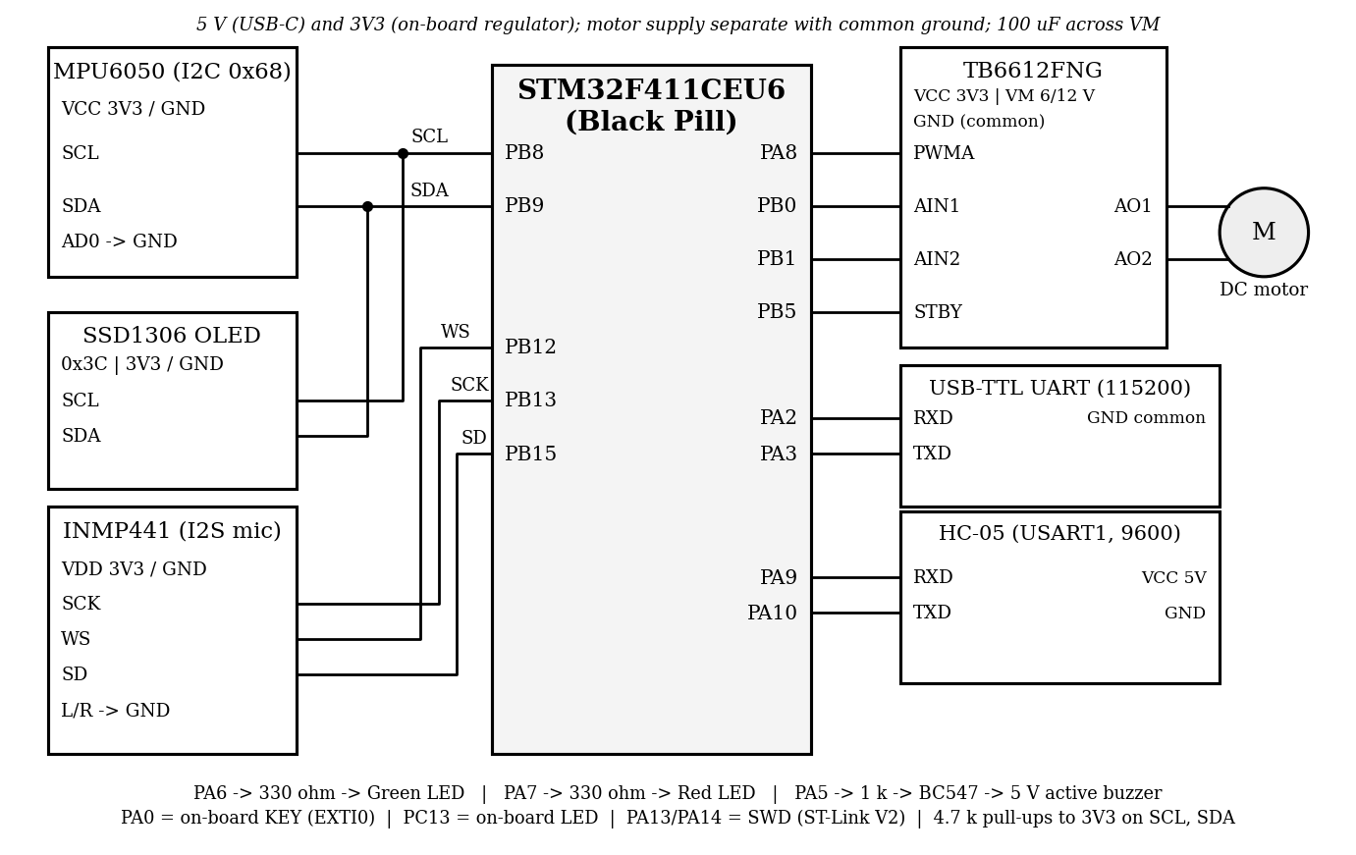
Figure 3. Connection diagram: sensors (left), STM32 Black Pill (centre), driver and communication modules (right)
Identification method (how the condition is decided)
- Acquire: MPU6050 sampled at 1 kHz (TIM3) into a 512-sample window (0.512 s); INMP441 streamed at 16 kHz by I2S2 + DMA, last 2048 samples used per window.
- Pre-process: subtract the mean (removes gravity/DC offset) and apply a Hann window before the FFT.
- Features: vibration RMS, peak, dominant frequency; audio RMS, peak, dominant frequency (CMSIS-DSP real FFT).
- Baseline: with the motor healthy, 20 windows give mean μ and standard deviation σ for each feature.
- Decide: z-score of every feature; if |z| > 3 for 3 consecutive windows the state is ABNORMAL, otherwise NORMAL. Hints: imbalance raises vibration RMS and the 1× running-frequency peak; loose mounting adds 2×/3× harmonics and broadband noise; load change shifts the dominant frequency and audio RMS.
Formulas
a = raw / 8192 (g, ±4 g range) x = raw₂₄ / 2²³ (audio, −1 to +1) x′[n] = x[n] − mean(x)
RMS = √[(1/N) Σ x′[n]²] Peak = max|x′[n]| Peak-to-peak = max(x′) − min(x′)
X[k] = Σ x′[n]·w[n]·e^(−j2πkn/N) f_k = k·f_s / N f_dom = f_k at max|X[k]|, 1 ≤ k ≤ N/2
Resolution Δf = f_s / N: vibration 1000/512 = 1.95 Hz; audio 16000/2048 = 7.8 Hz f_run = rpm / 60
z = (x − μ_b) / σ_b μ_b = (1/N_b) Σ x_b σ_b = √[Σ(x_b − μ_b)² / (N_b − 1)] N_b = 20
f_PWM = f_TIM / [(PSC+1)(ARR+1)] = 100 MHz / (100×100) = 10 kHz Duty = CCR / (ARR+1)
Interrupts (NVIC)
Source | IRQ | Priority | Action
SysTick | SysTick_IRQn | 0 | 1 ms tick for timeouts, debounce and buzzer pattern
I2S2 RX DMA | DMA1_Stream3_IRQn | 1 | Half/full buffer complete: mark audio window ready
TIM3 update (1 kHz) | TIM3_IRQn | 2 | Read MPU6050 X, Y, Z sample into the vibration buffer
KEY button (PA0) | EXTI0_IRQn | 3 | Debounce, set start/stop flag
USART1 receive | USART1_IRQn | 4 | Read 'B', 'M' or 'S' from phone, set flag
Firmware: C with CMSIS and CMSIS-DSP, 100 MHz clock (25 MHz HSE → PLL). ISRs stay short and only set flags or store samples; FFT and decisions run in the main-loop state machine.

6.2 Schematic State Diagram  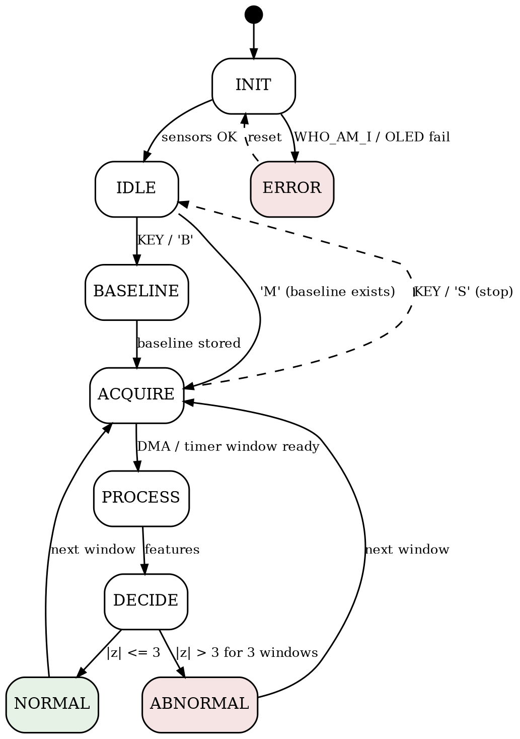  Figure 4. State diagram | 6.3 Flow Diagram  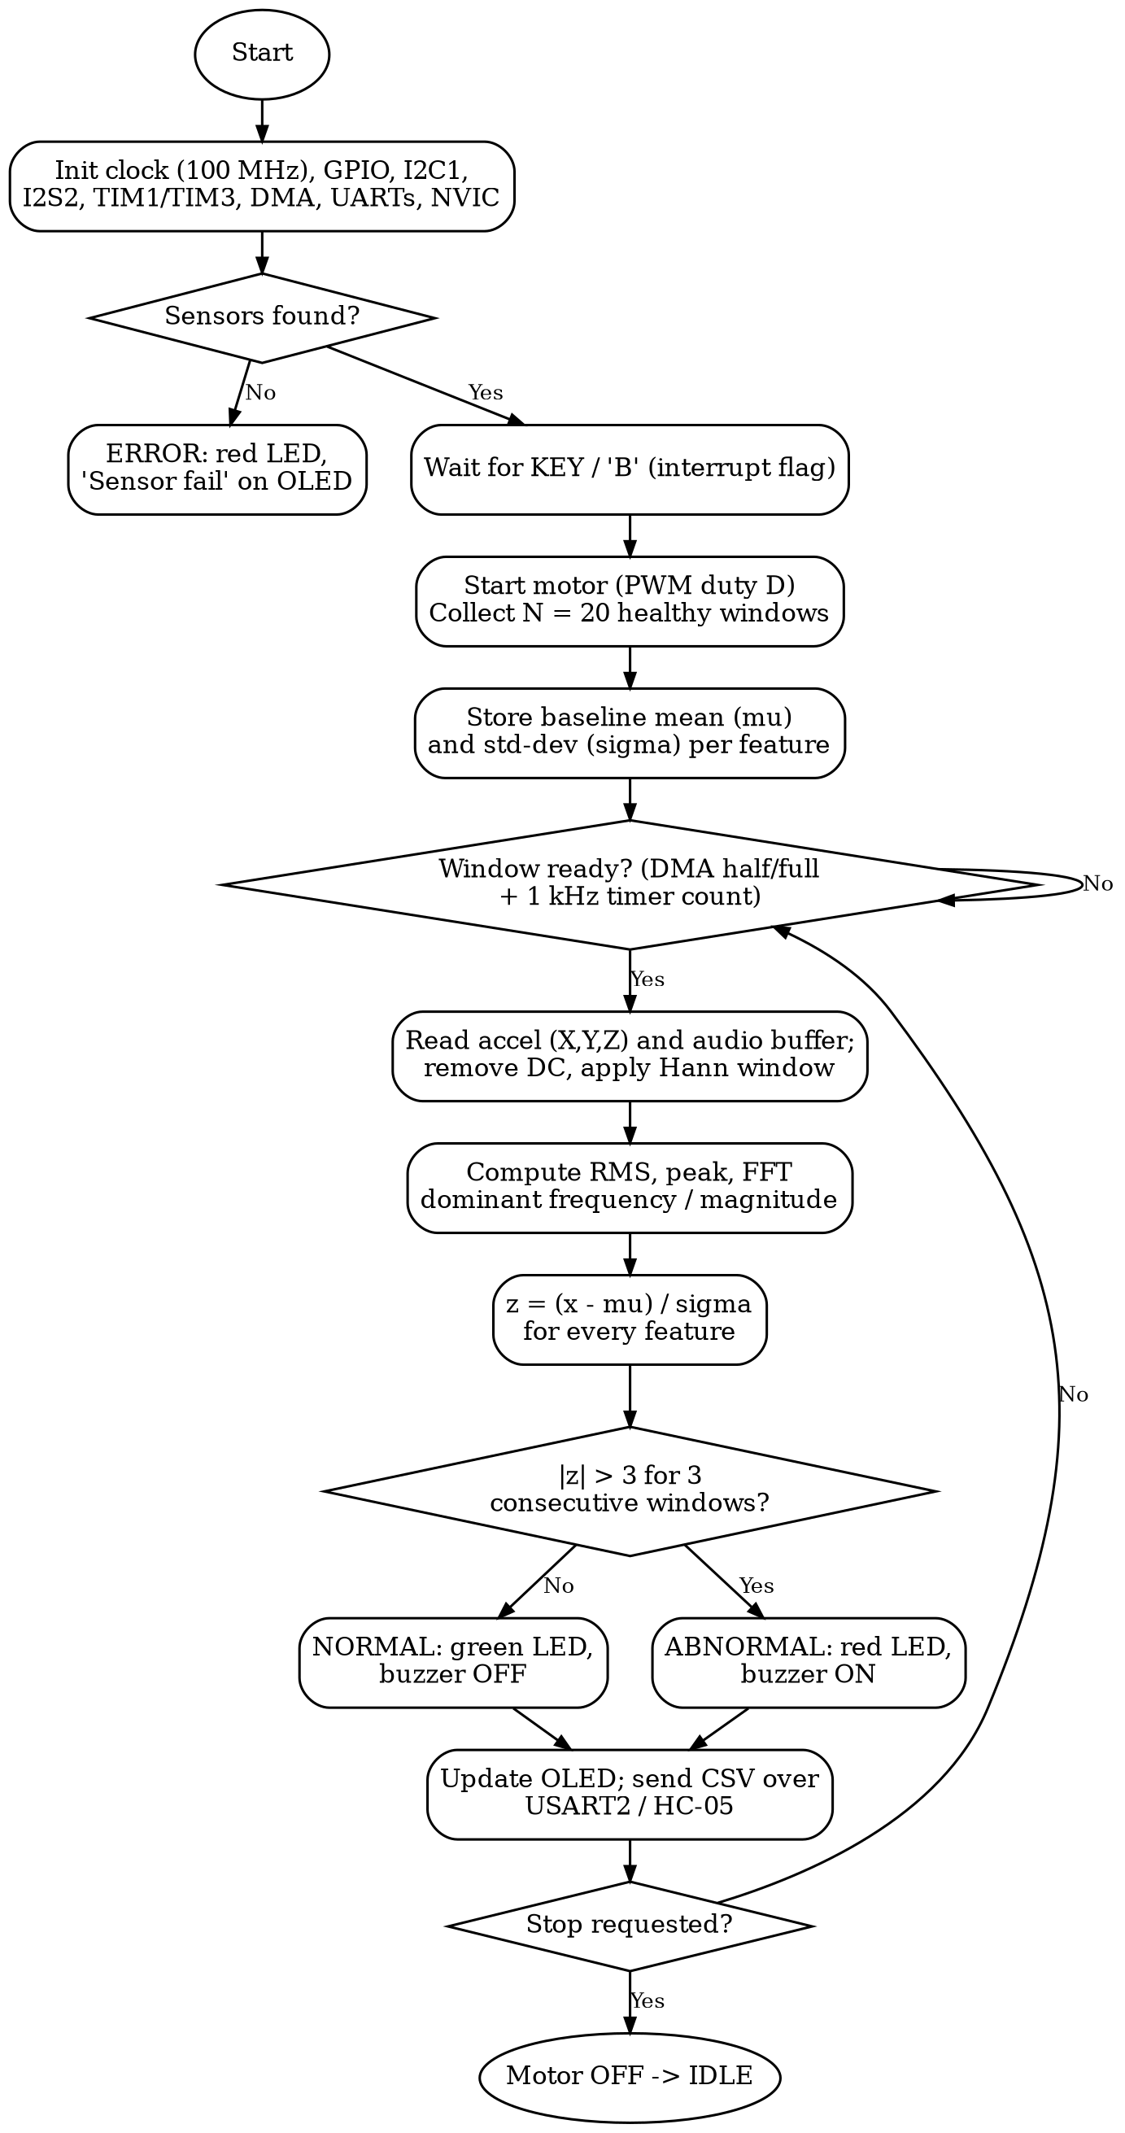  Figure 5. Flow diagram of the monitoring loop
  State | Action | OLED shows
  INIT | Set up clock, GPIO, I2C, I2S, TIM, DMA, UART, NVIC | Monitor v1.0
  IDLE | Motor off; wait for KEY / BT | Ready / Press KEY
  BASELINE | Motor on; learn μ, σ from 20 windows | Learning n/20
  ACQUIRE | Fill vibration and audio windows | Monitoring...
  PROCESS | DC removal, window, RMS, FFT | ---
  DECIDE | z-scores, 3-window rule | ---
  NORMAL | Green LED on, buzzer off | NORMAL + values
  ABNORMAL | Red LED + buzzer on | ABNORMAL + values
  ERROR | Sensor missing (WHO_AM_I ≠ 0x68) | Sensor fail
7. Tools / Software Used
Tool | Purpose
Keil µVision 5 (MDK-ARM) + CMSIS, CMSIS-DSP | C firmware: build and debug; register definitions, NVIC, SysTick, FFT functions
STM32CubeMX (optional) | Clock tree, pin alternate-function and I2S/DMA configuration check
ST-Link V2 + STM32CubeProgrammer | Flashing and debugging over SWD
Tera Term / serial terminal | Telemetry log from USART2 (115200 baud)
Serial Bluetooth Terminal (Android) | Phone interface over HC-05
Python (NumPy, Matplotlib), Graphviz | Offline FFT check, plots, and the block/state/flow/pin diagrams
Digital multimeter | Power rails and wiring verification
8. Conclusion
The system turns a small DC motor into a monitored machine: the MPU6050 and INMP441 supply vibration and sound, the STM32F411 extracts RMS and FFT features at the edge, compares them with a learned healthy baseline, and signals the result on the OLED, LEDs, buzzer and UART/Bluetooth. Using the digital INMP441 instead of the analog MAX9814 removes the ADC from the audio path. Limitations: thresholds depend on the baseline recorded for one motor and mounting, so they must be tuned from experiments; fault tests must stay mechanically safe; all logic is 3.3 V. A TinyML classifier is a planned extension.

