EXERCISE NUMBER:8

DATE:21/11/2020

AIM:

To Write a Python class to find validity of a string of parentheses, '(', ')', '{', '}', '[' and '].

PROGRAM:

a=input()

sq_o,sq_c,fl_o,fl_c,pr_o,pr_c=0,0,0,0,0,0

for i in a:

if(i=='{'):

fl_o+=1

elif(i=='['):

sq_o+=1

elif(i=='('):

pr_o+=1

elif(i==')'):

pr_c+=1

elif(i=='}'):

fl_c+=1

elif(i==']'):

sq_c+=1

if(sq_o==sq_c and pr_o==pr_c and fl_o==fl_c):

print("valid")

else:

print("invalid")

LINK:­

EXERCISE NUMBER:14

DATE:21/11/2020

AIM:

To Write a Python class to find validity of a string of parentheses, '(', ')', '{', '}', '[' and '].

PROGRAM:

n=int(input())

list=[]

for i in range(n):

a=int(input())

list.append((a,a*a*a))

print(list)

for i in range(0,len(list)):

for j in range(i+1,len(list)):

if(list[j][1]<list[i][1]):

temp=list[i]

list[i]=list[j]

list[j]=temp

print(list)

LINK:­

[http://103.53.53.18/mod/vpl/forms/edit.php?id=327&userid=1793#](http://103.53.53.18/mod/vpl/forms/edit.php?id=327&userid=1793)

OUTPUT:

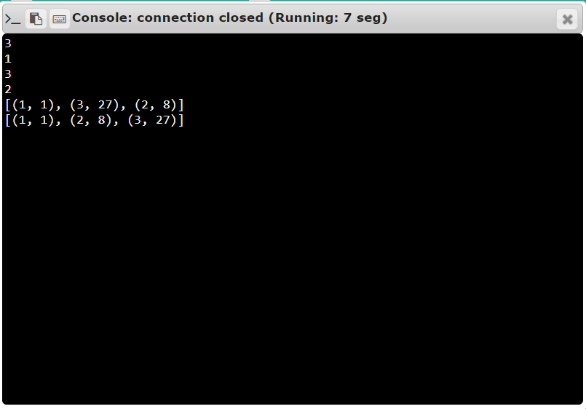

RESULT:

The expected output is obtained successfully.

OUTPUT:

s

RESULT:

The expected output is obtained successfully.