EXERCISE NUMBER:8

DATE:21/11/2020

AIM:

To Write a Python class to find validity of a string of parentheses, '(', ')', '{', '}', '[' and '].

PROGRAM:

n=int(input())

list=[]

for i in range(n):

a=int(input())

list.append((a,a\*a\*a))

print(list)

for i in range(0,len(list)):

for j in range(i+1,len(list)):

if(list[j][1]<list[i][1]):

temp=list[i]

list[i]=list[j]

list[j]=temp

print(list)

LINK:­

<http://103.53.53.18/mod/vpl/forms/edit.php?id=317&userid=1793>

OUTPUT:

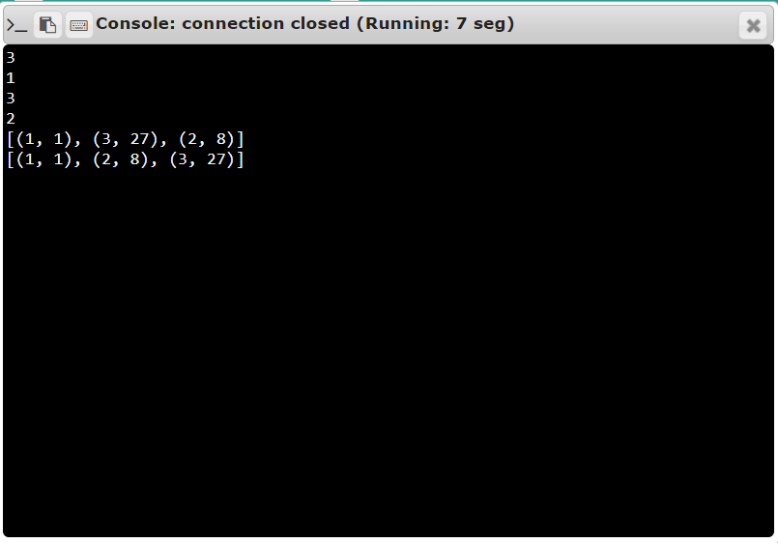

RESULT:

The expected output is obtained successfully.