NITTE MEENAKSHI INSTITUTE OF TECHNOLOGY
(AN AUTONOMOUS INSTITUTION, AFFILIATED TO VISVESVARAYA TECHNOLOGICAL UNIVERSITY, BELGAUM, APPROVED BY AICTE & GOVT.OF KARNATAKA

COURSE PROJECT REPORT
on
Machine_learning

Submitted in partial fulfilment of the requirement for the award of Degree of
Bachelor of Engineering
in
Computer Science and Engineering
Submitted by:
PRASANNA MG | 1NT18CS116



Department of Computer Science and Engineering

2019-20

 | Nitte Meenakshi Institute of Technology  (AN AUTONOMOUS INSTITUTION AFFILIATED TO VISVESVARAYA TECHNOLOGICAL UNIVERSITY, BELGAUM)  PB No. 6429, Yelahanka, Bangalore 560-064, Karnataka  Telephone: 080- 22167800, 22167860  Fax: 080 - 22167805 | 
Department of Computer Science and Engineering

CERTIFICATE
This is to certify that the Course Project titled Machine_Learning is an authentic work carried out by Prasanna MG bonafide students of Nitte Meenakshi Institute of Technology, Bangalore in partial fulfilment for the award of the degree of Bachelor of Engineering in COMPUTER SCIENCE AND ENGINEERING of Visvesvaraya Technological University, Belagavi during the academic year 2019-2020.

Dr Vijaya Shetty Dr. Thippeswamy M. N
Name Signature of the Faculty Incharge |  | Name and Signature of the HOD

DECLARATION

We hereby declare that

(i) This Presentation does not contain text, graphics or tables copied and pasted from the Internet, unless specifically acknowledged, and the source being detailed in the report and in the References sections.
(ii) All corrections and suggestions indicated during the internal presentation have been incorporated in the report.
(iii) Content of the report has been checked for the plagiarism requirement

Name USN Signature
PRASANNA MG | 1NT18CS116 | 

Date: 31/10/2019

ACKNOWLEDGEMENT

The satisfaction and euphoria that accompany the successful completion of any task would be incomplete without the mention of the people who made it possible, whose constant guidance and encouragement crowned our effort with success. We express our sincere gratitude to our Principal Dr. H. C. Nagaraj, Nitte Meenakshi Institute of Technology for providing facilities.

We wish to thank our HoD, Dr. Thippeswamy M.N for the excellent environment created to further educational growth in our college. We also thank him for the invaluable guidance provided which has helped in the creation of a better technical report.

Thanks to our Subject Faculty. We also thank all our friends, teaching and non-teaching staff at NMIT, Bangalore, for all the direct and indirect help provided in the completion of the presentation.
Name USN Signature
Prasanna MG | 1NT18CS116

Date: 31/10/2019

ABSTRACT
The mini project is of performing Machine learning and identifyiing hand written numbers
I am using MNIST data set, a data set containing binary files representing 60000 hand written digits ranging from 0 to 9. Performing ML with python is slower and everything is easily available,that is pre-built functions for loading the binary data and converting it into the little endian format and such, but I managed to achieve this whole thing by building these functions. Using C++ the program execution is waay faster than python execution.Using concept of Eucladian distances to find out KNN(K Nearesr Neighbour) I have achieved accuracies of upto 90%!

The program uses various concepts of Object Oriented Programming such as Message Passing, Encapsulation, Abstraction, Default Constructor, parameterised constructor and File Handling concepts. It includes use of vectors,mapping ,uint data types ,inheritance,creation of header files,linking all the files with the system libraries so that they are future implementable, creation of make files an much more!

TABLE OF CONTENTS

Index | Chapters | Page No
1. | Introduction | 7
1.1. | Literature Survey | 8
1.2 | Correlating theoretical concepts to practical implementation | 9
1.3 | Flow Diagram/Design of System and Implementation | 11
2. | Result and snapshots | 13
3. | Conclusions | 20
4. | Bibliography | 21

Chapter 1
INTRODUCTION
MACHINE LEARNING

Machine learning is an application of artificial intelligence (AI) that provides systems the ability to automatically learn and improve from experience without being explicitly programmed. Machine learning focuses on the development of computer programs that can access data and use it learn for themselves.
The process of learning begins with observations or data, such as examples, direct experience, or instruction, in order to look for patterns in data and make better decisions in the future based on the examples that we provide. The primary aim is to allow the computers learn automatically without human intervention or assistance and adjust actions accordingly.

Chapter 2
LITERATURE SURVEY
Computer aided diagnosis systems:
A computer aided medical diagnosis system generally consists of a knowledge base and a method for solving an intended problem. On the basis of the query posted to the system, it provides assistance to the physicians in diagnosing the patients accurately. The knowledge base of such medical systems relies on the inputs that spring up from the clinical experience of field experts. Knowledge acquisition is the process of transforming human expert knowledge and skills acquired through clinical practice to software. It is quite time consuming and labor intensive task. Common methods like Case Based Reasoning (CBR) solves the knowledge acquisition problem to some extent because the past records are maintained in a database, including possible remedies, past clinical decisions, preventive measures and expected diagnostic outcome measures. During patient diagnosis, the clinical database is matched for analogous past patient‘s record for taking suitable decisions. Some of the major problems faced during the development of an expert diagnosis system are: medical experts are less interested to share their knowledge with others, experience knowledge (called common sense) is practically impossible to be separated and designing a unique expert system for diagnosing all diseases is difficult.
Software reliability Software reliability is defined as the probability that a system will not have a failure over a specified period of time under specific conditions. The knowledge of software reliability is very vital in critical systems because it indicates the design perfection . In 11 this work, the primary aim is to enhance the software reliability of the computer aided diagnosis systems using machine learning algorithms. To provide quality treatment and prevent misdiagnosis are the prime motivations for developing a medical diagnosis system. Diagnosing a disease of a patient accurately is a great challenge in medical field. A huge amount is spent on advanced primary health care devices based on software reliability research as they are considered as critical systems. There are several software reliability models available in the literature; however, none of the models are perfect. An important research issue is choosing a suitable estimation model based on a specific application. One advantage of software reliability over hardware reliability is that a mechanical part surely undergoes ageing; suffer from wear and tear problem over time and usage; however software do not rust or wear out. Software reliability is a vital parameter for software quality, functionality and performance. Some common software reliability models are prediction and estimation models like bathtub curve, exponential, Putnam etc. 2.4. Supervised learning Supervised learning is the most common form of machine learning scheme used in solving the engineering problems [7]. It can be thought as the most appropriate way of mapping a set of input variables with a set of output variables. The system learns to infer a function from a collection of labeled training data. The training dataset contains a set of 12 input features and several instance values for respective features. The predictive performance accuracy of a machine learning algorithm depends on the supervised learning scheme [8]. The aim of the inferred function may be to solve a regression or classification problem. There are several metrics used in the measurement of the learning task like accuracy, sensitivity, specificity, kappa value, area under the curve etc. In this work, the aim is to classify the patients as healthy or ill based on the past medical records. Before solving any engineering problem, it is vital that it is necessary to choose a suitable algorithm for the training purpose based on the type of the data. The selection of a method depends primarily on the type of the data as the field of machine learning is data driven. The next important aspect is the optimization of the chosen machine learning algorithms.
Classification task Classification task is a classical problem in the field of data mining which deals with assigning a pre-specified class to an unknown data. A learning model is built based on the relationship between the predictor attribute values and the value of the target. The challenge is to correctly predict the class based on learning of past data. In machine learning, this kind of classification problems are referred to as supervised learning. Hence, we need to provide a data set containing instances with known classes and a test data set for which the class has to be determined. The success of the classification ability largely depends on the quality of data provided for learning and also the type of machine learning algorithm used . For example, the classification techniques can be used to predict the fraud customers in a bank who apply for a loan or classify mangoes whether 13 they are good or bad and lots of other real time applications. The most common type of classification problem is binary classification, where the target has two possible values like good or bad, yes or no etc. There are several methods for measuring the classification performance like confusion matrix, lift curve, receiver operator characteristics etc. 2.6. Optimization Every machine learning algorithm has a specific technique of learning and is based on the values of their parameters. When an algorithm is applied to solve a classification problem with a different set of parameters, the classification accuracy also differs abruptly in each case [12]. The challenge in machine learning to find the most suitable parameter values of the algorithms that solves an engineering problem to the best possible way in terms of performance metrics. Therefore, one has to fine tune the algorithm parameters that best suits the problem. There are several optimization techniques like genetic algorithm, particle swarm optimization [13], Tabu search methods etc. The focus of the study is to calibrate the algorithm parameters using design of experiment method

Chapter 3
CORRELATING THEORETICAL CONCEPTS TO PRACTICAL IMPLEMENTATION
The project aims to incorporate principles of object-oriented programming such as:
3.1: Data Abstraction:
- Abstraction refers to the act of representing essential features without including the background details or explanations.
- If a block of code is used in more than one places, it is better to make it a separate method or if a value is used more than once, consider declaring it as a global variable.
- The benefit of this OOP principle is maintenance of the code.
- Classes use the concept of abstraction.

3.2: Data Encapsulation:
- The wrapping up of data and functions into a single unit (called class) is known as Encapsulation.
- The data is not accessible to outside world, and only those functions which are wrapped in the class can access it.
- The benefit of this OOP principle is that it becomes easier to test and maintain the proper encapsulated code.
3.3: Default Constructor:
- A constructor is a member function that has same name as that of its class and is used to initialize the objects of the class.
- The default constructor is automatically called when the object of that class is created.

Chapter 4
4.FLOW DIAGRAM
Start
Welcome to CONNECT-4

command

command == Sign Up
command == Login
command == Exit

T
Read User Name, User Password
Read User Name, User Password
T

Save contents to file
Access contents from file and search for match
Match not found
“Login Successful. Welcome to CONNECT-4 Game” window opens

Match found
1
2

1
2
Read Choice
Choice==1
Choice==3
Choice==2
Choice==4
Play with another player. Enter both players names
About the game
Play game
How to play
Stop
T

T
T
T

Chapter 5
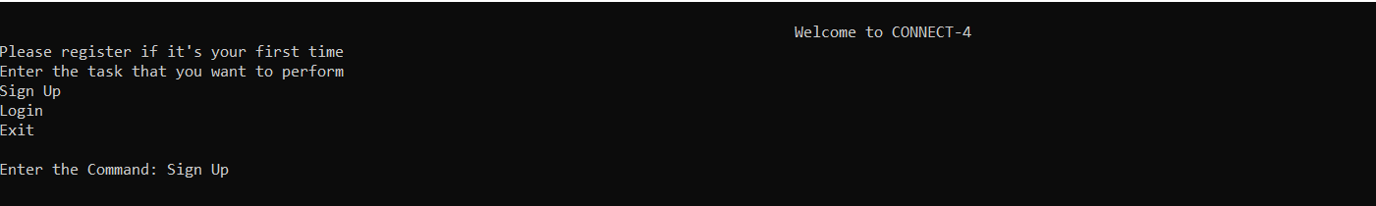
RESULTS/SNAPSHOTS

Fig 5.1: Welcome to CONNECT-4 screen ,command given: Sign Up
Fig 5.2: Sign Up screen

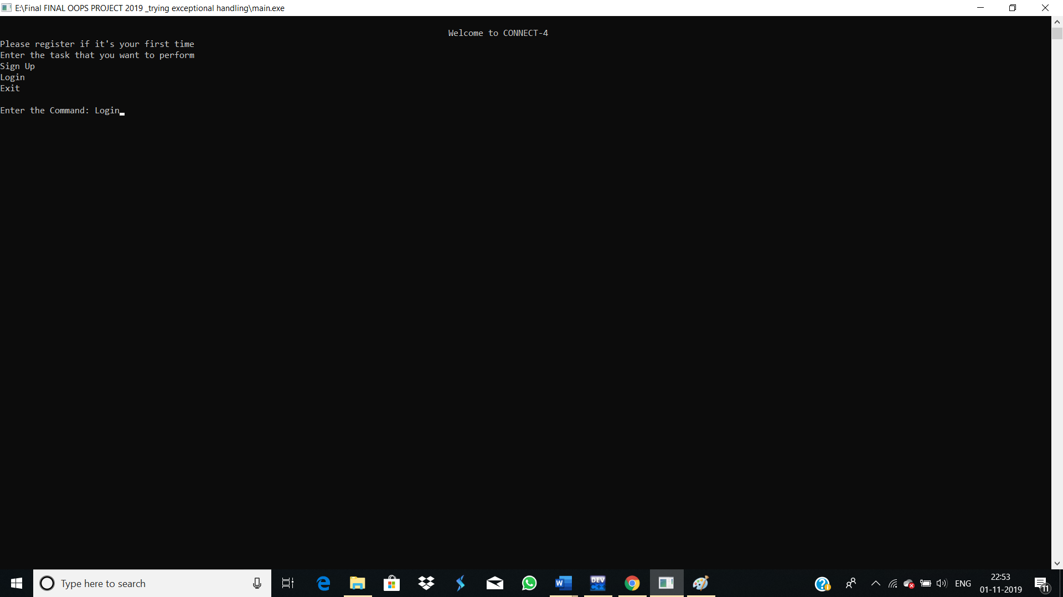
Fig 5.3: Welcome to CONNECT-4 screen, command given: Login

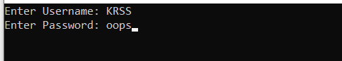
Fig 5.4a: Login screen

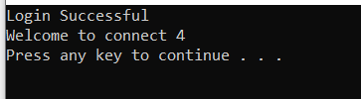
Fig 5.4b: Screen once Login is successful.

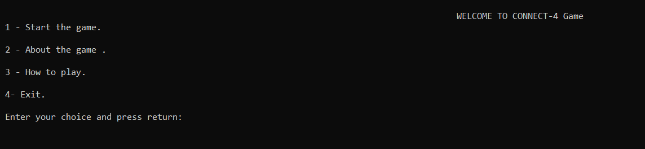
Fig 5.5: Welcome to CONNECT-4 Game screen

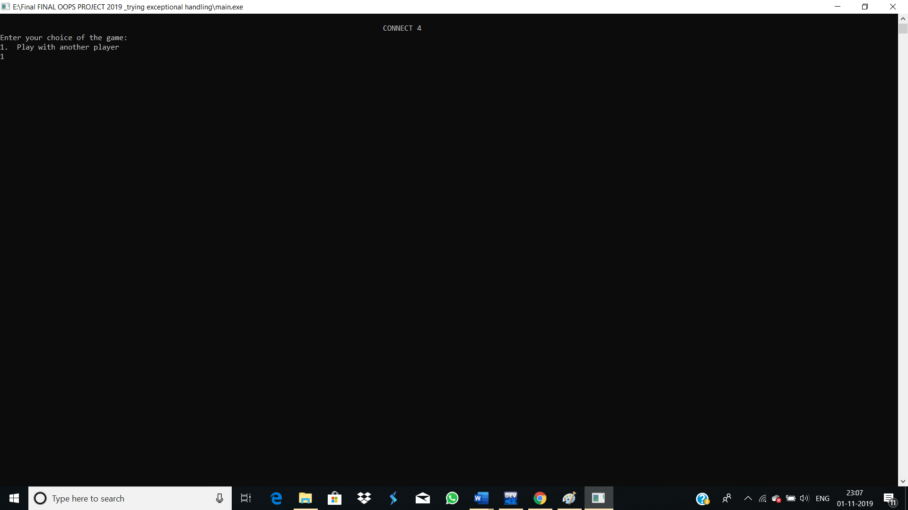
Fig 5.6: If choice is 1 in fig 5.5

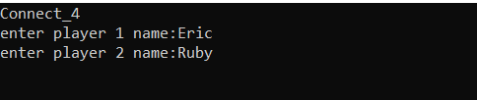
Fig 5.7: Asks for player names
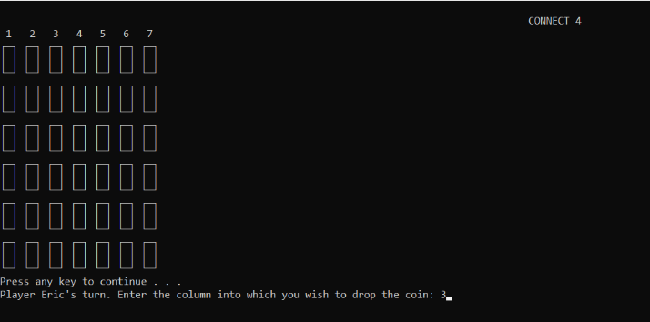
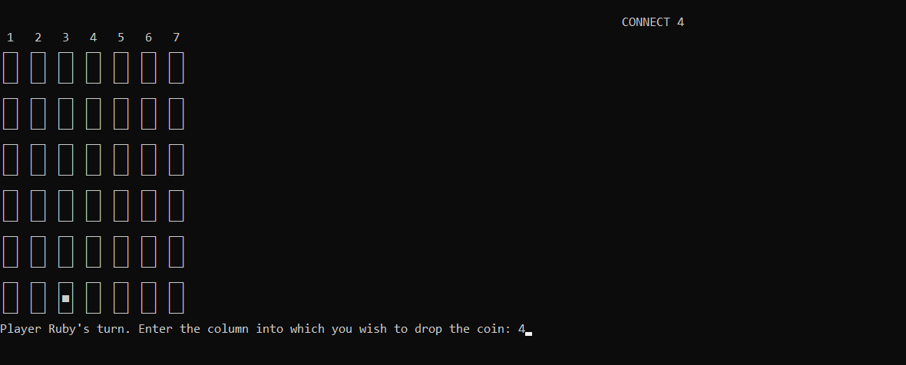
Fig 5.8a: Player 1’s turn
Fig 5.8b: Player 2’s turn

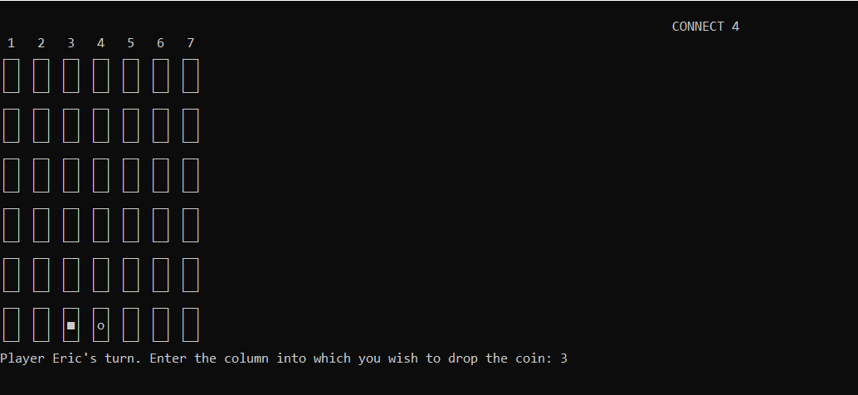
Fig 5.8c: After Player 2’s turn

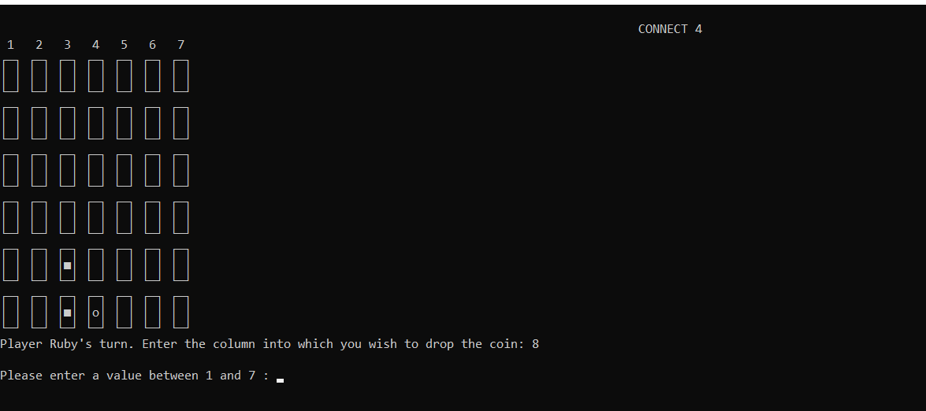
Fig 5.8d: When player enters a number that is not between 1-7

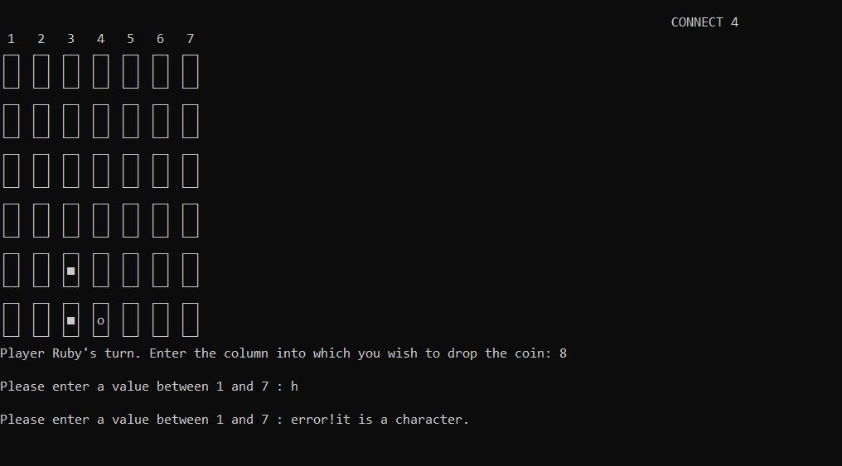
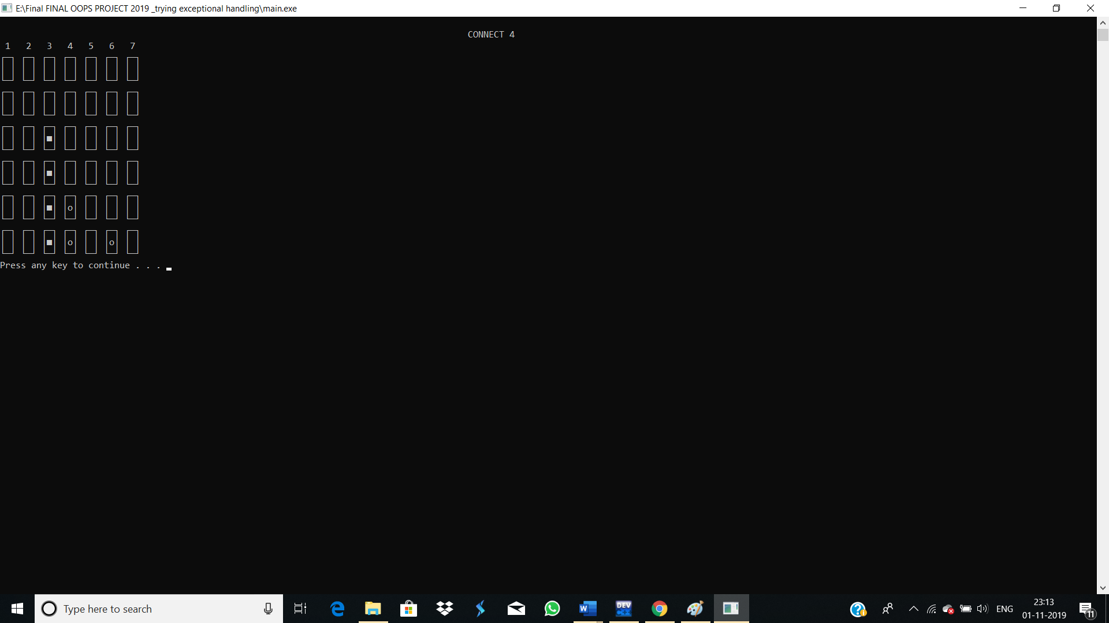
Fig 5.8e: When player enters a character
Fig 5.8f: When a player wins the game.


Fig 5.8g: When a player wins the game, prints the name of the winner.

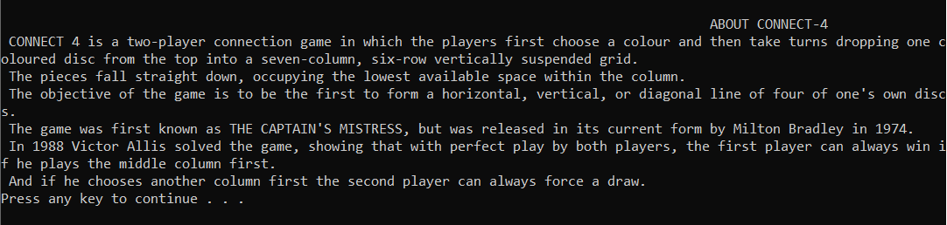
Fig 6: About the game screen

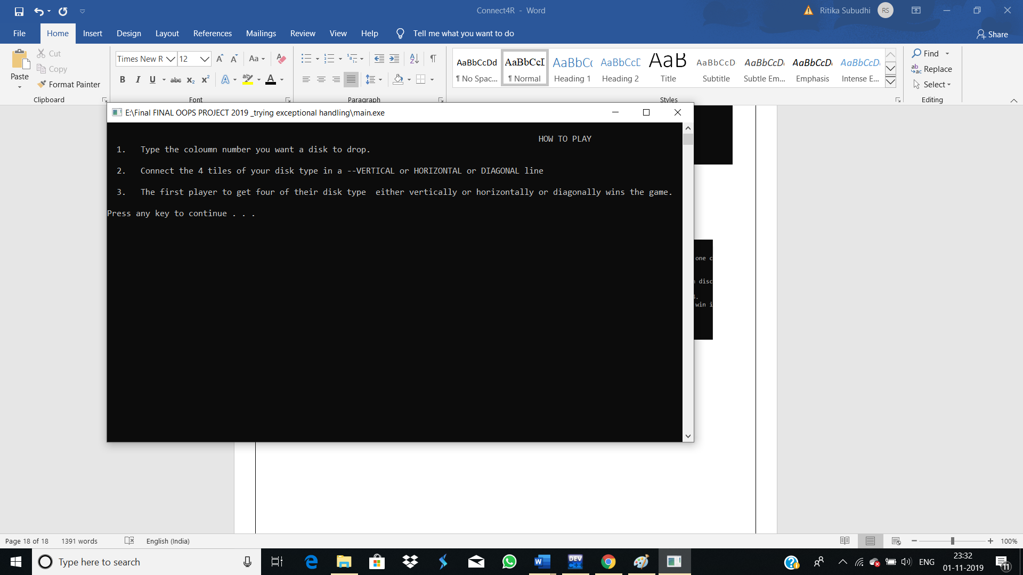
Fig 7: How to play screen

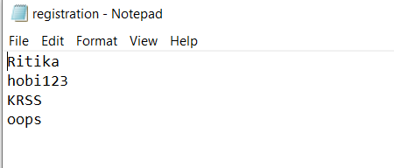

Fig 8: Contents of registration.txt file

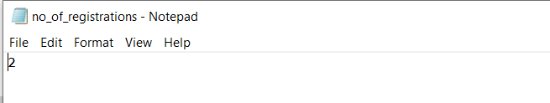
Fig 9: Contents of no_of_registrations.txt file

Chapter 6
CONCLUSION

Hence, the project allows the user to play the connect-4 game using a simple console screen. The entertaining, user friendly game that works on any C++ compiler.
The application provides the users an easy interface which also keeps track of the people who have played the game using its Sign Up and Login feature.

Chapter 7
BIBLIOGRAPHY
- For text books-

[1]. The Complete Reference C++,Herbert Schildt,4th Edition, TMH, 2005
[2]. Mastering C++ by K R Venugopal, Rajkumar and T Ravishankar

