DevOps
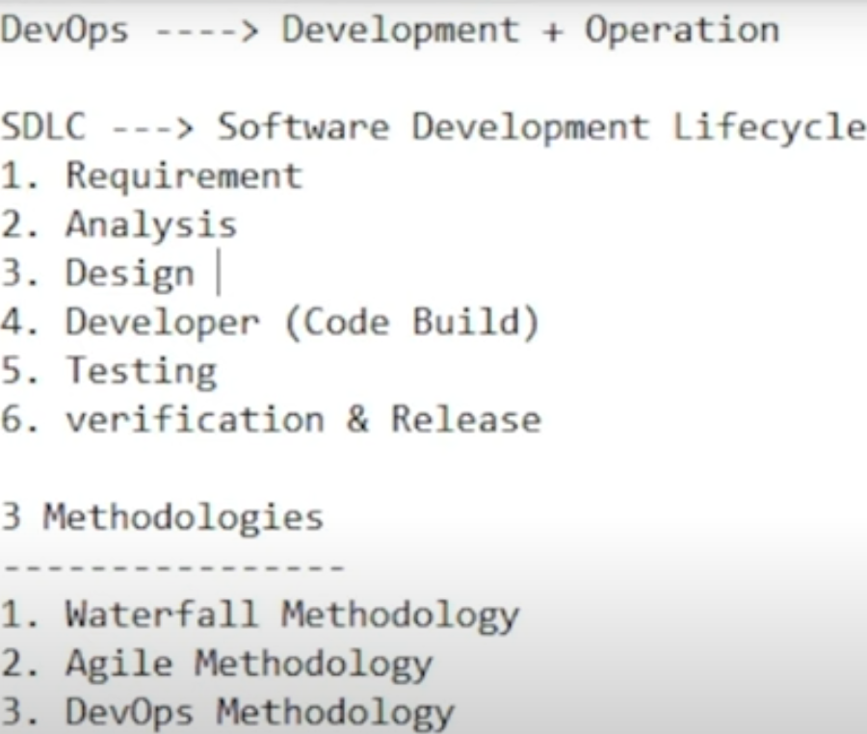
- Waterfall Methodology – Linear Model
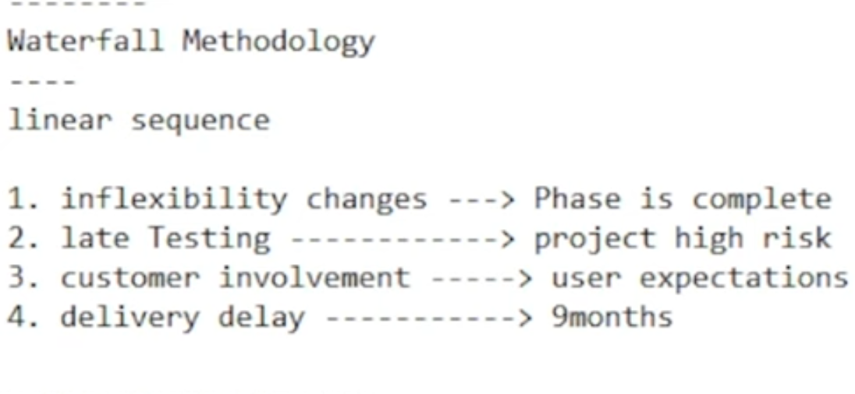
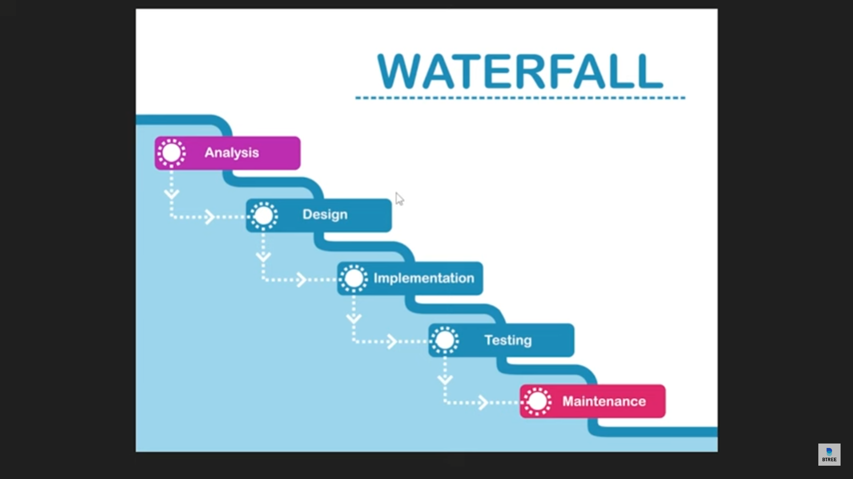

- Agile methodology
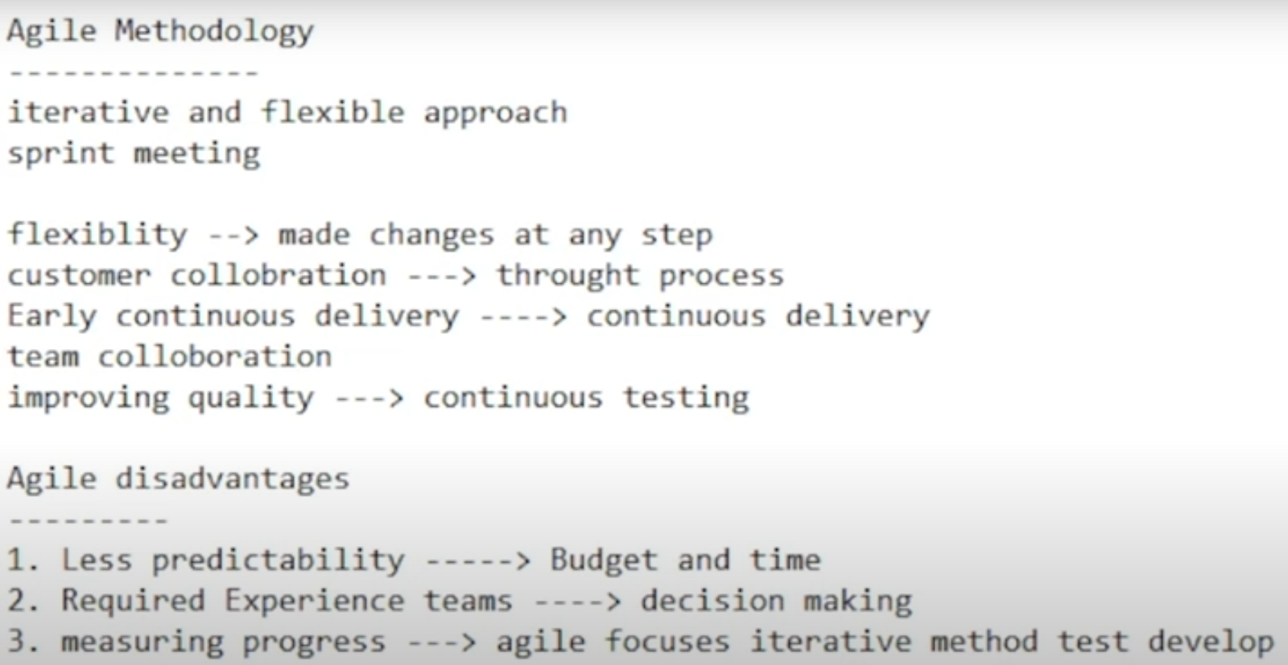
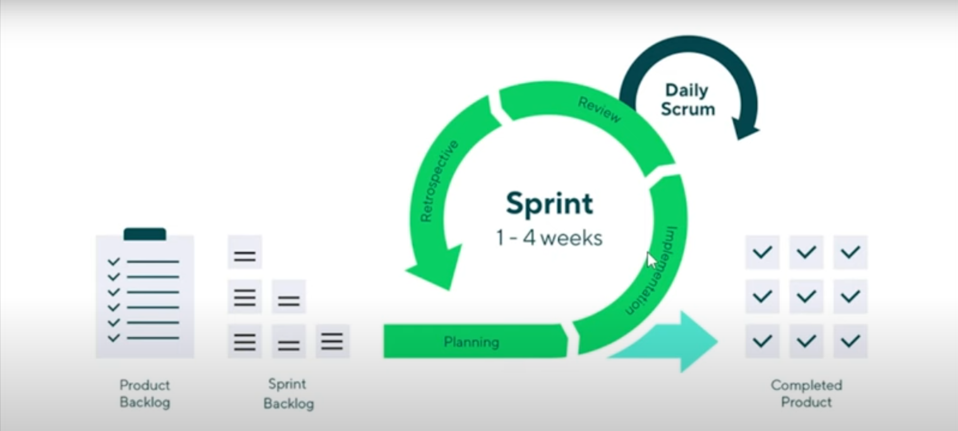
- DevOps Methodology
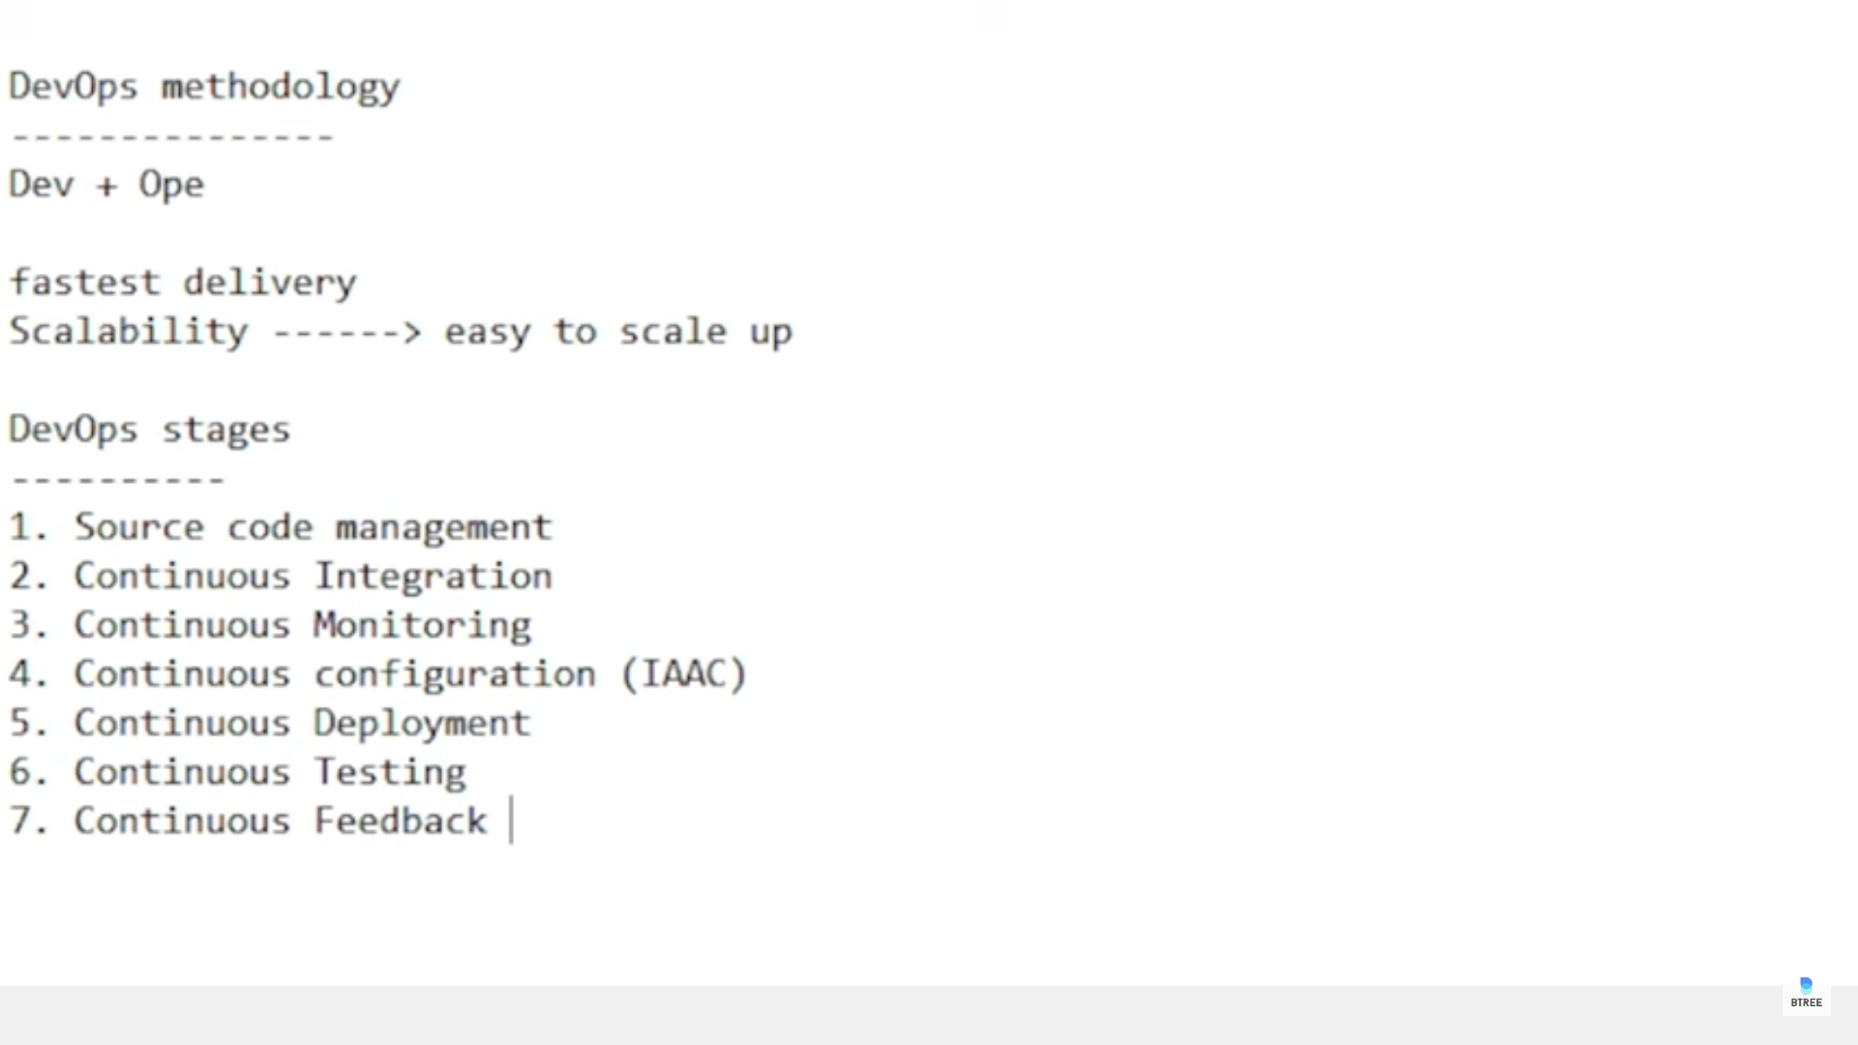
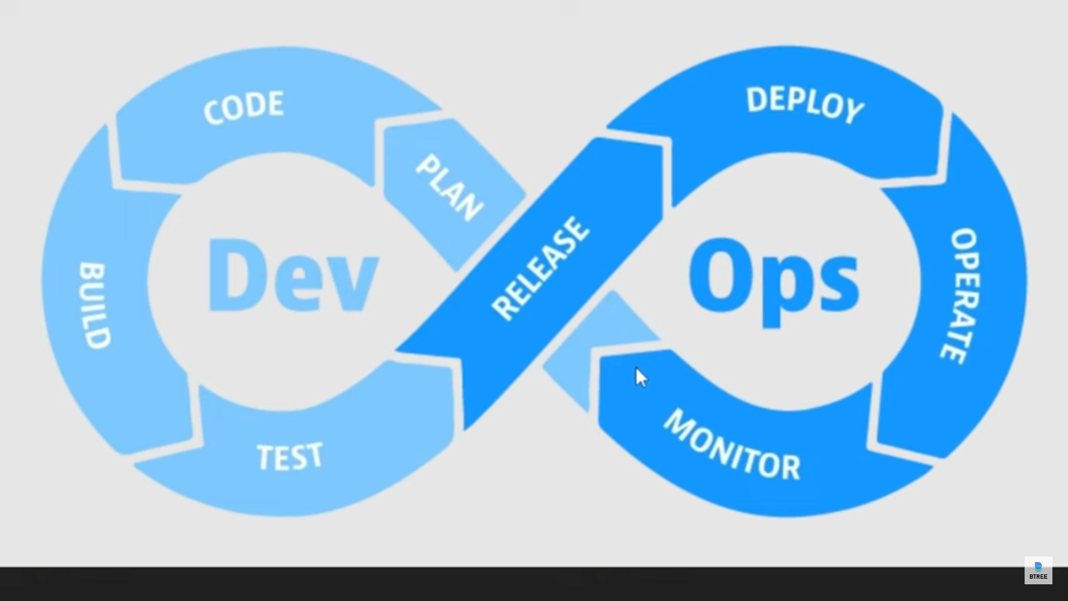
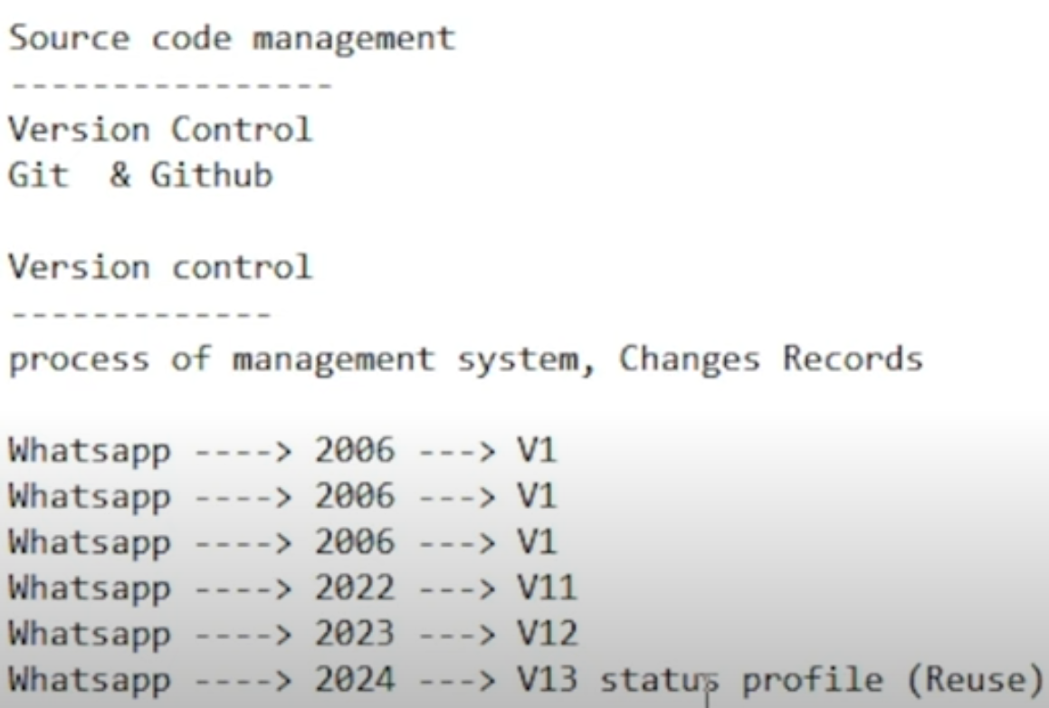

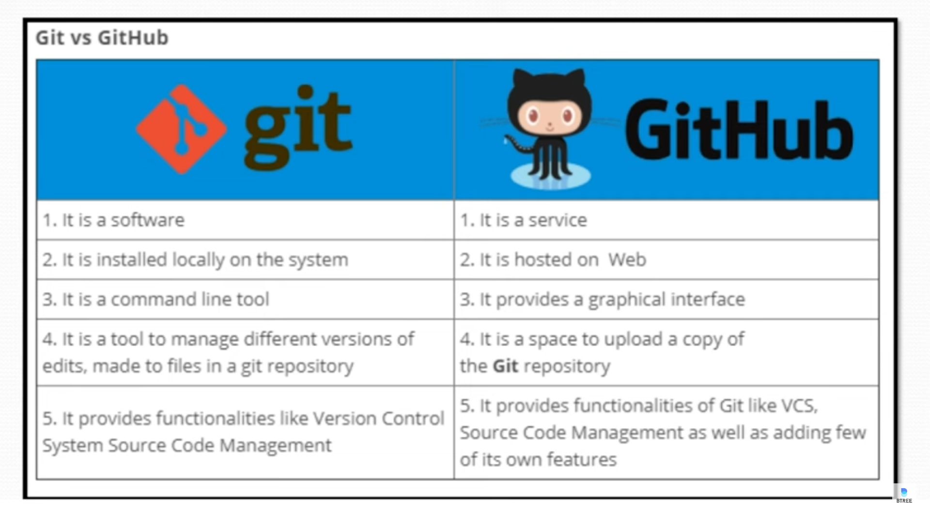
For connecting git and github using cmd
To connect the folder with the repository using vs code
- Select the folder in vs code
- Open the terminal in vs code
- Type the command git clone repo link
- Ex : git clone https://github.com/Harsha463/Bootcamp.git
Commands in Git
- Git config to configure the github
- Git clone to clone the repository
- Git status to know the status of the file
- Git add to send the file to staging area
- Git commit -m to commit the file and changes -m for creating message in local machine
- Git branch to know the current branch
- Git push -u origin main to push the local machine files to github
- For delete the file do the same procedure that has done for commit
- Git pull this is used to retrive the files form github to local Machine
- Git init this is used to initialize the new folder in the github
- Git remote add origin new repo link to change the origin to new repo
- Git branch -M main to change the branch name
- Git branch -a to list out the branches
- Git checkout newbranchname to change the branch
- Git diff branchname difference between cur branch and other branch
- Git merge branchname to merge two branches
- Git branch branchname to create new branch
- When the person doesn’t have the access to main branch the user need to request the pull request to update the main. This can be done in github in pull request tab in that select the two branch
- Git pull origin main this retrive files from the main branch

