**Concepts Of Pipelining**

**Pipelining :**

* Pipelining is when we don't just do one thing at a time, but we do manythings at once.
* It's like having an assembly line for instructions.
* Each step in the line is called a stage.
* We can process multiple instructions at the same time, as long as they are at different stages.
* Pipelining helps us get things done faster, but it doesn't make each instruction faster.
* The more stages we have, the faster we can get things done, as long as we have a lot of instructions to work with.

**Pipelining stages :**

* IF – Instruction Fetch.
* ID – Instruction Decode.
* EX – Execution or Address Calculation.
* Mem – Data Memory Access.
* WB – Write Back.

1. First, during the **IF stage,** the computer grabs the instruction from the instruction cache and moves the program counter ahead.

2. Next, in the **ID stage**, the computer figures out the instruction, reads the source registers from the register file, extends the immediate value, calculates the branch target address, and checks if the branch should be taken.

3. Then, in the **EX stage**, the computer calculates the memory access addresses and does math or logic operations on two register values or a register and an immediate value.

4. After that, in the **MEM stag**e, the computer either loads a value from the data cache or stores a value into it.

5. Lastly, during the **WB stage,** the computer updates the register file with the result of an operation or a load.

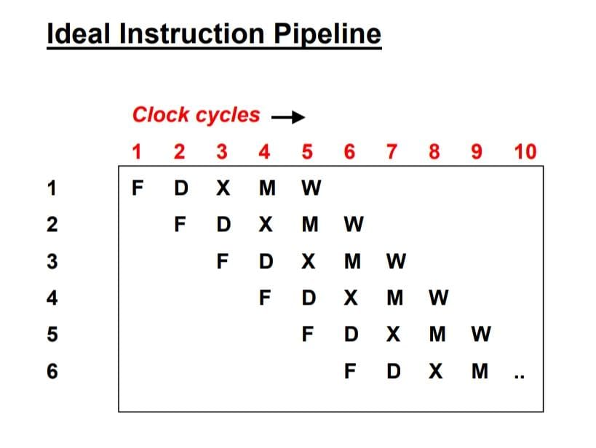

**Pipeline Conflicts :**

The pipeline is subject to certain factors that cause it to deviate from normal operation.

* **Timing Variations** :
* Different stages have different time.
* In particular, In the area of instruction processing where various instructions have different operand requirements and therefore need to be processed at different time, this issues arises.
* **Data hazards** :
* If multiple instruction are partially executed and reference the same data , problems can arise.
* It is crucial to ensure that the next instruction doesn’t try to access data before the current one avoid incorrect results.
* **Branching**  :
* Knowing the next instruction is essential for fetching and executing it.
* With the conditional branches , the next instruction may not be known until the current one is processed.
* **Interrupts** :
* Unwanted instructions can be introduced into the instruction stream by the interrupts , affecting the instruction execution.
* **Data Dependency** :
* When an instruction relies on the result of a previous one that isn’t available yet.

**Advantages :**

* Reduces the processor’s cycle time .
* Increases system throughput .
* Enhances system reliability.

**Disadvantages :**

* Complex and costly design of pipelined processors.
* Higher instruction latency.

**Pipelining hazards :**

A hazard is when something happens that makes the pipeline stop.

**Structural hazards :**

When hardware resources required by one instruction are unavailable due to another instruction in the pipeline using them, structural hazards occur**.**

**Typical reasons include:**

**Resource conflicts**: These happen when two or more instructions try to use the same hardware resource at the same time, like a memory module, bus, or functional unit (like the ALU, or arithmetic logic unit).

**Mitigation techniques:**

**Resource duplication**: It is the process of adding more hardware components to enable the simultaneous usage of a resource by several instructions.

**Pipeline Interlocks**: Pipeline stages are introduced to detect and resolve conflicts dynamically. This can be done by inserting stall cycles or using bypass paths to avoid resource contention.

**Data Hazards :**

Data hazards occur when there are dependencies between instructions, especially when subsequent instructions rely on the results of earlier ones. There are three main types of data hazards:

**Read After Write (RAW)**: This happens when a later instruction tries to read data before a prior instruction has finished writing it.

**Write After Read (WAR):** This occurs when a later instruction tries to write data before a prior instruction has finished reading it.

**Write After Write (WAW):** This happens when two instructions try to write to the same location in a register or memory without any intervening read.

**Mitigation techniques :**

**Data Forwarding (Bypassing):** This involves transmitting data directly from the output of one pipeline stage to the input of another to prevent stalls caused by data hazards.

**Register Renaming:** This involves reassigning logical registers to physical registers in order to break dependencies and enable out-of-order execution.

**Control Hazards :**

* Control hazards happen when the program's flow changes, like with branches or jumps.
* They can mess up the order of instructions.
* One common issue is when the processor has to wait for the branch target address to be calculated during a branch instruction.

**Mitigation technique :**

* **Branch Prediction:** Guessing if a branch will be taken or not before it's confirmed, so the pipeline can keep going without stopping.
* **Speculative Execution:** Running instructions based on branch predictions to lessen the effect of wrong guesses on the pipeline's speed.