**Final Project - WorkForceManagement**

Once user enters into WorkForceManagement site, Login Page will appear.

User needs to enter the username and password to log in.

Once user clicks the login button, the user will be authenticated in the backend if a user exists token will be returned and authorized.

**API Response:**

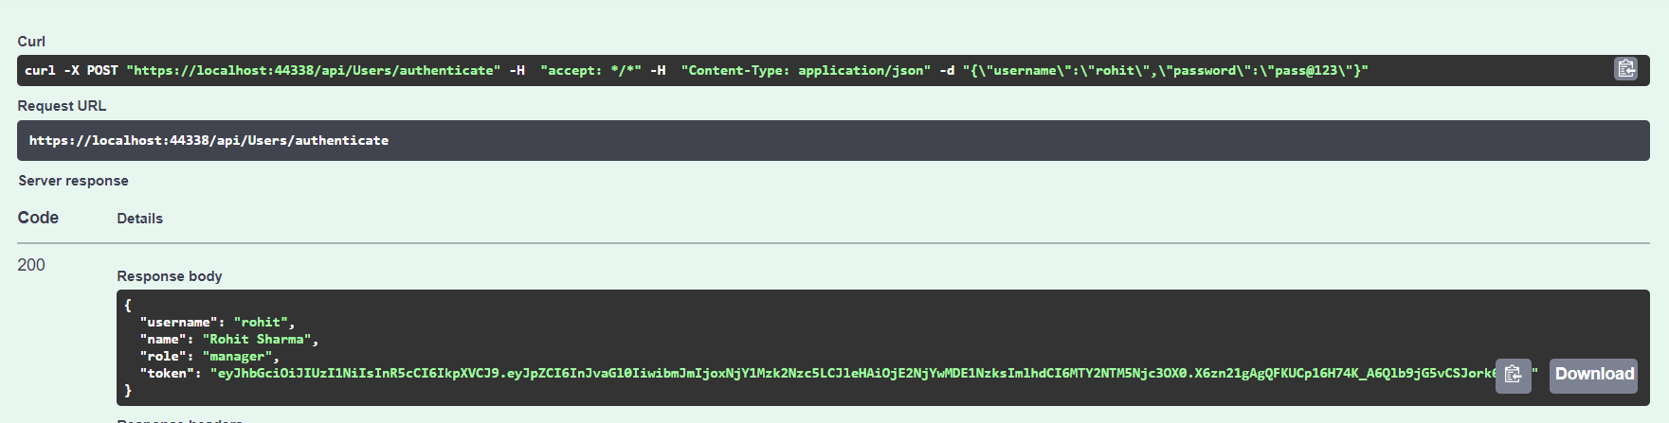

**UI:**

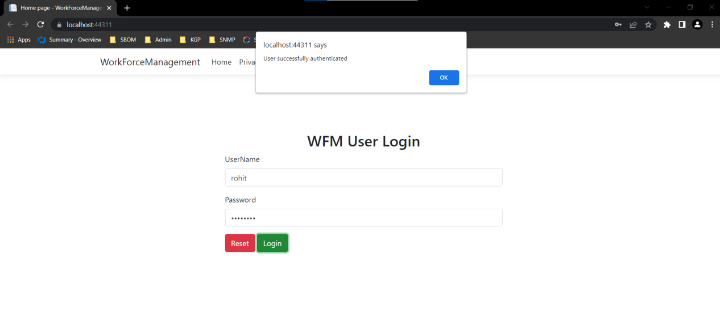

Based on user, Page will be redirected.

If user is manager, it will be redirected to ManagerHomePage.

Employee whose lockstatus is ‘not_requested’ will be shown.

**API Response:**

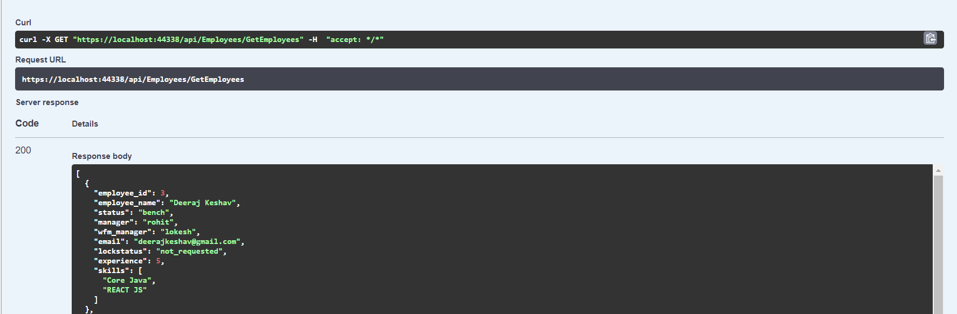

**UI:**

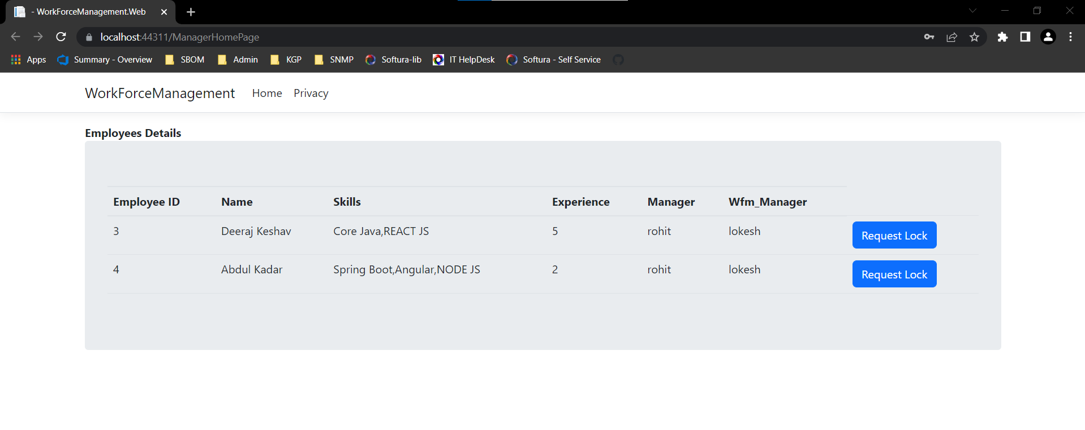

If the user wants particular employee for the project. Select RequestLock button to send request to that employee.

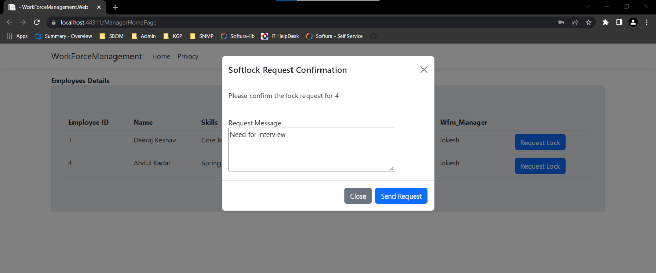

Once click Send Request, Details will be saved in Softlock table and update lockstatus for corresponding employee as ‘request_waiting’.

**DB:**

Softlock:



Employee:

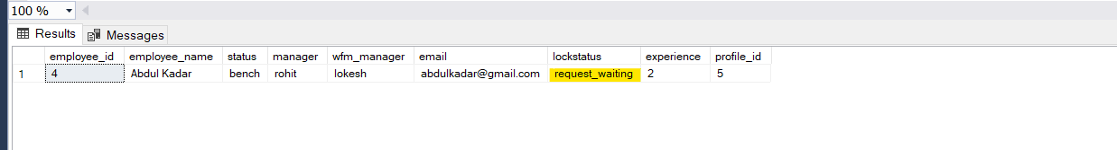

If User is Wfm-member, it will be redirected to EmployeeHomePage.

ManagerStatus of Softlock details which are ‘awaiting_confirmation’ will be shown.

**API Response:**

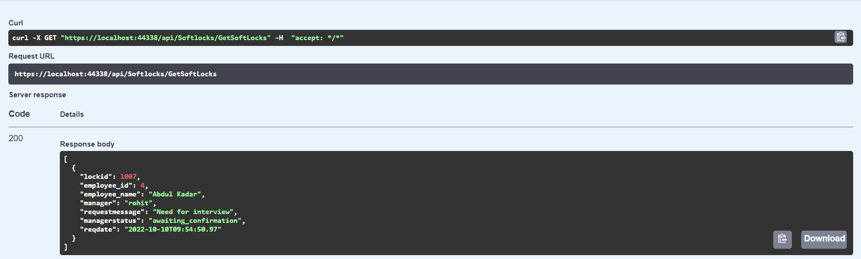

**UI:**

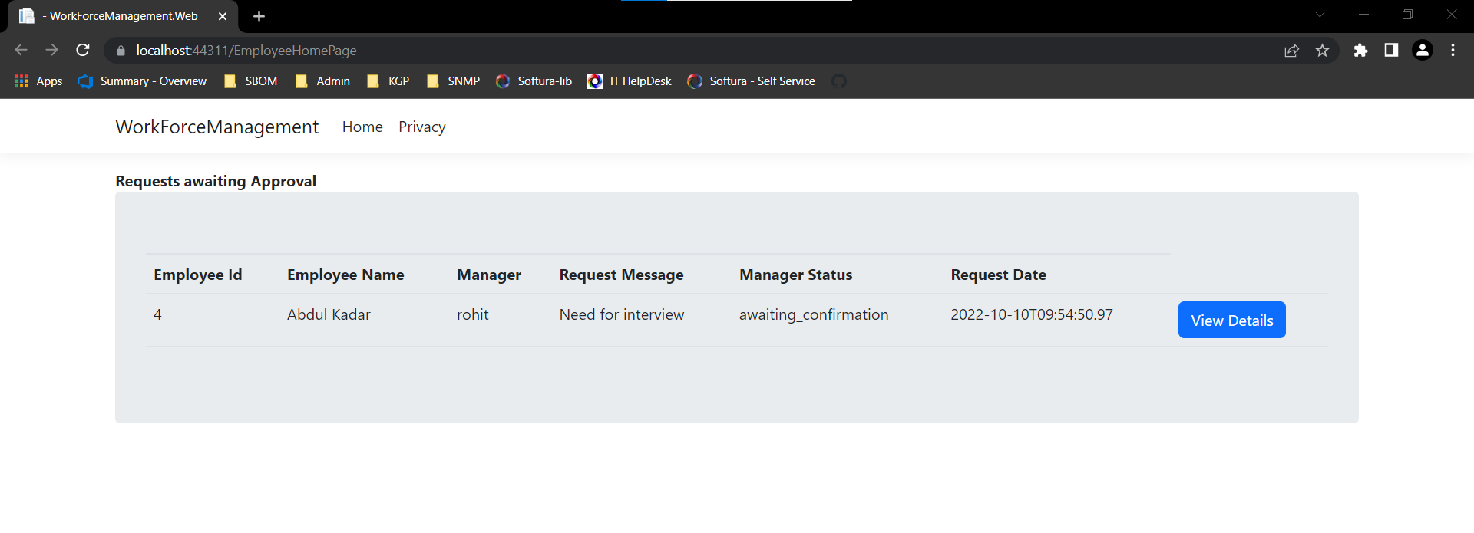

User have to accept or reject the request from manager.

User needs to click view details button and choose the status.

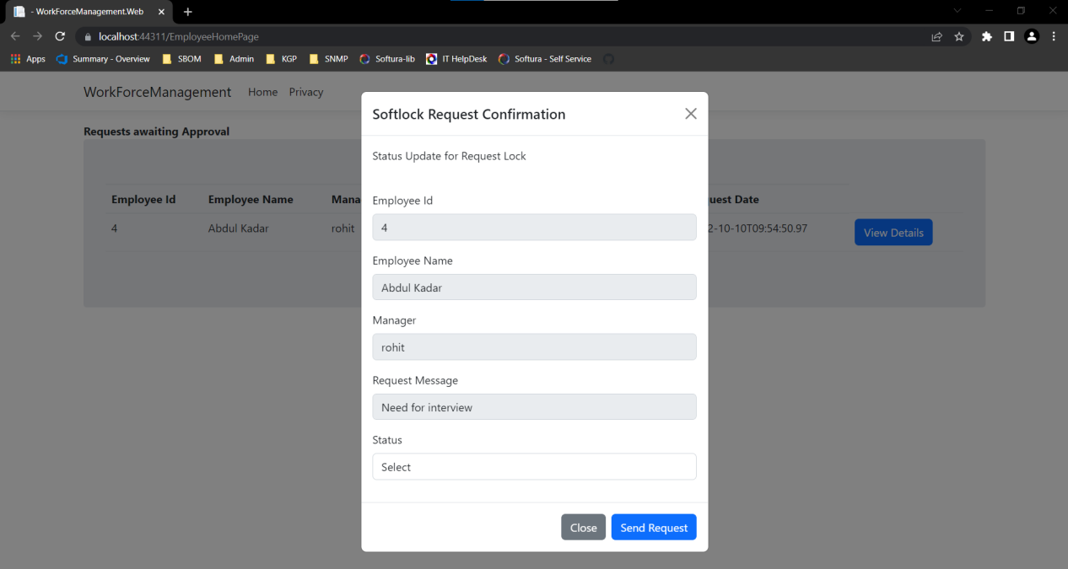

Once user has chosen the status, status will be updated in softlock table as either ‘Accepted’ or ‘Rejected’ and for the corresponding employee in employee table as either ‘locked’ or ‘not_requested’

**DB:**

