Implemetation of Simple Calculator using Arduino uno
Project Report submitted by
B.MAHITHA
Y.PRASANNA
J.NAGA SWATHI
R170758
R170962
R170765
under the Guidance
of
N.MOHAN RAJU
Assistant Professor,
in the partial fulfillment for the award of the degree of
BACHELOR OF TECHNOLOGY
in
ELECTRONICS AND COMMMUNICATION ENGINEERING


RAGIV GANDHI UNIVERSITY OF KNOWLEDGE AND
TECHNOLOGIES
RAGIV KNOWLEDGE VALLEY,
KADAPA, A.P -516330.
2021-2022.
DEPT. OF ECE i

CERTIFICATE

This is to certify that the work which is being presented in the B.Tech Mini
Project Report on “ IMPLEMENTATION OF SIMPLE CALCULATOR USING ARDUINO UNO” submitted by
B.MAHITHA,Y.PRASANNA,J.NAGA SWATHI, bearing ID No: R170758,R170962,R170765 to the
Rajiv Gandhi University of Knowledge and Tecnologies (RGUKT),
RK VALLEY in the fulfilment of the requirements for award of the
Bachelor of Technology in Electronics and Communication Engineering.

Results emboided in this have not been submitted to any other
university/institution for award of degree.

Head of the Department, Dept of ECE, Project Guide, Mr.P Janardhan Reddy , N.MOHANRAJU
Assistant professor . Assistant professor.

ii

DECLARATION BY STUDENT
We certify that,The work made in this report has been done by me under the guidance of
my supervisor. We have confirmed to the norms and guidelines given in the
ethical code of conduct of the institute. Whenever we have used materials (data, theoritical analysis, figures and text) from other sources, we have given due credit to them by siting them in the text of the report and giving their details in the references. Furher, we have taken permission from the copyright owners of the sources, whenever necessary.

Project submitted by,
B.MAHITHA.
Y.PRASANNA.
J.NAGASWATHI.

iii

ACKNOWLEDMENT
It is a great pleasure and privilege to express my profound sense of gratitude
and deep regards to N.MOHAN RAJU, M Tech, Assistant Professor, Department of Electronics and communicaton Engineering, Rajiv Gandhi University of knowledge Technologies, R.K.Valley for his valuable guidance,motivation, support and giving me the opppurtunity to work under his guidance.
We would also like to thank my Electronics and Communication Engineering
Faculty who supported me in our academics.
We thank Mr.P Janrdhan Reddy, Head of the Electronics and Engineering
Department, RGUKT, R.K.Valley for permitting to do project and Encouraged
us in every effort.
Finally, We express my thanks to my parents and my friends for their timely
suggestions and encouragement.

iv

Project overview :
In this project, we will take input from the user using a keypad and perform the operation using Arduino UNO and display the result on an LCD display.
Arduino UNO – It is used for performing calculation-related operations, other user-related operations like interfacing with keypad module and LCD module. 16×2 LCD module- It is used to display user-related messages such as input digits and selected arithmetical operations and calculatedresults. 4×4 Keypad- It is used for user input. From this module, the user can enter the numerical values and arithmetic operations.

v
TABLE OF CONTENTS:
TITLE PAGE NO

Part I

1.TITLE PAGE i

2.CERTIFICATE ii

3.DECLARATION iii

4.ACKNOWLEDGEMENT iv

5.PROJECT OVERVIEW v

Part II

6.Abstract 1

7.Introduction 2

8.Components 3

9.Components Description
1.Arduino uno 3-4
2.16x2 LCD display 5-6
3.Keypad 7

10.Block diagram 8

11.Circuit Design 9-10

12.Circuit Images 11-16

13.Advantages and Disadvantages 17

14.Features and Future scope 18

15.Conclusion 19

vi

ABSTRACT :

Programming is always fun and Arduino is a wonderful platform if you are just getting started with Embedded programming. In this tutorial we will build our own calculator with Arduino. The values can be sent in through a keypad (4×4 keypad) and result can be viewed on a LCD screen (16×2 Dot-matrix). This calculator could perform simple operations like Addition, Subtraction, Multiplication and Division with whole numbers. But once you understand the concept you can implement even scientific functions with Arduino’s built in functions.

At the end of this project you will know how to use a 16x2 LCD and Keypad with Arduino and also how easy it is to program for them using the readily available libraries. You will also understand how to program your Arduino for accomplishing a particular task.

1

INTRODUCTION :

A Calculator is a device that is used to perform simple arithmetic operations to complex mathematical calculations. The rise of calculators can be seen from devices like Abacus to credit card sized complex electronic solid state devices in the modern day usage.
Apart from small calculators, which can be used to perform simple arithmetic calculations, calculators also come in complex scientific outlook that can perform various mathematical and statistical operations like trigonometry, algebra, calculus, etc. But such complex scientific calculators can be very costly.
In this project, we will design a simple arithmetic calculator using Arduino UNO, a 16 x 2 LCD display and 4 x 4 Matrix Keypad.

2

COMPONENTS :

1.Arduino UNO

2.16 x 2 LCD Display

3.4 x 4 Matrix Keypad Module or 16 push bottons

4.Connecting Wires

COMPONENTS EXPLAINATION :
ARDUINO UNO
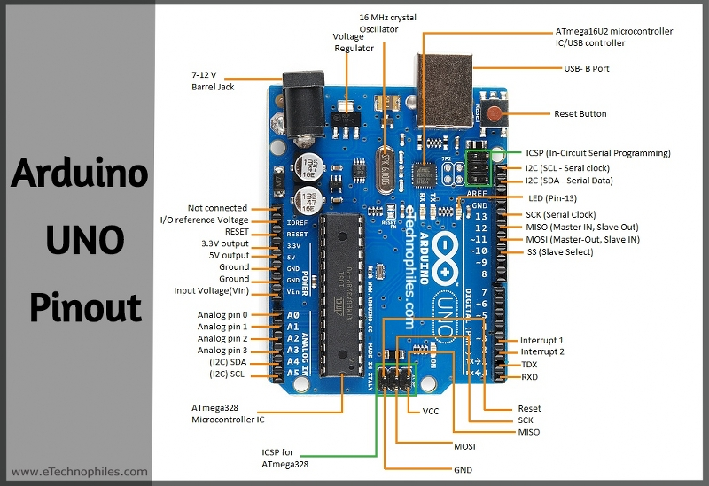
fig1.Arduino uno

3
- Arduino UNO is an open-source development board that we have used in this project.

- It works on the ATMega328P microcontroller developed by Atmel.

- It has an 8-bit RISC based processing core and up to 32 KB of flash memory

- It has 14 digital input/output pins from D0 – D13 with a resolution of 8 bits, these pins can be used for taking any digital input or can be used as output pins for controlling peripherals.

- In the 14 digital pins, there are 6 PWM pins.

- It is suggested that you do not use the D0 and D1 pins of Arduino UNO for digital read or write purposes because they have an extra functionality of UART communication.

- Arduino UNO has 6 analog input/output pins from A0-A5, which can be used to read analog values.

- Analog pins have 10 bits of ADC (Analog to Digital convertor) resolution ranging values from 0 – 1023.

- Arduino UNO has one hardware UART peripheral (D0, D1), one I2C peripheral, and one SPI peripheral.

- We can use the power supply from 7 to 12 volts to power the Arduino UNO, but it is suggested to use a voltage supply of less than or equal to 9 volts but not below 5 volts.

We will use the Arduino IDE for writing and uploading the code on Arduino UNO. It is an open-source software developed by Arduino.

4

FEATURES OF ARDUINO UNO :

Microcontroller | ATmega328P
Operating Voltage | 5V
Input Voltage (recommended) | 7-12V
Input Voltage (limit) | 6-20V
Digital I/O Pins | 14 (of which 6 provide PWM output)
PWM Pins | 6( Pin 3, 5, 6, 9, 10, and 11)
Analog Input Pins | 6
Communication protocol | UART x 1, SPI x 1, I2C x 1
DC Current per I/O Pin | 20 mA
DC Current for 3.3V Pin | 50 mA
ICSP Header | 2
Flash Memory | 32 KB (ATmega328P)  of which 0.5 KB used by the bootloader
SRAM | 2 KB (ATmega328P)
EEPROM | 1 KB (ATmega328P)
Clock Speed | 16 MHz
LED_BUILTIN | 13
Power Sources | Power Jack, USB port, Vin pin
Length | 68.6 mm
Width | 53.4 mm
Weight | 25mg
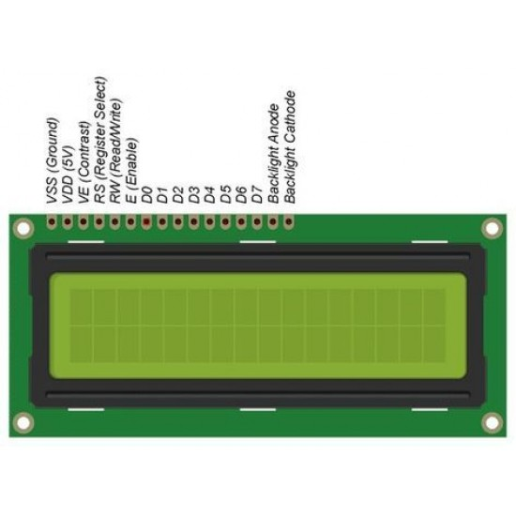
2.16x2 LCD DISPLAY
figure 2: lcd display module pin diagram

- LCD stands for Liquid Crystal Display, and this display is made using liquid crystal technology.

- In this project, we have a 16×2 LCD display which means we can display a max of 32 ASCII characters on this at a time.

5
- The LCD module has 16 pins but we will not use all the pins in this project.

- The LCD module can be used in two different modes, the first is 4-bit mode and the second is 8-bit mode.

- We will use the 4-bit mode in this project, therefore, we have to connect only 4 data pins of the LCD module.

- The major difference between 8-bit mode and 4-bit mode is, an ASCII character is 8 bit long so when we use 8-bit mode, LCD will process the data in single instruction but in 4- bit mode, microcontroller will send 2 chunks of 4 bits and the LCD will process that in two instructions.

- There are two registers in the LCD module: The Data register and the Command register.

- When the RS(Register Select) pin is set to logic high, the data register mode is selected, and when it is set to logic low, the command register mode is selected.

- The RS pin will be set to logic high to display the data on the LCD.
The operating power supply will be 5 volts for the LCD module.

6

3.4×4 Keypad
- It is a membrane-based push keypad.
- We have used a 4×4 keyboard which means it has 4 rows and 4 columns.
- It has 0-9 numbers and basic arithmetic operations like addition, subtraction, multiplication, and division.
- It has four pins for each row and 4 pins for each column.
- The switch between a column and a row trace is closed, when a button is pressed, which completes the circuit and allows current to pass between
- column pin and a row pin.
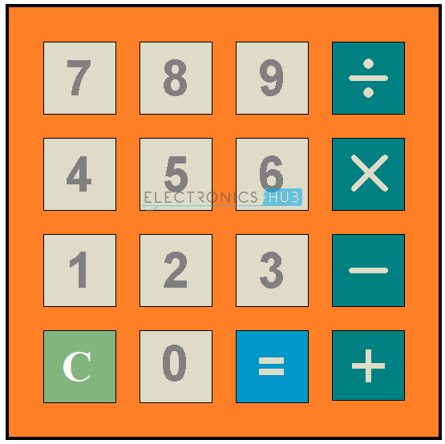
figure 3 : keypad

7

BLOCK DIAGRAM :

POWER SUPPLY

ARDIUNO
NUMERIC
KEYPAD
DISPLAY

figure 4: block diagram of simple calculator

8

CIRCIUT DESIGN :
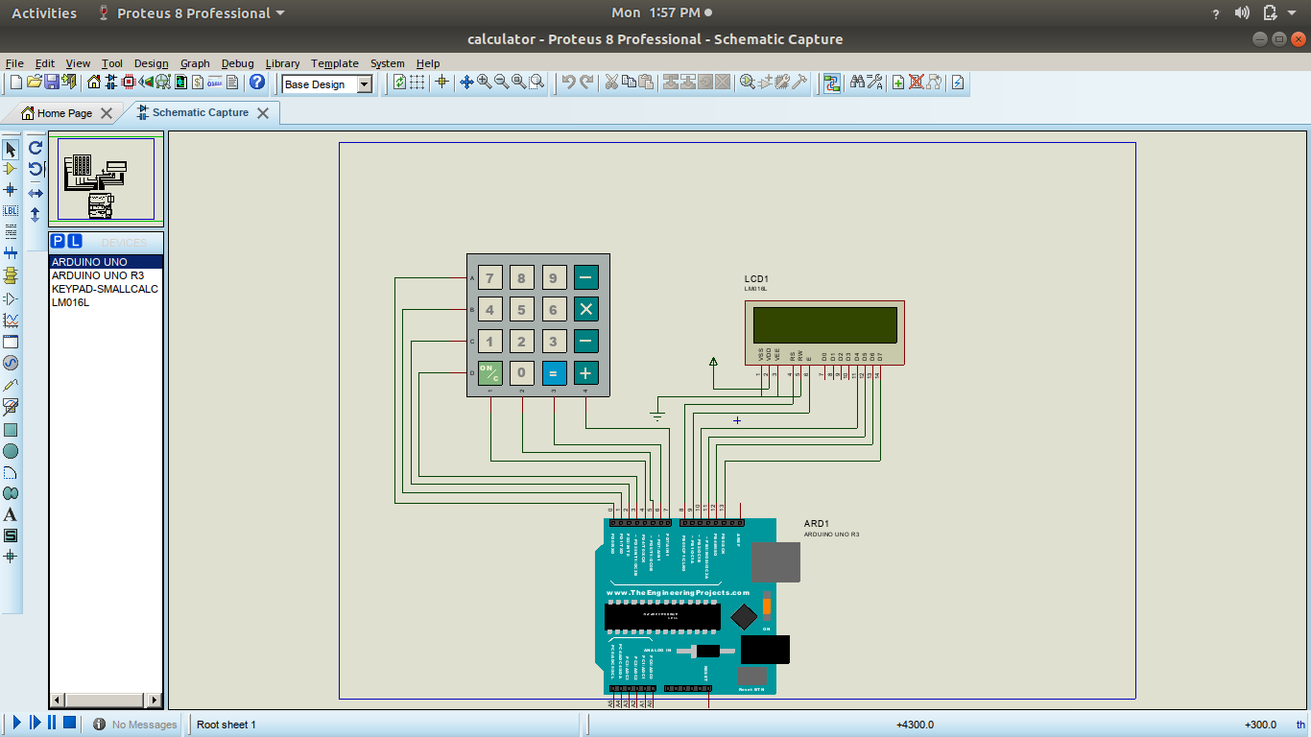
figure5:Circuit design

9
The complete circuit diagram of this Arduino Calculator Project is given above. The +5V and ground connection shown in the circuit diagram can be obtained from the 5V and ground pin of the Arduino.
We are operating the LCD in 4-bit mode with Arduino so only the last four data bits of the LCD is connected to Arduino. The Keyboard will have 8 output pins which have to be connected from pin 0 to pin 7 as shown above.
Arduino Name: | Pin Connected to:
D0 | 1st pin of the keyboard
D1 | 2nd pin of the keyboard
D2 | 3rd pin of the keyboard
D3 | 4th pin of the keyboard
D4 | 5th pin of the keyboard
D5 | 6th pin of the keyboard
D6 | 7th pin of the keyboard
D7 | 8th pin of the keyboard
D8 | Register select pin of LCD (pin 4)
D9 | Enable pin of LCD (pin 6)
D10 | Data pin 4 (pin 11)
D11 | Data pin 4 (pin 11)
D12 | Data pin 4 (pin 11)
D13 | Data pin 4 (pin 11)
+5V | Connected to Vdd pin of LCD (pin 2)
Ground | Connected to Vss,Vee and RW pin of LCD (pin 1,3 and 5)
Table2: pindiagram pins explanation
Some Arduino boards might show an error while uploading program if there are anything connected to pin 0 and pin1, so if you experience any just remove the keypad while uploading the program.

10

Simulation of Arduino Calculator:
We can simulating the project using Proteus software. Proteus does not have an Arduino component on it’s own, but can be easily downloaded and added to its library. Once you have the Arduino component on Proteus, just add Alphanumeric LCD and Keypad to make the connection as shown in the circuit diagram.
Then download the hex file from here and add it to the Arduino by double clicking on board in Proteus and point the “program file” to this downloaded hex file.

Working of Arduino Calculator:
Make the connections as per circuit diagram and upload the code below. If it shows error make sure you have added the library as per the instruction given above. You can also try the simulation to check if the problem is with your hardware. If everything is done as it’s supposed to be, then your hardware will look something like this below with the LCD displaying this.
Since the keypad used here does not have proper markings on it I have assumed the Alphabets to be operators as listed below
Character Keypad | Assumed to be
“A” | Addition (+)
“B” | Subtraction (-)
“C” | Multiplication (*)
“D” | Division (/)
“*” | Clear (C)
“#” | Equals (=)

11
OUTPUT CIRCUIT IMAGES :
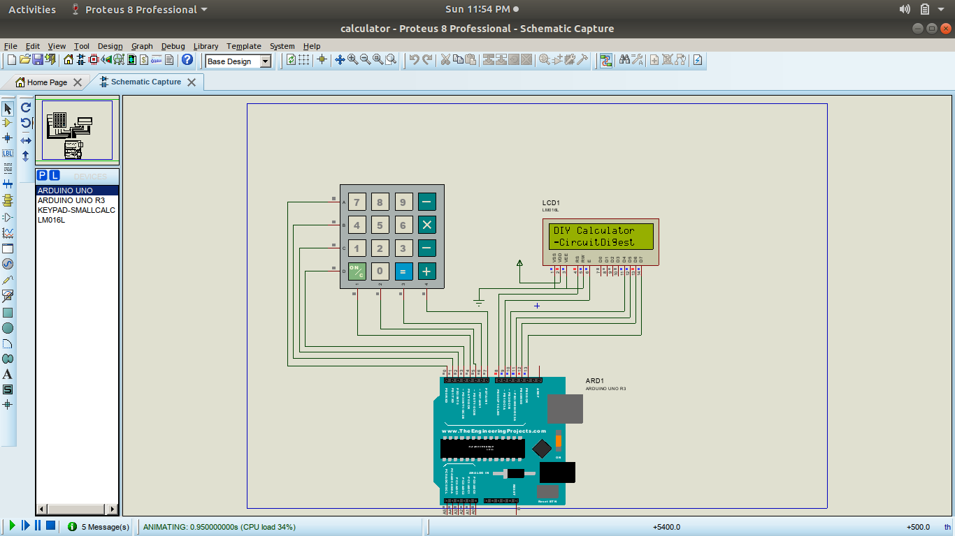
figure5:output for display the letters in lcd

12
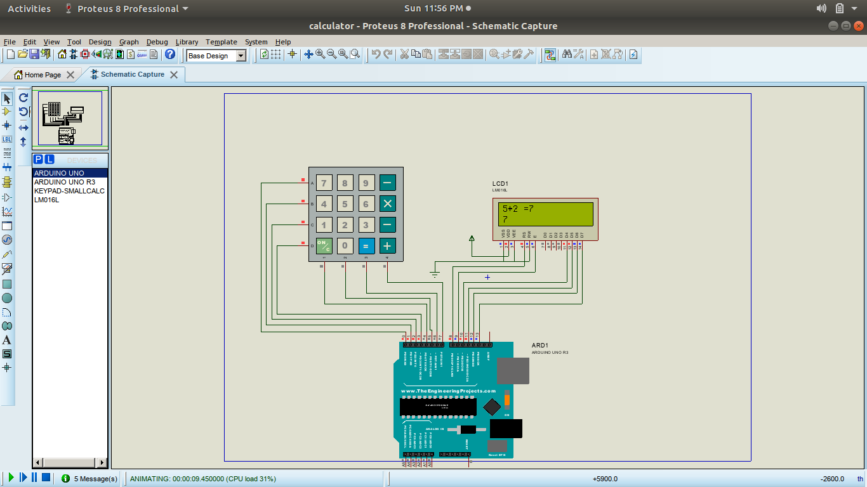
Figure6:Output for addition

Here we take input numbers as 5 and 2.
Addition operation performed.
Then the result will be 7.

13

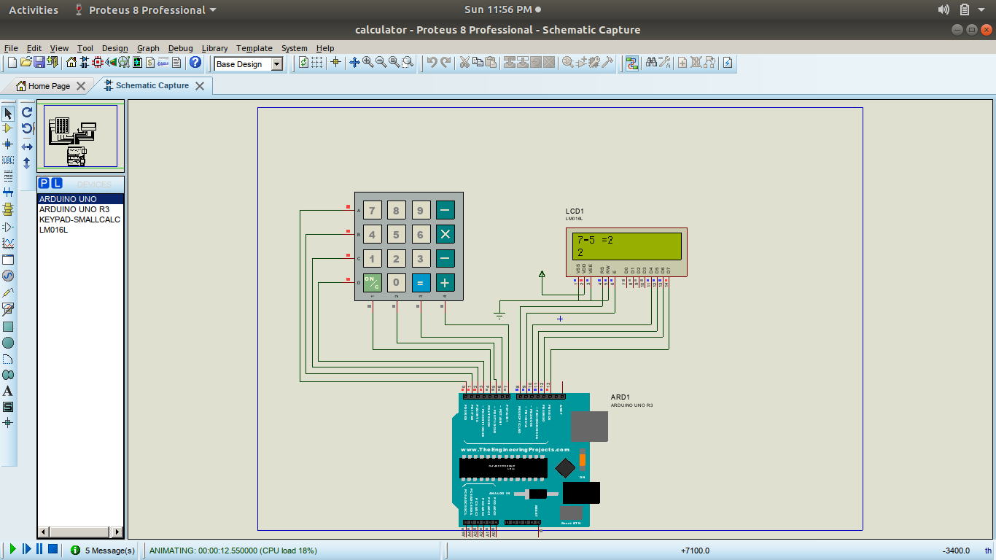
figure7:output for substraction

Here we take input numbers as 7 and 5.
Subtraction operation performed.
Then the result will be 2.

14

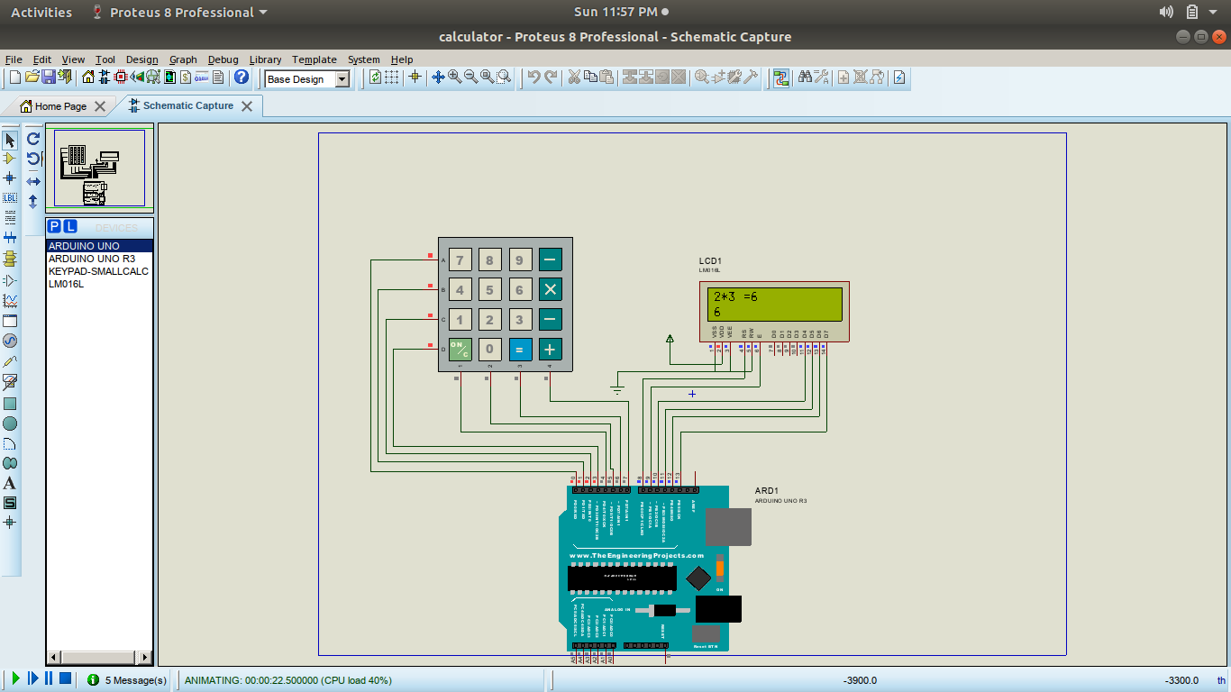
figure8:output for multiplication

Here we take input numbers as 2 and 3.
Multiplication operation performed.
Then the result will be 6.

15

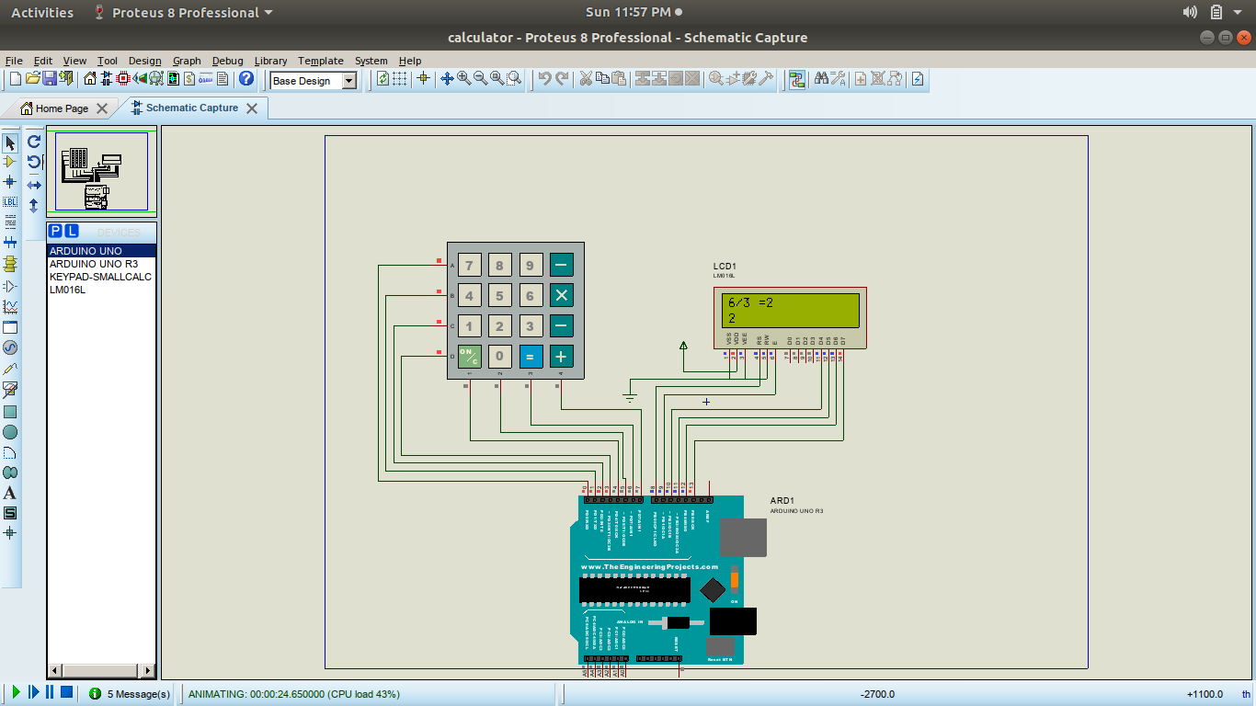
figure8:output for division

Here we take input numbers as 6 and 3.
Division operation performed.
Then the result will be 2.

16
ADVANTAGES :
- A simple arithmetic calculator is implemented in this project using Arduino UNO, matrix keypad and LCD.
- Can be extended to perform complex calculations, but the logic must be carefully designed in order to solve those calculations. This may even result in increased number of switches.

DISADVANTAGES :
- Dependency:Even though calculators can do the basic operations instantly, students should not use it all the time. ...
- Cheating:The availability of graphic calculators has made it easier for students to cheat during their tests. ...
- High cost.

17
FUTURE SCOPE :
- Reduction of paper work.
- Human initiative or manual labour may be significantly minimized.
- Large operations that are conducted manually can be completed in a matter of seconds.

FEATURES :
- A calulator is a device that perform arithmatic operations on numbers.
- The simplest calculators can do only substraction, addition, multiplication, division.
- Most calculators these days requires electricity to operate.
- Portable,Battery powered calculators are popular with engineers and engineering students.

18

CONCLUSION :
Although this project is a simple calculator made with an Arduino, it mainly explains how to use a keypad to acquire characters and form a whole number out of individually entered characters.
It also explains how to control an LCD connected to an Arduino and combine the two into a functional calculator. This program is limited by the Arduino's platform variables and math, so don’t expect too much from it— Arduino has limitations when it comes to big numbers and floating point. For example, when it comes to floating point numbers, you have float and double. Double should have bigger precision than float, but on Arduino that is not the case. So using double instead of float will not give you higher precision unless you are using an Arduino Due.

19

