Project#3: Capstone using Cloud formation:

Cloud formation stack:

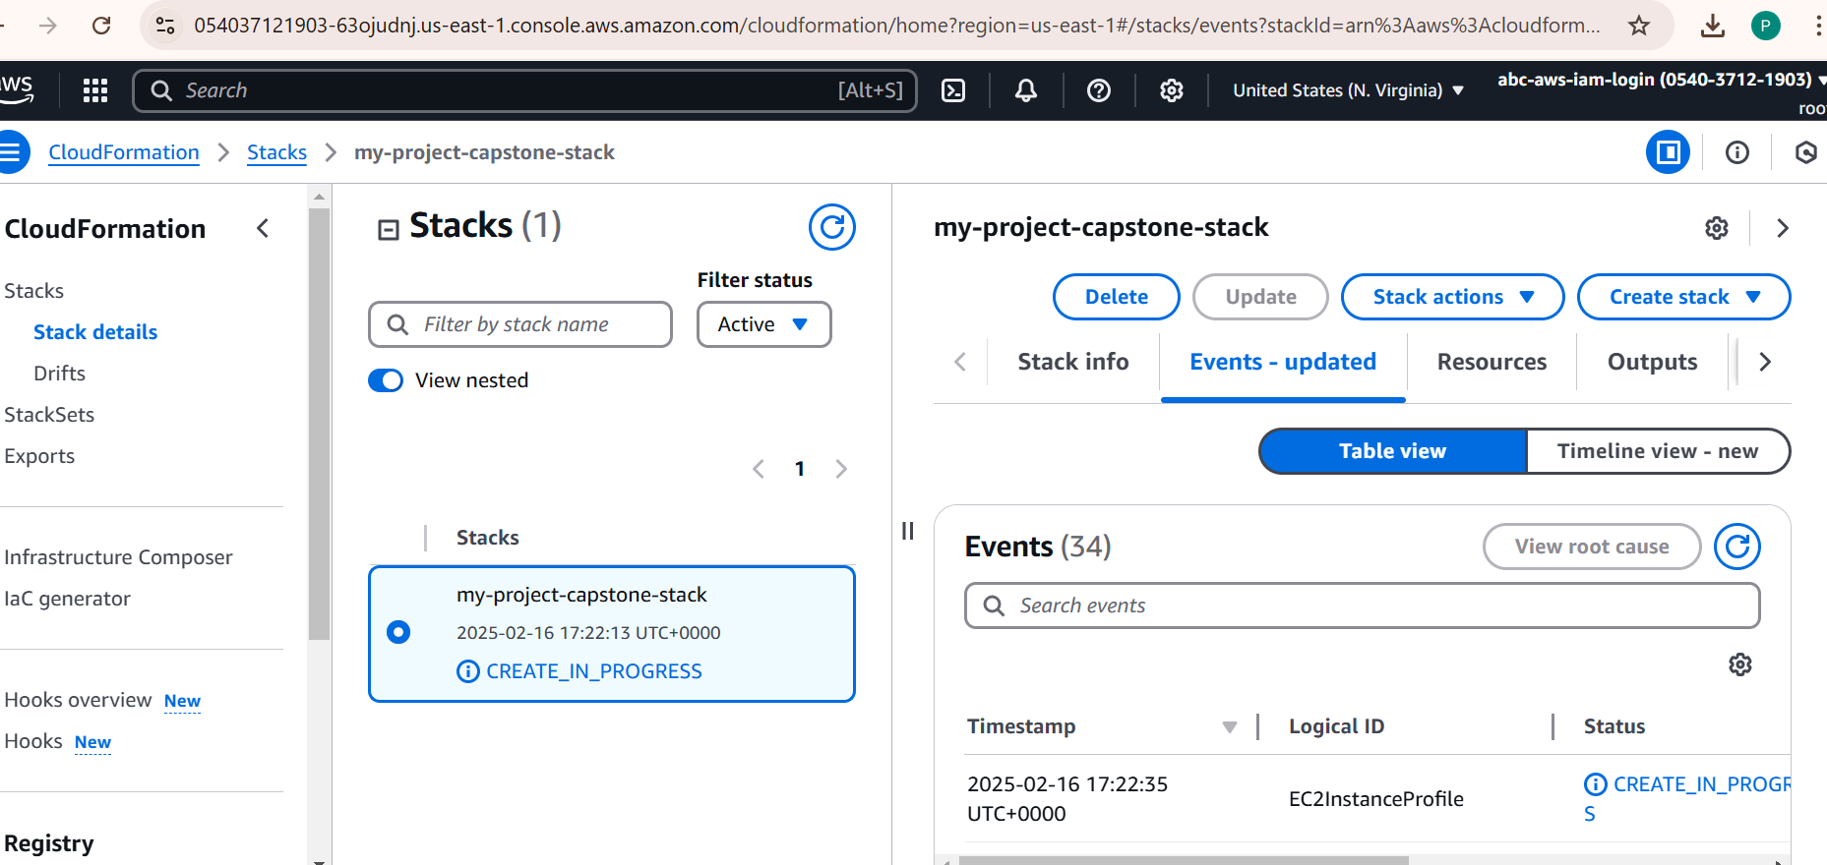

EC2 created from Cloud formation:

Created SNS topic from CloudFormation:

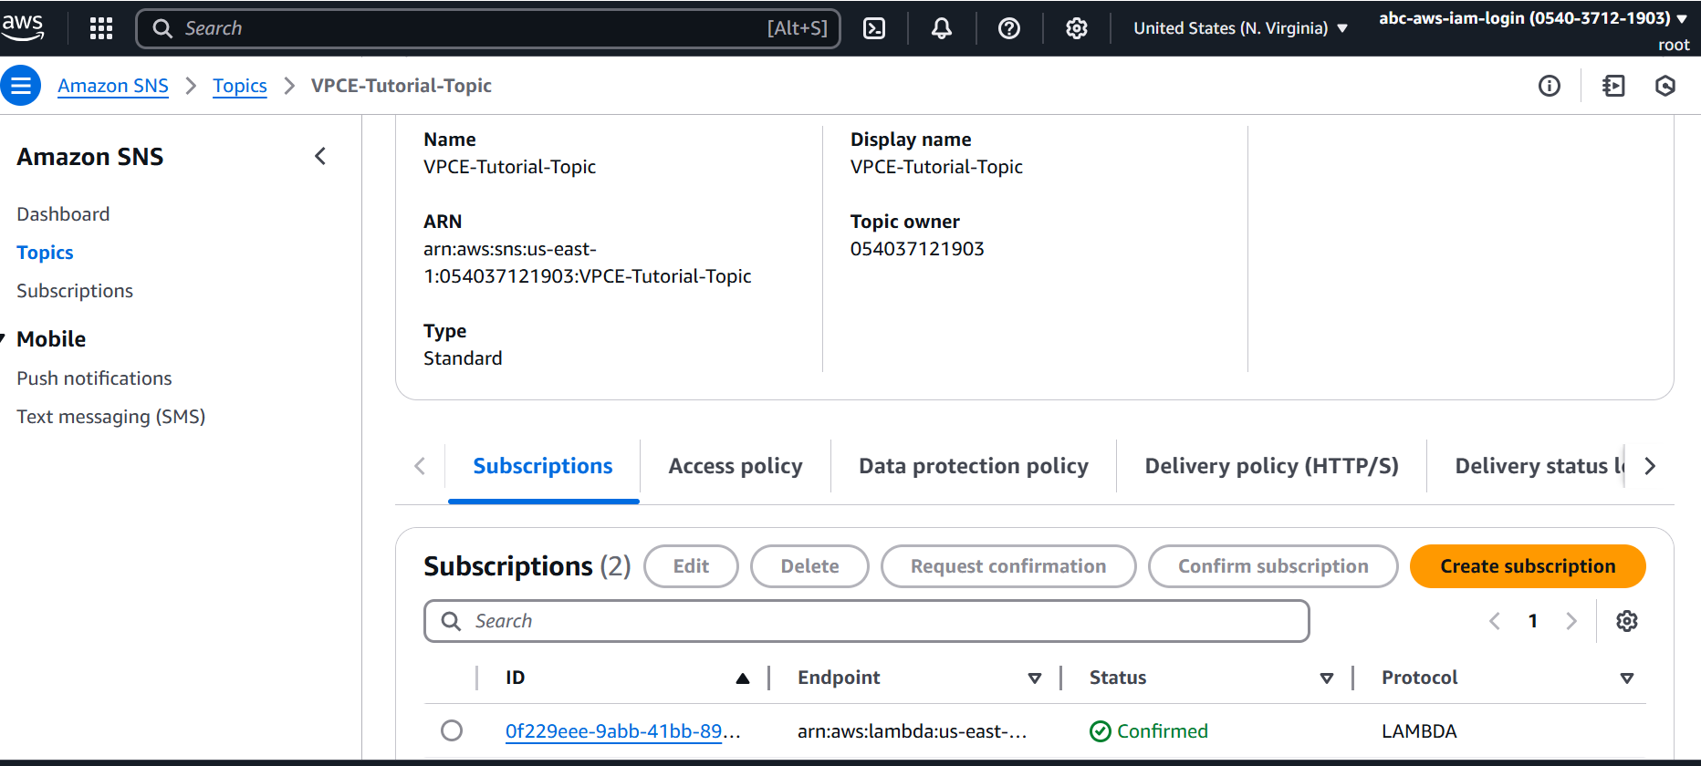

Created lambda from Cloud formation:

Lambda Code created from cloud formation:

Message from Ec2 Instance:

Lambda logs on Cloudwatch log stream:

VPC End point for SNS topic:

