***BVM GLOBAL @ PERUNGUDI***

***SENIOR SECONDARY SCHOOL***

***PERUNGUDI, CHENNAI – 600096***



***TYPING SPEED TEST – GUI***

*Project submitted to the CENTRAL BOARD OF SECONDARY EDUCATION (CBSE) in partial fulfilment for the requirement of All India senior school certificate examination (AISSCE) 2020-2021, Department of computer science.*

*BY: GOUTHAM KUMAR*

*GUIDED BY: MRS. LALITHA SRINIVASAN*



***BVM GLOBAL @ PERUNGUDI***

***SENIOR SECONDARY SCHOOL***

***CERTIFICATE***

*This is to certificate that the project work title ________________________is a Bonafide record done by: Reg No __________ in partial fulfilment of the project in ______________ during the academic year 2020 - 2021 by ____________________.*

*Certified that the candidate was examined by us in the project work / viva voce examination held at BVM GLOBAL @ PERUNGUDI on ______________.*

*Internal examiner                                                      External examiner*

*Principal*

***ACKNOWLEDGMENT***

*I take this opportunity to express a deep sense of gratitude to MS. DEBJANI GHOSH, Principal of BVM global @ perungudi for her cordial support, valuable information and guidance which helped me in completing this task through various stages.*

*I also take this opportunity to express my profound gratitude to my guide MRS. LALITHA SRINIVASAN for her exemplary guidance, monitoring and constant encouragement throughout the course of this project. The blessings, help and guidance given by her time to time shall carry me a long way in the journey of life on which I am about to embark.*

***Introduction***

**Words per minute**, commonly abbreviated **wpm** (sometimes uppercased **WPM**), is a measure of words processed in a minute, often used as a measurement of the speed of typing, reading or Morse code sending and receiving.

Since the length or duration of words is clearly variable, for the purpose of measurement of text entry, the definition of each "word" is often standardized to be five characters or keystrokes long in English, including spaces and punctuation. In 1999, the average rate for transcription was 32.5 words per minute, and 19.0 words per minute for composition. In the same study, when the group was divided into "fast", "moderate", and "slow" groups, the average speeds were 40 wpm, 35 wpm, and 23 wpm, respectively.

***Source Code***

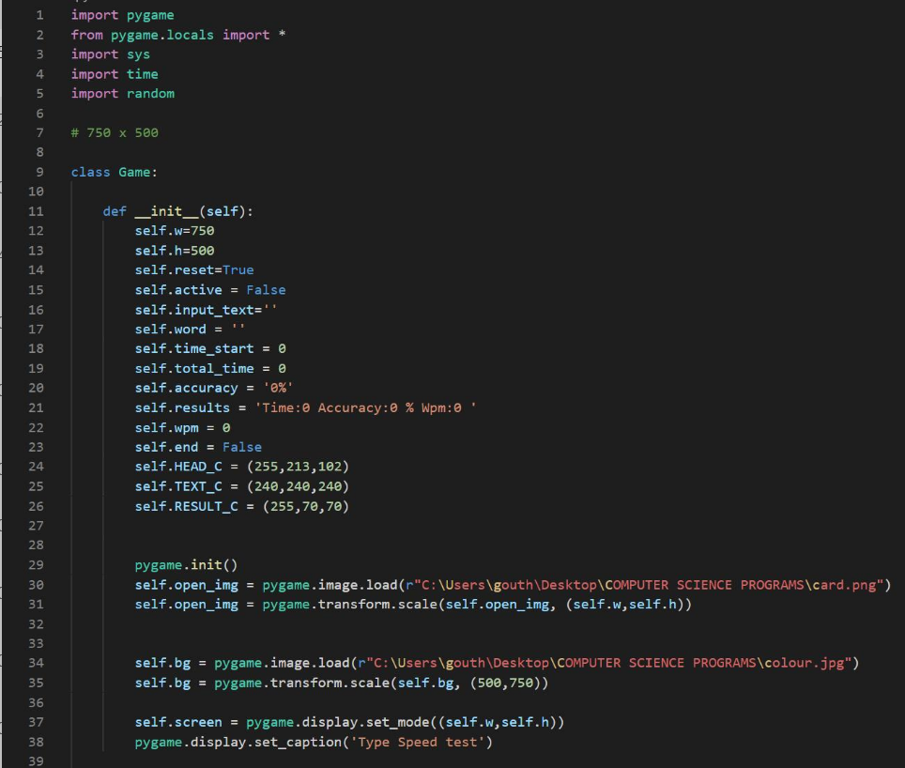

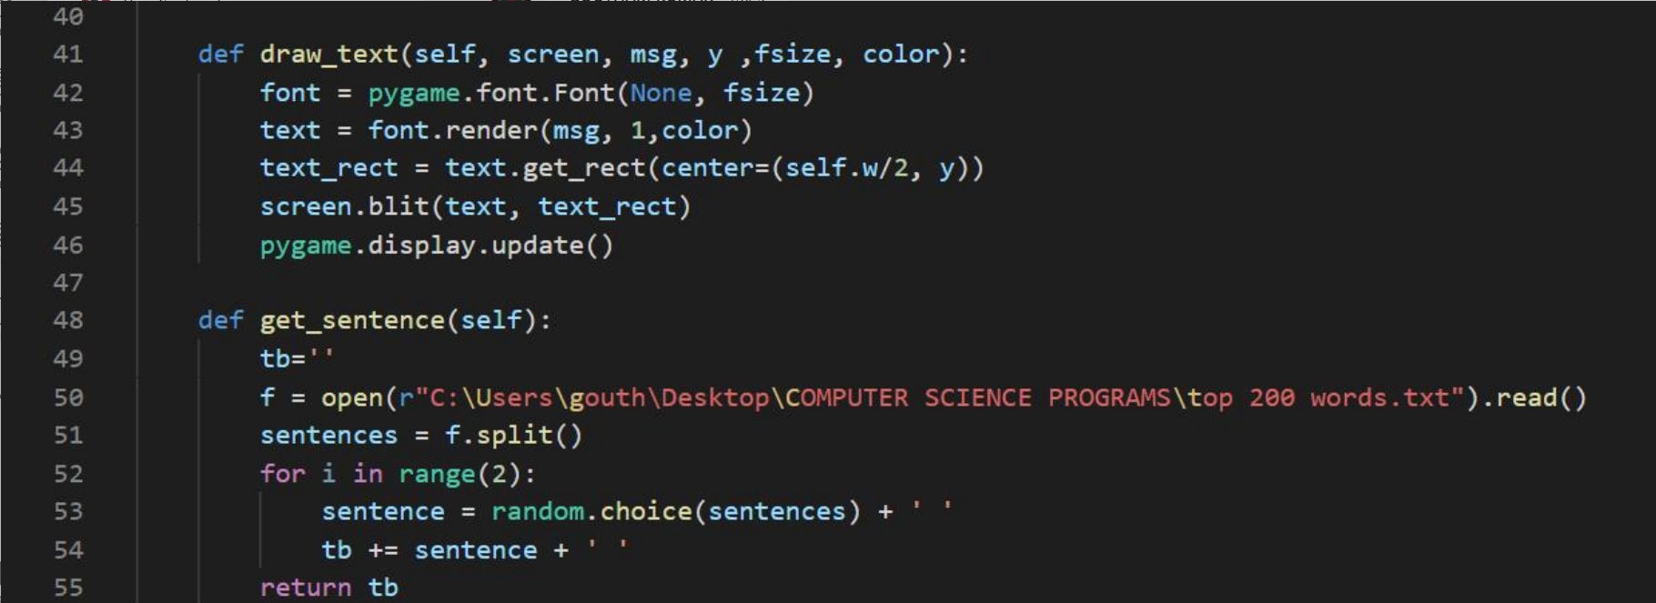

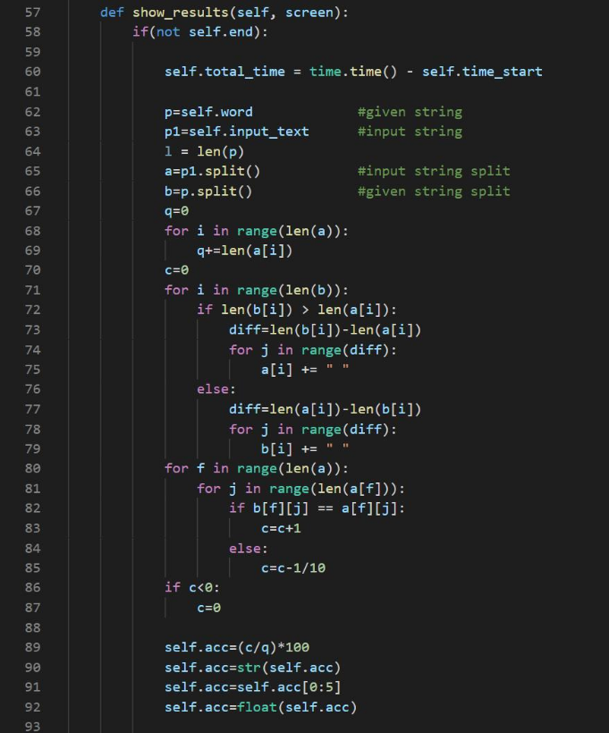

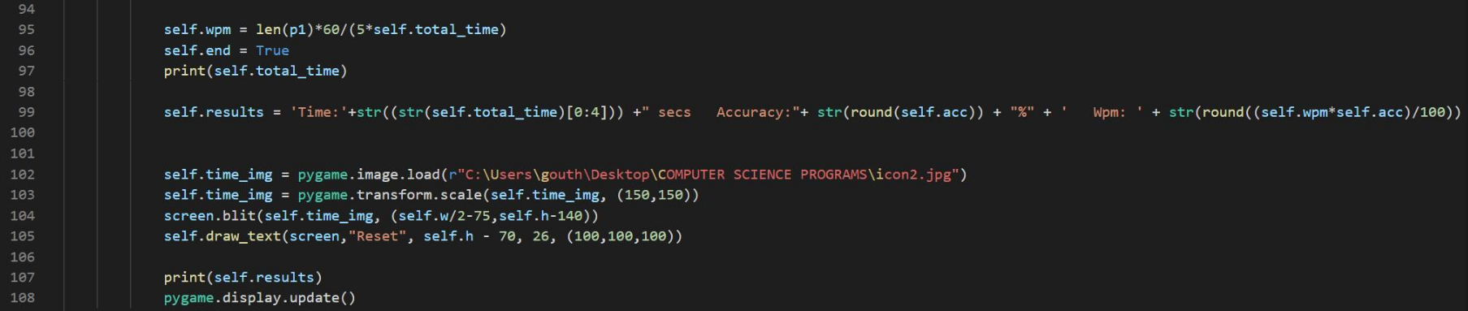

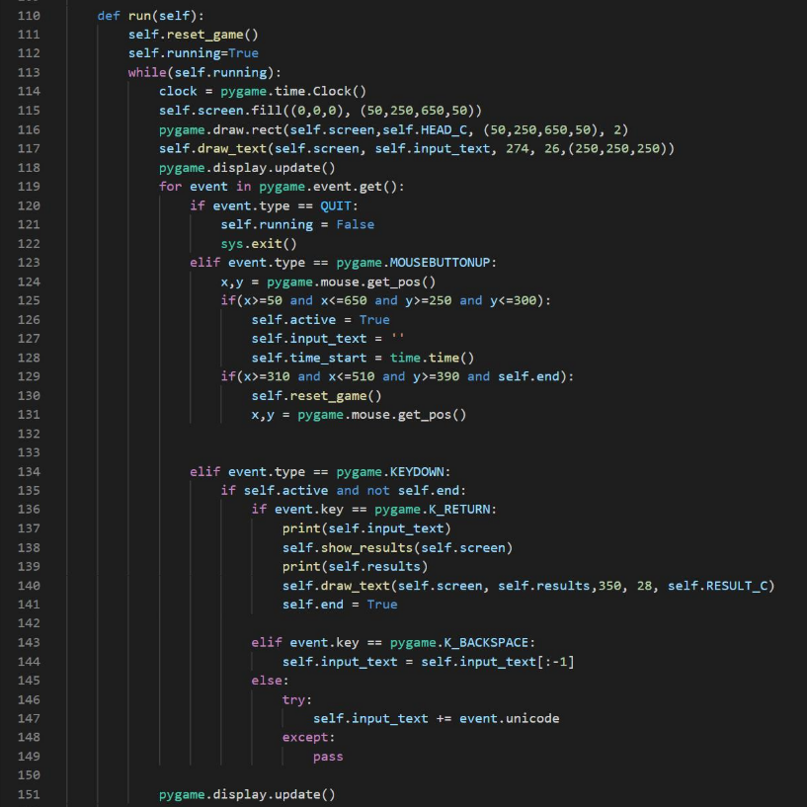

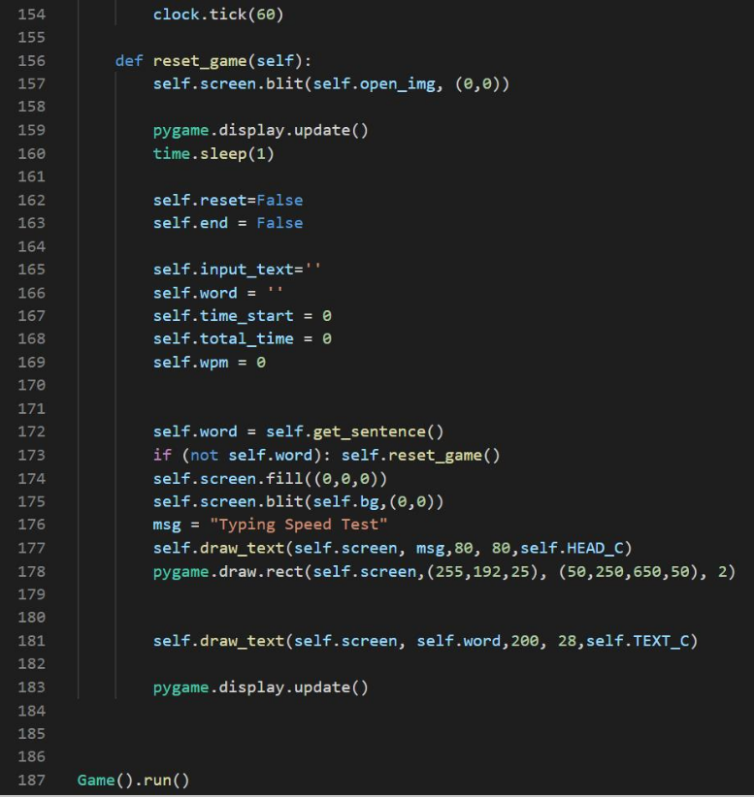

***Output***



