

**Placement Empowerment Program**

**Cloud Computing & DevOps Centre**

Automate File Copying with a Script

Create a script to copy files from one folder to another folder automatically.

**Name:** Prasanna Krishna B

**Dept:** IT

**Reg number:** 312323205171

**INTRODUCTION**

**Automated file copying** ensures that important files are regularly backed up, synchronized, or transferred between folders without manual intervention. This can be useful for **backup management, data synchronization, and workflow automation**. By using a script, users can define a **source folder** (where files are located) and a **destination folder** (where files should be copied), and automate the process using scheduling tools like **Windows Task Scheduler** or **cron jobs** on Linux. With programming languages like **Python**, automation can be customized to include features such as filtering specific file types, copying only modified files, and monitoring changes in real time.

**OBJECTIVE**

The primary objective of automating file copying with a script is to **eliminate manual effort** and **ensure efficient file management** by automatically transferring files from a **source folder** to a **destination folder**. This automation helps in **data backup, synchronization, and organization**, reducing the risk of human errors and data loss.

**Step-by-Step process:**

**Step 1:** Create two folders named “Source” and “Destination”.

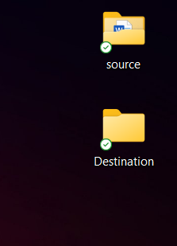

**Step 2:** Store some file inside the folder you created.

**Step 3:** Open the notepad or notepad++ and type the following code and give the source address and destination address.

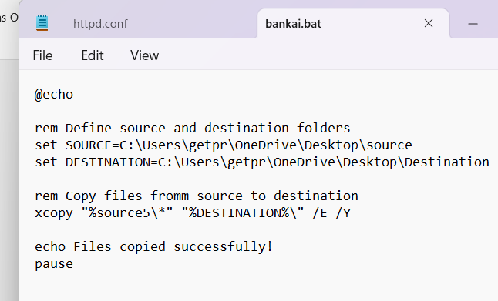

**Step 4:** Then save the file in the desktop or wherever you like to save it.

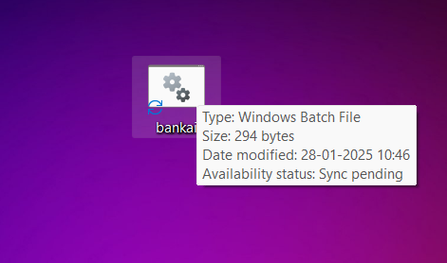

**Step 5:** Press Windows + r and a small box will pop up on your bottom left screen and then Type taskschd.msc and click on enter.

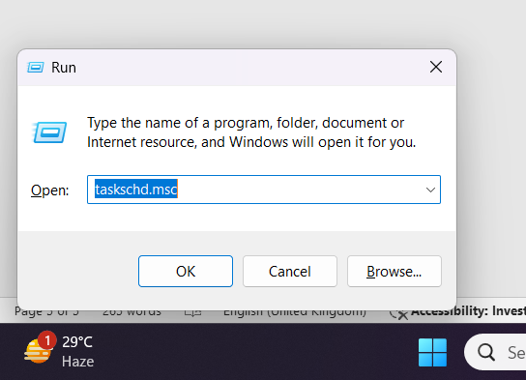

**Step 6:** In the task scheduler window, select on CREATE A BASIC TASK and create a new one.

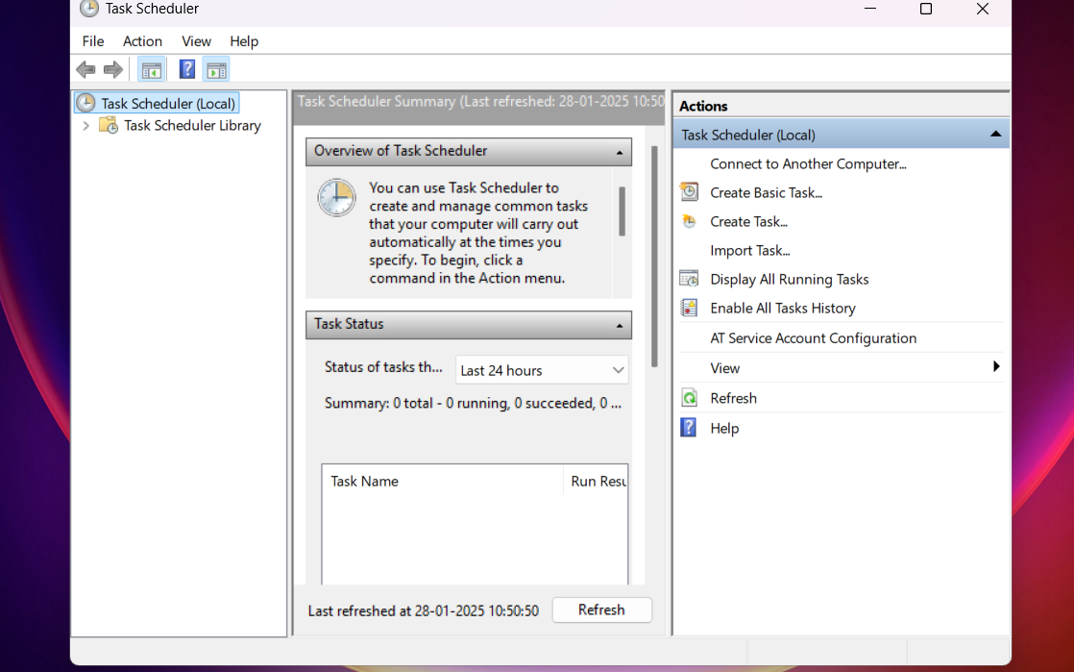

**Step 7:** Enter the name of the task and add description if needed.

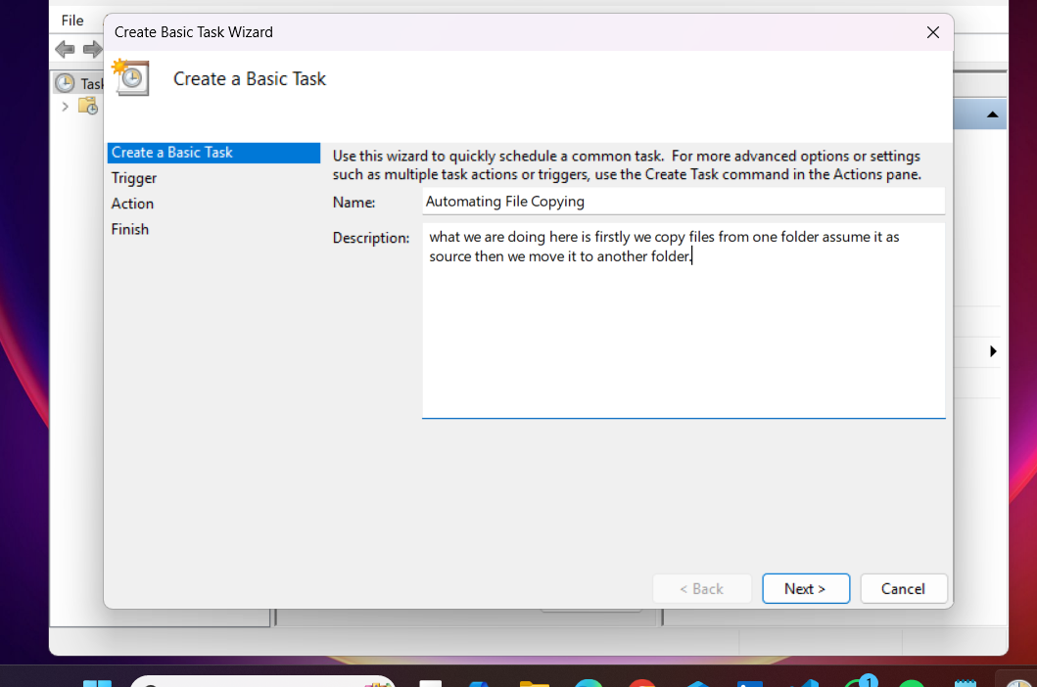

**Step 8:** Choose a Schedule. And set the time and frequency and the proceed to the next page.

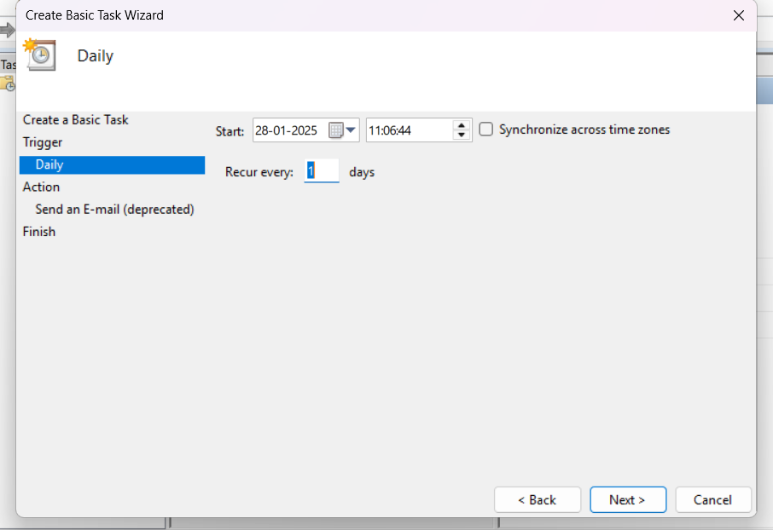

**Step 9:** Set the action as “TO START A PROGRAM”.

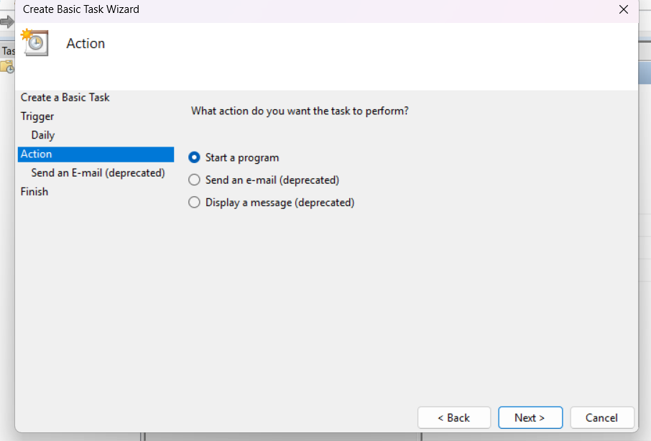

**Step 10**: We print the script. Once done move on to the next page.

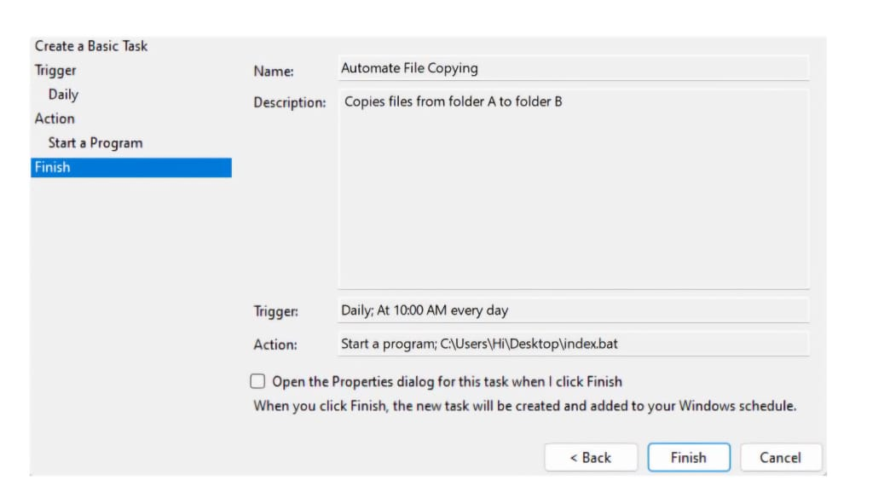

**Step 12:** Find your task in the home page and select it. Then click on “RUN”.

**Step 13**: Go to the folder(destination) and check whether the file has been transferred or not.

