

**PLACEMENT EMPOWERMENT PROGRAM**

**Cloud Computing & DevOps Center**

Create a simple Backup Script: Create a script that backs up your entire Git Repo to a local folder daily.

**Name:** Prasanna Krishna B

**Dept:** IT

**Reg number:** 312323205171

**INTRODUCTION**

In today's fast-paced development environment, ensuring that your code and version history are safely backed up is critical to avoid any loss of important work. One effective way to achieve this is by automating the process of backing up your Git repository to a local folder on a regular basis. By creating a simple backup script, you can ensure that your entire Git repository, including all branches, commits, and history, is securely copied to a backup location without any manual intervention. Automating the backup process daily not only provides peace of mind but also saves time and reduces the risk of human error. In this script, we will explore how to use basic shell scripting combined with Git commands to automate the backup of a Git repository to a local folder every day. This approach will ensure that even in the event of an unexpected system failure or data loss, you will have a secure copy of your entire repository, enabling you to restore your project with ease.

**Step-by-step process**

**Step 1:** Create a folder in your desktop for backing up files.

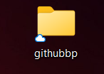

**Step 2:** Open the notepad and type this script given below.

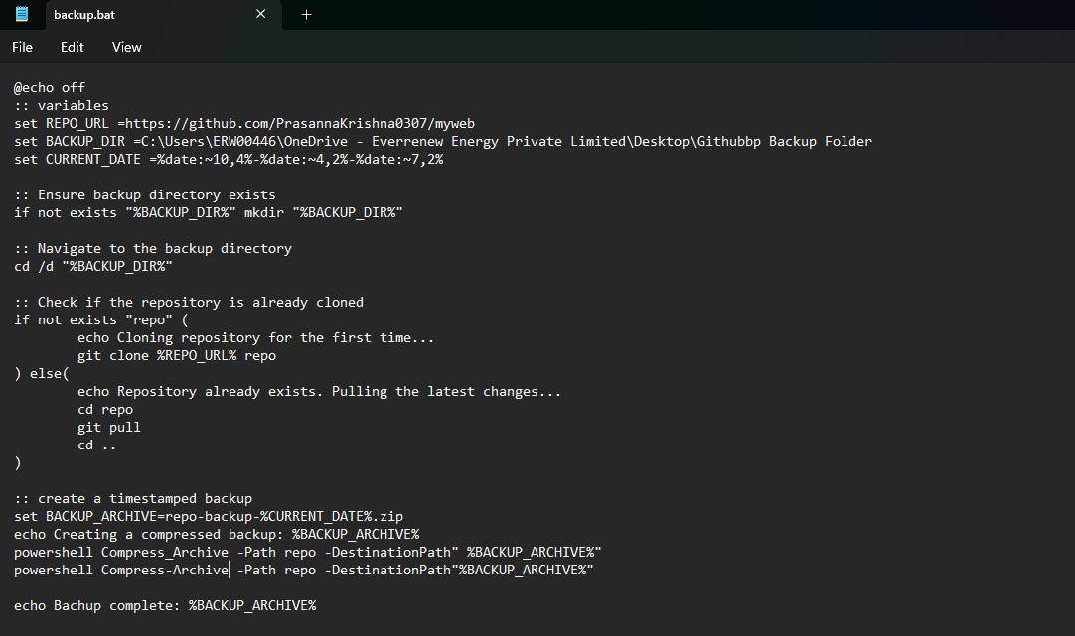

**Step 3:** Open Windows+r on. Type taskschd.msc in the run box.

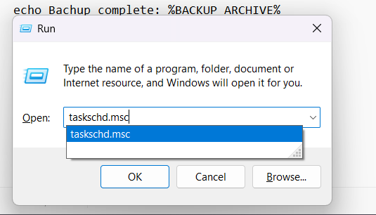

**Step 4:** Create a basic task in the Task Scheduler.

**Step 5:** Enter a name for the task you are going to perform.

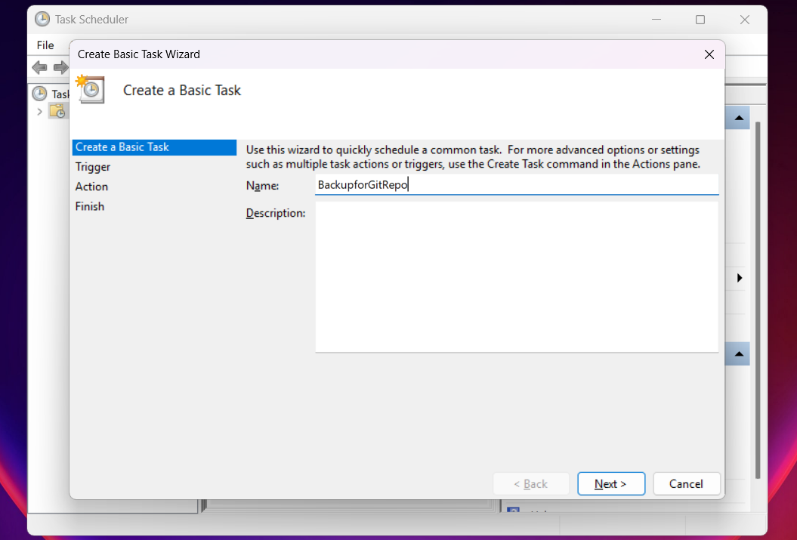

**Step 6:** Set the frequency and time, also schedule whether the backup is going to be done:

* Daily
* Weekly
* Monthly
* One time
* When the computer starts
* When I log on
* When a specific event is logged

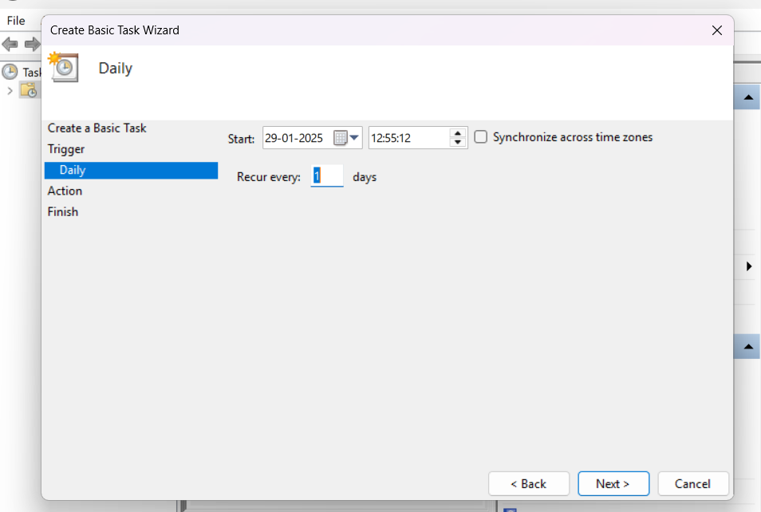

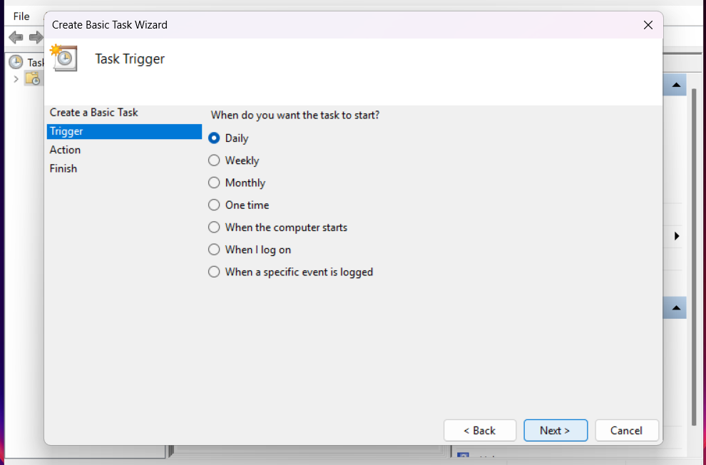

**Step 8:** Set the Action and once done select “START THE PROGRAM” as action.

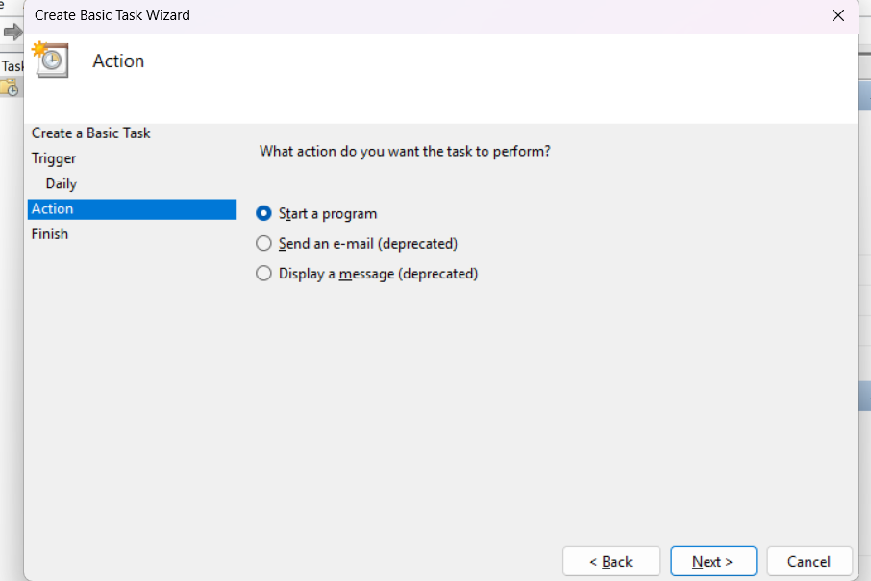

**Step 9:** Browse your bat file and upload it.

**Step 10:** Once done with all click on finish. Then go to the home page and select the task that you want to run, and click on run.

**Step 11:** Once done the cmd prompt will pop up.

**Step 12:** You can go to the folder and check whether the file has been backed up or not.