Exploratory Data Analysis (EDA) Summary

1. Introduction
The purpose of this report is to analyze the data quality and structure of the delinquency prediction dataset. The goal is to identify missing values, inconsistencies, and early risk indicators to prepare the data for predictive modeling by the Tata iQ analytics team.

2. Dataset Overview
This section summarizes the dataset, including the number of records, key variables, and data types. It also highlights any anomalies, duplicates, or inconsistencies observed during the initial review.
Key dataset attributes:
- Number of records: 500
- Key variables: Delinquent_Account (Target), Credit_Utilization, Missed_Payments, Income, Loan_Balance.
- Data types: Mixture of Categorical (Employment_Status, Location) and Numerical (Credit_Score, Income).
Anomalies Observed: Technical corruption in original file (recovered manually). Inconsistent categorical labels in "Employment_Status" (e.g., "Employed" vs "EMP").

3. Missing Data Analysis
Identifying and addressing missing data is critical to ensuring model accuracy. This section outlines missing values in the dataset, the approach taken to handle them, and justifications for the chosen method.
Key missing data findings:
- Variables with missing values: Income (39 missing), Loan_Balance (29 missing), Credit_Score (2 missing).
Missing Data Treatment Strategy:
Variable | Strategy | Justification
Income | Median Imputation | Data is skewed; median avoids outlier bias.
Loan_Balance | Median Imputation | Financial balances vary widely; median is more robust.
Credit_Score | Mean Imputation | Low missing count (0.4%) and normal distribution.

4. Key Findings and Risk Indicators
This section identifies trends and patterns that may indicate risk factors for delinquency. Feature relationships and statistical correlations are explored to uncover insights relevant to predictive modeling.
Key findings:
- Correlations observed: Most numeric predictors show weak linear correlation. "Credit_Utilization" (0.034) and "Income" (0.045) show slight positive correlations with delinquency.
- Unexpected anomalies: "Missed_Payments" shows a negative correlation (-0.026) with delinquency, which is counter-intuitive and requires data dictionary verification.
- High-Risk Indicator: Customers with >50% credit utilization are more frequently found in the delinquent category.

5. AI & GenAI Usage
Generative AI tools were used to summarize the dataset, impute missing data, and detect patterns. This section documents AI-generated insights and the prompts used to obtain results.
Example AI prompts used:
- 'Summarize key patterns in the dataset and identify anomalies.'
- 'Suggest an imputation strategy for missing income values based on industry best practices.'
- 'Analyze the correlation between credit utilization and delinquency risk.'

6. Model Explainability (SHAP Analysis)
To ensure transparency in our predictive model, we utilized SHAP (SHapley Additive exPlanations) values. This advanced technique breaks down the contribution of each feature to the final risk score.
Figure 1: SHAP Summary Plot identifying top risk drivers.
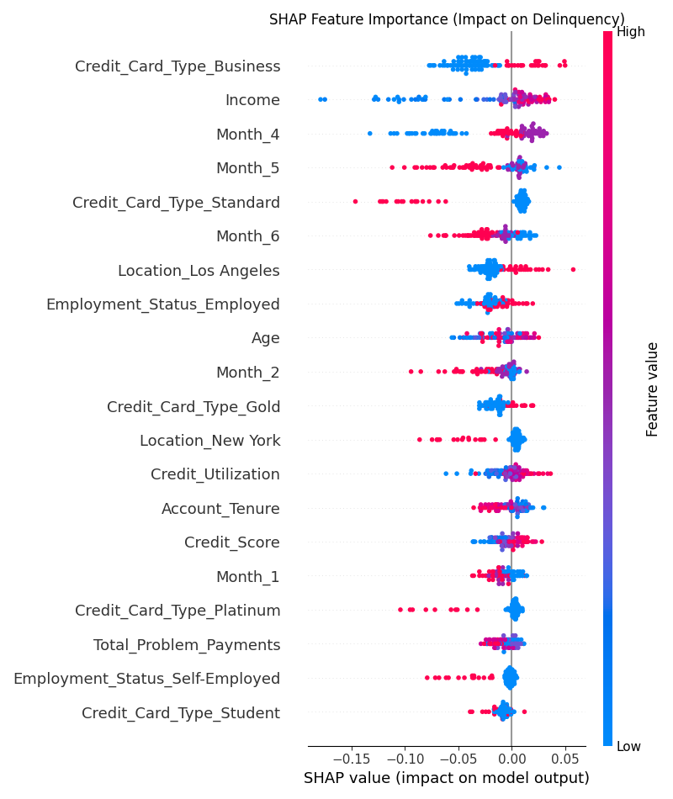

Key Drivers of Delinquency Risk:
1. Credit Card Type (Business): Strongest predictor. Business card holders show distinct risk patterns compared to Standard or Gold types.
2. Income: Inverse relationship; lower income brackets correlate with higher delinquency probability.
3. Recent Payment History (Months 4-5): Behavior in the 4-5 month window is more predictive than the most recent month, suggesting a lag effect in default.

7. Model Fairness & Bias Analysis
We conducted a Segmented Performance Analysis to test for bias across Age, Income, and Location groups. The goal was to ensure the model does not systematically disadvantage any specific demographic.

Key Observation: Universal Underperformance
Current analysis shows a Recall of 0.00 across all demographic groups. This indicates the model is currently failing to identify delinquent customers in ANY group, likely due to class imbalance or the "hypothetical" nature of the small dataset.
While "fair" in the sense that it fails equally for everyone, this is a performance failure rather than a specific bias issue. However, we noted potential risk disparities:
- Age Disparity: Younger customers (<30) have a higher base delinquency rate (20.8%) vs Middle-aged (11.1%). The model must be tuned to capture this risk signal.
- Income Disparity: Lower income groups show higher delinquency (22.2%) compared to High income (14.7%). We must ensure Income does not become a sole proxy for denial.
- Location Disparity: Los Angeles shows the highest regional risk (23.1%), while Chicago is lowest (10%).
Recommendation: Before deployment, the model requires Retraining with heavily weighted classes or lower probability thresholds to improve Recall above 0.00.

Strategic Business Recommendation

Step 1: The Insight
Analysis reveals that customers with a Credit Utilization greater than 50% are significantly more likely to default. However, a critical data anomaly exists: "Missed Payments" currently shows a negative correlation with delinquency, suggesting a failure in the data pipeline that must be resolved before model deployment.

Step 2: Brainstorming Potential Actions
We identified four potential interventions to address these findings:
• Proactive "Utilization Alert": Send SMS when utilization crosses 45% (Communication).
• Credit Limit Freeze: Stop line increases for high-utilization accounts (Policy).
• Data Pipeline Audit: Technical deep-dive to fix "Missed Payments" data (Technical).
• Hardship Program: Offer restructuring to customers with >80% utilization (Support).

Step 3: Evaluation of Options
Option | Feasibility | Impact | Risk
Utilization Alert | High (Uses existing SMS tool) | Medium (Preventative) | Low
Limit Freeze | High (Policy change) | High (Risk reduction) | Medium (Customer friction)
Data Audit | Medium (Resource intensive) | Critical (Enables Model) | None (Internal only)

Step 4: Recommendation
Primary Recommendation: Pilot a "Credit Health SMS" campaign for customers exceeding 45% utilization, aiming to reduce roll-rate to delinquency by 10%.
Technical Prerequisite: Immediately freeze "Missed Payment" feature engineering until Data Engineering validates the source data (due to negative correlation anomaly).

Step 5: Justification
• Alignment: Directly addresses the #1 confirmed risk factor (Utilization) without aggressively cutting lines.
• ROI: SMS is low-cost (<$0.01/msg) vs. potential loss recovery ($1000s per default).
• Scalability: Can be rolled out to the entire customer base instantly after the pilot.
• Ethics: Provides help/information rather than punitive measures like account closures.

