Abstract:

Group RUGFORD, University of Northampton.

As every sector is getting computerized, the education sector is also applying their courses in computer-based system. It will benefit the both student and staff of the institution. So, the Woodlands University College also intends to make the Course Management System for the college. Woodlands University College provides the higher education in wide range of degree courses. So, the software team would like to deliver the proper system that the Woodland University College is expecting. To deliver the proper system firstly, it will be very important to know the requirement of the stakeholders. The requirement gathering will be great help to overcome the problem and find the possible solutions for the problem domain that occurs during the project. The outcome of the elicitation activities will also be great help to research about problem domain characteristics. The research of the project will be done using Agile Scrum methodology. As the institution wants to implement the pilot system it will be provided as per the request. The pilot system will be the test for the Woodlands University College. If pilot system is asked not to be implemented there will be the provisional functionality with its certain areas for the website. The comparable system will be looked after with all legal/regulatory supplies. It is expected to be budget friendly; the system function will be limited to manage the project with the budgeting.

INTRODUCTION:

The essential thought process of this project is to create the digital system of the Woodlands University College. The intent was taken by the course team of the University and potential users has shown the field of interest in creating the system. The Woodlands University College is known to be small institution providing Higher Education in within wide range of degree courses. The current system used in WUC is centered on clerical work.As data and record management is perquisite of any organization the course management system is still paper based system in Woodlands University College. In order to move forward the clerical framework the university has at last picked to utilize computerized framework for the course management system and for the relevant information. The system is to be coordinated in part by part that could be a blueprint with the essential objective of finding out problem domains and requirements. During the development phase, the system will be built in blocks based on the functionalities and their priority. The system will be properly tested to ensure reliable, high performance, stable, secure website.So, the system when completed is to be drove for the robust system. The intent is to develop a pilot system mainly focused for the computing department, record management which is computerized, basic, additional functionality will be essential for the better system. If not pilot system addition to provisional system functionality will be included. The system is decided to be clear, simple and reliable. This report comprises all the requirement engineering, system analysis & design, system interface designs, system build, technical notes, testing and evaluate using traditional development strategy.

Project Background:

The course leader Dr White hired the software development company for the possible outcome through the computerized course management system. For the better and proper system, it is important to understand the existing system requirement of the stakeholders.

The proper delivery of the system is to be conveyed. It is only possible if the depth understanding of the problem domain, requirements and project background by members is ready to convey a legitimate proper solution and arrangement that has been requested by the clients. The documentation is anticipated to be completed and proper study of documentation is to be done with legitimate arrangement of the problem domain with solutions. The elicitation activities will be the comfortable way to discover the required result for the proper solution of the problem. The awareness of the topic is to be shared within every group member as all the topics are interrelated.

The system specification with its aspect is to be investigated properly for the proper system. The necessary understanding of the existing system requirement of the stakeholder is to be studied and the clerical system with documentation is to be completed firstly. The system is to be fetched according to the employees related field and the job responsibility, the roles that is involved in every related field of employees to be connected in the development process with its criteria. The project must address the process of record management system and data entry through website. So, website is to be reliable for both employee and student with criteria and the problem domain and its characteristics is to be acquired through the elicitation activity that has been carried out. The potential users in the system are to be considered to be supporting factor for the development of the course management system as all of the people may not have simple knowledge of computer. The functional and non-functional requirement will be implemented as per the client request of the project including legal/regulatory requirements. The elicitation interview will be great help for the development team to cope up with the knowledge near problems and help overcome software solution for the system.

The requirement formulation of the project must include the functional requirement, performance requirement, design constraints and commercial constraints after the inclusion of system specification is completed. The comparable system will also be looked after with all legal/regulatory supplies.

The effective management of the project is to be delivered through the observation of the quality report presented. The project will be holding all the component of required documentation from elicitation activities, requirement specification, prototype, system design, test and evaluation and all the component will be included using effective project management.

The system is proposed to be computerized with the simple pilot system for the necessary grade of flexibility. It is uncertain that pilot system will be observed if it is experiment. The certainty of the pilot system is confirmed after some time of implementation and stage of operation. If the development team is unable to provide pilot system the provisional system functionality is to be used. The system is to be made clear and simple as per the cost plan and time of development in the documentation.

The data and information related to student and employee of the university must be included. The data includes essential functionality in certain areas that is Student records, Staff records according to their roles, the course records that is being studied with module management, there must be inclusion of assignment management, student attendance records, personal tutor management with timetable management, diary and report generation management in the system. The database is to be created through the backend tools of the web system. The web system will fulfill all the given provisional system functionality.

The stakeholders given information will be huge help in performing the project in specific way. The web system is to be user-friendly with the roles that is involved in every related field of employees to be connected in the development process with its criteria.

Project aims and objectives:

The aim of this project is to form the web system of Woodland University College computerized and electronic with the implantation of the web application through frontend and backend for the database server storing. The web system must include all the functionality aiming on requirement of the stakeholders and other potential users. For reaching this aim of the project identification of all essential components with given material is to be included that is reflected in the workshop.

The software team will adapt that the idea of the brief provided to work with the relevant problem domain information that has been held in workshop when elicitation activity took place. The pilot system is to be implemented for the degree of flexibility and make system robust with the future expansion plan. If the pilot system is not implemented the development team will work for the provisional functionality in the catalogue with its essential functionality and the area to be covered.

The essential functionality will include create, amend, archive, display, assign and so on of the certain areas. The essential functionality will contain Student records and Staff records fitting to their parts, module management with the course records, assignment management, student attendance records, personal tutor management according to timetable management and so on. So, the website must look professional that will have all the problem domain documentation which will mainly focus on the roles of the employees, potential user expectation, legal requirements to be met. The website also needs to fulfill not only system specification but also functional requirement, performance requirement, design constraints and commercial constraints. The system will also have the database design with relational Entity relation and Data Flow Diagram for the planning of database outline. The record management system will contain complex search criteria and make the addition and removal of data less complicated and straightforward. The website will design a product interface that includes all of the features of the course management system.

The project plan to accomplish the subsequent objectives:

* The brief and documentation of the project with the proposed client requirement to be studied.
* The suitable problem domain characteristic to be classified in the group.
* To make the budgeting of the project managed by limiting the system functions.
* Locate the comparable system and applicable legal/regulatory requirements.
* The elicitation activities will be held to come up with the proper solution of the problem.
* The elicitation activities will be of great help to determine the features of the problem domain which is suitable.
* The requirement formulation with functional and performance requirement will be established.
* To establish requirement formulation software specification is to be implemented for the development of all the functionality in the software.
* Setout basic software component to the system. Test and check the system, incorporating clients as needed.
* The approval of finalized project to be presented after the verification and validation to the client.

## 1.3 Project Development Methodology

Methodology is also important as much as others are important this is the era where we all need to discuss with the client and user , what types of content and design they expect from the applications so methodology is important because it identifies the roadmap of the web application .

Agile development methodology will be used to develop the system. Agile is a methodology where continuous iterations and testing take place during the entire Software Development Life Cycle (SDLC) of a product (Srivastava et al., 2017). Scrum is a subset of agile. It is the most extensively used and is a lightweight agile development process framework.

Scrum is most commonly used to manage complicated software and product development projects utilizing iterative and incremental methods. Scrum is the combination of the Iterative model and the incremental model because the builds are successive and incremental in terms of the features to develop object oriented software (Srivastava et al., 2017). Specific concepts and practices distinguish the Scrum approach from other agile processes which is divided into three classes of time boxes, roles and artifacts.Scrum's workflow includes close collaboration between the scrum team and the scrum master with the product owner. Scrum Master, product owner, and the scrum Team are all involved in the scrum process. The primary responsibility of the scrum master is to remove roadblocks. Scrum is a cross-functional team that includes developers, testers, and other specialists from diverse industries who work together to create a versatile product that fulfills the needs of the client. In comparison to traditional "waterfall" procedures, Scrum considerably enhances productivity and reduces time to benefits.Scrum methods allow organizations to respond quickly to changing needs and generate a product that fulfills changing business objectives. A sprint is the smallest unit of scrum, consisting of a small team working on a specific assignment. It lasts between one and three weeks. The product backlog is a list of needs called user stories that are determined by the product owner. It is divided into sprint backlogs, which covers methods for completing a sprint. A daily scrum is held at the conclusion of each day to track progress on the work set for the day. Each sprint's goal is to develop a product that can be shipped. A sprint review is held with the product owner at the end of each sprint. The quality of the deliverables can be improved by the use of scrum agile along with that it can adapt with the changes more easily. It also provides more accurate projections while spending less time doing so.

As scrum is agile methodology it is known to be fast, effective, flexible and have many rewards compared to other methodologies. The schedule is created for the team work to be divided.

For the first phase of the study the requirements of the project is gathered. The development team will gather all the findings and requirements through different process that can be staff questionnaire, student questionnaire, different documentations and others. As it has been already mentioned that the college is still dependent on clerical system. The main requirement of the project is to make the system digitalized and computerized. The other requirements include functional, additional and provisional requirement. It is confirmed that if pilot system is not implemented the provisional functionality with its certain area is to be developed with features like amend, display, delete and others.

After the requirement gathering the system is to be specified. The problem domain research for different system should be done. The development team will find the problem domain and properly planned solution for the website. In this, the student is facilitated in choosing the module and course also facilitate the teacher in various aspects . This web application is developed after discussing with the students, teachers and college staff individually. This web application facilitates all the users of the application. For students it gives about the module information ,module content etc, it also facilitates to teacher in updating the content of the module time to time and upload the result and many more like this.The all the requirement will be specified in the given time period. As all the requirement will be developed before deadline of the project. The project budget is to be specified according to system function in the project. There must be areas for the functional essential functionality with its areas. The project is started when all requirements are specified later a backlog is created.

When the requirements are specified, the analysis is done to know what are stakeholder actually seeking for. Through methodology technical analysis , user analysis, cost analysis, risk analysis etc will been done. The sprint planning is done after all the documentation and research are specified. It is divided into sprint backlogs, which covers methods for completing a sprint.The backlog is created at in specification phase. The backlog is also analyzed to know the client, who is providing the website, what are the expectation of the website and is expectation met or not. All the answers of the questionnaire will also be analyzed based on priority. The research will be content based for analyzing all the specification. In analysis phase it will be discovered if the system is feasible or not to build.

After analyzing the specification, the system is now ready to design as per the stakeholder necessities. Different tools will be used to design the system part by part. Firstly, the development team will follow the algorithm plan that is created at the beginning of the project. The planning of the website is completed through mockup designs, class responsibility collaborator, BON diagram, navigation diagram, wireframes, textual analysis using flowchart tool, etc. This will be helpful to determine requirement and to create the prototype using those tools. The designed will be recognized after this point with reasonable solutions. The design will be designed according to stakeholder supplied idea thorough questionnaire. As it is mentioned that the system is to be designed according to budget limit with provided functionality the prototype of the design and its functionality will be shown to client time and again. If any of other requirement is to be added in the system it will also be updated in the design phase of the website. It means that the meeting will be held time and again which is in weekly basis.

The design will be confirmed and the coding is to be started to complete the project in given time period. The build of the project starts with documentation process. The coding part is distributed to team members with their parts. The build phase is also known as development phase. There will also be small prototype of comparable system that will be looked after in the building of the system.

The loop holes in the system are to be tested that may occur during building the system or after the system is build. It may be rare case that there will be found some problems found during developing the system. The website will be verified after the coding part is completed the domains will be hosted and all the databases that was accessed in development phase will also be tested. The excellence of the system will be recognized after testing. Both the black box and white box testing will be done to ensure if the software is made excellence. The black box testing will be held to determine the external behavior of the website. And white box testing will be held to determine the internal behavior of the website. If the system does not have any bugs, it will be ready to be applied. The system is presented to client if they are satisfied with all the functionality after testing the system or not. If not, the feature will be added in the design, build and tested again and showed to client. This process takes place until the stakeholders are satisfied.

After the stakeholders wants are fulfilled after testing of the system. The system will be ready to be finalized, it will be informed to the stakeholders that the website is set to be launched. Now the system is validated and verified to be launched. After verification and validation, the website is launched with all client requirements. So, the Woodland College University will be computerized from the clerical-based system by following all the documentations, questionnaire, and methodology.

After the implementation the website the website is to be updated and to be maintained in monthly basis.

2.1.3.4 User Group Questionnaires

The User group questionnaire is to take place in the month of May that is intended to be completed by all the potential users that has requested the faculty for the website and system for WCU.

The questionnaire will be the main help to know the personal view regarding the system of the user group. The potential users and the user group will be answering the questions which will be very related with them according to responsibilities. Knowing the perspective of the user groups it will help to develop the better understanding between users, the user group consists academic staff and students whose involvement will help to make effective product and the product that is expected.

2.1.3.4.1 Student Experience Questionnaire

The student experience questionnaire obtains the information that the students and their perspective for the course management system. The prototype designs will also be showed to the student for their comfort to understand the questionnaire correctly. The participation of the students will be significant and will be seriously appreciated.

2.1.3.4.1.1 Questionnaire Development

The development team tends to ask the questions that will be very familiar with the students and their wants. The questionnaire will contain limited questions. The development team will be obtaining information’s related to changes that need to be done in the system and additional features. The student’s questionnaire will be huge help to make the system user oriented and it will also be discussed with the stakeholders.

The questionnaire for the students will be asked not be asked about their personal information and there will be question related to the system which may look like:

* What do you expect form the new system?
* How has the current clerical-based system impacted your academic performance?
* Do you think it is good idea to go computerized based system form clerical-based system for students?
* What changes do you want to have different form the prototype model?
* Do you want to change any functionality that can be changed in the system?

The given questions are the blueprints that can be asked to the students in the questionnaire. And the data provided by the student will be anonymous from other students and only main stakeholder will have access to it.

2.1.3.4.1.2 Questionnaire Results

Our development team expect the good response form the students. All the responses form the students will be stored in the database and it will be checked. Only the stakeholder will have access to the response submitted by the students. The results will be implemented after sometimes with reviewing with all the stakeholder. If the responses of stakeholder will be positive towards legit functionality from the student questionnaire it will be added to the system.

2.1.3.4.1.3 Questionnaire Analysis

The questionnaire analysis part includes the main questions important for better system. Research will be held to find the significant questions. The results that were catalogued will be implemented slowly. The data will be interrogated and the result will be initialized if the findings are legit. The questionnaire will be conducted in simple way as the questions. The team will watch out for the most common response of the student and the must impactful answers will be given the priority. The questionaries will also obtain the final result of the projects. So, the analysis of the result will be done according to priority and majority of same responses either it is positive or negative response.

2.1.3.4.2 Academic Staff Experience Questionnaire

The Questionnaire is to be run by May which will be completed by all the staff of the University. It is pretend to be a good response from all the staff. The Academic staff experience questionnaire will include the information for the potential user of their faculty and their perspective about the system. Questions for the questionnaire will be interrelated.

2.1.3.4.2.2 Questionnaire Development

The questionnaire will be developed for the academic staff experience regarding the development of the on-going system. Partial and important questions will be selected for the questionnaire. The software development team will also ask additional questions regarding the budget formulation and time if anything is to be added in the Course management system. As it was mentioned in documentation of the project that project should be managed by limiting the system functions and budget. The questions will also be developed for the users who are unable to use the computer or who have less knowledge about the system and also regarding potential users. Staff records, courses record, module management, and other essential functionality will also be developed though the results of questionnaire.

The questionnaire questions may look like:

* What are other additional features that you would like to add in the system?
* What is your role as a staff of this college?
* Do you think the system is well managed?
* What are your views regarding the performance of the system?

The results of this questionnaire will be anonymous from others.

2.1.3.4.2.2 Questionnaire Results.

The response of the staff will be hidden and all the responses will be stored in the catalogue of the database. The response will be implemented slowly as it is important to know the views form the staff. The results is to be implemented after discussing it with the main stakeholders and if the budget is incremented.

2.1.3.4.2.3 Questionnaire Analysis

The analysis of the questionnaire will be done after the results. Research will be thought to discover the important answers. The results will be implemented according to the majority of the same response form the staffs. The data will be interrogated. After the interrogation the most impactful answers will be imported. The final outcome of the project will also be determined through the questionnaire. All the positive and negative responses will be kept in the database.

2.2.3.3 Woodlands University College Corporate Website:

2.2.3.3.1 Speed

* The website must load within 1 seconds and shouldn’t take time more than seconds.
* The navigation bar should be able to hold other pages within 1 second.
* If anything is being searched by the user it should not take longer then 3 seconds to load.
* All the related information should be shown with in 1 second.
* The maximum latency for the website can be up to 100ms.
* The login should be finished until 3 second’s time.
* The signup page could be load with in 3 seconds.

3.4.1 E-R Model

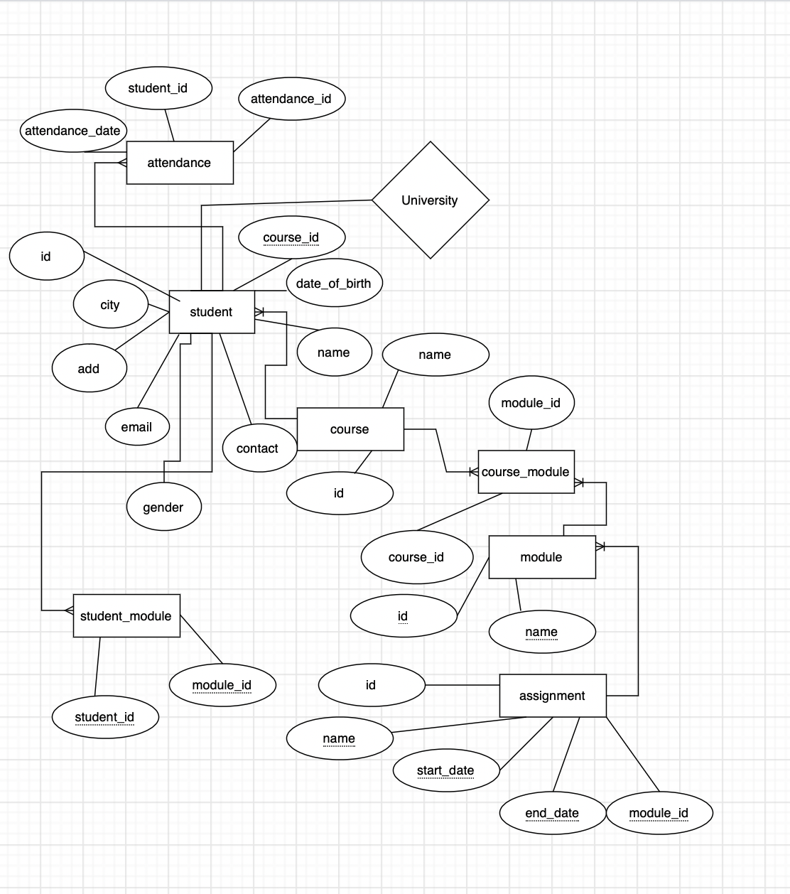

Figure: ER-model

References

Srivastava, A., Bhardwaj, S., & Saraswat, S. (2017). SCRUM model for agile methodology. 2017 *International Conference on Computing, Communication and Automation (ICCCA)*. https://doi.org/10.1109/ccaa.2017.8229928