Task 4: set up and use firewall on Windows/Linux

I have used Linux machine to set up firewall and used windows machine to test the firewalls rules set on linux machine.

Steps:

1. There is no firewall installed in my linux machine

So I have installed UFW for my linux using the command :> sudo apt install ufw.

1. After the UFW is installed. We have to start the firewall

Command to start ufw: > sudo ufw enable

This will enable the firewall services on the machine

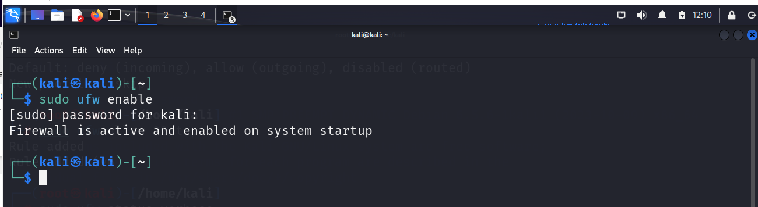

1. We can list current firewall rules:

Command: sudo ufw status verbose

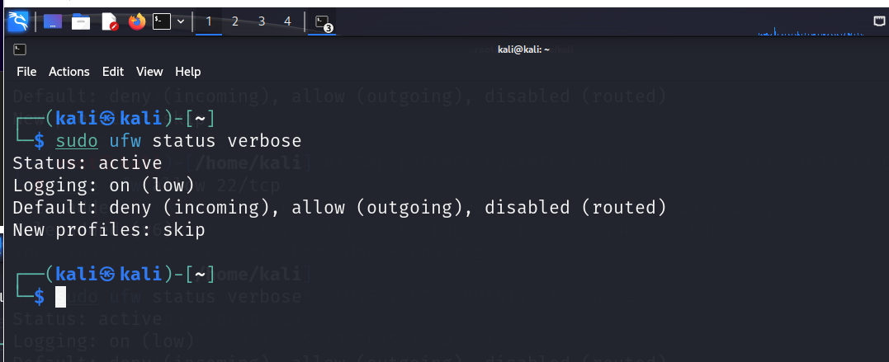

We can see by default the ufw is denying all incoming traffic and allows all outgoing traffic.

1. To block specific incoming port traffic we can add the rules to the firewall

In this example, I have taken to allow ssh incoming traffic (i.e.port 22)

And Deny ssh incoming traffic.

If the ufw is disabled and we start ssh service , machine will allow ssh traffic, if the firewall is enabled it will by default deny incoming ssh traffic even if the ssh service is running on your localhost machine.

To check this, I have disabled firewall, started ssh service with command

>sudo systemctl start ssh

When the firewall is disabled, I have tested it from the remote machine (windows machine) . The output expected is to allow the incoming ssh traffic: is as follows

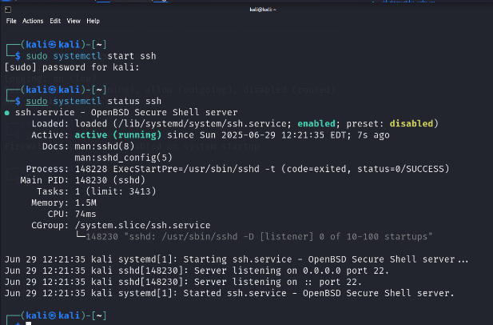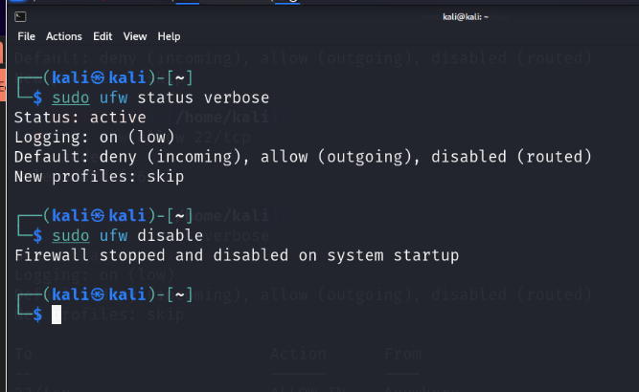

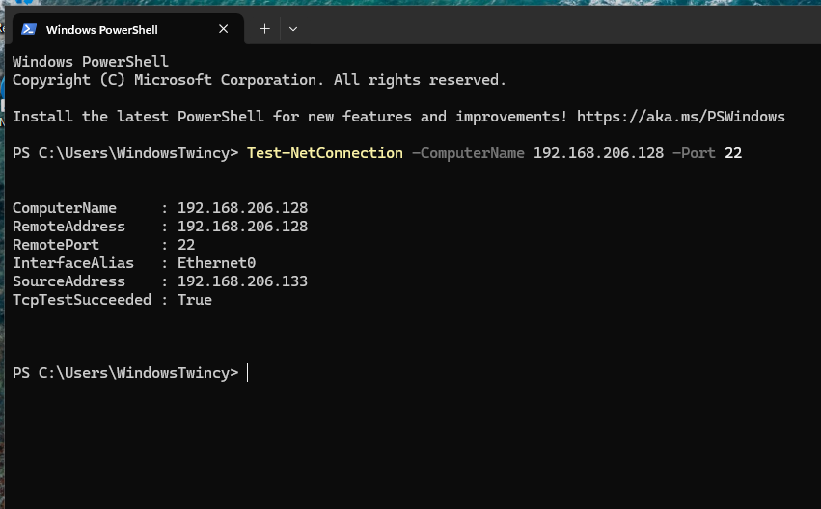

1. Later,I have enabled ufw with ssh running, so by default all incoming traffic is denied.

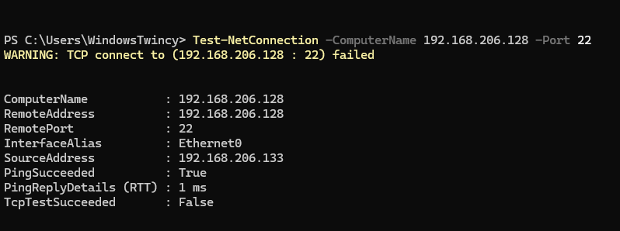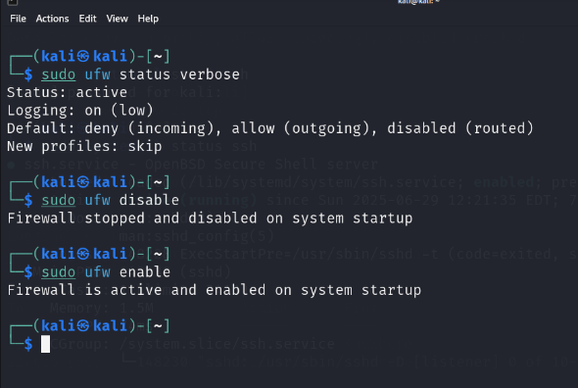

1. I have added a rule in ufw(firewall) to allow ssh incoming traffic

Command: sudo ufw allow 22/tcp

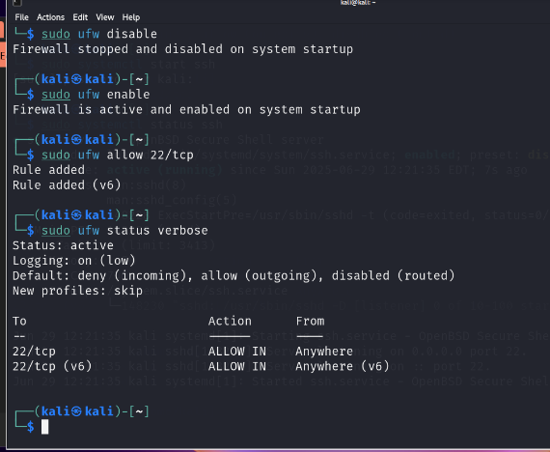

1. If we test the Connection now in a remote machine, expected result is that firewall should allow ssh connection. The result is as follows

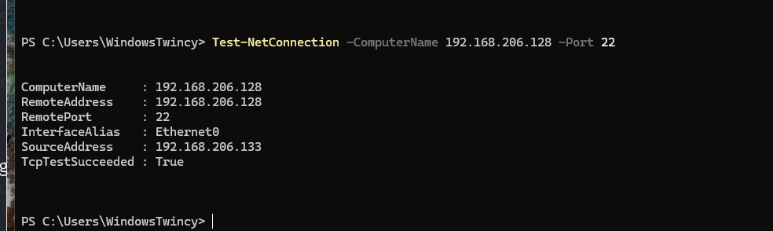

So we can see that firewall is working correctly by allowing incoming traffic on port 22(ssh)

1. I have deleted the rule created and restored to original, and the expected result is that , Firewall should be blocking ssh and the result is as follows

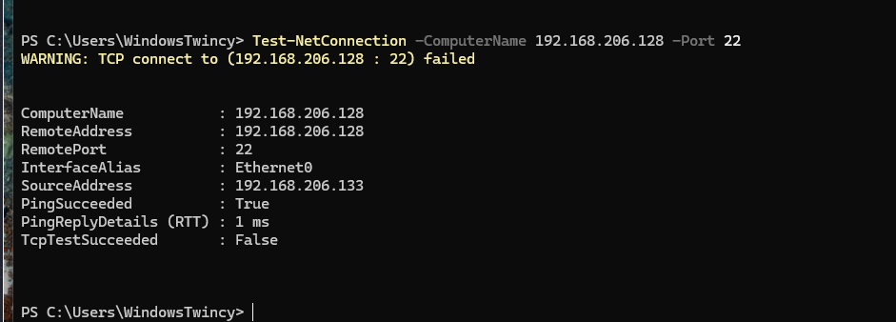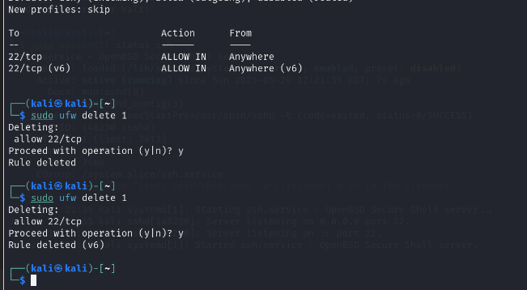

So by this we can see how firewall is working by allowing us to create specific custom rules while having the rules already at place.

It allows to create custom rules and works accordingly.

This helps us for blocking internet access to specific applications or ports.