**Task 7: Learn to spot and remove potentially harmful browser extensions**

**Tools: Chrome browser**

**What are Browser Extensions?**

**Browser extensions** (also called add-ons or plugins) are small software programs that customize or enhance the functionality of a web browser.

**Advantages:**

* They are useful to prevent malware downloads, force secure connections and to block adds for a seamless user experience.
* Add new features
* Improve productivity
* Block unwanted content
* Change how websites behave
* Integrate with third-party tools

**Disadvantages:**

Not all extensions are trustworthy. Some may:

* Collect browsing data
* Show unwanted ads
* Redirect your searches
* Install malware

**How to view extensions in our Browser:**

**Steps:**

1. Open your browser and click on the 3 dots , on the left corner of the page, you can see the options 🡪 search for Extensions and click on it.

You can see what extensions are available for your browser.

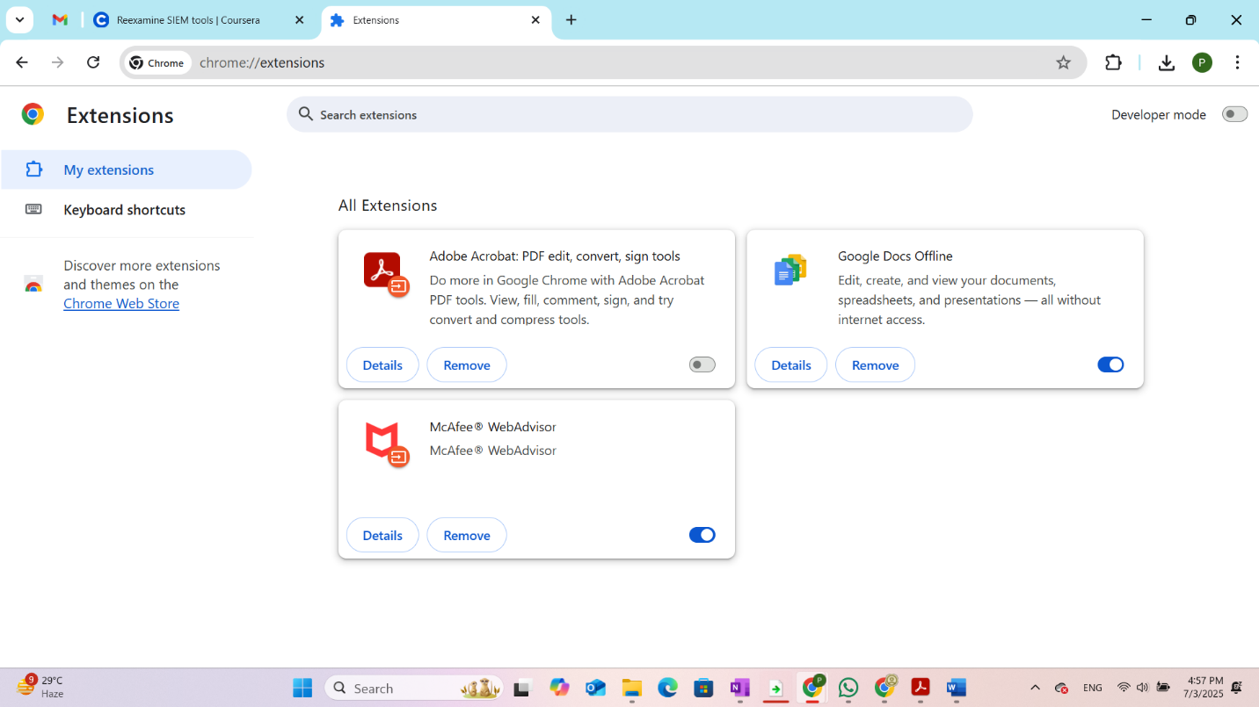

2.In my browser I have 3 extensions: Adobe, Google Docs, McAfee.

You can click on details in each of the extension to see the details of the extension and the permissions which are allowed in the extension.

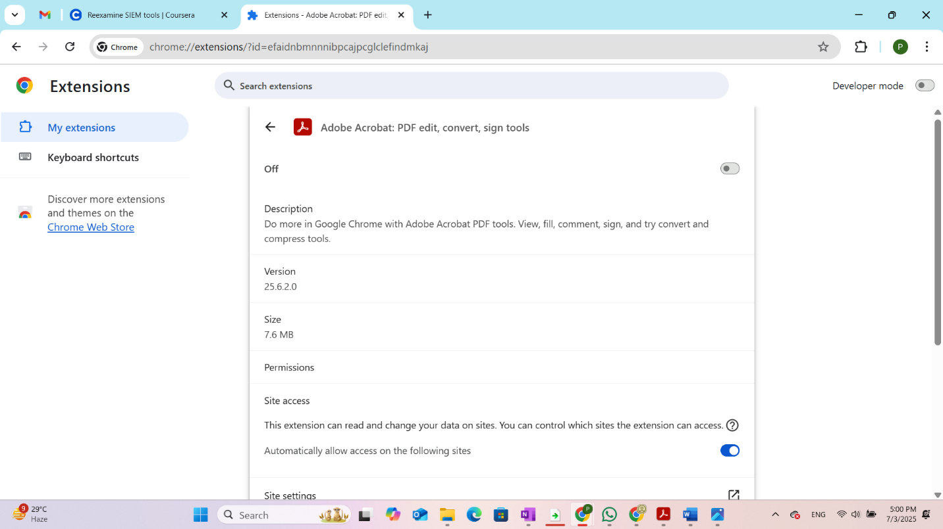

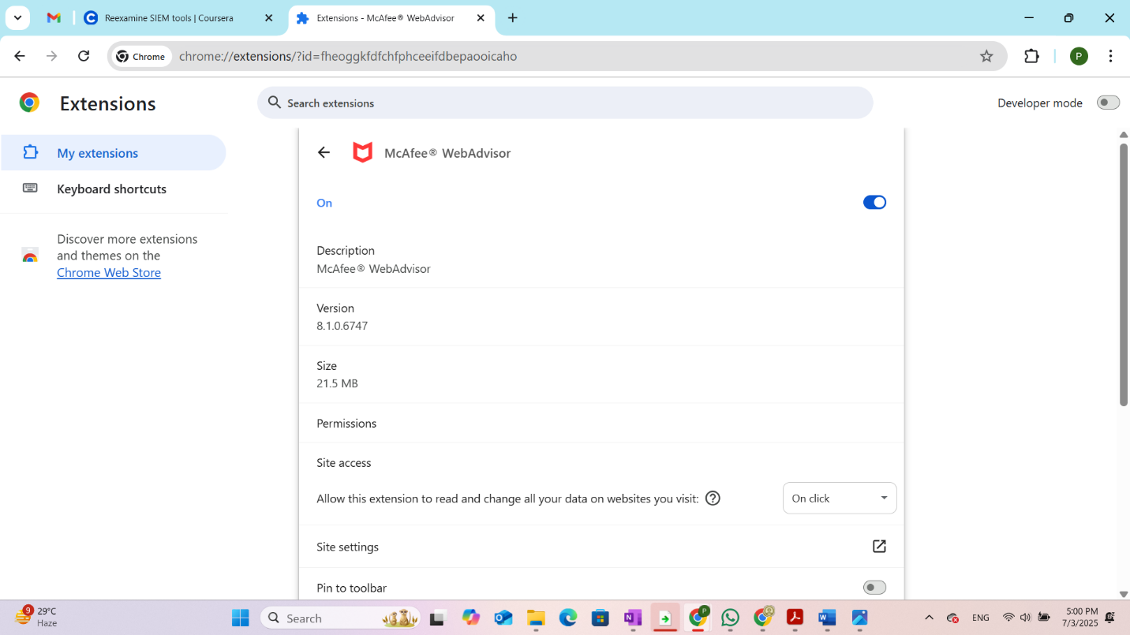

3. Both the extensions I have in my browser has site access permission which allows the extension to collect the browsing data, permission to read and change all the data on the websites I visit.

4. Since those extensions require additional permissions to read my browsing data , I wish to disable those extensions.

5. Adobe is already disabled.

6. I have disabled my McAfee extension now.

7. We have an option to delete/ remove the browser extension beside the Details option (you can see in the above screenshot)

**How to identify malicious Browser Extensions?**

**It is always better to check before adding an extension**

* Who published it
* User reviews and ratings
* Permissions it asks for
* Number of installs
* Last update date

**Browser Extensions may:**

* Steal our personal data by capturing login data or by accessing cookies.
* They might spy on our browsing data by collecting every site we visit and record the time we spend on each site.
* They might redirect us to fake websites or phishing sites.
* They might download files secretly without us knowing about it which can harm our computer.

**So we can remove the unwanted extensions**:

Browser extensions may harm your computer if you have given additional permissions that can collect your browsing data.

* Untrusted extensions may collect the data, it is always best to check for the allowed permissions.
* If the extension is asking for too many permissions like reading browsing data, cookies etc., it is better to remove that extension as it is no useful for your computer.
* Latest web browser already been designed to detect and block malicious sites, also they can scan for harmful downloads and warn you.
* So additional extensions are not required if you have good antivirus downloaded on you desktop, windows defender etc can do the job well.
* Browser extensions may slow down the system unnecessarily so it can be avoided.
* Some trusted extensions can be added for the improved performance.