 | 
EV-AGENT: AGENTIC AI POWERED SMART EV
CHARGING PLATFORM
A PROJECT REPORT
Submitted by
PRASANNAA DP
in partial fulfilment for the award of the degree
of
BACHELOR OF TECHNOLOGY
in
ARTIFICIAL INTELLIGENCE AND DATA SCIENCE
PRATHYUSHA ENGINEERING COLLEGE
(AN AUTONOMOUS INSTITUTION)
TIRUVALLUR – 602 025
SEPTEMBER 2026

PRATHYUSHA ENGINEERING COLLEGE
(AN AUTONOMOUS INSTITUTION)
TIRUVALLUR – 602 025
BONAFIDE CERTIFICATE
Certified that this project report “EV-AGENT: AGENTIC AI POWERED SMART EV CHARGING PLATFORM” is the Bonafide work of “PRASANNAA DP” who carried out the project work under my supervision.

SIGNATURE  SUPERVISOR  Ms. Angalaparameswari  Assistant Professor,  Department of AI & DS,  Prathyusha Engineering College,  Tiruvallur- 602025 | SIGNATURE  HEAD OF THE DEPARTMENT  Ms. R. Kannamma  Assistant Professor,  Department of AI & DS,  Prathyusha Engineering College,  Tiruvallur- 602025

Place: Tiruvallur
Date:
Submitted for the project vice-voce held on .......................... at Prathyusha Engineering College, Tiruvallur- 602 025.

INTERNAL EXAMINER | EXTERNAL EXAMINER

ACKNOWLEDGEMENT
I sincerely thank Shri. P. RAJARAO, Chairman, Shri. CHARAN TEJA, Vice Chairman and Smt. P. PRATHYUSHA, CEO, Prathyusha Engineering College for facilitating me to do this project.
I would like to express my heartfelt gratitude to the Principal of Prathyusha Engineering College for providing the academic environment and support required for completing this project.
I am sincerely thanking Ms. R. Kannamma, Assistant Professor and Head of the Department of Artificial Intelligence and Data Science, for her guidance and encouragement throughout the project.
I am grateful to Dr. C. Srivenkateswaran, Professor and Project Coordinator, for his valuable suggestions, review support and guidance during the development of the project.
I am more thankful to my project Supervisor, Ms. Angalaparameswari, Assistant Professor, Department of Artificial Intelligence and Data Science, for assisting me with her suggestions and continuous support to complete this project.
I also wish to extend my sincere thanks to all the committee members for their constant support throughout the project reviews.
I wish to express my sincere gratitude to my parents and friends for their valuable help, cooperation and encouragement during this project work.

COMPANY BONAFIDE CERTIFICATE
ACADEMIC MINI PROJECT
EV-Agent: Agentic AI Powered Smart EV Charging Platform
This project was carried out as academic Mini Project Work.
No external company bonafide certificate is applicable to this project.

ABSTRACT
EV-Agent: Agentic AI Powered Smart EV Charging Platform is a staged intelligent mobility platform developed to improve electric-vehicle charging discovery, route-aware station selection and charging decision support for Chennai. The architecture combines user and vehicle information, charging-station data, geospatial routing, weather context, recommendation logic and an agentic decision layer. The supplied project documentation records Stage 1 and Stage 2 as completed foundations covering the frontend interface, Chennai reference dataset, open-data integration, canonical schemas, deduplication, conflict auditing, routing and weather enrichment. Telemetry ingestion and autonomous recommendation/optimization are defined as later stages. The Chennai reference dataset contains operator, location, coordinate, connector and charging-power fields and is explicitly treated as seed data. Station location is separated from live availability, while data source, verification time and demo status are recorded. Approximate coordinates require independent verification. The platform integrates sources such as BEE, Open Charge Map, OpenStreetMap, OSRM, Open-Meteo and TNEV. A Haversine proximity rule and name similarity support deduplication, while source discrepancies are retained in an audit trail. The prototype provides dashboard, station-registry, map, recommendation and reservation-oriented views. OSRM adds route context and Open-Meteo adds weather information, while demo or simulated vehicle states are distinguished from live operational data. The project therefore provides a foundation for future context-aware charging decisions based on battery state, user preferences, compatibility, availability, travel constraints, charging power, price and environmental context. The current work is a proof-of-concept and does not claim validated live charger availability, autonomous charger control or measured cost or energy savings.
Keywords:
Electric Vehicles, EV Charging, Agentic AI, Charging Station Recommendation, OSINT, Open Charge Map, OpenStreetMap, OSRM, Open-Meteo, Geospatial Routing, Smart Charging, Chennai

TABLE OF CONTENTS
CHAPTER NO. | TITLE | PAGE NO.
 | ABSTRACT | v
 | LIST OF FIGURES | viii
 | LIST OF TABLES | ix
 | LIST OF ABBREVIATIONS | x
 | LIST OF SYMBOLS | xii
1 | INTRODUCTION | 1
1.1 | OVERVIEW | 2
1.2 | PROBLEM STATEMENT | 3
1.3 | OBJECTIVE | 4
1.4 | SCOPE OF THE PROJECT | 4
1.5 | PROJECT MOTIVATION | 5
2 | LITERATURE SURVEY | 6
3 | SYSTEM ANALYSIS | 10
3.1 | EXISTING SYSTEM | 11
3.1.1 | DISADVANTAGES | 11
3.2 | PROPOSED SYSTEM | 12
3.2.1 | ADVANTAGES | 12
3.3 | SYSTEM REQUIREMENTS | 13
3.3.1 | HARDWARE REQUIREMENTS | 13
3.3.1.1 | MINIMUM REQUIREMENTS | 13
3.3.1.2 | RECOMMENDED REQUIREMENTS | 13
3.3.2 | SOFTWARE REQUIREMENTS | 13
3.4 | SOFTWARE DESCRIPTION | 14
4 | SYSTEM DESIGN | 15
4.1 | SYSTEM ARCHITECTURE | 17
4.2 | UML DIAGRAM | 18
4.2.1 | CLASS DIAGRAM | 18
4.2.2 | SEQUENCE DIAGRAM | 19

TABLE OF CONTENTS
CHAPTER NO. | TITLE | PAGE NO.
5 | SYSTEM IMPLEMENTATION | 20
5.1 | LIST OF MODULES | 21
5.2 | MODULE DESCRIPTION | 21
5.2.1 | DATA COLLECTION & CANONICALIZATION | 21
5.2.2 | DEDUPLICATION & CONFLICT AUDIT | 22
5.2.3 | ROUTING & WEATHER ENRICHMENT | 22
5.2.4 | RECOMMENDATION & AGENTIC DECISION LAYER | 22
5.2.5 | RESERVATION & CHARGING SESSION UI | 23
5.2.6 | DATA INTEGRITY & DEMO/LIVE SAFEGUARDS | 23
5.2.7 | CANONICAL STATION DATA FIELDS | 23
6 | TESTING | 24
6.1 | UNIT TESTING | 25
6.1.1 | TEST OBJECTIVES | 25
6.2 | INTEGRATION TESTING | 26
6.3 | SYSTEM TESTING | 26
7 | RESULTS AND DISCUSSION | 27
7.1 | RESULTS | 28
7.2 | DISCUSSION | 29
8 | CONCLUSION AND FUTURE ENHANCEMENT | 30
8.1 | CONCLUSION | 31
8.2 | FUTURE ENHANCEMENT | 31
 | ANNEXURE | 33
APPENDIX A | SOURCE CODE | 34
APPENDIX B | SCREENSHOTS | 39
APPENDIX C | DATA SCHEMA AND SAMPLE RECORDS | 43
 | REFERENCES | 44
 | PROJECT COMPLETION CERTIFICATE | 45

LIST OF FIGURES
FIGURE NO. | FIGURE NAME | PAGE NO.
4.1.1 | System architecture for proposed EV-Agent platform | 18
4.2.1 | Class diagram for proposed EV-Agent platform | 18
4.2.2 | Sequence diagram for recommendation and reservation flow | 19
7.1.1 | EV-Agent desktop dashboard prototype | 29
7.1.2 | Charging station registry prototype | 29
B.1 | EV-Agent dashboard output | 39
B.2 | Station registry output | 40
B.3 | Chennai map output | 41
B.4 | Recommendation/reservation output | 42

LIST OF TABLES
TABLE NO. | TABLE NAME | PAGE NO.
3.3.1.1 | MINIMUM REQUIREMENTS | 13
3.3.1.2 | RECOMMENDED REQUIREMENTS | 13
3.3.2 | SOFTWARE REQUIREMENTS | 13
5.1.1 | MODULE SUMMARY | 21
5.2.1 | CANONICAL STATION DATA FIELDS | 23
6.1.1 | UNIT TEST CASES | 25
6.2.1 | INTEGRATION TEST CASES | 26
6.3.1 | SYSTEM TEST CASES | 26

LIST OF ABBREVIATIONS
AI Artificial Intelligence
API Application Programming Interface
AC Alternating Current
BEE Bureau of Energy Efficiency
CCS2 Combined Charging System 2
CSV Comma-Separated Values
DC Direct Current
EV Electric Vehicle
EVCS Electric Vehicle Charging Station
GPS Global Positioning System
HTML HyperText Markup Language
HTTP HyperText Transfer Protocol
IEA International Energy Agency
INR Indian Rupee
JSON JavaScript Object Notation
ML Machine Learning
OCM Open Charge Map
OSM OpenStreetMap
OSRM Open Source Routing Machine
REST Representational State Transfer
SoC State of Charge
SQL Structured Query Language
TTL Time To Live
TNEV Tamil Nadu Electric Vehicle platform
TNGECL Tamil Nadu Green Energy Company Limited
UI User Interface
V2G Vehicle-to-Grid
kW Kilowatt
kWh Kilowatt-hour

LIST OF ABBREVIATIONS
OSINT Open-Source Intelligence
ETA Estimated Time of Arrival
EVSE Electric Vehicle Supply Equipment
GIS Geographic Information System
LLM Large Language Model
PWA Progressive Web Application
QR Quick Response
SSE Server-Sent Events
URL Uniform Resource Locator
VIN Vehicle Identification Number

LIST OF SYMBOLS
S.NO | NOTATION NAME | DESCRIPTION
1 | Class | Represents a collection of similar entities grouped together
2 | Association | Represents a static relationship between classes or modules
3 | Actor | Specifies a role played by a user that interacts with the system
4 | Communication | Represents communication between system elements or use cases
5 | Initial State | Initial state of an interaction or process
6 | Final State | Final state of an interaction or process
7 | Control Flow | Represents process flow between states or modules
8 | Decision Box | Represents decision-making based on constraints

CHAPTER 1
INTRODUCTION

CHAPTER 1
INTRODUCTION
1.1 OVERVIEW
The increasing adoption of electric vehicles has changed the requirements placed on transportation energy infrastructure. Charging is not equivalent to refuelling a conventional vehicle because the time taken, charging power, connector compatibility, queue conditions, route constraints, electricity price and available facilities can all influence the usefulness of a charging station. A driver may therefore face a decision problem rather than a simple location lookup problem.
The EV-Agent project addresses this decision problem through a staged platform for Chennai. The project materials describe the platform as a multi-stage engineering system for charging discovery, routing and energy management. The current prototype focuses on the data and interaction foundation: it brings together public and open data sources, normalizes station records, resolves duplicates, audits conflicts, calculates route context and displays station information through a desktop and mobile-oriented interface.
The platform is organized around an EV-Agent core that connects user and vehicle information with external data. The reference architecture contains a Data Collection Module, AI Analysis Module, Agentic AI Decision Module and Charging Optimization Module. These components are intended to transform raw station and mobility data into a recommendation that is understandable to the driver and adaptable to changing context. The implementation status is intentionally staged: the project README records Stage 1 and Stage 2 as completed, while telemetry ingestion and the autonomous recommendation/optimization engine are identified as planned stages.
A key design requirement is data integrity. The Chennai station reference document explicitly distinguishes a station location from live availability and states that a station listed in a dataset is not evidence that a charger is available at a particular moment. Approximate coordinates are similarly treated as non-production data until they are independently verified. EV-Agent therefore records data source, verification time and demo status and keeps simulated data visually distinct from operational states.
The platform also incorporates geospatial intelligence. OSRM is used for road-route analysis, while OpenStreetMap provides geographic context and Open-Meteo supplies weather information. The project design uses these services to enrich station selection with travel distance, estimated travel time and environmental conditions rather than relying only on straight-line proximity. Open Charge Map and other public sources provide charging-station information that can be normalized into a canonical station entity.
1.2 PROBLEM STATEMENT
Conventional EV charging applications generally expose station lists, maps or simple filtering options. These interfaces are useful for discovery, but they do not necessarily solve the larger problem of deciding when and where an EV should charge under multiple constraints. A driver may need a station that is close to the current route, compatible with the vehicle, available at the required time, sufficiently fast, affordable and aligned with personal preferences. The decision becomes harder when different public data sources disagree or when some records contain only approximate coordinates.
Another challenge is the gap between static recommendation systems and autonomous decision support. Recent research demonstrates the value of multi-factor recommendation, user preferences and learned ranking. However, the supplied literature largely treats recommendation as a scoring or optimization task rather than as a continuously orchestrated agentic workflow that combines external data, routing context, vehicle state and explicit user controls. EV-Agent is positioned as an engineering platform intended to connect these elements while keeping the human driver informed.
The project therefore addresses four related gaps: fragmented charging information, weak context awareness, limited data-integrity controls and insufficient integration between recommendation and the charging-session workflow. The present prototype concentrates on building a trustworthy foundation for these functions rather than claiming production-grade autonomous control.
1.3 OBJECTIVE
• Provide an intelligent platform for identifying charging stations and charging options from multiple data sources.
• Collect and normalize station information into a consistent canonical schema that can support downstream analysis.
• Use geospatial routing and environmental context to enrich station selection beyond simple proximity.
• Incorporate user and vehicle preferences such as State of Charge, destination, charging requirements and desired charging characteristics.
• Provide a recommendation interface that explains station information, route context, estimated cost and charging characteristics.
• Create a staged architecture in which telemetry ingestion, agentic decision-making and dynamic optimization can be added without redesigning the entire platform.
• Maintain clear separation between verified, estimated, operator-listed, live-status and demo records so that simulated information is not confused with real infrastructure.
1.4 SCOPE OF THE PROJECT
The scope covers the design and prototype implementation of an urban EV charging intelligence platform focused on Chennai. The completed project materials include a frontend prototype, a defined visual design system, a Chennai charging-station reference dataset, an OSINT/open-data integration layer, data schemas, deduplication and conflict-audit logic, route calculation through OSRM and weather enrichment through Open-Meteo. The interface includes station registry, Chennai map, dashboard, recommendation and reservation-oriented views.
The scope also includes the definition of future system layers for vehicle telemetry and autonomous optimization. These layers are intentionally separated from the current implementation status. Stage 3 is defined for telemetry ingestion and real-time EV diagnostics, while Stage 4 is defined for an autonomous recommendation engine and dynamic optimization. This staging supports incremental development and reduces the risk of presenting simulated vehicle information as live telemetry.
The scope does not establish production-grade charger control, does not guarantee current charger availability from the seed dataset and does not provide a validated percentage reduction in charging cost or energy consumption. Such claims require live data, controlled experiments and a vehicle or charger integration environment that are not supplied with the current project materials.
1.5 PROJECT MOTIVATION
Research on EV charging repeatedly identifies the need to move beyond single-factor selection. The literature supplied for this project discusses charging cost, charging time, travel distance, station availability, station preferences and charging infrastructure planning as distinct but interacting concerns. This creates a strong motivation for a platform that can assemble these factors in a single workflow rather than making users switch between multiple tools.
The project is also motivated by the practical characteristics of Chennai as a dense urban corridor with varied road conditions, many operator networks and heterogeneous station records. A map or a station directory alone cannot resolve differences in source quality, coordinate accuracy or current operational status. EV-Agent therefore treats data provenance and conflict visibility as first-class engineering requirements, while still providing the intuitive interactions expected from a mobility application.
Finally, agentic AI is used in the project as a future-oriented orchestration concept rather than a claim that all autonomous functions are already production ready. The architecture reserves a dedicated decision layer so that future versions can combine vehicle state, route conditions, station data, weather and user preferences into context-aware actions. This makes the current platform a foundation on which progressively more autonomous charging management can be built.
CHAPTER 2
LITERATURE SURVEY

CHAPTER 2
LITERATURE SURVEY
Recent research on EV charging station selection can be grouped into four themes: charging infrastructure and technology reviews, optimal station placement and grid impact, multi-criteria user-preference-based recommendation, and data-driven personalization. The papers supplied for this project represent all four themes and provide the technical motivation for the EV-Agent architecture.
[1] Savari et al. (2022) – Assessment of charging technologies, infrastructure and charging station recommendation schemes of electric vehicles: A review
Savari et al. provide a broad review of EV charging infrastructure, charging technologies and charging-station identification. The work discusses charging power, power transfer between EVs and the grid, infrastructure requirements and customer-facing station selection. The review emphasizes that users need more than a list of charging locations, because station choice depends on technical characteristics, availability and practical service considerations. This paper therefore supports the EV-Agent decision to combine infrastructure data with user-facing recommendation logic.
For the EV-Agent project, the limitation is not in the review itself but in the gap between reviewing multiple charging technologies and implementing an integrated urban decision-support workflow. The project extends the discussion into a prototype that normalizes station records, connects public sources, adds route context and exposes station choices through a single interface.
[2] Ahmad et al. (2022) – Optimal location of electric vehicle charging station and its impact on distribution network: A review
Ahmad et al. review the EV charging-station location problem from the perspective of infrastructure planning and distribution-network impact. The paper surveys objective functions, constraints, EV load modelling, uncertainty, renewable-energy integration, charging types and optimization techniques. The review demonstrates that charging infrastructure cannot be designed independently of network effects and demand patterns.
The focus of this research is mainly system-level placement and distribution planning. EV-Agent addresses a different layer of the problem: once stations exist, a driver still needs a context-aware way to identify a suitable station along a route. The two perspectives are complementary. Infrastructure planning can determine where stations should exist, while an urban recommendation platform can help users decide which station to use at a particular time.
[3] Liu et al. (2023) – Study on Two-Tier EV Charging Station Recommendation Strategy under Multi-Factor Influence
Liu et al. propose a two-tier recommendation strategy that separates high-level battery alerts from general charging needs. For urgent users, charging distance is given greater priority. For general users, the paper evaluates charging price, charging time, charging-station preference and distance together. The authors use real EV-station and ride-hailing data from Xiamen and report improved stability across service-density variance, coverage rate, price cost and distance cost compared with single-factor approaches.
This work is especially relevant to EV-Agent because it demonstrates the importance of multi-factor recommendation and state-dependent prioritization. The EV-Agent architecture similarly places battery state, travel context, station characteristics and user requirements inside a broader decision layer. The major difference is architectural: EV-Agent is designed as a data-orchestration and agentic platform that can ingest heterogeneous external sources and present an explainable action flow to the user.
[4] Habbal and Alrifaie (2024) – A User-Preference-Based Charging Station Recommendation for Electric Vehicles
Habbal and Alrifaie propose a User-Preferences based Charging Station Recommendation Scheme using multiple-attribute decision-making. Their method uses the Analytical Hierarchical Process (AHP) to derive criterion weights and TOPSIS to rank available charging stations. The selected criteria include practical user concerns such as travel distance, waiting time, charging time, price and other service requirements. The method is evaluated in MATLAB using a real dataset from the U.S. Department of Energy and is intended to produce more personalized recommendations than approaches based only on proximity or price.
The paper provides direct methodological support for personalized station selection. EV-Agent adopts the same problem framing at a platform level but does not claim to implement the exact AHP-TOPSIS algorithm from the paper. Instead, the current prototype establishes the data, routing and UI layers required to support a multi-factor recommendation engine. Future work can incorporate an explicit multi-criteria weighting model or a learned ranking model within the agentic decision module.
[5] Li et al. (2024) – Electric Vehicle Charging Station Recommendations Considering User Charging Preferences Based on Comment Data
Li et al. investigate personalized EV charging-station recommendation using user comment data. Their hybrid method combines LightGBM for user-rating and feature-importance analysis with singular value decomposition (SVD) for recommendation. The study uses 28,306 charging orders from 508 users at 241 charging stations in Linyi, China and reports improved precision, recall and F1 compared with benchmark approaches. The paper also notes limitations involving data-collection duration and computational complexity for larger or more dynamic settings.
The paper is relevant to EV-Agent because it illustrates how personalization can be learned rather than manually configured. The current project does not implement the LightGBM-SVD pipeline. Instead, it stores user and station attributes in a form that can support later ranking or preference-learning models. The design can therefore evolve from explicit user preferences toward behavior-driven personalization without changing the underlying station-data layer.
Literature Synthesis
The literature indicates that EV charging decisions are inherently multi-factor. Infrastructure reviews explain the technical diversity of chargers; placement reviews address network-level planning; multi-factor recommendation studies show that distance, price, waiting time, charging time and preference should be considered together; and preference-learning research demonstrates that historical user behavior can further personalize ranking. Across these studies, the core challenge is to integrate dynamic information without sacrificing decision quality or transparency.
EV-Agent is designed around this integration requirement. Its data-collection layer aggregates heterogeneous sources, the canonical schema provides consistent station entities, the deduplication engine reduces multiple records for the same station, route and weather adapters enrich context, and the recommendation layer is reserved for multi-factor decision-making. The current prototype therefore serves as the engineering bridge between data integration and future autonomous charging decisions.
CHAPTER 3
SYSTEM ANALYSIS

CHAPTER 3
SYSTEM ANALYSIS
3.1 EXISTING SYSTEM
The existing EV charging experience typically consists of map applications, operator-specific charging applications, station directories and manually planned charging stops. These services can answer questions such as “Where is the nearest station?” but the decision is often fragmented across providers. A driver may have to compare multiple operator pages, interpret different connector names, estimate route time separately and determine whether a listed station is actually operational.
The project literature also shows that different research systems optimize different objectives. Some focus on station placement, others on cost, distance or time, while user-preference systems introduce multi-criteria ranking. These approaches solve valuable sub-problems but are not necessarily packaged as one urban mobility workflow.
3.1.1 DISADVANTAGES
• Data is fragmented across charging-network operators and public directories.
• Station listings may not reflect real-time charger availability.
• Different sources may contain duplicate or conflicting records for the same station.
• Approximate coordinates can produce incorrect map placement if treated as exact data.
• Simple nearest-station logic ignores connector compatibility, charging power, route context and user priorities.
• Users may need to manually compare cost, charging speed and travel distance.
• Autonomous or agentic decision-making is generally separated from the station-discovery interface.
3.2 PROPOSED SYSTEM
The proposed EV-Agent system is a modular platform that connects the driver, vehicle profile, external charging data and route context through an orchestration layer. The project architecture groups the platform into four core logical modules: Data Collection, AI Analysis, Agentic AI Decision and Charging Optimization. These modules are surrounded by a station network, an EV context layer and external data services.
The implementation currently emphasizes the data and interface foundation. Public and open data adapters feed a canonical station schema. Normalization and deduplication produce a cleaner set of station entities, while an audit mechanism records conflicts instead of silently choosing one source. OSRM provides route analysis, Open-Meteo contributes weather context and the user interface exposes station information, map views, recommendations and reservation-oriented flows. Future telemetry and autonomous optimization can consume this same normalized data layer.
3.2.1 ADVANTAGES
• Provides a single workflow for station discovery, route context and recommendation.
• Normalizes heterogeneous station records into a canonical 22-field schema.
• Uses source provenance, verification timestamps and demo flags to support data integrity.
• Uses Haversine proximity and name similarity to reduce duplicate station records.
• Logs source conflicts rather than performing silent overwrites.
• Adds road-network routing and weather context to station information.
• Keeps agentic and simulated functions visually distinguishable from live infrastructure states.
• Allows future vehicle telemetry and dynamic optimization modules to be integrated incrementally.
3.3 SYSTEM REQUIREMENTS
3.3.1 HARDWARE REQUIREMENTS
3.3.1.1 MINIMUM REQUIREMENTS
Component | Minimum Specification
Processor | Dual-core 64-bit processor, 2.0 GHz or better
RAM | 8 GB
Storage | 10 GB available SSD/HDD space
Display | 1366 × 768 or better
Network | Stable internet connection for external open-data services
Browser | Modern Chromium/Firefox/Edge/Safari browser

3.3.1.2 RECOMMENDED REQUIREMENTS
Component | Recommended Specification
Processor | Quad-core 64-bit processor or better
RAM | 16 GB
Storage | 20 GB free SSD space
Display | 1920 × 1080 or better
Network | Reliable broadband / 4G / 5G connection
GPU | Not required for current Stage 1/2 prototype; optional for future ML workloads

3.3.2 SOFTWARE REQUIREMENTS
Category | Specification
Frontend | React 19, TypeScript, Vite, Tailwind CSS, Lucide React
Mapping | Leaflet and React-Leaflet
Backend | Python 3.12+, Flask, urllib3
Database | SQLite 3
Geospatial / Routing | OpenStreetMap, Overpass, Nominatim, OSRM
Weather | Open-Meteo Weather API
Charging Data | Open Charge Map, BEE dataset, TNEV directory and network adapters
Development | VS Code or equivalent editor, Git, Node.js/npm, Python virtual environment

3.4 SOFTWARE DESCRIPTION
3.4.1 Python
Python is used for the backend and data-oriented processing layer. Its role is to support API services, station-data transformations, OSINT adapter logic, deduplication, audit handling and the data flow required for recommendation-oriented features. The project README specifies Python 3.12+ for the backend environment.
3.4.2 Flask
Flask provides the lightweight backend web framework for EV-Agent. It is suitable for exposing REST-style services, handling incoming requests and connecting the interface to data-processing logic. The project materials specify Flask together with SQLite and urllib3, providing a compact backend suitable for a prototype that relies heavily on external open-data services.
3.4.3 React, TypeScript and Vite
The frontend is implemented using React 19 with TypeScript and Vite. React supports a component-oriented interface in which station cards, telemetry panels, maps, recommendation drawers and reservation controls can be maintained independently. TypeScript provides static structure for data passed between UI components, while Vite supports a fast development workflow and production build process.
3.4.4 SQLite
SQLite is used as the local persistence layer for the normalized station entities and related application data. The README describes a canonical 22-field schema and indicates that station entities are normalized with individual hardware charger mapping. SQLite is appropriate for the prototype because it offers transactional storage without requiring a separate database server.
3.4.5 OpenStreetMap and OSRM
OpenStreetMap provides geographic reference information, while OSRM supplies road-network routing. This combination enables route-aware charging decisions based on actual roads rather than purely geometric distance. The project README specifically records turn-by-turn driving polylines plotted on the Chennai map.
3.4.6 Open-Meteo
Open-Meteo supplies weather context for the urban corridor. The project design places weather information inside the navigation header so that environmental conditions can be incorporated into future charging-demand or travel-time reasoning.
3.4.7 Open Charge Map and Open Data Sources
Open Charge Map, BEE and other public sources provide station records that can be combined by the OSINT layer. Because source structures differ, the adapter layer converts upstream responses into a common station entity model. The architecture intentionally avoids silent merging and exposes conflict information to maintain traceability.
3.4.8 Pandas and Data Processing
Pandas and related Python tooling can support cleaning, transformation, tabular analysis and data export. In the present project, the core emphasis is on station-data normalization and the preparation of structured records for mapping and recommendation workflows rather than on large-scale model training.
CHAPTER 4
SYSTEM DESIGN

CHAPTER 4
SYSTEM DESIGN
4.1 SYSTEM ARCHITECTURE
System architecture defines how the user, EV profile, external charging data, analytical services and decision layers interact. The EV-Agent architecture follows a modular pipeline so that data acquisition and integrity management remain independent from future autonomous reasoning. This separation is particularly important because the source materials distinguish between completed data integration and future telemetry/optimization stages.
The User submits EV details, location and preferences to the platform. The Data Collection Module gathers charging-station and contextual information from external sources. The AI Analysis Module evaluates the collected data and derives features such as availability, travel distance, charging power, cost and route context. The Agentic AI Decision Module is designed to combine those signals with user goals. The Charging Optimization Module then formulates the charging plan that can be presented to the user or used by a future automated charging controller.
The architecture below is the project architecture supplied with the EV-Agent materials. It shows the external data path, the EV-Agent internal modules, the station network and the vehicle feedback relationship. The figure also communicates the intended closed-loop nature of the system: a user request produces a recommendation, the station and vehicle provide operational feedback, and the decision layer can update the plan when new information is available.
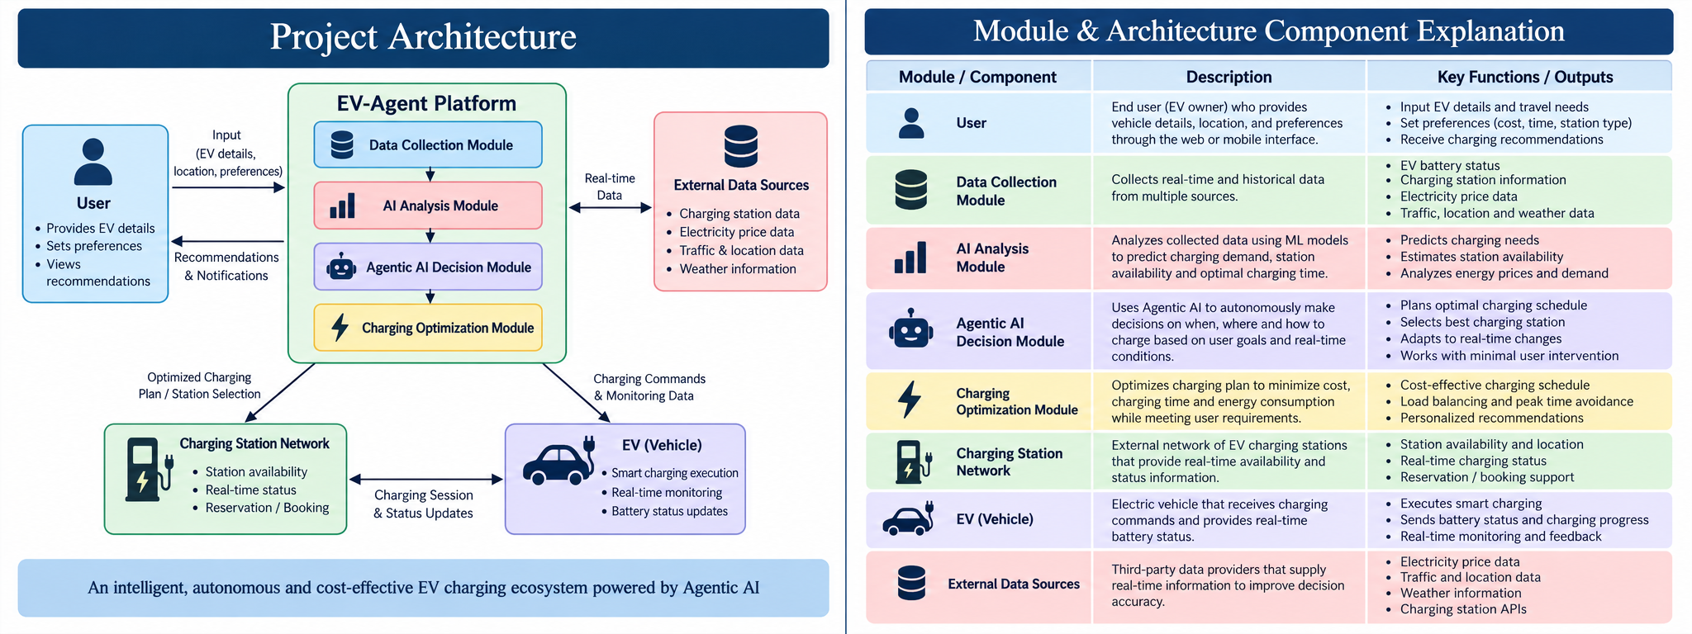
Figure 4.1.1: System architecture for proposed EV-Agent platform
4.2 UML DIAGRAM
The UML view models the software objects and interactions required to support the EV-Agent workflow. The classes are intentionally platform-oriented rather than tied to one implementation language. They represent the entities and services that the current prototype already defines or that the architecture requires for later stages.
4.2.1 CLASS DIAGRAM
The class diagram contains User and EVProfile objects for driver context, DataAdapter and StationRecord objects for external data collection, DeduplicationEngine for record linking, RouteService and WeatherService for contextual enrichment, RecommendationEngine for station ranking and Reservation for booking-oriented interactions. The diagram separates raw external data from the normalized station representation and shows how the recommendation layer consumes route and weather context.
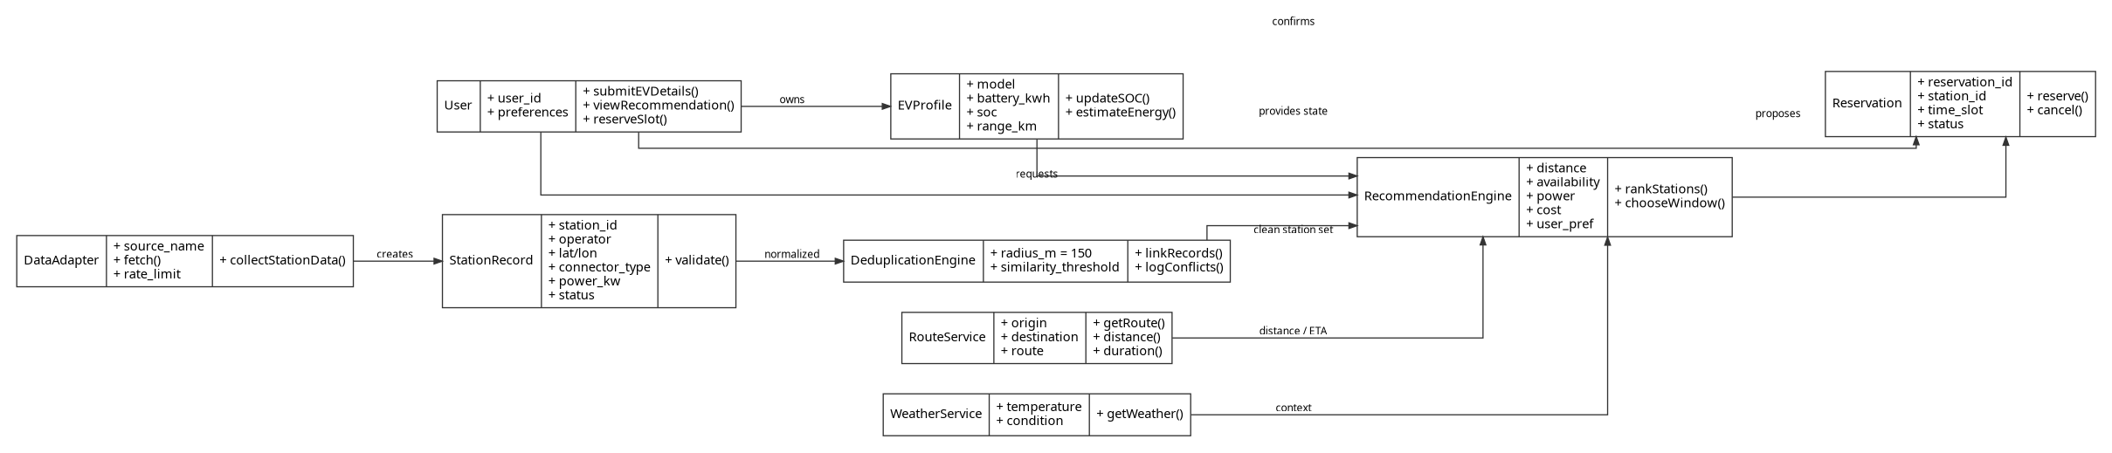
Figure 4.2.1: Class diagram for proposed EV-Agent platform
4.2.2 SEQUENCE DIAGRAM
The sequence model begins when the user enters EV details, location and preferences. The interface requests candidate stations from the backend, which invokes the open-data adapters. The returned records are normalized, deduplicated and audited before route and weather context is added. The recommendation layer then evaluates the candidate set and returns a station suggestion and rationale to the interface. A user can confirm a reservation or charging-session step through the prototype flow. Vehicle telemetry and automatic charger control are represented as later extensions rather than as currently verified live integrations.
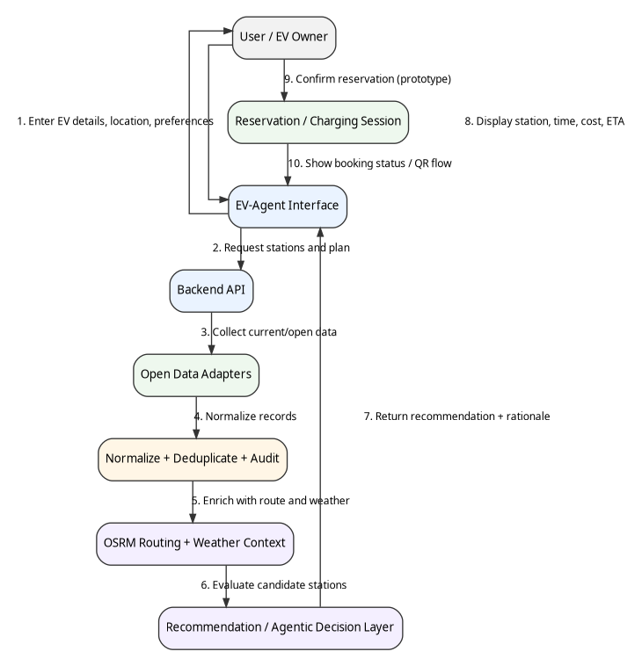
Figure 4.2.2: Sequence diagram for recommendation and reservation flow
CHAPTER 5
SYSTEM IMPLEMENTATION

CHAPTER 5
SYSTEM IMPLEMENTATION
5.1 LIST OF MODULES
MODULE | NAME | PURPOSE
1 | Data Collection & Canonicalization | Collects external station records and converts them to the common station schema.
2 | Deduplication & Conflict Audit | Links duplicate records and records disagreements between sources.
3 | Routing & Weather Enrichment | Adds road distance, travel time and weather context.
4 | Recommendation & Agentic Decision Layer | Evaluates user, vehicle, station and contextual attributes; current UI demonstrates the interaction, while deeper autonomous optimization is staged for later implementation.
5 | Reservation & Charging Session UI | Provides station detail, slot reservation and charging-session interface patterns.
6 | Data Integrity & Demo/Live Safeguards | Prevents approximate or simulated data from being presented as verified live infrastructure.

5.2 MODULE DESCRIPTION
5.2.1 DATA COLLECTION & CANONICALIZATION
The data-collection module forms the ingestion boundary of EV-Agent. The README identifies 15 open-data adapters covering BEE, Open Charge Map, OpenStreetMap Overpass, Nominatim, OSRM, Open-Meteo, the TNEV directory, Data.gov.in, IEA and six network-specific stubs. The adapters are not expected to return identical field structures, so the platform normalizes them into a canonical station entity.
The accompanying Chennai reference dataset defines 22 recommended fields: station_id, station_name, operator, address, city, area, latitude, longitude, phone, opening_time, closing_time, is_24_hours, station_status, charger_id, connector_type, charger_type, power_kw, status, price_per_kwh, last_verified_at, data_source and is_demo. This schema separates descriptive station information from charger-level information and explicitly records provenance.
5.2.2 DEDUPLICATION & CONFLICT AUDIT
The project uses a Haversine distance threshold of less than 150 metres together with tokenized name similarity to identify records that likely represent the same physical station. Deduplication is important because a single location may appear across several operator or open-data sources with slightly different station names, coordinates or metadata.
The audit conflict engine follows a zero-silent-overwrite policy. When sources disagree, the discrepancy is stored in a conflict record and can be displayed on station cards. This approach is important for an EV charging platform because a visually clean record can still be operationally wrong if one source is silently allowed to replace another.
5.2.3 ROUTING & WEATHER ENRICHMENT
OSRM provides road-aware route geometry and travel estimates for the selected origin, destination and candidate station. Unlike a straight-line distance, road routing accounts for the actual network. The README states that turn-by-turn driving polylines are plotted directly on the interactive Chennai Leaflet map.
Open-Meteo contributes ambient weather information that can be displayed alongside navigation context. In later stages, the same weather features can be passed into a demand or energy-consumption model. At present, the prototype uses weather primarily as contextual information and makes no unsupported claim that a weather variable has a measured causal effect on the charging outcome.
5.2.4 RECOMMENDATION & AGENTIC DECISION LAYER
The recommendation layer combines the factors that appear throughout the supplied project materials: battery state, travel needs, station availability, connector compatibility, charging power, distance, estimated travel time, cost and user preference. Research papers in the literature survey show the usefulness of multi-factor ranking and preference-aware recommendation, while EV-Agent provides the engineering infrastructure needed to combine these inputs.
The user interface already demonstrates an agentic recommendation card that explains why a station is suggested and exposes an action such as reserving an optimal time window. These values are prototype outputs and can be simulated. The project README classifies the autonomous recommendation engine and dynamic optimization as Stage 4, so the current implementation should be interpreted as an interface and architecture foundation for future agentic reasoning rather than a validated autonomous charging controller.
5.2.5 RESERVATION & CHARGING SESSION UI
The prototype includes a slot reservation flow and charging-session-oriented views. A station card presents connector type, charging power, tariff information and status badges. The reservation flow provides a structured path from station selection to time-slot confirmation. The visual design separates reserved, available, limited, occupied and offline states so that the interaction can later be connected to an operator booking API.
5.2.6 DATA INTEGRITY & DEMO/LIVE SAFEGUARDS
The Chennai station document is explicit that listed coordinates are seed data and that live charger availability must be verified before being represented as real-time. The project UI therefore uses badges such as DEMO / SIMULATED VEHICLE and LIVE MODE rather than blending both states. Approximate coordinates are excluded from map plotting in the station-registry workflow, and each record can carry data_source, last_verified_at and is_demo fields.
5.2.7 CANONICAL STATION DATA FIELDS
FIELD | DESCRIPTION
station_id | Unique station identifier
station_name | Charging-station name
operator | Charging-network or operator name
address | Full station address
city | City value; Chennai in the reference dataset
area | Locality or neighbourhood
latitude | Station latitude
longitude | Station longitude
phone | Station/contact number when available
opening_time | Opening time
closing_time | Closing time
is_24_hours | 24-hour operating flag
station_status | Overall station status
charger_id | Unique charger identifier
connector_type | CCS2, Type 2, LEV DC and related types
charger_type | AC or DC
power_kw | Charging power in kW
status | Available, occupied, reserved, maintenance or offline
price_per_kwh | Verified price where available
last_verified_at | Verification timestamp
data_source | BEE, TNEV, operator or other source
is_demo | Whether the record is simulated/demo data

CHAPTER 6
TESTING

CHAPTER 6
TESTING
Testing for EV-Agent is organized at unit, integration and system levels. Because the supplied project is a staged prototype and the available documentation does not include a complete automated backend test report, the test plan below distinguishes structural verification of the supplied implementation materials from future runtime validation. The aim is to ensure that data quality rules, external-service integration and user-facing flows behave consistently before telemetry and autonomous control are introduced.
6.1 UNIT TESTING
Unit-level checks focus on deterministic components that can be validated independently of the user interface. Examples include schema validation, station-record normalization, coordinate-quality classification, Haversine distance calculations, name-token similarity, conflict-record generation and the construction of route/weather request parameters. These checks are important because downstream recommendations are only as reliable as the station records that reach the decision layer.
6.1.1 TEST OBJECTIVES
ID | AREA | TEST OBJECTIVE | EXPECTED BEHAVIOR
UT01 | Canonical schema | Validate required station fields are available and consistently named. | Required fields are present and data types are normalized.
UT02 | Coordinate guard | Reject approximate coordinates from production map plotting. | Approximate records are not plotted until verified.
UT03 | Deduplication | Link records within the configured proximity and name-similarity rule. | Duplicate candidates are linked rather than silently replicated.
UT04 | Conflict audit | Record field-level disagreements between sources. | Conflicts remain visible in the audit structure.
UT05 | Routing adapter | Send valid origin/destination parameters to OSRM. | Route distance and duration can be returned for display.
UT06 | Weather adapter | Request weather context for a selected urban coordinate. | Current/forecast context is available when the upstream service responds.
UT07 | Demo flag | Keep simulated records distinguishable from live data. | is_demo and UI status badges preserve the distinction.

6.2 INTEGRATION TESTING
Integration testing verifies that the external-data adapters, normalization layer, routing service, weather service, database and user interface work together. The principal end-to-end flow is: query data sources, normalize records, deduplicate candidates, enrich route and weather context, expose station cards, render the map and pass the selected station into the recommendation or reservation view.
ID | INTEGRATION | CHECK | EXPECTED BEHAVIOR
IT01 | Adapter aggregation | Combine records from multiple open-data sources into a canonical station set. | No duplicate schema branches; source provenance retained.
IT02 | Map integration | Plot only coordinate-bearing verified records and show route context. | Approximate records are omitted and valid records are geocoded.
IT03 | Weather + map | Display current weather context alongside the map/navigation state. | Weather context appears without changing station identity fields.
IT04 | Station registry + details | Open a station card and display connector, power, tariff and status. | The detail view contains the corresponding normalized record.
IT05 | Recommendation + reservation | Pass a selected station into the reservation-oriented flow. | Station identity and slot information remain consistent.

6.3 SYSTEM TESTING
System testing considers the complete user experience on the desktop and mobile-oriented prototypes. The supplied screenshots demonstrate a dashboard state, station registry, map view and recommendation/reservation interaction. The system-level objective is to ensure that navigation, station context, recommendation rationale and action controls remain consistent across the workflow.
ID | MODULE | SCENARIO | EXPECTED BEHAVIOR
ST01 | Dashboard | Load vehicle summary and recommendation card. | Vehicle state, range context and recommended station are visible.
ST02 | Station Registry | Filter/view station records. | Cards show operator, connector, power, tariff and status.
ST03 | Chennai Map | Display candidate stations and route. | Map shows route and station markers only for usable coordinate records.
ST04 | Recommendation | Show agentic recommendation information. | Recommendation includes station context and a reason/rationale area.
ST05 | Reservation | Confirm a prototype slot. | Reservation state is displayed in a dedicated booking-oriented view.
ST06 | Mobile layout | Render the dashboard on a narrow screen. | Critical actions remain accessible without desktop-only layout assumptions.

The testing chapter should be interpreted as a verification framework for the supplied prototype materials. A production release would require automated unit tests, integration tests against live service responses, API contract tests, load testing, security testing, failure-recovery tests and hardware-in-the-loop validation for any future charger-control interface. The current documents do not provide measured pass-rate or latency statistics, so this report does not invent such metrics.
CHAPTER 7
RESULTS AND DISCUSSION

CHAPTER 7
RESULTS AND DISCUSSION
7.1 RESULTS
The completed Stage 1 and Stage 2 materials establish a functional prototype foundation for EV charging intelligence. The frontend design system provides a consistent mobility interface, while the open-data layer connects multiple public sources and normalizes their station records into a 22-field canonical structure. The README documents 15 open-data adapters, including BEE, Open Charge Map, OpenStreetMap, OSRM, Open-Meteo, TNEV and additional network stubs.
The Chennai reference dataset contains 20 station records covering operators such as Ather, Tata Power, Zeon, Yocharge, Statiq, Mahindra and TEDA. Several records have exact latitude and longitude values while other records are explicitly marked approximate. The dataset therefore supports both normal mapping and data-quality demonstrations. The record structure also includes connector type and charging power, allowing future recommendation logic to filter candidate stations by vehicle compatibility and expected charging speed.
The deduplication engine is documented as using a Haversine rule below 150 metres and tokenized name similarity. The audit engine records conflicts rather than silently overwriting source values. OSRM route polylines and Open-Meteo weather context are also integrated into the prototype. These components collectively demonstrate that the platform is more than a static list of stations: it is an orchestration layer for combining heterogeneous context.
The UI prototype demonstrates the user journey through a vehicle dashboard, station registry, Chennai map, station-detail and recommendation views, along with reservation-oriented interactions. The project screenshots show status badges for demo/simulated vehicle data and distinct action controls for finding chargers, viewing the map and booking a slot. These outputs provide visual evidence of the intended end-user workflow.
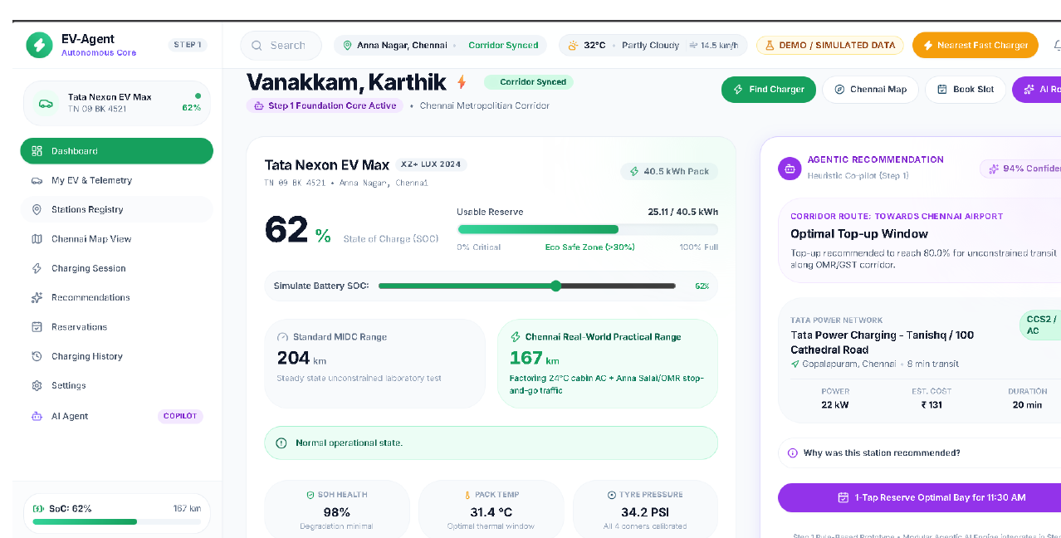
Figure 7.1.1: EV-Agent desktop dashboard prototype
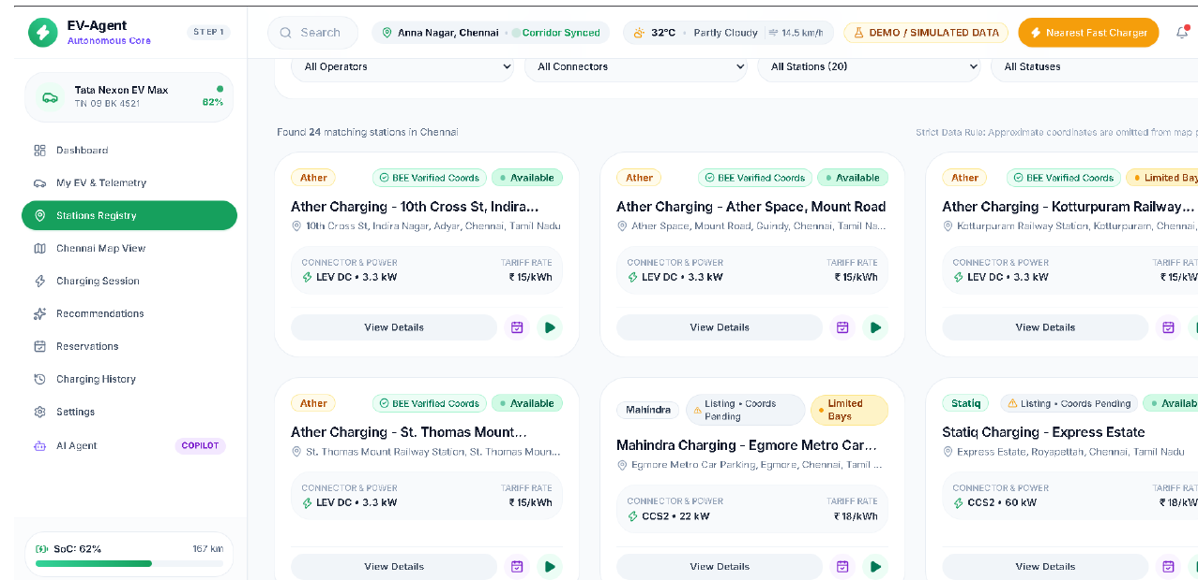
Figure 7.1.2: Charging station registry prototype
7.2 DISCUSSION
The main contribution of the project is architectural integration. The literature shows that EV charging recommendation can be approached through infrastructure planning, multi-criteria optimization, explicit user preferences or learned personalization. EV-Agent creates an engineering environment in which those approaches can be combined with live or open-data ingestion, route context and a user interface. This positioning is valuable because recommendation quality depends not only on the ranking algorithm but also on the correctness, freshness and traceability of the candidate data.
The prototype also demonstrates a practical principle for agentic systems: autonomy should operate on trustworthy inputs and remain distinguishable from simulation. The explicit demo/live separation, data-source fields and conflict audit reduce the risk of presenting uncertain information as operational truth. This is especially important for EV charging, where an incorrect location, connector type or availability state can cause a failed trip or unnecessary detour.
The current limitations are equally important. The supplied project materials identify telemetry ingestion and autonomous dynamic optimization as planned stages. The reference dataset does not guarantee live station availability, and many coordinate values require independent verification. No controlled experiment in the supplied material measures a percentage reduction in charging cost, waiting time or energy consumption. Accordingly, the results should be understood as prototype capability and architectural readiness rather than as a statistically validated production benchmark.
CHAPTER 8
CONCLUSION AND FUTURE ENHANCEMENT

CHAPTER 8
CONCLUSION AND FUTURE ENHANCEMENT
8.1 CONCLUSION
EV-Agent: Agentic AI Powered Smart EV Charging Platform establishes a modular foundation for intelligent EV charging discovery and decision support in the Chennai metropolitan corridor. The project brings together a canonical charging-station schema, open-data adapters, deduplication, source-conflict auditing, route analysis, weather context and a user-facing mobility interface. The architecture is deliberately layered so that recommendation and optimization logic can evolve without redesigning the underlying data infrastructure.
The project materials show that Stage 1 and Stage 2 are completed, providing the interface and data-integration foundation. The prototype also demonstrates how station information, route context and recommendation-oriented actions can be presented in a single user workflow. The system is therefore a useful base for future agentic charging applications, while its current limitations make clear that live charger control and autonomous optimization still require additional validation and integration work.
8.2 FUTURE ENHANCEMENT
• Integrate live EV telemetry such as battery State of Charge, remaining range, energy consumption and charging state.
• Connect verified operator APIs for live charger availability, pricing and booking information.
• Develop the Stage 4 autonomous recommendation engine using multi-criteria ranking or learned personalization.
• Add dynamic pricing and time-window optimization to minimize charging cost while satisfying route and battery constraints.
• Implement multi-agent coordination for route planning, station selection, energy optimization and reservation management.
• Extend the platform toward smart-grid integration and Vehicle-to-Grid operation after suitable safety and control interfaces are available.
• Improve demand and energy-consumption prediction using larger historical datasets and advanced machine-learning models.
• Develop a production mobile application with notifications, navigation, reservations and charging-session history.
• Add predictive maintenance features for station reliability and charger-fault detection.
• Introduce stronger authentication, access control, monitoring, secure API gateways and cloud deployment for multi-user operation.

ANNEXURE

APPENDIX A
SOURCE CODE
The following excerpts reproduce selected parts of the supplied EV-Agent interface and data-design materials. They are included to document the implementation style and the separation between user interaction, station information and reservation logic. The excerpts are not intended to represent the complete production source tree.
A1.1 Mobile Dashboard – code.html
<!DOCTYPE html>
<html class="h-full bg-surface" lang="en"><head><meta charset="utf-8"/><meta content="width=device-width, initial-scale=1.0, maximum-scale=1.0, user-scalable=no, viewport-fit=cover" name="viewport"/><meta content="mobile_tab" name="shell-type"/><title>EV-Agent</title><link href="https://fonts.googleapis.com/css2?family=Material+Symbols+Outlined:opsz,wght,FILL,GRAD@20..48,100..700,0..1,-50..200" rel="stylesheet"/>
<link href="https://fonts.googleapis.com/css2?family=Material+Symbols+Outlined:wght,FILL@100..700,0..1&amp;display=swap" rel="stylesheet"/><script src="https://cdn.tailwindcss.com"></script><script id="tailwind-config">tailwind.config = { darkMode: 'class', theme: { extend: { colors: { 'primary': '#006a3b', 'inverse-on-surface': '#ecf0ff', 'inverse-surface': '#273143', 'error-container': '#ffdad6', 'on-secondary': '#ffffff', 'surface-container-low': '#f0f3ff', 'secondary': '#386380', 'surface-container-highest': '#d9e3fb', 'on-tertiary-fixed-variant': '#4918c8', 'primary-fixed-dim': '#64dd93', 'on-background': '#111c2d', 'tertiary-fixed': '#e6deff', 'on-error-container': '#93000a', 'secondary-container': '#b2dcfe', 'error': '#ba1a1a', 'surface': '#f9f9ff', 'primary-fixed': '#81faad', 'tertiary-container': '#7857f8', 'surface-dim': '#d0daf2', 'surface-container': '#e8eeff', 'primary-container': '#00864b', 'surface-container-high': '#dfe8ff', 'background': '#f9f9ff', 'outline': '#6d7a6f', 'on-secondary-fixed': '#001e2f', 'surface-tint': '#006d3c', 'secondary-fixed': '#c9e6ff', 'tertiary-fixed-dim': '#cabeff', 'surface-container-lowest': '#ffffff', 'on-tertiary-fixed': '#1c0062', 'on-tertiary': '#ffffff', 'on-tertiary-container': '#fffbff', 'on-primary-fixed-variant': '#00522c', 'secondary-fixed-dim': '#a1cced', 'on-primary-container': '#f6fff4', 'on-primary': '#ffffff', 'on-secondary-fixed-variant': '#1d4b67', 'on-secondary-container': '#37627f', 'on-primary-fixed': '#00210e', 'inverse-primary': '#64dd93', 'surface-bright': '#f9f9ff', 'on-error': '#ffffff', 'outline-variant': '#bdcabd', 'tertiary': '#5f3add', 'on-surface-variant': '#3e4a40', 'surface-variant': '#d9e3fb', 'on-surface': '#111c2d' }, borderRadius: { 'DEFAULT': '0.25rem', 'lg': '0.5rem', 'xl': '0.75rem', 'full': '9999px' }, spacing: { 'space-lg': '1.5rem', 'space-xs': '0.25rem', 'gutter': '1rem', 'margin': '1rem', 'space-xl': '2rem', 'space-md': '1rem', 'space-sm': '0.5rem' }, fontFamily: { 'headline-md': ['Inter'], 'label-sm': ['Inter'], 'body-sm': ['Inter'], 'headline-lg': ['Inter'], 'label-md': ['Inter'], 'metric-display-mobile': ['Inter'], 'headline-xl-mobile': ['Inter'], 'metric-display': ['Inter'], 'body-md': ['Inter'], 'label-lg': ['Inter'], 'headline-sm': ['Inter'], 'body-lg': ['Inter'], 'headline-lg-mobile': ['Inter'], 'headline-xl': ['Inter'] }, fontSize: { 'headline-md': ['20px', { lineHeight: '28px', letterSpacing: '-0.01em', fontWeight: '600' }], 'label-sm': ['11px', { lineHeight: '14px', letterSpacing: '0.03em', fontWeight: '600' }], 'body-sm': ['12px', { lineHeight: '16px', letterSpacing: '0.01em', fontWeight: '400' }], 'headline-lg': ['30px', { lineHeight: '38px', letterSpacing: '-0.015em', fontWeight: '600' }], 'label-md': ['12px', { lineHeight: '16px', letterSpacing: '0.01em', fontWeight: '500' }], 'metric-display-mobile': ['36px', { lineHeight: '42px', letterSpacing: '-0.025em', fontWeight: '700' }], 'headline-xl-mobile': ['32px', { lineHeight: '40px', letterSpacing: '-0.015em', fontWeight: '700' }], 'metric-display': ['48px', { lineHeight: '52px', letterSpacing: '-0.03em', fontWeight: '700' }], 'body-md': ['14px', { lineHeight: '20px', letterSpacing: '0em', fontWeight: '400' }], 'label-lg': ['14px', { lineHeight: '20px', letterSpacing: '0.005em', fontWeight: '500' }], 'headline-sm': ['16px', { lineHeight: '24px', letterSpacing: '0em', fontWeight: '600' }], 'body-lg': ['16px', { lineHeight: '24px', letterSpacing: '0em', fontWeight: '400' }], 'headline-lg-mobile': ['24px', { lineHeight: '32px', letterSpacing: '-0.01em', fontWeight: '600' }], 'headline-xl': ['40px', { lineHeight: '48px', letterSpacing: '-0.02em', fontWeight: '700' }] } } } };</script><style>@layer base { html, body { width: 100vw; min-height: 100%; margin: 0; padding: 0; } body { overscroll-behavior-y: none; -webkit-tap-highlight-color: transparent; } .pb-safe { padding-bottom: env(safe-area-inset-bottom, 0px); } .pt-safe { padding-top: env(safe-area-inset-top, 0px); } main > :first-child { margin-top: 0 !important; } main > :last-child { margin-bottom: 0 !important; } } ::-webkit-scrollbar { display: none; }</style></head><body class="bg-surface font-body-md text-on-surface flex flex-col min-h-screen antialiased selection:bg-primary selection:text-on-primary"><header class="fixed top-0 inset-x-0 z-50 bg-surface/85 backdrop-blur-xl shadow-[0_1px_8px_rgba(0,0,0,0.03)] pt-safe"><div class="h-20 px-space-md flex flex-col justify-center gap-space-xs"><div class="flex items-center justify-between gap-space-sm"><div class="flex items-center gap-space-sm min-w-0 flex-1"><img alt="Brand logo. - Primary color: #16a05d - Font: inter - Mode: light - Roundness: rounded-md" class="h-8 w-auto object-contain flex-shrink-0" src="https://lh3.googleusercontent.com/aida/AEtjO1VMn25VcOJAt2yBLekUuLNfxZ42Wu4H60JS8lKtCd8eaoiRY_mM42j8skXS_ULAHnnSnGSHrmGu9iie7doBtKeVUq0aE2kcuLAWREXyqyUewqeoyY8QrVyqfHaY7-uumH0QN1kcWxFOMnjtL002E8kc8wbQiA6NMaOWUIy2YcacPxZBl2kZyk64kVFvJCYKuLp9fS7VMaSGRPAb1hSz3r6VwvidCLbQVqg0BVEQfW6oKXgwwbsJD_kMJ0E"/><div class="flex flex-col min-w-0"><div class="flex items-center gap-space-xs"><span class="font-headline-sm text-headline-sm text-on-surface truncate">EV-Agent</span><span class="px-space-xs py-0.5 rounded-full bg-primary-fixed text-on-primary-fixed font-label-sm text-label-sm font-semibold tracking-wide uppercase">Live</span></div><div class="flex items-center gap-space-xs"><span class="font-body-sm text-body-sm text-on-surface-variant truncate">Tata Nexon EV Max • 62% SoC</span></div></div></div><div class="flex it

A1.2 Station Details – code.html
<!DOCTYPE html>
<html class="h-full bg-surface" lang="en"><head><meta charset="utf-8"/><meta content="width=device-width, initial-scale=1.0, maximum-scale=1.0, user-scalable=no, viewport-fit=cover" name="viewport"/><meta content="mobile_tab" name="shell-type"/><title>EV-Agent</title><link href="https://fonts.googleapis.com/css2?family=Material+Symbols+Outlined:opsz,wght,FILL,GRAD@20..48,100..700,0..1,-50..200" rel="stylesheet"/>
<link href="https://fonts.googleapis.com/css2?family=Material+Symbols+Outlined:wght,FILL@100..700,0..1&amp;display=swap" rel="stylesheet"/><script src="https://cdn.tailwindcss.com"></script><script id="tailwind-config">tailwind.config = { darkMode: 'class', theme: { extend: { colors: { 'primary': '#006a3b', 'inverse-on-surface': '#ecf0ff', 'inverse-surface': '#273143', 'error-container': '#ffdad6', 'on-secondary': '#ffffff', 'surface-container-low': '#f0f3ff', 'secondary': '#386380', 'surface-container-highest': '#d9e3fb', 'on-tertiary-fixed-variant': '#4918c8', 'primary-fixed-dim': '#64dd93', 'on-background': '#111c2d', 'tertiary-fixed': '#e6deff', 'on-error-container': '#93000a', 'secondary-container': '#b2dcfe', 'error': '#ba1a1a', 'surface': '#f9f9ff', 'primary-fixed': '#81faad', 'tertiary-container': '#7857f8', 'surface-dim': '#d0daf2', 'surface-container': '#e8eeff', 'primary-container': '#00864b', 'surface-container-high': '#dfe8ff', 'background': '#f9f9ff', 'outline': '#6d7a6f', 'on-secondary-fixed': '#001e2f', 'surface-tint': '#006d3c', 'secondary-fixed': '#c9e6ff', 'tertiary-fixed-dim': '#cabeff', 'surface-container-lowest': '#ffffff', 'on-tertiary-fixed': '#1c0062', 'on-tertiary': '#ffffff', 'on-tertiary-container': '#fffbff', 'on-primary-fixed-variant': '#00522c', 'secondary-fixed-dim': '#a1cced', 'on-primary-container': '#f6fff4', 'on-primary': '#ffffff', 'on-secondary-fixed-variant': '#1d4b67', 'on-secondary-container': '#37627f', 'on-primary-fixed': '#00210e', 'inverse-primary': '#64dd93', 'surface-bright': '#f9f9ff', 'on-error': '#ffffff', 'outline-variant': '#bdcabd', 'tertiary': '#5f3add', 'on-surface-variant': '#3e4a40', 'surface-variant': '#d9e3fb', 'on-surface': '#111c2d' }, borderRadius: { 'DEFAULT': '0.25rem', 'lg': '0.5rem', 'xl': '0.75rem', 'full': '9999px' }, spacing: { 'space-lg': '1.5rem', 'space-xs': '0.25rem', 'gutter': '1rem', 'margin': '1rem', 'space-xl': '2rem', 'space-md': '1rem', 'space-sm': '0.5rem' }, fontFamily: { 'headline-md': ['Inter'], 'label-sm': ['Inter'], 'body-sm': ['Inter'], 'headline-lg': ['Inter'], 'label-md': ['Inter'], 'metric-display-mobile': ['Inter'], 'headline-xl-mobile': ['Inter'], 'metric-display': ['Inter'], 'body-md': ['Inter'], 'label-lg': ['Inter'], 'headline-sm': ['Inter'], 'body-lg': ['Inter'], 'headline-lg-mobile': ['Inter'], 'headline-xl': ['Inter'] }, fontSize: { 'headline-md': ['20px', { lineHeight: '28px', letterSpacing: '-0.01em', fontWeight: '600' }], 'label-sm': ['11px', { lineHeight: '14px', letterSpacing: '0.03em', fontWeight: '600' }], 'body-sm': ['12px', { lineHeight: '16px', letterSpacing: '0.01em', fontWeight: '400' }], 'headline-lg': ['30px', { lineHeight: '38px', letterSpacing: '-0.015em', fontWeight: '600' }], 'label-md': ['12px', { lineHeight: '16px', letterSpacing: '0.01em', fontWeight: '500' }], 'metric-display-mobile': ['36px', { lineHeight: '42px', letterSpacing: '-0.025em', fontWeight: '700' }], 'headline-xl-mobile': ['32px', { lineHeight: '40px', letterSpacing: '-0.015em', fontWeight: '700' }], 'metric-display': ['48px', { lineHeight: '52px', letterSpacing: '-0.03em', fontWeight: '700' }], 'body-md': ['14px', { lineHeight: '20px', letterSpacing: '0em', fontWeight: '400' }], 'label-lg': ['14px', { lineHeight: '20px', letterSpacing: '0.005em', fontWeight: '500' }], 'headline-sm': ['16px', { lineHeight: '24px', letterSpacing: '0em', fontWeight: '600' }], 'body-lg': ['16px', { lineHeight: '24px', letterSpacing: '0em', fontWeight: '400' }], 'headline-lg-mobile': ['24px', { lineHeight: '32px', letterSpacing: '-0.01em', fontWeight: '600' }], 'headline-xl': ['40px', { lineHeight: '48px', letterSpacing: '-0.02em', fontWeight: '700' }] } } } };</script><style>@layer base { html, body { width: 100vw; min-height: 100%; margin: 0; padding: 0; } body { overscroll-behavior-y: none; -webkit-tap-highlight-color: transparent; } .pb-safe { padding-bottom: env(safe-area-inset-bottom, 0px); } .pt-safe { padding-top: env(safe-area-inset-top, 0px); } main > :first-child { margin-top: 0 !important; } main > :last-child { margin-bottom: 0 !important; } } ::-webkit-scrollbar { display: none; }</style></head><body class="bg-surface font-body-md text-on-surface flex flex-col min-h-screen antialiased selection:bg-primary selection:text-on-primary"><header class="fixed top-0 inset-x-0 z-50 bg-surface/85 backdrop-blur-xl shadow-[0_1px_8px_rgba(0,0,0,0.03)] pt-safe"><div class="h-20 px-space-md flex flex-col justify-center gap-space-xs"><div class="flex items-center justify-between gap-space-sm"><div class="flex items-center gap-space-sm min-w-0 flex-1"><img alt="Brand logo. - Primary color: #16a05d - Font: inter - Mode: light - Roundness: rounded-md" class="h-8 w-auto object-contain flex-shrink-0" src="https://lh3.googleusercontent.com/aida/AEtjO1VMn25VcOJAt2yBLekUuLNfxZ42Wu4H60JS8lKtCd8eaoiRY_mM42j8skXS_ULAHnnSnGSHrmGu9iie7doBtKeVUq0aE2kcuLAWREXyqyUewqeoyY8QrVyqfHaY7-uumH0QN1kcWxFOMnjtL002E8kc8wbQiA6NMaOWUIy2YcacPxZBl2kZyk64kVFvJCYKuLp9fS7VMaSGRPAb1hSz3r6VwvidCLbQVqg0BVEQfW6oKXgwwbsJD_kMJ0E"/><div class="flex flex-col min-w-0"><div class="flex items-center gap-space-xs"><span class="font-headline-sm text-headline-sm text-on-surface truncate">EV-Agent</span><span class="px-space-xs py-0.5 rounded-full bg-primary-fixed text-on-primary-fixed font-label-sm text-label-sm font-semibold tracking-wide uppercase">Live</span></div><div class="flex items-center gap-space-xs"><span class="font-body-sm text-body-sm text-on-surface-variant truncate">Tata Nexon EV Max • 62% SoC</span></div></div></div><div class="flex it

A1.3 Slot Reservation Flow – code.html
<!DOCTYPE html>
<html class="h-full bg-surface" lang="en"><head><meta charset="utf-8"/><meta content="width=device-width, initial-scale=1.0, maximum-scale=1.0, user-scalable=no, viewport-fit=cover" name="viewport"/><meta content="mobile_stack" name="shell-type"/><title>EV-Agent</title><link href="https://fonts.googleapis.com/css2?family=Material+Symbols+Outlined:opsz,wght,FILL,GRAD@20..48,100..700,0..1,-50..200" rel="stylesheet"/>
<link href="https://fonts.googleapis.com/css2?family=Material+Symbols+Outlined:wght,FILL@100..700,0..1&amp;display=swap" rel="stylesheet"/><script src="https://cdn.tailwindcss.com"></script><script id="tailwind-config">tailwind.config = { darkMode: 'class', theme: { extend: { colors: { 'primary': '#006a3b', 'inverse-on-surface': '#ecf0ff', 'inverse-surface': '#273143', 'error-container': '#ffdad6', 'on-secondary': '#ffffff', 'surface-container-low': '#f0f3ff', 'secondary': '#386380', 'surface-container-highest': '#d9e3fb', 'on-tertiary-fixed-variant': '#4918c8', 'primary-fixed-dim': '#64dd93', 'on-background': '#111c2d', 'tertiary-fixed': '#e6deff', 'on-error-container': '#93000a', 'secondary-container': '#b2dcfe', 'error': '#ba1a1a', 'surface': '#f9f9ff', 'primary-fixed': '#81faad', 'tertiary-container': '#7857f8', 'surface-dim': '#d0daf2', 'surface-container': '#e8eeff', 'primary-container': '#00864b', 'surface-container-high': '#dfe8ff', 'background': '#f9f9ff', 'outline': '#6d7a6f', 'on-secondary-fixed': '#001e2f', 'surface-tint': '#006d3c', 'secondary-fixed': '#c9e6ff', 'tertiary-fixed-dim': '#cabeff', 'surface-container-lowest': '#ffffff', 'on-tertiary-fixed': '#1c0062', 'on-tertiary': '#ffffff', 'on-tertiary-container': '#fffbff', 'on-primary-fixed-variant': '#00522c', 'secondary-fixed-dim': '#a1cced', 'on-primary-container': '#f6fff4', 'on-primary': '#ffffff', 'on-secondary-fixed-variant': '#1d4b67', 'on-secondary-container': '#37627f', 'on-primary-fixed': '#00210e', 'inverse-primary': '#64dd93', 'surface-bright': '#f9f9ff', 'on-error': '#ffffff', 'outline-variant': '#bdcabd', 'tertiary': '#5f3add', 'on-surface-variant': '#3e4a40', 'surface-variant': '#d9e3fb', 'on-surface': '#111c2d' }, borderRadius: { 'DEFAULT': '0.25rem', 'lg': '0.5rem', 'xl': '0.75rem', 'full': '9999px' }, spacing: { 'space-lg': '1.5rem', 'space-xs': '0.25rem', 'gutter': '1rem', 'margin': '1rem', 'space-xl': '2rem', 'space-md': '1rem', 'space-sm': '0.5rem' }, fontFamily: { 'headline-md': ['Inter'], 'label-sm': ['Inter'], 'body-sm': ['Inter'], 'headline-lg': ['Inter'], 'label-md': ['Inter'], 'metric-display-mobile': ['Inter'], 'headline-xl-mobile': ['Inter'], 'metric-display': ['Inter'], 'body-md': ['Inter'], 'label-lg': ['Inter'], 'headline-sm': ['Inter'], 'body-lg': ['Inter'], 'headline-lg-mobile': ['Inter'], 'headline-xl': ['Inter'] }, fontSize: { 'headline-md': ['20px', { lineHeight: '28px', letterSpacing: '-0.01em', fontWeight: '600' }], 'label-sm': ['11px', { lineHeight: '14px', letterSpacing: '0.03em', fontWeight: '600' }], 'body-sm': ['12px', { lineHeight: '16px', letterSpacing: '0.01em', fontWeight: '400' }], 'headline-lg': ['30px', { lineHeight: '38px', letterSpacing: '-0.015em', fontWeight: '600' }], 'label-md': ['12px', { lineHeight: '16px', letterSpacing: '0.01em', fontWeight: '500' }], 'metric-display-mobile': ['36px', { lineHeight: '42px', letterSpacing: '-0.025em', fontWeight: '700' }], 'headline-xl-mobile': ['32px', { lineHeight: '40px', letterSpacing: '-0.015em', fontWeight: '700' }], 'metric-display': ['48px', { lineHeight: '52px', letterSpacing: '-0.03em', fontWeight: '700' }], 'body-md': ['14px', { lineHeight: '20px', letterSpacing: '0em', fontWeight: '400' }], 'label-lg': ['14px', { lineHeight: '20px', letterSpacing: '0.005em', fontWeight: '500' }], 'headline-sm': ['16px', { lineHeight: '24px', letterSpacing: '0em', fontWeight: '600' }], 'body-lg': ['16px', { lineHeight: '24px', letterSpacing: '0em', fontWeight: '400' }], 'headline-lg-mobile': ['24px', { lineHeight: '32px', letterSpacing: '-0.01em', fontWeight: '600' }], 'headline-xl': ['40px', { lineHeight: '48px', letterSpacing: '-0.02em', fontWeight: '700' }] } } } };</script><style>@layer base { html, body { width: 100vw; min-height: 100%; margin: 0; padding: 0; } body { overscroll-behavior-y: none; -webkit-tap-highlight-color: transparent; } .pb-safe { padding-bottom: env(safe-area-inset-bottom, 0px); } .pt-safe { padding-top: env(safe-area-inset-top, 0px); } main > :first-child { margin-top: 0 !important; } main > :last-child { margin-bottom: 0 !important; } } ::-webkit-scrollbar { display: none; }</style></head><body class="bg-surface font-body-md text-on-surface flex flex-col min-h-screen antialiased selection:bg-primary selection:text-on-primary"><header class="fixed top-0 inset-x-0 z-50 bg-surface/85 backdrop-blur-xl shadow-[0_1px_8px_rgba(0,0,0,0.03)] pt-safe"><div class="h-16 px-space-md flex items-center justify-between gap-space-sm"><div class="flex items-center gap-space-xs min-w-0 flex-1"><button aria-label="Go back" class="w-11 h-11 flex items-center justify-center rounded-full text-on-surface hover:bg-surface-container active:bg-surface-container-high transition-colors -ml-2" onclick="history.back()" type="button"><span class="material-symbols-outlined text-[24px]">arrow_back</span></button><img alt="Brand logo. - Primary color: #16a05d - Font: inter - Mode: light - Roundness: rounded-md" class="h-7 w-auto object-contain flex-shrink-0" src="https://lh3.googleusercontent.com/aida/AEtjO1VMn25VcOJAt2yBLekUuLNfxZ42Wu4H60JS8lKtCd8eaoiRY_mM42j8skXS_ULAHnnSnGSHrmGu9iie7doBtKeVUq0aE2kcuLAWREXyqyUewqeoyY8QrVyqfHaY7-uumH0QN1kcWxFOMnjtL002E8kc8wbQiA6NMaOWUIy2YcacPxZBl2kZyk64kVFvJCYKuLp9fS7VMaSGRPAb1hSz3r6VwvidCLbQVqg0BVEQfW6oKXgwwbsJD_kMJ0E"/><h1 class="font-headline-sm text-headline-sm text-on-surface truncate ml-1">Slot Reservation Flow</h1></div><div class="flex items-center gap-space-xs flex-shrink-0"><div class="relative flex items-center justify-center"><button aria-label="Notifications" class="w-1

A1.4 CANONICAL DATA RECORD – JSON EXAMPLE
{
"station_id": "CHN-ZEON-PORUR-001",
"station_name": "Zeon Charging Station Porur",
"operator": "Zeon",
"city": "Chennai",
"area": "Porur",
"latitude": 13.035,
"longitude": 80.156,
"connector_type": "CCS2",
"charger_type": "DC",
"power_kw": 30,
"status": "AVAILABLE",
"price_per_kwh": null,
"is_demo": false,
"data_source": "operator_listing",
"last_verified_at": null
}
The example follows the station-data structure supplied with the Chennai EV-Agent dataset and illustrates how provenance and demo/live status are represented alongside physical charger characteristics.

APPENDIX B
SCREENSHOTS
Figure B.1: EV-Agent dashboard output with vehicle state and recommendation panel

Figure B.2: Charging station registry output with operator, connector, power and tariff information

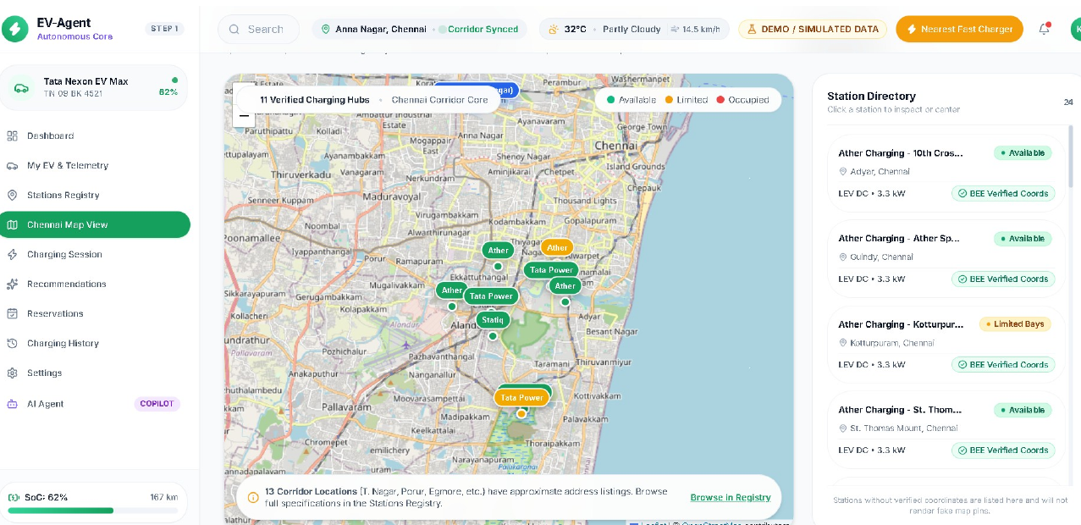
Figure B.3: Chennai map output with station locations and route context

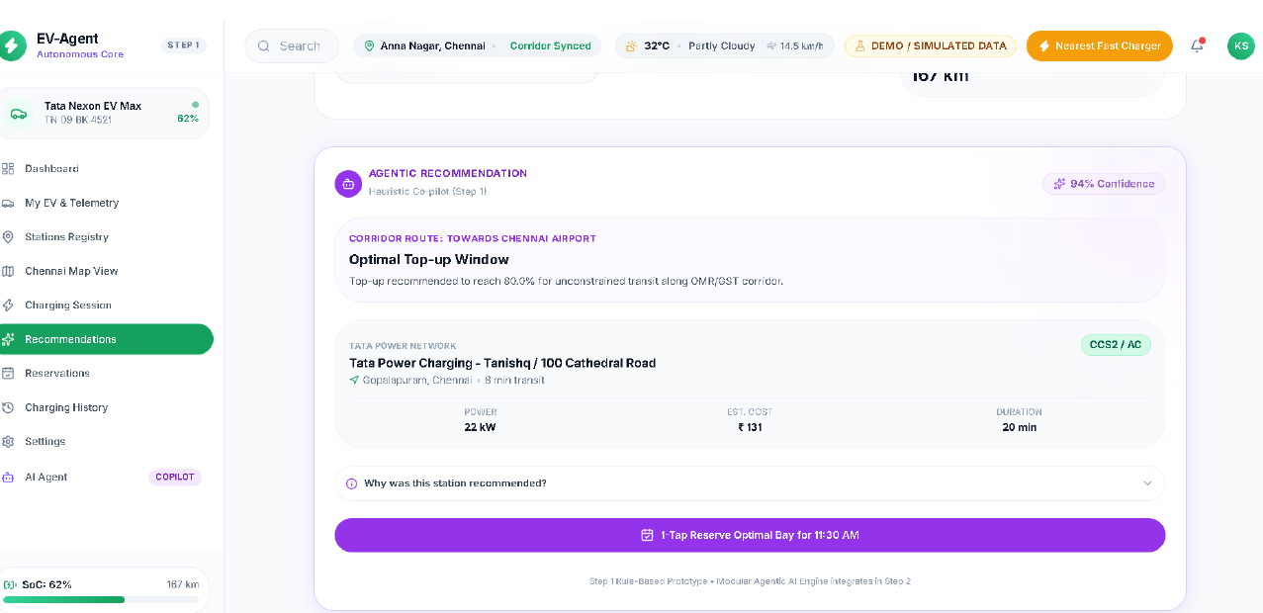
Figure B.4: Agentic recommendation and charging action interface

APPENDIX C
DATA SCHEMA AND SAMPLE RECORDS
The following sample records are reproduced from the Chennai EV charging-station reference dataset supplied with the project. The dataset is intended as seed data; approximate coordinates are not production-grade and live availability must be verified through current authoritative sources.
NO. | OPERATOR | STATION | AREA | LAT | LONG | TYPE | POWER
1 | Ather | St. Thomas Mount Railway Station | St. Thomas Mount | 12.994410 | 80.199288 | LEV DC | 3.3 kW
2 | Ather | 10th Cross St, Indira Nagar | Adyar | 12.996663 | 80.251779 | LEV DC | 3.3 kW
3 | Ather | Ather Space, Mount Road | Guindy | 13.012477 | 80.220603 | LEV DC | 3.3 kW
4 | Ather | Kotturpuram Railway Station | Kotturpuram | 13.013870 | 80.248060 | LEV DC | 3.3 kW
5 | Tata Power | Chennai One | Thoraipakkam | 12.948492 | 80.232697 | Type 2 AC | 7.4 kW
7 | Tata Power | Covelong Beach | Covelong | 12.797170 | 80.247583 | Type 2 AC | 7.4 kW
13 | Zeon | Pantheon Road | Egmore | Approx. | Approx. | CCS2 | 60 kW
14 | Zeon | Darmapuram, 6th Street | T. Nagar | Approx. | Approx. | CCS2 | 30 kW
17 | Yocharge | Anna Salai | Central Chennai | Approx. | Approx. | CCS2 | 60 kW
18 | Statiq | Express Estate | Royapettah | Approx. | Approx. | CCS2 | 60 kW
20 | TEDA | NPKRR Maaligai, 144 Anna Salai | Thousand Lights | Approx. | Approx. | AC | Varies

Data-quality rules used by EV-Agent: VERIFIED_COORDINATE indicates exact latitude and longitude from a coordinate-bearing source; OPERATOR_LISTING indicates a reported station whose coordinates may require verification; LIVE_STATUS identifies current availability; ESTIMATED identifies values calculated by the application; and DEMO identifies simulated data used for development or testing.

REFERENCES
[1] G. F. Savari, M. J. Sathik, L. A. Raman, A. El-Shahat, H. M. Hasanien, D. Almakhles, S. H. E. Abdel Aleem, and A. I. Omar, “Assessment of charging technologies, infrastructure and charging station recommendation schemes of electric vehicles: A review,” Alexandria Engineering Journal, 2022, DOI: 10.1016/j.asej.2022.101938.
[2] F. Ahmad, A. Iqbal, I. Ashraf, M. Marzband, and I. Khan, “Optimal location of electric vehicle charging station and its impact on distribution network: A review,” Energy Reports, vol. 8, pp. 2314–2333, 2022, DOI: 10.1016/j.egyr.2022.01.180.
[3] M. Liu, L. Feng, Y. Yuan, Y. Liu, and P. Geng, “Study on Two-Tier EV Charging Station Recommendation Strategy under Multi-Factor Influence,” JAI, vol. 5, 2023, DOI: 10.32604/jai.2023.046066.
[4] A. Habbal and M. F. Alrifaie, “A User-Preference-Based Charging Station Recommendation for Electric Vehicles,” IEEE Transactions on Intelligent Transportation Systems, 2024, DOI: 10.1109/TITS.2024.3379469.
[5] H. Li, Q. Han, X. Bai, L. Zhang, W. Wang, W. Chen, and L. Xiang, “Electric Vehicle Charging Station Recommendations Considering User Charging Preferences Based on Comment Data,” Energies, vol. 17, 5514, 2024, DOI: 10.3390/en17215514.
[6] International Energy Agency, “Global EV Outlook 2025,” IEA, 2025.
[7] Bureau of Energy Efficiency, “EV Public Charging Station Dataset,” Government of India.
[8] Open Charge Map, “Global Electric Vehicle Charging Locations and Data.”
[9] OpenStreetMap Foundation, “OpenStreetMap: Open Geographic Database.”
[10] OSRM Project, “Open Source Routing Machine.”
[11] Open-Meteo, “Weather Forecast API and Data Services.”
[12] Tamil Nadu TNEV / TNGECL, “EV Charger Discovery and Charging Infrastructure Platform.”
[13] EV-Agent project documentation, “Chennai EV Charging Station Reference Dataset,” supplied project document, 2026.
[14] EV-Agent project README, “EV-Agent: Agentic AI Powered Smart EV Charging Platform,” supplied project documentation, 2026.

PROJECT COMPLETION CERTIFICATE
This page is reserved for the final academic certification and signatures associated with the project submission.
SUPERVISOR  Ms. Angalaparameswari  Assistant Professor  Department of AI & Data Science | HEAD OF THE DEPARTMENT  Ms. R. Kannamma  Assistant Professor  Department of AI & Data Science
PROJECT COORDINATOR  Dr. C. Srivenkateswaran  Professor  Department of AI & Data Science | INTERNAL / EXTERNAL EXAMINER  Signature and Date

