3



Application Monitoring

Release 2



Version 1.0

December 6, 2019

**Table of Contents**

Document Version History 3

**1.0** **Overview** 4

**2.0** **Enhancements** 5

1. Any Process Model, taking more than its average execution time, send notification in case waiting limit exceeds x% of average execution time. 5

2. Change in the notification email body to include URL. 5

3. Change in the notification email body in case analysis is in waiting state. 6

# Document Version History

| Author(s) | Version | Amendments/Reasons | Date |
| --- | --- | --- | --- |
| Atul Sharma | 1.0 | Application Monitoring Release 2 | 6-Dec-2019 |
|  |  |  |  |
|  |  |  |  |

# 

# **Overview**

Application monitoring component is a standalone Java application deployed on application server where DQ+ application and PostgreSQL database are hosted. It monitors DQ+ processes, generates log file from the observations and send email notifications.

Whenever any PM, analysis or data view is executed in DQ+, its execution history is maintained in PostgreSQL database. This application monitoring component will rely on execution history to send notifications. This component will monitor only the first level processes (be it scheduled or manually triggered process) and not the intermediate processes.

As part of Release 2, following notification enhancements have been identified:

* Any Process Model taking more time than its average execution time, a notification will be sent in case time limit exceeds x% of average execution time.
* Change in the notification body to include last n executions of a process model and its minimum and maximum execution time.
* Change in calculation of average execution time to exclude outliers.
* Change in the notification email body for Waiting, Failed and Missed frequency notifications.
* Included the URL in notification email to navigate directly to an analysis/Process Model under the execution screen based on work id.

# **Enhancements**

## Any Process Model, taking more than its average execution time, send notification in case waiting limit exceeds x% of average execution time.

For a process model, taking more than its average execution time, a threshold limit is set. This threshold limit (**avg_time_threshold**) is configurable in app_properties.xml. The average time is calculated excluding outliers and for last n notifications. Value of n (**executions_for_avg**) is configurable in app_properties.xml.

Following is an example of notification sent for this scenario:

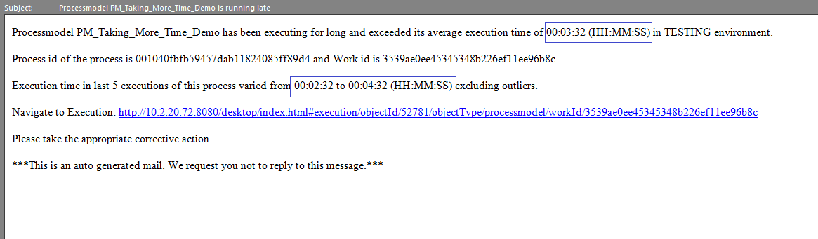

## Change in the notification email body to include URL.

For a process model or analysis ended in a failure state, a notification will be sent including the URL to navigate to that particular execution under executions tab. The part of URL is configurable in app_properties.xml ([**http://10.2.20.72:8080/desktop/index.html#execution/objectId/**](http://10.2.20.72:8080/desktop/index.html#execution/objectId/)).

The process id and work id are pulled from database for respective analysis/process model.

Following is an example notification sent for failed scenario:

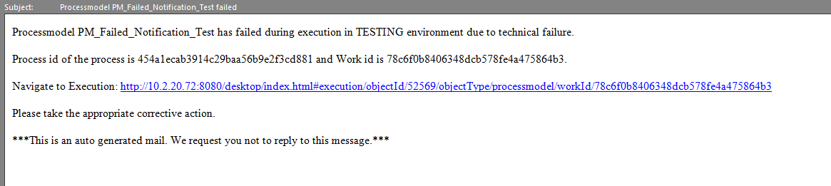

## Change in the notification email body in case analysis is in waiting state.

For an analysis in waiting state for more than assigned waiting period, a notification will be generated.

Following is an example notification sent for waiting period of 10 seconds:

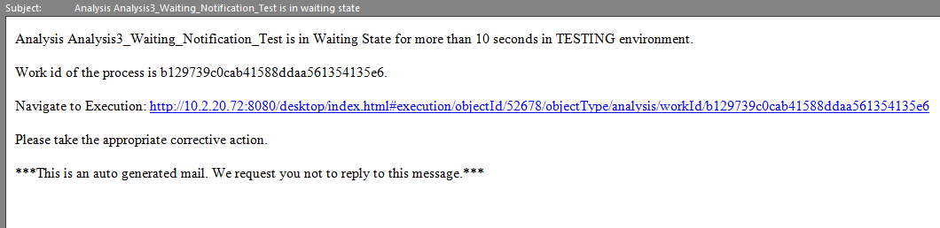

Following is an example notification sent for waiting period of 1:

