**PHASE 2 – PUBLIC TRANSPORT EFFICIENCY ANALYSIS**

**PROJECT DEFINITION:**

The project involves analysing public transportation data to assess service efficiency, on time performance, and passenger feedback. The objective is to provide insights that support transportation improvement initiatives and enhance the overall public transportation experience. This project includes defining analysis objectives, collecting transportation data, designing relevant visualizations in IBM Cognos, and using code for data analysis.

**APPROACH:**

To analyse performance, optimize routes, and propose improvements to enhance public transport efficiency, considering both operational and passenger experience aspects.

**OBJECTIVE:**

To optimize routes, schedules, and resource allocation to maximize efficiency and urban mobility.

**PROCEDURE:**

Exploratory Data Analysis (EDA):

a. Analyse existing data to identify patterns, trends, and outliers relevant to operational efficiency, passenger satisfaction, environmental impact, and route optimization.

b. Visualize key performance metrics and variables to gain insights into the current state of the public transport system.

Performance Benchmarking:

a. Research industry benchmarks and standards related to public transport efficiency.

b. Compare the available data against benchmarks to identify areas for improvement.

Analysis and Optimization:

a. Analyse existing routes, schedules, and operational practices.

b. Propose optimizations based on the analysis to improve coverage, frequency, cost-effectiveness, and environmental sustainability of the public transport system.

Integration and Recommendations:

a. Integrate insights from the analyses to create a comprehensive view of the public transport system's efficiency.

b. Formulate actionable recommendations, considering input from all analyses, to optimize the public transport system for efficiency and sustainability.

Implementation and Continuous Monitoring:

a. Implement the recommended changes and improvements to the public transport system.

b. Establish a system for continuous monitoring, collecting post-implementation data, and making iterative adjustments to ensure sustained efficiency gains.

By following this procedure, the project aims to systematically analyse and enhance the public transport system's efficiency, aligning with the objective of improving urban mobility and sustainability.

**DATABASE LINK:**

[Public Bus Transport Dataset (kaggle.com)](https://www.kaggle.com/datasets/rednivrug/unisys?select=20140711.CSV)

**BENEFITS:**

Enhanced Operational Efficiency:

Identification of operational bottlenecks and inefficiencies leads to optimized routes, schedules, and operational practices, ensuring a more efficient public transport system.

Cost Savings:

Optimization of routes, schedules, and resources reduces operational costs, leading to financial savings for public transport authorities and potentially lowering ticket prices for passengers.

Improved Passenger Experience:

Insights from passenger feedback and analysis lead to service enhancements, reducing waiting times, enhancing comfort, and overall satisfaction for passengers.

Environmental Sustainability:

By optimizing routes and reducing fuel consumption, the project contributes to a reduction in greenhouse gas emissions and environmental impact, promoting a more sustainable and eco-friendly transport system.

Traffic Reduction and Congestion Mitigation:

A more efficient public transport system encourages a shift from private vehicles to public transit, reducing traffic congestion, and improving overall traffic flow in urban areas.

Equitable Access and Social Inclusion:

Route optimization ensures that public transport reaches underserved areas, promoting equitable access to transportation for all socio-economic groups, including those in less accessible neighbourhoods.

**FLOW CHART:**

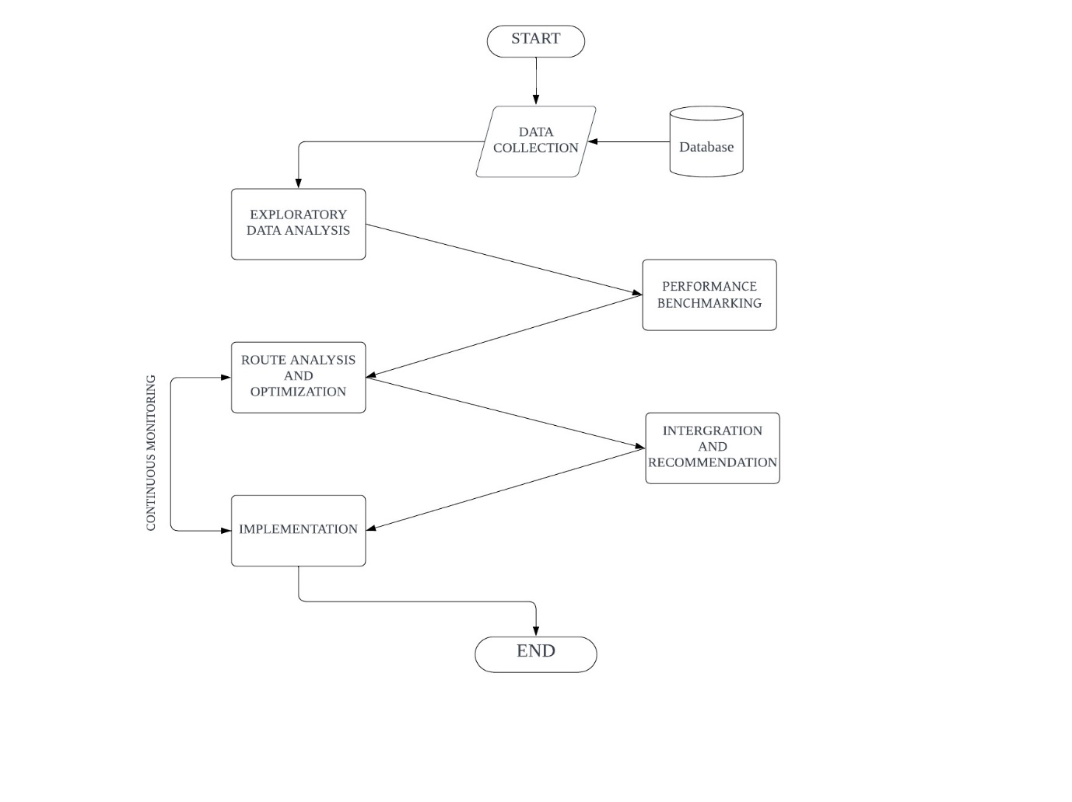

**CONCLUSION:**

In conclusion, improving public transport efficiency is a multifaceted process that requires careful planning, data analysis, and implementation of effective solutions. By following the procedure outlined above, transportation authorities and stakeholders can work together to address issues, enhance the quality of public transportation, and provide a more reliable and convenient service for commuters. Continuous monitoring and evaluation are essential to ensure that the improvements are sustained and further refined, ultimately contributing to a more sustainable and efficient public transport system.

**TEAM MEMBERS:**

Siddesh S – 2021504545

Vishal K – 2021504558

Mohamed Samasdeen – 2021504301

Prasannah SKS - 2021504536