1. Which district has more colleges?

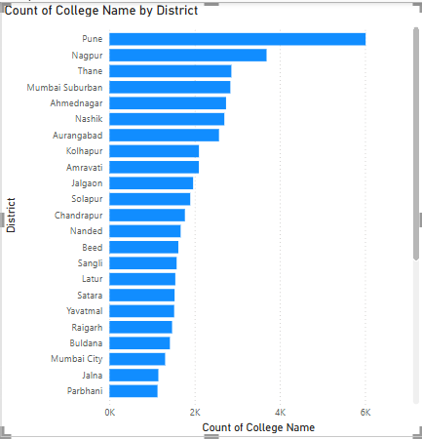

1. What are the most common course categories?

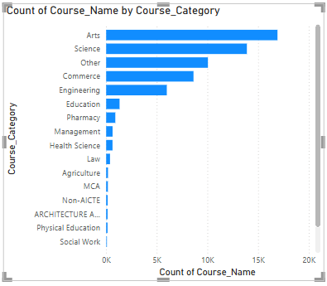

1. Which universities offer the widest range of course types?

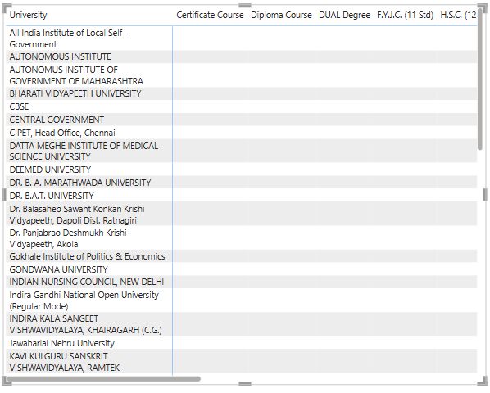

1. Are unaided courses more common in professional or non-professional programs?

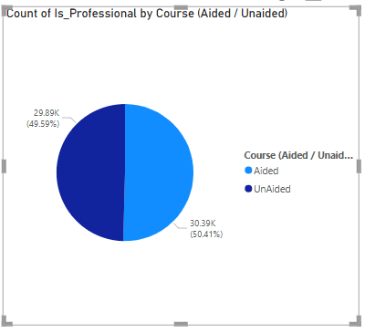

1. Which college has the longest average course duration?

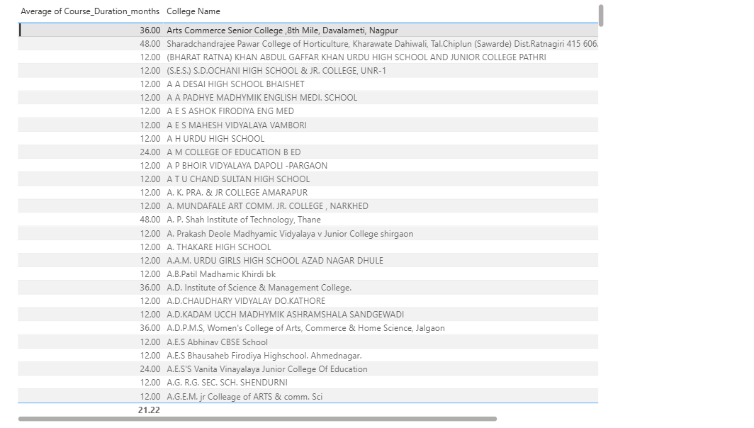

1. What is the top specialization in the state?

