INTERNAL PRACTICAL ASSESSMENT-2
TASK 1 Forensic analysis

Step-1 Creating an case name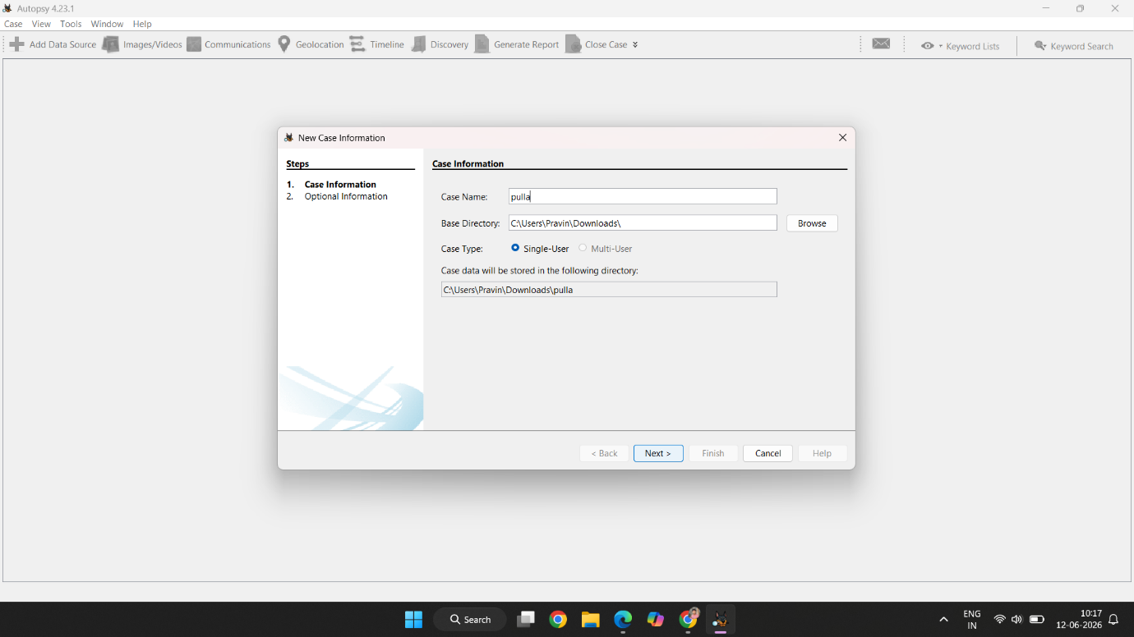
A new Autopsy case named "pulla" was created and configured as a Single-User case.

Step-2 Inserting the case file and complete the steps
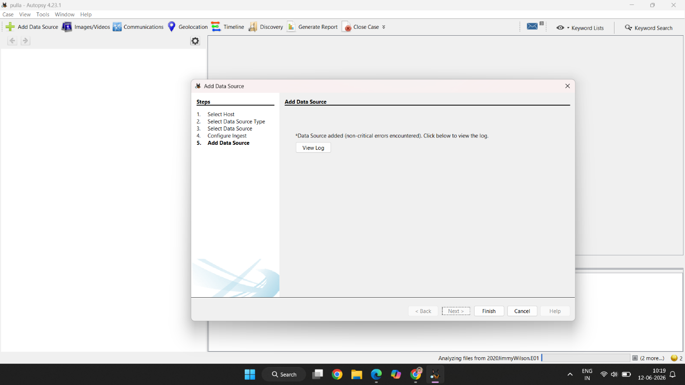
The forensic image 2020JimmyWilson.E01 was successfully added to the case.
Step-3 Opened the case file and get the forensic image and records
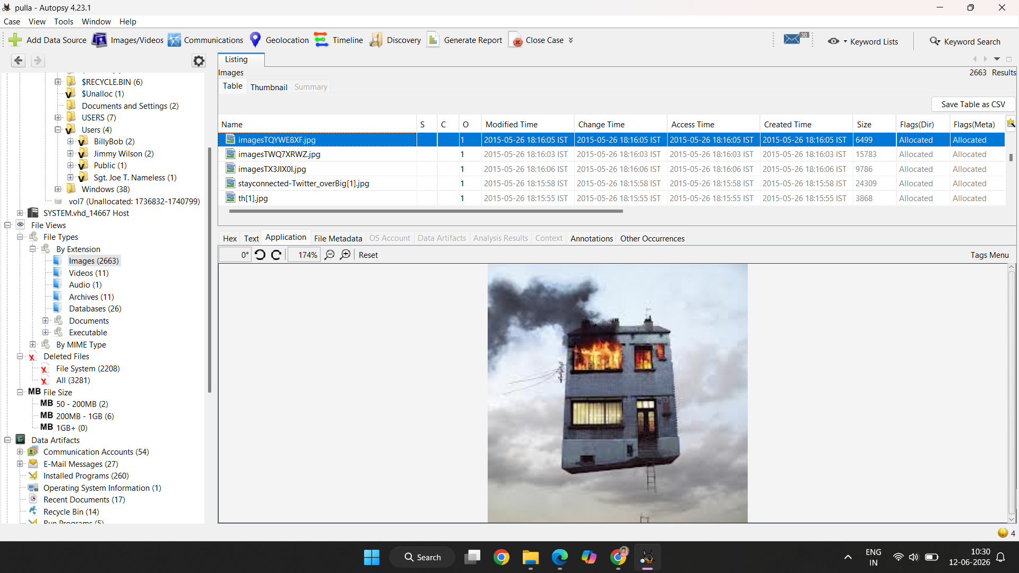
Several image files were recovered and displayed by Autopsy.

Step-4 Identifying the usename in the file
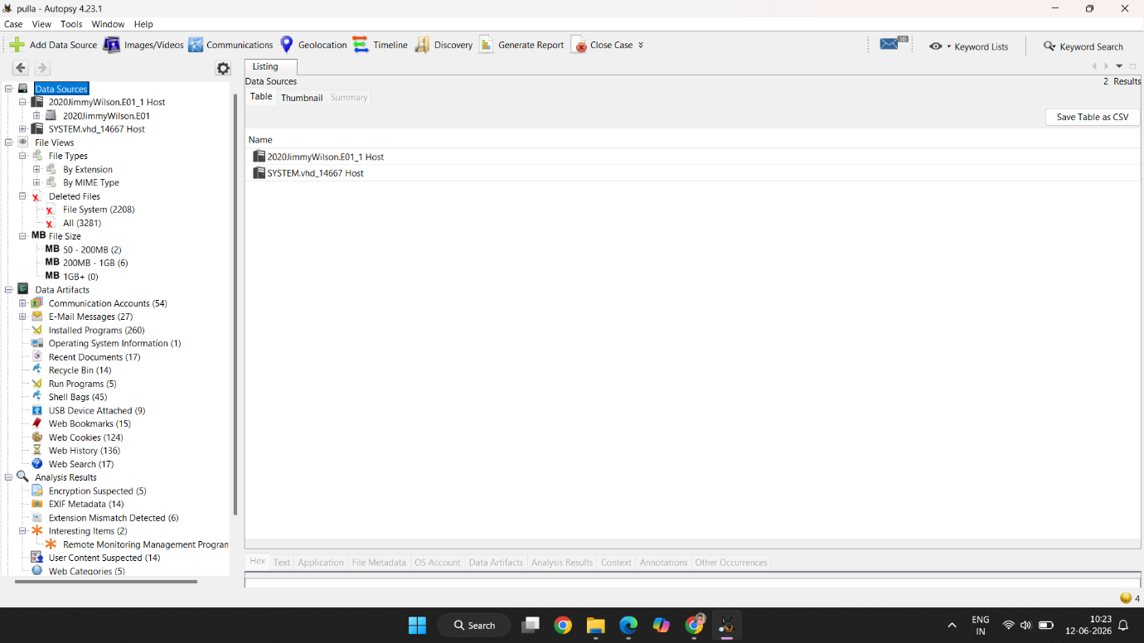

Step-5 Find out the browser used by them
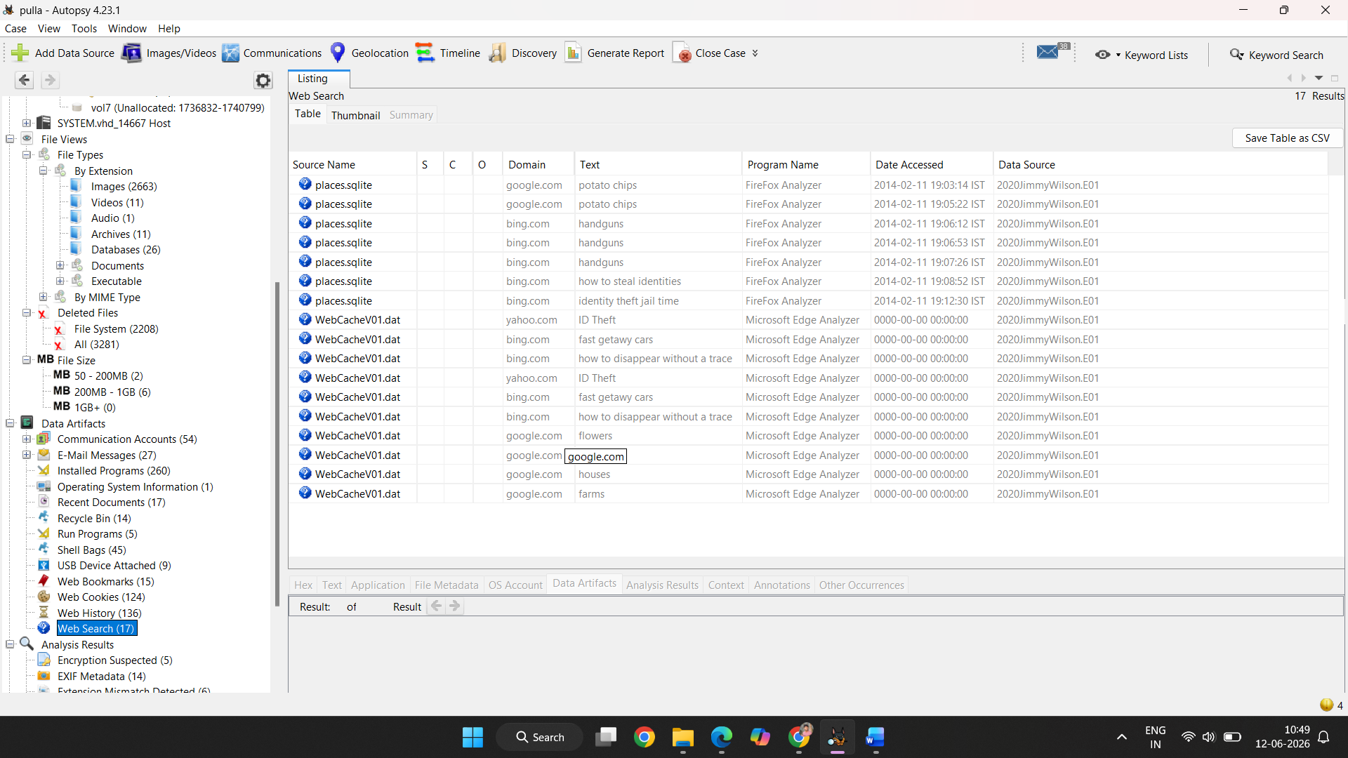
Web history artifacts provide information about websites visited by the user. These records can help reconstruct online behavior and establish timelines of activity.

Step-7 Evidence source name
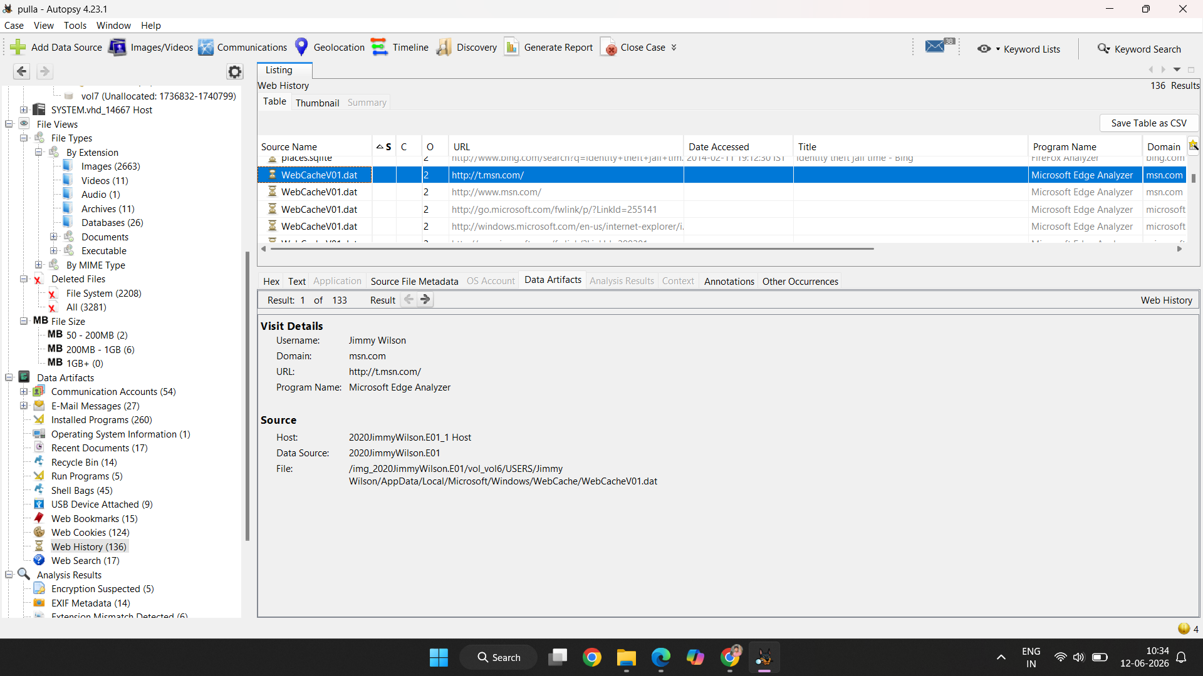

Step-8 Artifact finded
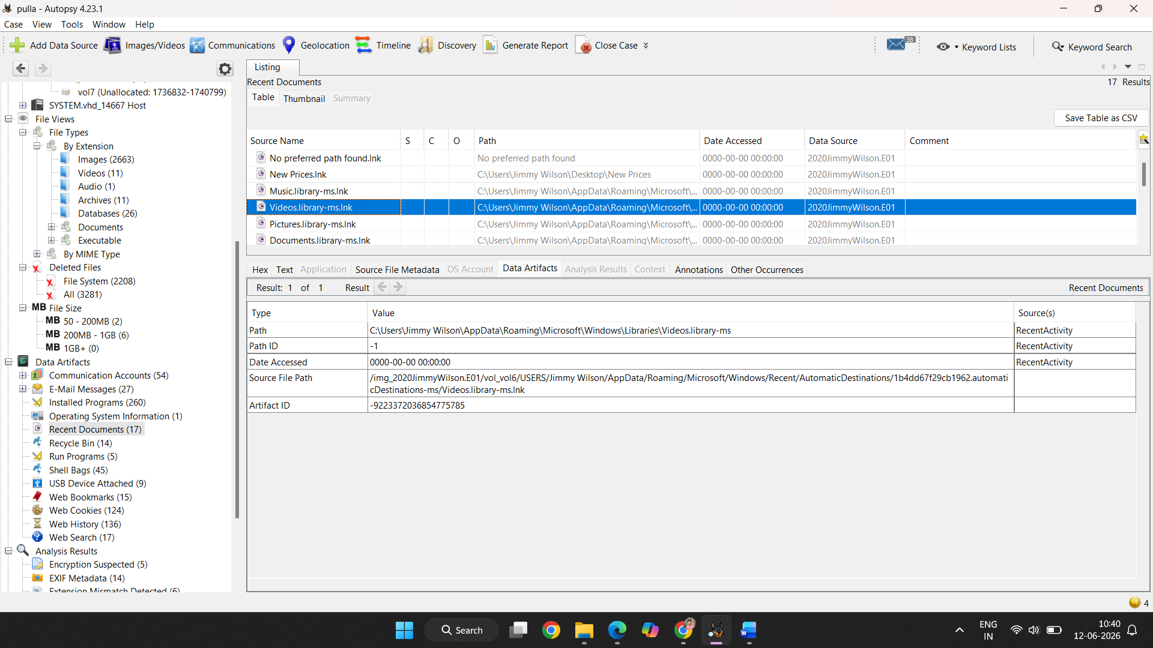
Search history artifacts reveal the exact terms searched by the user. Such evidence is often used to determine user intent, interests, and possible involvement in suspicious activities.

Conclusion:
The forensic investigation was conducted using Autopsy on the evidence source 2020JimmyWilson.E01. Analysis identified the primary user account as Jimmy Wilson. Browser artifacts showed usage of both Mozilla Firefox and Microsoft Edge. Several forensic artifacts were recovered, including web history, web searches, recent documents, cookies, and images. The web search history contained searches related to identity theft and evasion techniques, demonstrating how forensic artifacts can provide valuable insight into user behavior and activities. The investigation successfully extracted and analyzed relevant evidence while maintaining forensic integrity.

TASK 2 USB Investigation

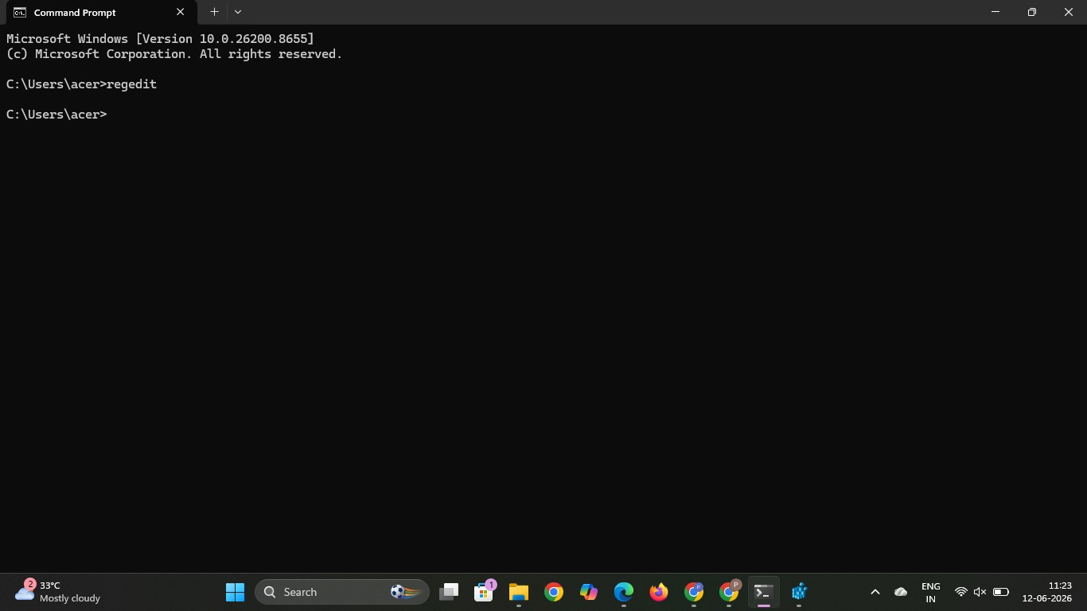
Using the command prompt as run as administrator and open the Registry Editor using the regedit

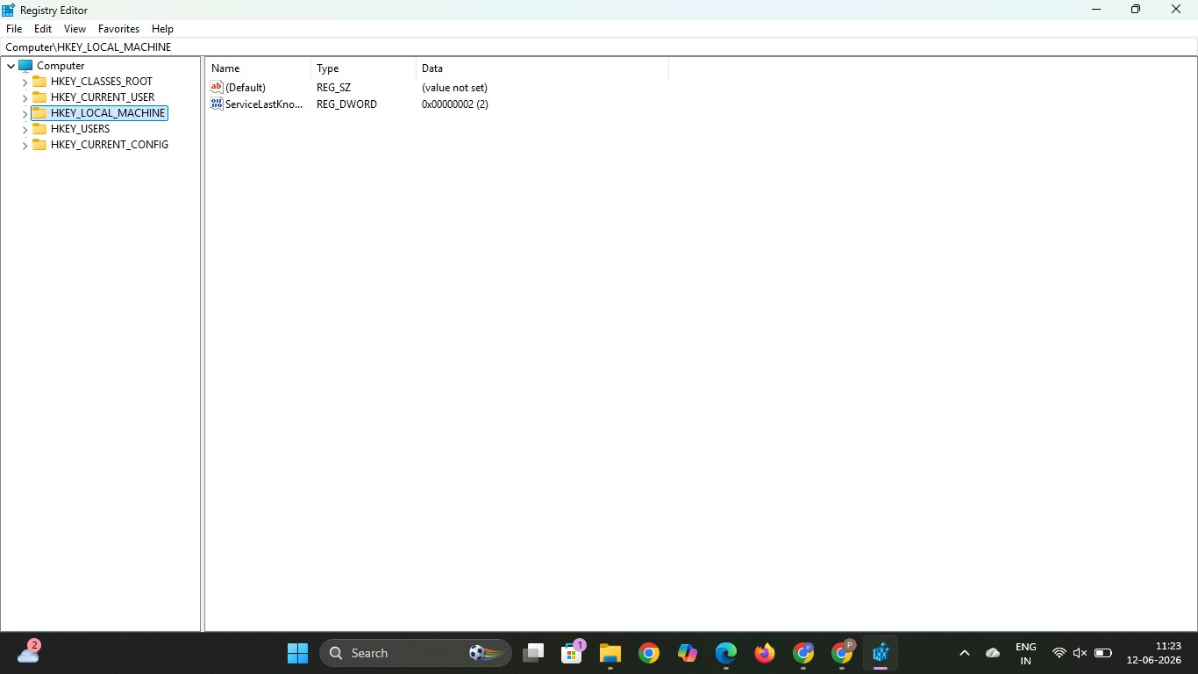

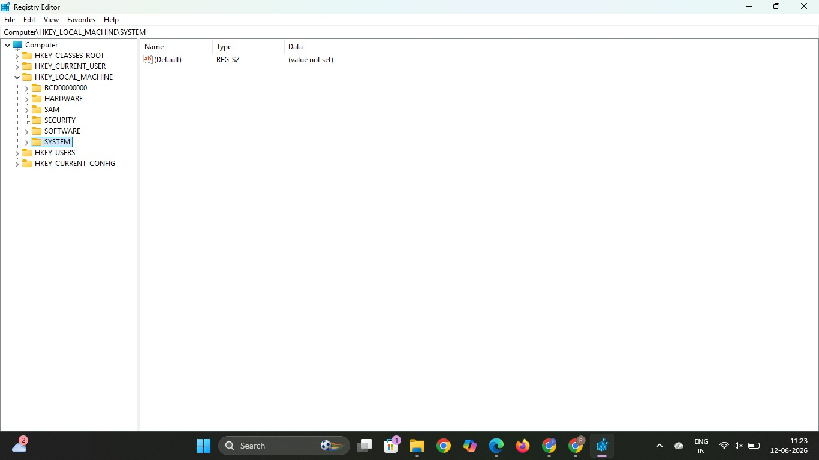

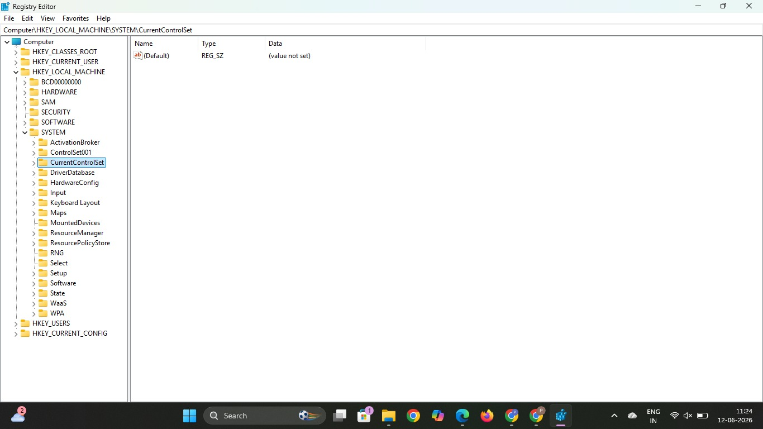

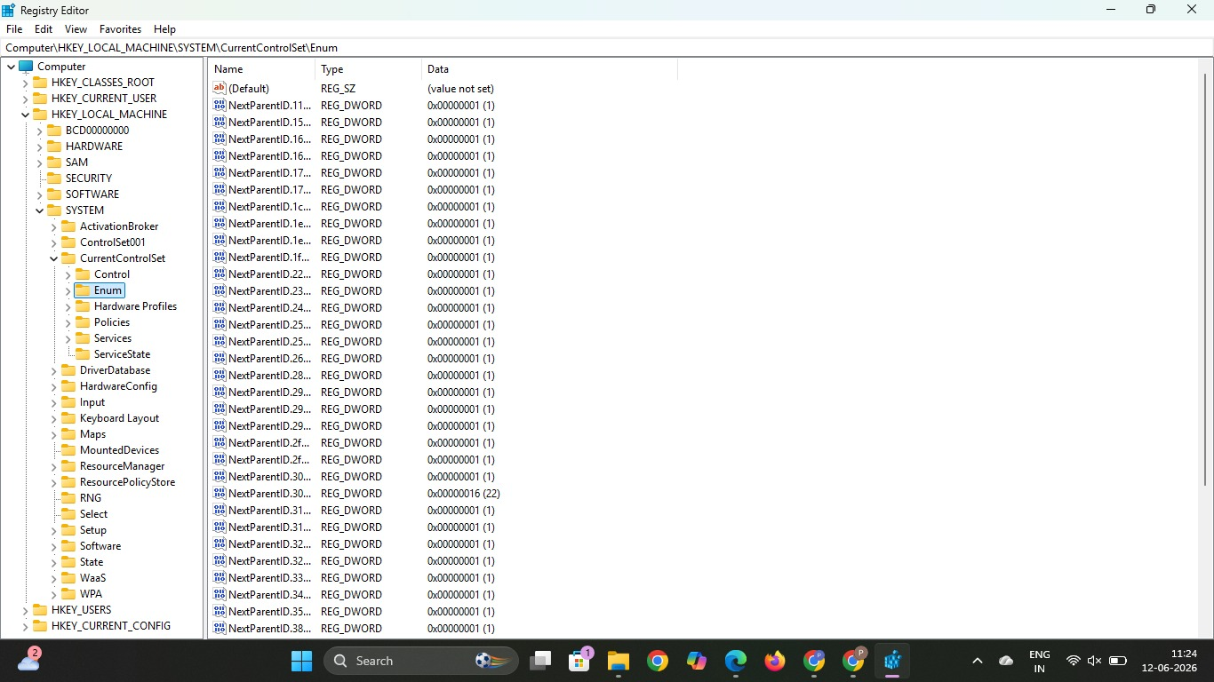

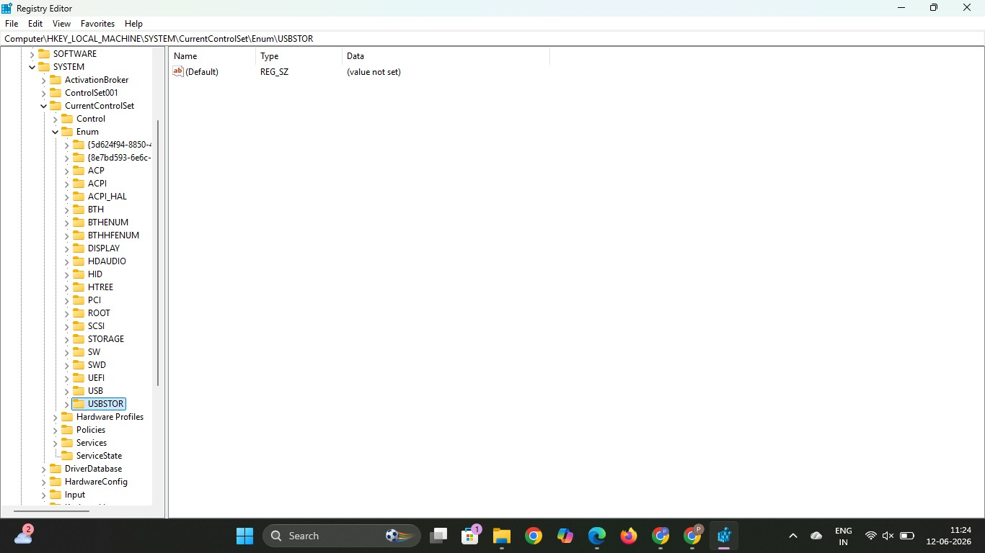

Navigation through Registry Editor to locate USB device records under HKEY_LOCAL_MACHINE\SYSTEM\CurrentControlSet\Enum.
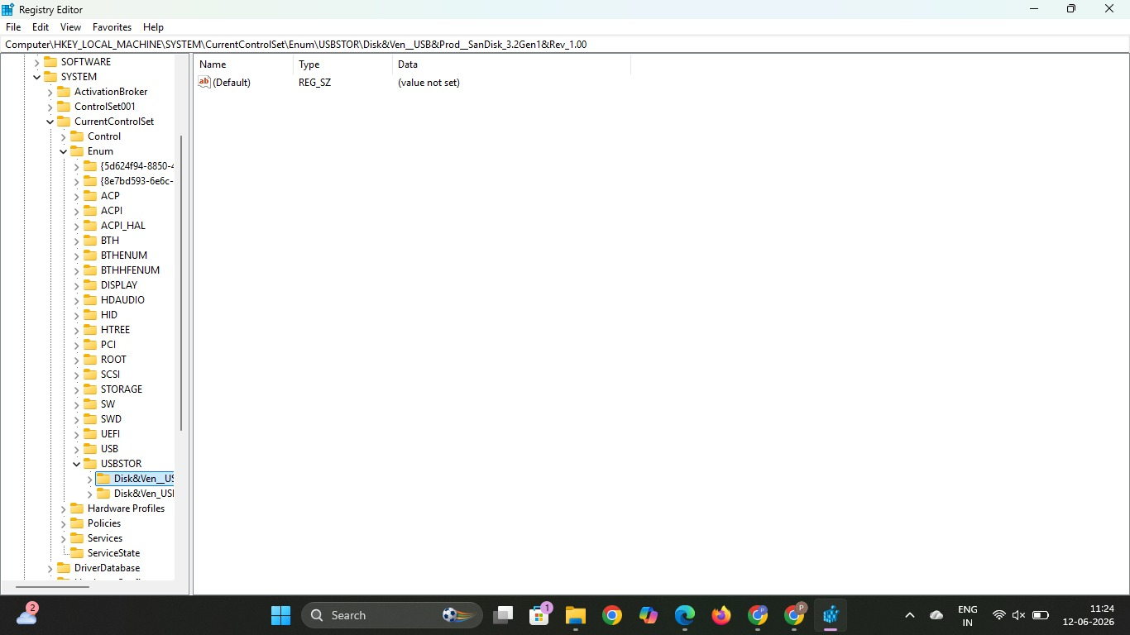
Registry entry showing the connected device as USB SanDisk 3.2Gen1 USB Device.

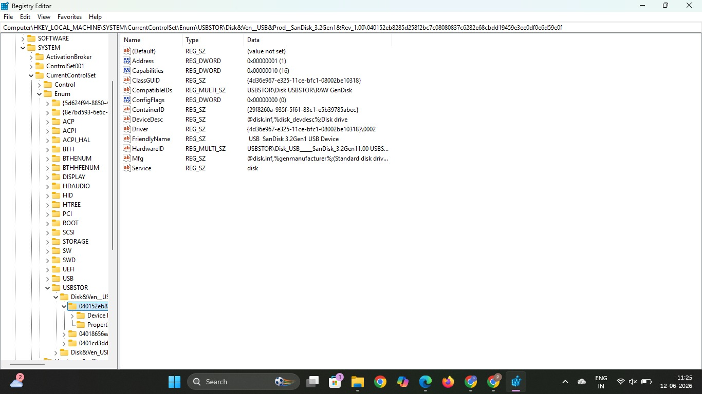Confirmation of device information and registry artifacts used as forensic evidence.

- The activity is suspicious because an external USB storage device was connected to the computer and may have been used to transfer or access sensitive data. Unauthorized USB devices can be used for data theft, malware introduction, or bypassing organizational security controls. The presence of a USB storage device in the USBSTOR registry key confirms that removable media was connected to the system.
2. Evidence supporting the USB investigation includes:
  - USBSTOR Registry Entries
  - Device Description Information
  - Hardware IDs
  - Vendor Information
  - USB Serial Number
  - Registry Artifacts showing previous device connections

3. The USB serial number uniquely identifies a specific USB device.
040152eb8285d258f2bc7c08080837c6282e68cbdd19459e3ee0df0e6d59e0f

Conclusion:
The USB forensic investigation identified evidence of a removable storage device connected to the system. Analysis of the Windows Registry under USBSTOR revealed a SanDisk 3.2 Gen1 USB Device along with its unique serial number. These artifacts confirm that the USB device had been connected to the computer. The recovered registry information provides valuable evidence for tracking device usage and determining whether sensitive data may have been accessed or transferred. Further analysis of file access and system logs is recommended to identify any data movement associated with the device.

TASK-3 MALWARE ANALYSIS
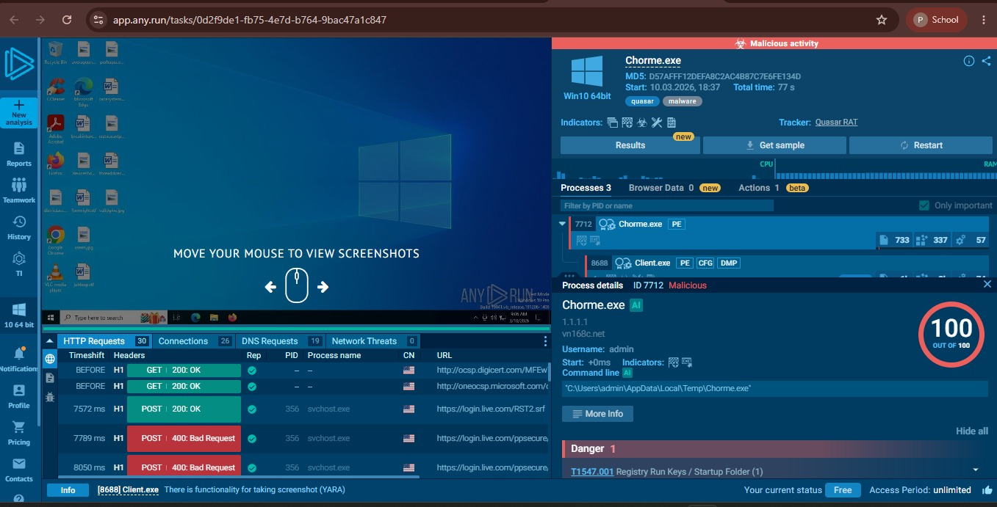
Quasar RAT is a Remote Access Trojan that allows attackers to remotely control an infected system. It can perform actions such as monitoring user activity, stealing credentials, transferring files, capturing screenshots, and executing commands on the victim's computer without authorization.

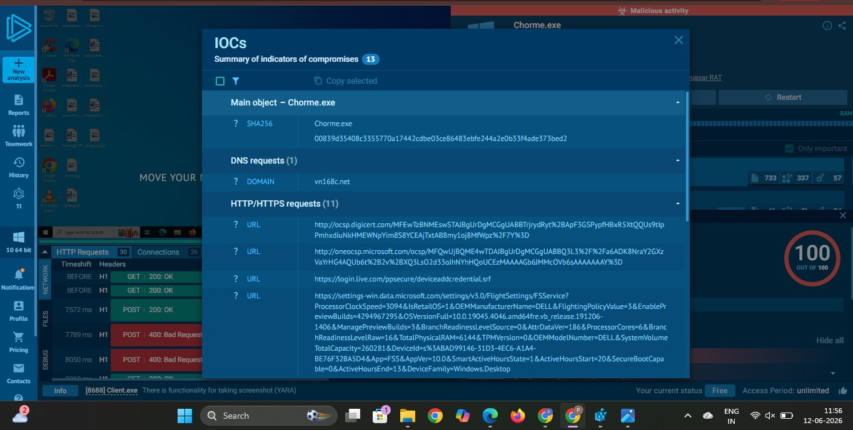
Indicators of Compromise (IOCs) are pieces of forensic evidence that suggest a system may have been infected or compromised by malware. Security analysts use IOCs to identify malicious activity, detect infected systems, and perform incident response activities.
In the ANY.RUN analysis, several IOCs were identified that indicate the presence of Quasar RAT malware.

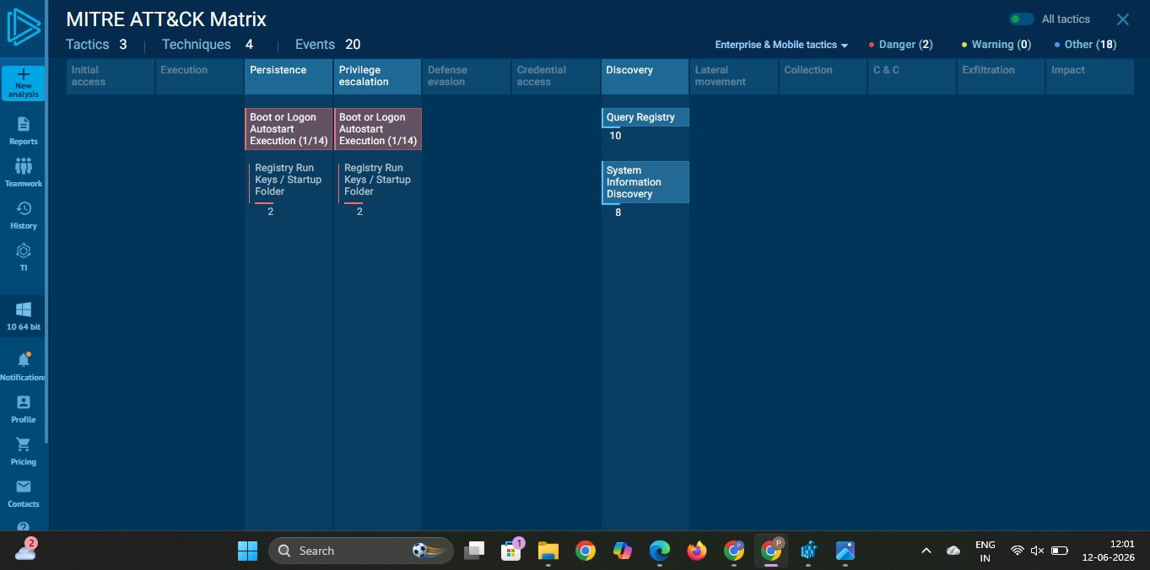
The MITRE ATT&CK Matrix from the ANY.RUN analysis shows the techniques used by the Quasar RAT malware during execution. These techniques help investigators understand the behavior and objectives of the malware.

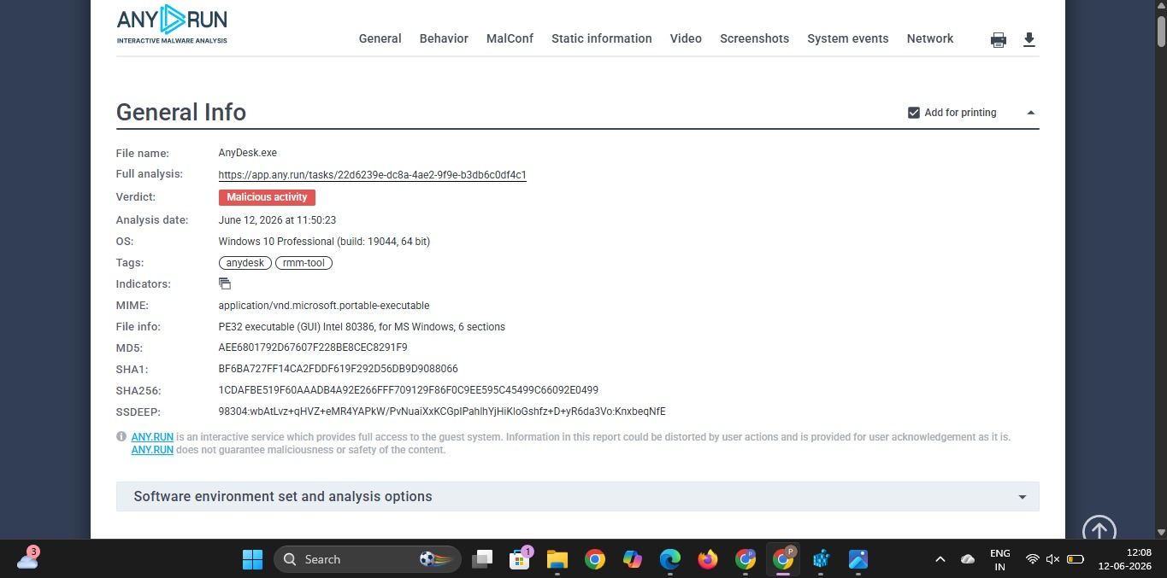

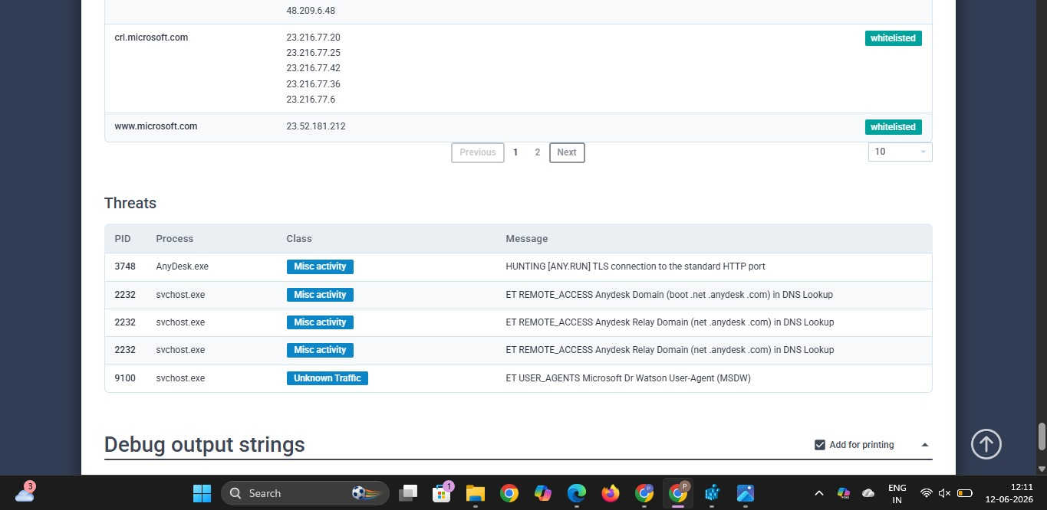

The ANY.RUN analysis identified the malware as Quasar RAT, a Remote Access Trojan. The malware created persistence through Registry Run Keys, collected system information, and communicated with external domains. Several Indicators of Compromise (IOCs), including the file hash, malicious executable, and suspicious domain, were identified. These activities indicate a high risk of unauthorized access and data theft. The infected system should be isolated immediately, and the malware should be removed to prevent further compromise.
TASK-4 EMAIL SECURITY INVESTIGATION

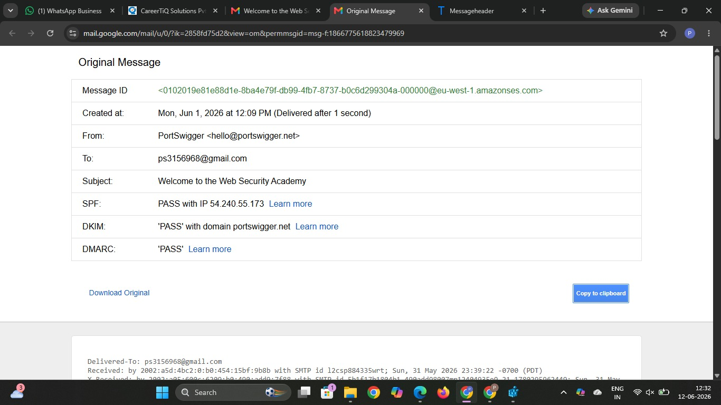
The raw email header contains technical information about the email, including the sender, recipient, return path, and authentication results. It helps security analysts verify the origin of the email and identify any signs of spoofing or phishing.

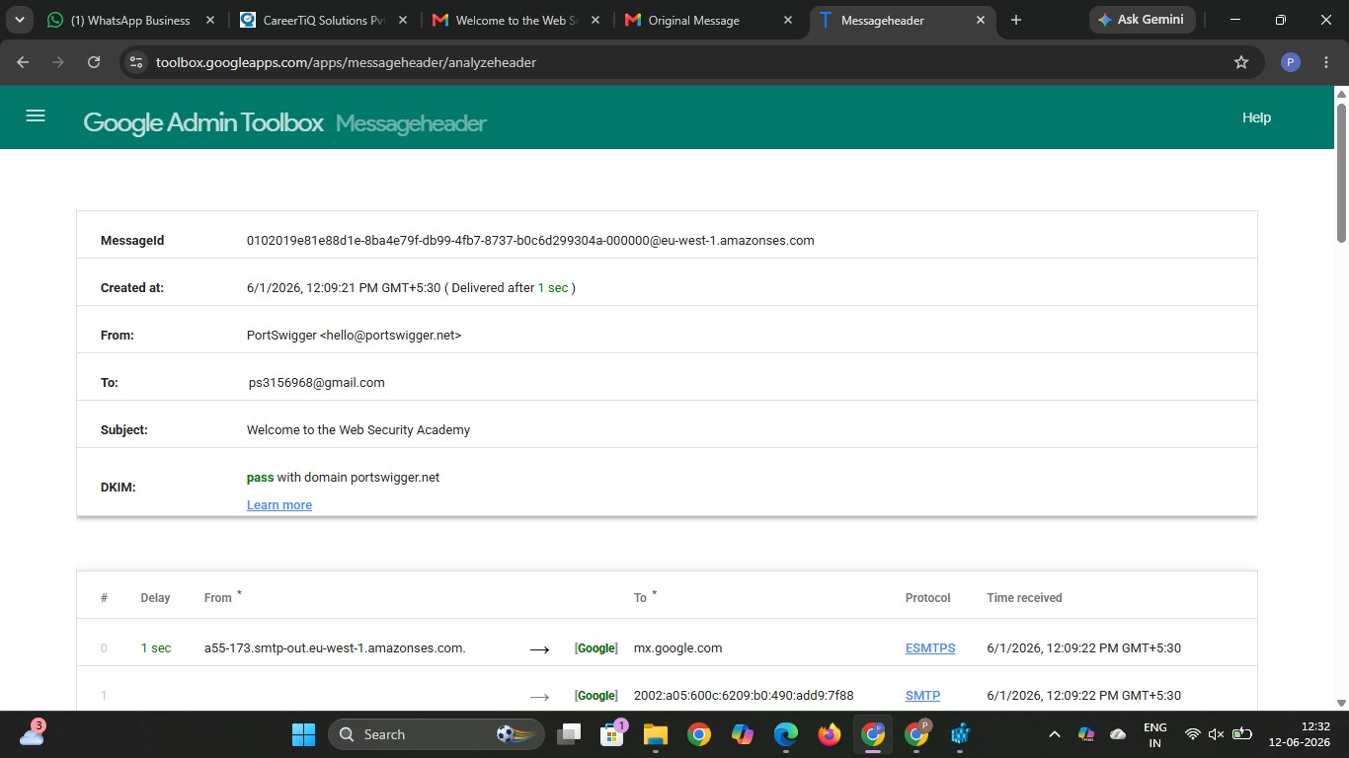
The Google Messageheader Analyzer provides a summary of the email details. It shows the sender (hello@portswigger.net), recipient, subject, and confirms that the email passed DKIM authentication, indicating message integrity.

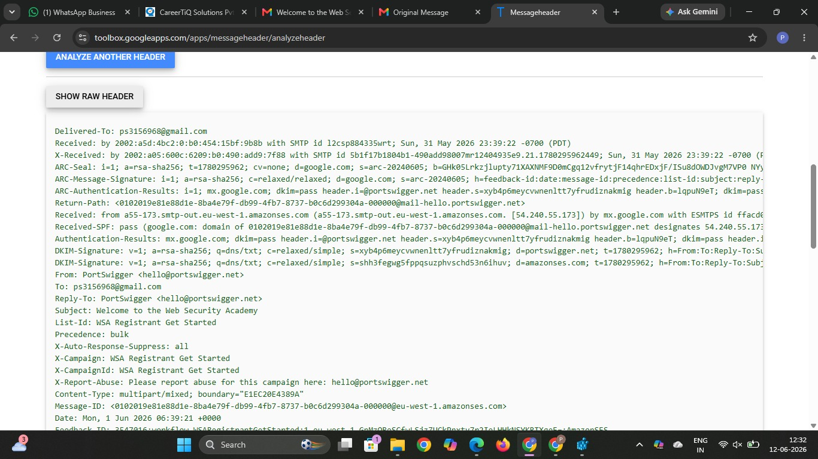

The Gmail Original Message view displays the email authentication results. The email passed SPF, DKIM, and DMARC checks, confirming that the sender is legitimate and the email was not altered during transmission.

Conclusion:
Based on the analysis of the email header, Google Messageheader report, and Gmail Original Message details, the email from hello@portswigger.net is legitimate. The message successfully passed SPF, DKIM, and DMARC authentication checks and was transmitted through trusted mail servers without any signs of spoofing or tampering. Therefore, the email can be considered safe and trustworthy.

TASK-5 SECURITY CASE STUDY
Scenario
An employee receives a phishing email and enters company credentials on a fake login page. A successful login is later observed from an unknown IP address.
1. What was the initial attack vector?
The initial attack vector was a phishing email that directed the employee to a fake login page designed to steal company credentials.
Phishing is a social engineering attack in which attackers impersonate legitimate organizations to trick users into revealing sensitive information such as usernames and passwords. In this scenario, the attacker successfully obtained the employee's credentials through a fraudulent login page.

2. What activity appears suspicious?
The suspicious activity is a successful login from an unknown IP address after the employee entered credentials on the fake login page.
A login from an unfamiliar IP address may indicate unauthorized access by a threat actor. Since the login occurred after the phishing incident, it suggests that the attacker used the stolen credentials to access company resources.

3. What should the SOC team investigate?
The SOC (Security Operations Center) team should investigate:
- The phishing email source and sender details.
- Login logs associated with the compromised account.
- The unknown IP address and its geolocation.
- Any unusual account activities after the login.
- Changes to account settings or permissions.
- Access to sensitive files or systems.
- Whether other employees received similar phishing emails.
- Evidence of data theft or lateral movement within the network.
The SOC team's goal is to determine the scope of the compromise, identify affected systems, and assess whether the attacker gained further access beyond the compromised account.

4. What immediate action should be taken?
The following immediate actions should be taken:
- Disable or lock the compromised account.
- Force a password reset.
- Revoke all active user sessions.
- Enable Multi-Factor Authentication (MFA) if not already enabled.
- Block the suspicious IP address.
- Notify affected users and management.
- Begin incident response procedures.
Quick containment actions help prevent further unauthorized access and reduce the risk of data loss or additional compromise.

5. How could this attack have been prevented?
The attack could have been prevented through:
- Security awareness training for employees.
- Multi-Factor Authentication (MFA).
- Email filtering and anti-phishing solutions.
- URL filtering and web security controls.
- Regular phishing simulation exercises.
- Conditional access policies.
- User verification before entering credentials.
Most phishing attacks rely on human error. Combining employee awareness with technical security controls significantly reduces the likelihood of successful credential theft.

Investigation Conclusion
The incident began with a phishing email that tricked an employee into entering company credentials on a fake login page. The stolen credentials were later used to successfully access the account from an unknown IP address, indicating a potential account compromise. Immediate containment actions such as account suspension, password reset, and IP investigation should be performed. Implementing employee security awareness training and Multi-Factor Authentication (MFA) would significantly reduce the risk of similar attacks in the future.

