Selenium

How to find the elements in the chrome ?

Press12

Press ESC

Then you can write $x(“//input[@id=’test’]”) press Enter you will find the elements

**Xapth starts-with Example**

$x(“//input[starts-with(@value,’text’)]”)

**Xapth substring example**

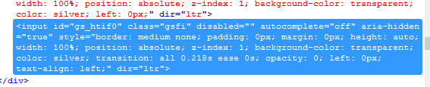

xpath=//input[substring(@class,2)='sfi'] // For search Filed of Google

xapth=//input[substring(@class,2,3)=

**Text Example in xapth**

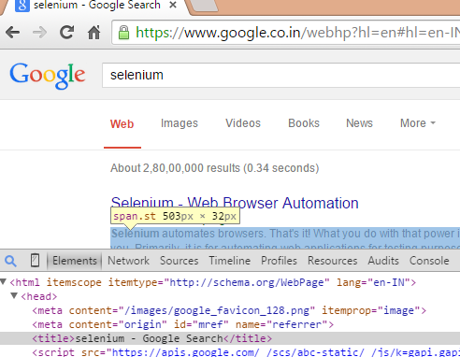

$x("//title[text()='selenium - Google Search']")

TO normalize the space in the text then

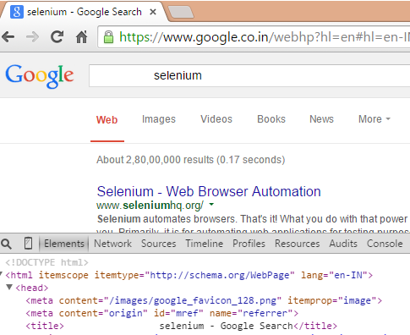

$x("//title[normalize-space(text())='selenium - Google Search']")

**Contains with xpath**

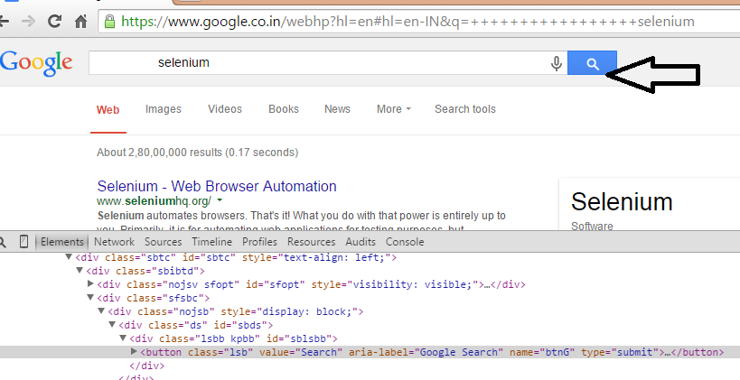

$x("//button[contains(@name,'nG')]")

**Using the coordinates in the xpath**

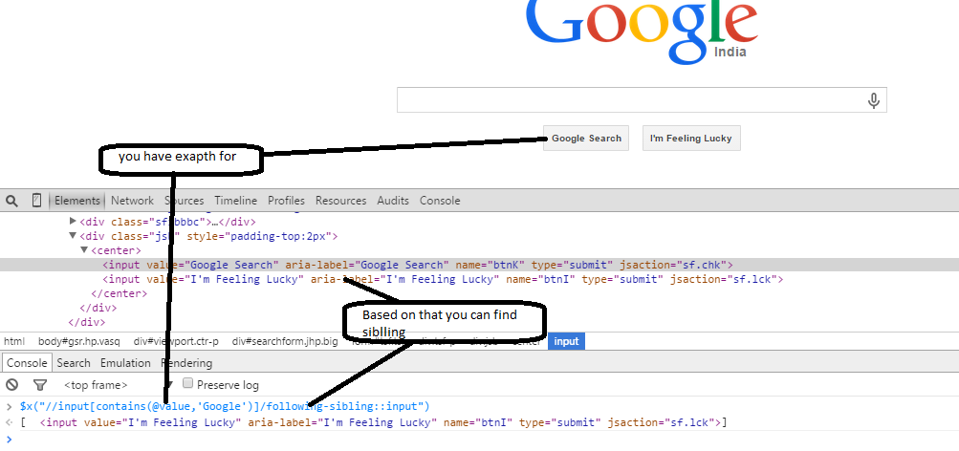

$x("//input[contains(@value,'Google')]/following-sibling::input")

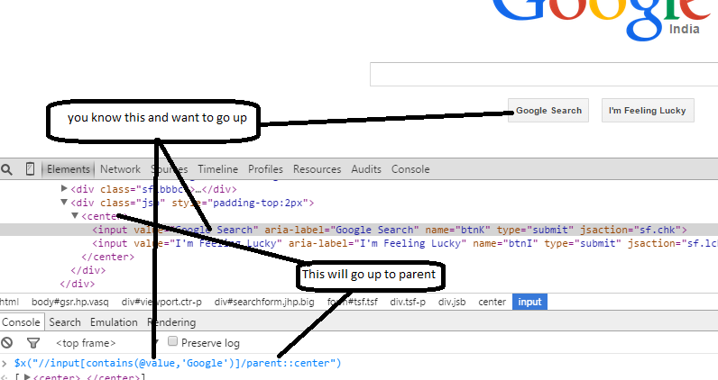

**If you want to go back up to the parent**

$x("//input[contains(@value,'Google')]/parent::center")

If you want to use the parent instead of above you can use simple syntax

$x("//input[contains(@value,'Google')]/..")

**Parent of this**

$x("//input[contains(@value,'Google')]/../..")

**Preceding-sibling**

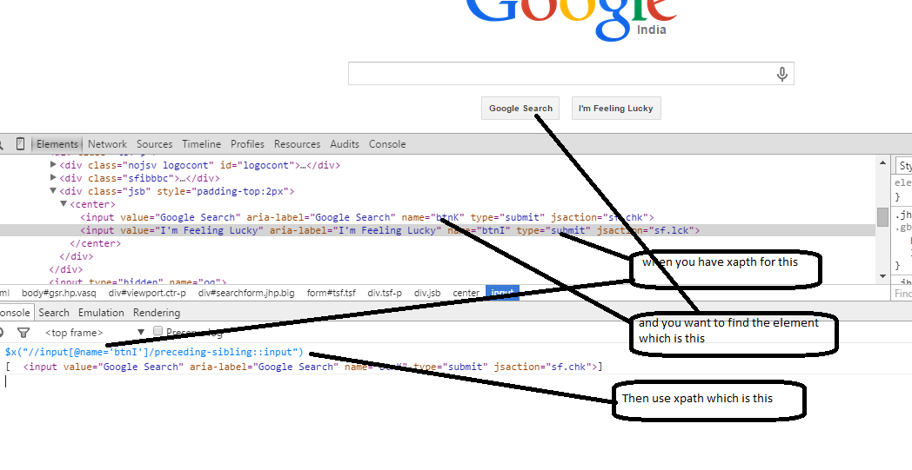

$x("//input[@name='btnI']/preceding-sibling::input")

**How the Base class would look like**

mport org.openqa.selenium.WebDriver;

import org.openqa.selenium.chrome.ChromeDriver;

import org.openqa.selenium.firefox.FirefoxDriver;

import org.testng.annotations.Optional;

import org.testng.annotations.Parameters;

import org.testng.annotations.Test;

import org.testng.annotations.BeforeMethod;

import org.testng.annotations.AfterMethod;

public class Seletest {

WebDriver d;

@Parameters({"Browser","URL"})

@BeforeMethod

public void LaunchBrowser(@Optional("Firefox")String b,@Optional("https://www.facebook.com/")String url) {

if(b.equalsIgnoreCase("Firefox"))

{

d=new FirefoxDriver();

d.get(url);

}

else

{

System.setProperty("webdriver.chrome.driver", "C:\\Work\\Selenium_Jars\\chromedriver_win32\\chromedriver.exe");

d=new ChromeDriver();

d.get(url);

}

}

@AfterMethod

public void closebrowser() {

d.close();

}

}

TestNG suite file

<?xml version=*"1.0"* encoding=*"UTF-8"*?>

<!DOCTYPE suite SYSTEM "http://testng.org/testng-1.0.dtd" >

<suite name=*"Suite1"*>

<test name=*"test on Firefox"*>

<parameter name=*"Browser"* value=*"Firefox"* />

<parameter name=*"URL"* value=*"https://www.facebook.com/"* />

<classes>

<class name=*"org.prasanna.test.SignupTest"* />

</classes>

</test>

<test name=*"test on chrome"*>

<parameter name=*"Browser"* value=*"chrome"* />

<parameter name=*"URL"* value=*"https://www.facebook.com/"* />

<classes>

<class name=*"org.prasanna.test.SignupTest"* />

</classes>

</test>

</suite>

**PAGE OBJECT**

1.Hides implementation from Test

2.Single Reposbilities principle

3.assertion should be done on test