|  |  |  |
| --- | --- | --- |
| ***Medicare*** | | |
|  | Capstone project -For online ordering of  Medicines |  |

*Developed by:prasanna kumari*

**This document contains sections for:**

 Project overview

 Project's core concepts

 Flow of the Application

 Agile and Scrum: User Stories from the Project

 Pushing code on Github

 Conclusions

* The code for this project is hosted at: https://github.com/Prasannasyam/Medicare.git

**Project Overview:**

1. Technologies used

SpringBoot,J-Unit,Spring Data Jpa ,Angular

Database: MySQL

**Features:**

1. Medicare application is made specifically to the required business needs. It is completely flexible and scalable to the business demands and growth.
2. The whole application is a Single Page Application that is more efficient in terms of processing and provides a seamless user experience.
3. The application web pages are responsive and secure.
4. The application has one Administrator. The Admin Portal features are:
   * + The admin can login with username and password in admin portal.
     + The admin can add or remove medicine details.
     + Edit medicine details like name, price etc., to keep the product information updated with current prices. • Enable or disable the medicines.
5. The application has a User portal. The User Portal features are: • Sign up and login with username and password.
   * The User can maintain the record of activities.
   * Search for products based on the search keyword.
   * Apply filters and sort result based on different categories.
   * Add the product to cart and customize the purchase at the end.
   * Experience a seamless payment experience.
   * Receive an order summary once the payment is successful.

**Project’s Core concepts:**

 Language: Java (Eclipse IDE) concepts

* + Angular framework for frontend UI’s. • Spring boot framework for backend .
  + MySQL Database for storing all the data.
  + HTML, Bootstrap 4.
  + Typescript.
  + Spring Security and JWT Authentication.
  + Spring Data Jpa, Spring Web.

**Flowchart of the Application:**

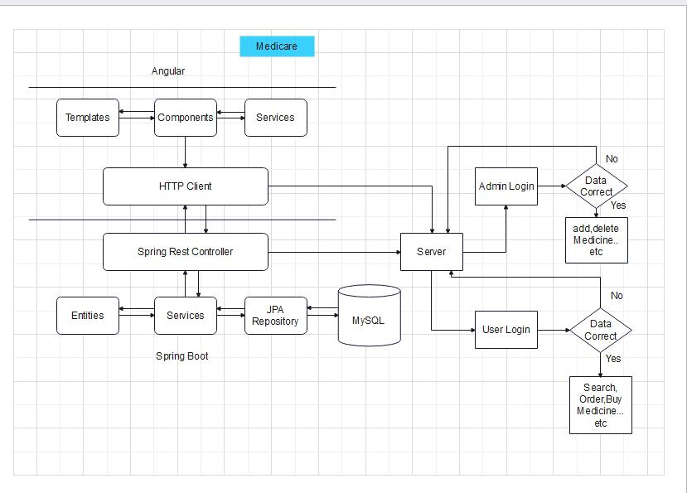

# **A**gile and Scrum: Users Stories

The project will be finished in three sprints. The following tasks are expected to be performed throughout the sprint:

⇒ Creating the application's flow

⇒ Setting up a git repository to track changes as the project develops.

⇒ Writing a Java programme to meet the project's requirements.

⇒ Putting the Java software through its paces with various types of user input  Using GitHub to push code.

***Users Stories to be covered per sprint:***

**Sprint Planning and Task Achieved:**

Number of sprint planned = 4.

**Sprint 1:**

1. Planned to develop backend code for project. Generated Spring boot project from [http://start.spring.io.](http://start.spring.io/)
2. Planned to develop the rest api’s to create Admin and User. Used spring security and Jwt authentication to achieve this task.
3. Planned to develop api’s for admin portal to add, update, delete, enable or disable products.
4. Successfully developed and tested the admin portal rest api’s using Postman software.
5. Planned to develop frontend code for project. Generated Angular project using angular cli.
6. Planned to develop login ui for admin and user portal. Successfully developed the ui’s for admin and user.
7. Planned to develop admin dashboard that enables admin to perform the required functionalities. Successfully developed the admin dashboard.

**Sprint 2:**

1. Planned to develop home page of the application. Successfully developed the home ui of the application.
2. Planned to develop Sign up ui for users. Developed successfully.
3. Planned to develop ui for search product based on keyword, show product based on category. Successfully developed the ui’s for user portal feature.
4. Planned to develop user home ui. Developed successfully.

**Sprint 3:**

1. Planned to develop add to cart feature ui in user portal. Developed successfully.
2. Planned to develop rest api’s to create an order and to view orders by user. Successfully developed and tested the user order api’s using postman software.
3. Planned to develop create a new order ui in user portal. Developed successfully.
4. Planned to develop ui’s for order summary, show all orders in user and admin portal. Developed successfully.

**Sprint 4:**

1. Planned to test the complete web application by giving the required inputs in respective fields.
2. Successfully tested all the admin portal features and user portal features.
3. The Web application is responsive, secure and all features are working as per the given requirements.

## Pushing the code to GitHub repository

* Open your command prompt and navigate to the folder where you have created your files.

*cd <folder path>*

* Initialize repository using the following command:

*git init*

* Add all the files to your git repository using the following command:

*git add .*

* Commit the changes using the following command:

*git commit . -m <commit message>*

* Push the files to the folder you initially created using the following command:

*git push -u origin master*

## Conclusions

An application with a sprint duration of four sprints has been developed in the programme. This application manages the Medicines data. The user can create account and search the Medicines by using filters and ordered the product. After completing the order it shows confirmation page with payment details.The administrator can manipulate the available medicines data and add new medicines to cart by logging in with an email ID and password.