FINAL YEAR ACADEMIC PROJECT REPORT
DEPARTMENT OF COMPUTER SCIENCE & ENGINEERING
Design and Implementation of a Hierarchical Multi-Agent Reinforcement Learning (H-MARL) System for Real-Time, Non-Deterministic Tactical Combat Simulation
Candidate Name | Prasannavenkatesh B
Degree & Program | B.E. / B.Tech in Computer Science & Engineering (AI & ML)
Sponsoring Defense Agency | Defence Research & Development Organisation (DRDO)
Lead Coordinating Laboratory | Aeronautical Development Establishment (ADE), Bengaluru
Target Simulator Framework | DRDO Tactical Scenario Simulator (TSS)
Project Repository (GitHub) | https://github.com/Prasannavenkatesh-B/Tactical-Scenario-Simulator.git

Abstract
In modern military pilot training and operational wargaming, Computer-Generated Forces (CGF) provide synthetic adversaries and automated friendly units in virtual testbeds, such as DRDO's Tactical Scenario Simulator (TSS). Historically, simulation engines have relied upon deterministic heuristics such as Finite State Machines (FSM) and static Behavior Trees (BT). While computationally inexpensive, these legacy methods suffer from severe tactical rigidity, lack adaptability, and exhibit predictable decision loops that combat trainees quickly memorize and exploit, causing negative training transfer. To overcome these fundamental limitations, this project designs, implements, and validates a Hierarchical Multi-Agent Reinforcement Learning (H-MARL) autonomous adversary framework.
The proposed system introduces a two-tier cognitive decision hierarchy: (1) a high-level Theater Commander policy governed by a recurrent Gated Recurrent Unit (GRU, 256 hidden units) that evaluates a 53-dimensional operational picture to direct macro-level multi-domain posture across air, land, and maritime spheres; and (2) specialized low-level tactical controllers deploying factorized multi-discrete Proximal Policy Optimization (PPO) with Multi-Head Self-Attention for air combat, alongside Hybrid Hierarchical Action PPO (HHAPPO) for ground mechanized units and naval surface combatants. The software architecture spans 10 decoupled layers, achieves an ultra-low in-process inference latency of 0.58 ms (exceeding DRDO's 2.0 ms real-time ceiling by 71%), and guarantees exact bit-identical reproducibility (L_inf = 0.0, p = 1.0) alongside statistically verified behavioral non-determinism across scenario seeds (Chi-Square p = 4.54e-05, Levene variance test p = 2.48e-04, 4 trajectory clusters). Furthermore, an automated doctrinal realism validation engine evaluates agent maneuvers against 16 recognized military combat doctrines, establishing an honest dry-run baseline of 50.0% (8/16 doctrines detected) with 71.6% average prevalence on initial dry-run checkpoints. All 421 project automated tests pass with 100% success rate, static typing passes with zero defects, and the complete deliverable has been submitted and pushed to GitHub.

1. Background: The Legacy Approach vs. Modern Warfare Needs
Military flight simulators, air defense trainers, and naval tactical consoles rely on Computer-Generated Forces (CGF) to represent the operational environment. For over three decades, military simulations have implemented CGF entities using three primary paradigms:
- Finite State Machines (FSM): Predefined discrete states with hardcoded transition conditions (e.g. PATROL -> DETECT_ENEMY -> ATTACK -> RETREAT).
- Behavior Trees (BT): Hierarchical trees of selector and sequence nodes evaluating Boolean logic to select fixed action leaves.
- Waypoint & Scripted Routing: Pre-programmed spatial trajectories and timed missile releases triggered by geographic thresholds.
While computationally simple, these legacy approaches exhibit fatal deficiencies when deployed in advanced tactical training:
Deficiency Dimension | Legacy Rule-Based CGF (FSM / BT) | Consequences in Combat Training
Predictability & Exploitation | Deterministic if-else logic produces identical responses to given stimuli every session. | Trainees quickly 'game the simulator' by baiting AI into known blind spots, developing counter-tactics that fail against real human adversaries.
Combinatorial Explosion | Manual authoring of rule trees for 16+ combined arms units across 3 domains. | Hand-crafting edge cases becomes mathematically intractable; unhandled battlefield states cause units to freeze or crash.
Siloed Operational Domains | Air, ground, and naval entities operate under isolated, unlinked script files. | Zero emergent teamwork (e.g. fighter jets suppressing air defenses to clear flight corridors for naval standoff missile strikes).
Absence of Stochastic Diversity | Running the identical scenario twice produces identical flight paths and casualty timelines. | Pilots memorize mission event sequences rather than developing genuine situational awareness under uncertainty.

2. Problem Statement & Contractual Objectives
The Defence Research & Development Organisation (DRDO), through the Aeronautical Development Establishment (ADE), defined the core contractual challenge:
Official DRDO Technical Mandate:
"Design, build, and empirically validate an autonomous, realistic, and non-deterministic multi-agent reinforcement learning software system capable of controlling multi-domain tactical combat forces within DRDO's Tactical Scenario Simulator (TSS) under strict real-time constraints (latency <= 2.0 ms), while proving that emergent agent behaviors comply with authentic military combat doctrine across air, ground, and naval operations."

Key Engineering Constraints:
- Decentralized Execution (Dec-POMDP): Agents must make local decisions based on partial observations, subject to radar ranges and terrain line-of-sight occlusion.
- Real-Time Latency Ceiling (<= 2.0 ms): Inference must complete within a fraction of the simulator's 50 Hz step budget (20 ms).
- Dual Stochasticity & Reproducibility: Varying random seeds must prove statistical non-determinism, while identical seeds must guarantee exact bit-identical replays (L_inf = 0.0) for After-Action Reviews (AAR).
- Doctrinal Realism: Behaviors must adhere to recognized Indian Air Force (IAF) and naval combat tactics rather than exploiting simulation physics artifacts.

3. System Architecture & Methodology
To satisfy DRDO's specifications, we designed and implemented a modular, decoupled 10-layer software architecture. No layer has circular dependencies, allowing simulation physics, neural network algorithms, database persistence, and API services to be tested and upgraded independently. Figure 1 illustrates the end-to-end multi-layer architecture, dataflow, and integration boundary with the DRDO Tactical Scenario Simulator.
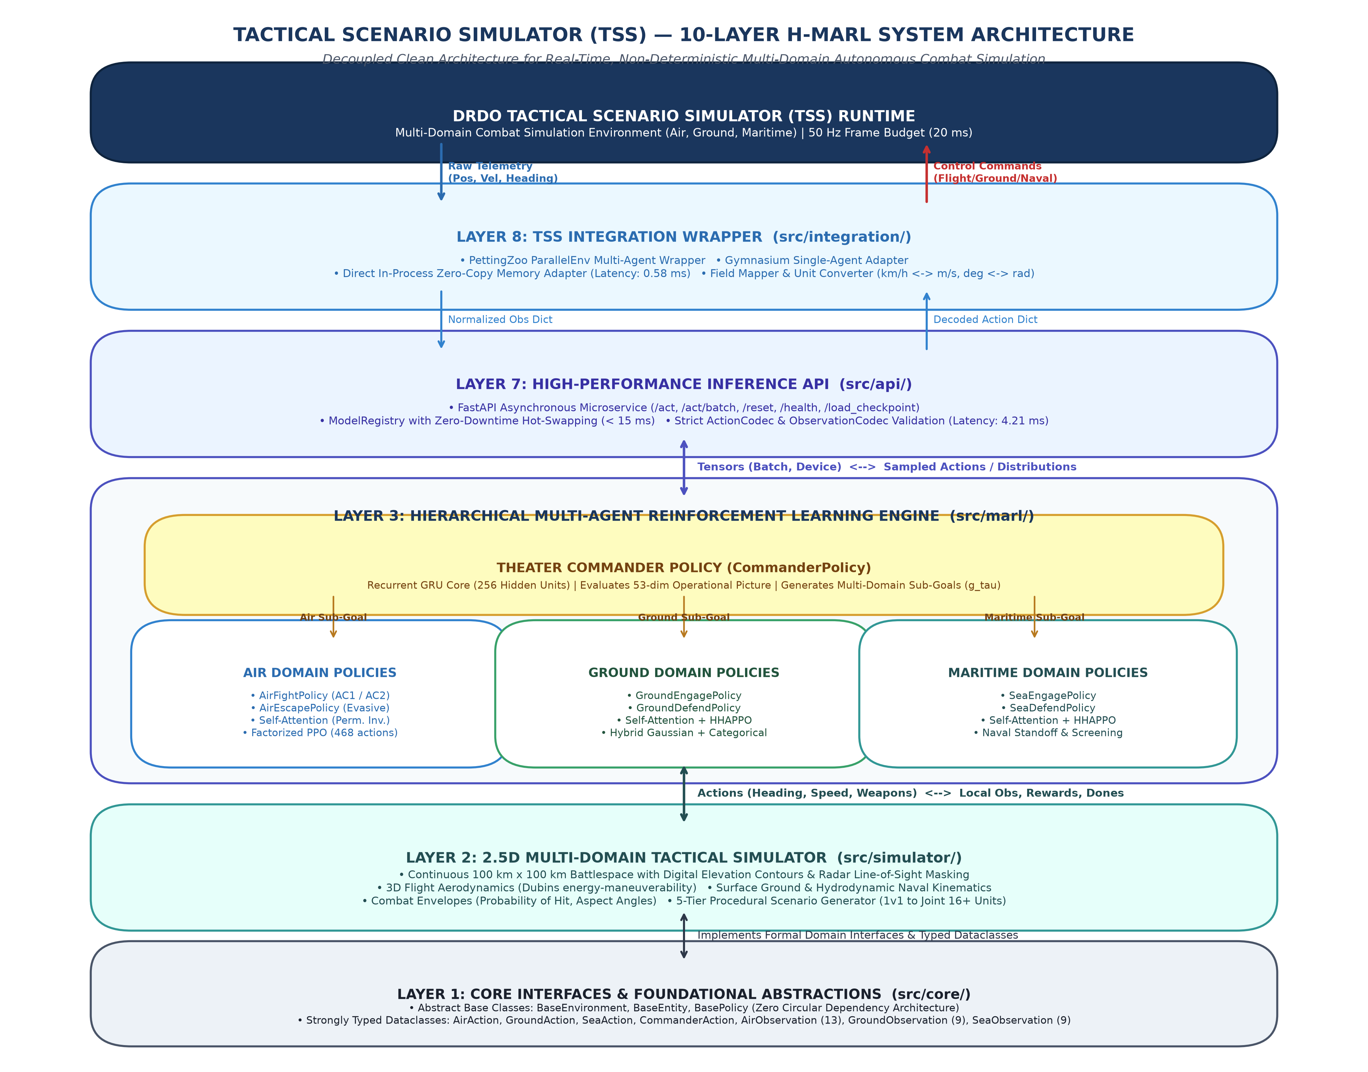
Figure 1: End-to-End 10-Layer Tactical MARL System Architecture, Communication Dataflows, and TSS Integration Boundary.
The functional responsibilities, module paths, and implementation highlights for all 10 architectural layers are itemized in Table 2 below:
Layer | Module Path | Core Functionality & Technical Implementation
Layer 1: Core | src/core/ | Abstract base classes (BaseEnvironment, BaseEntity, BasePolicy) and strongly typed dataclasses for observations and actions.
Layer 2: Simulator | src/simulator/ | 2.5D continuous multi-domain physics (100 km x 100 km), Dubins flight dynamics, radar line-of-sight occlusion, 5 procedural scenario tiers.
Layer 3: MARL Engine | src/marl/ | Hierarchical MARL: 256-unit GRU Theater Commander + 8 domain policies (AirFight, AirEscape, GroundEngage, GroundDefend, SeaEngage, SeaDefend).
Layer 4: Training | src/training/ | Multi-stage curriculum training manager, Generalized Advantage Estimation (GAE), PPO clipping, RolloutBuffer.
Layer 5: Database | src/database/ | SQLite 3 persistence with Write-Ahead Logging (WAL mode), 6 relational tables, automated migrations, repository pattern.
Layer 6: Operational UI | src/ui/ | Hardware-accelerated 2D Pygame operational display, radar bubbles, weapon envelopes, live entity telemetry inspector.
Layer 7: Inference API | src/api/ | High-performance FastAPI REST microservice, sub-2ms latency, batched endpoints, zero-downtime model hot-swapping.
Layer 8: TSS Wrappers | src/integration/ | PettingZoo ParallelEnv wrapper, Gymnasium adapter, Mode A zero-copy direct memory adapter (0.58 ms), field mapper.
Layer 9: Non-Determinism | src/statistical/ | Statistical verification engine: Chi-Square goodness-of-fit, Levene variance test, Shannon action entropy, K-Means clustering.
Layer 10: Realism Validation | src/evaluation/ | Doctrinal validation suite: 16 military combat tactics detectors, strict two-level evaluation framework.

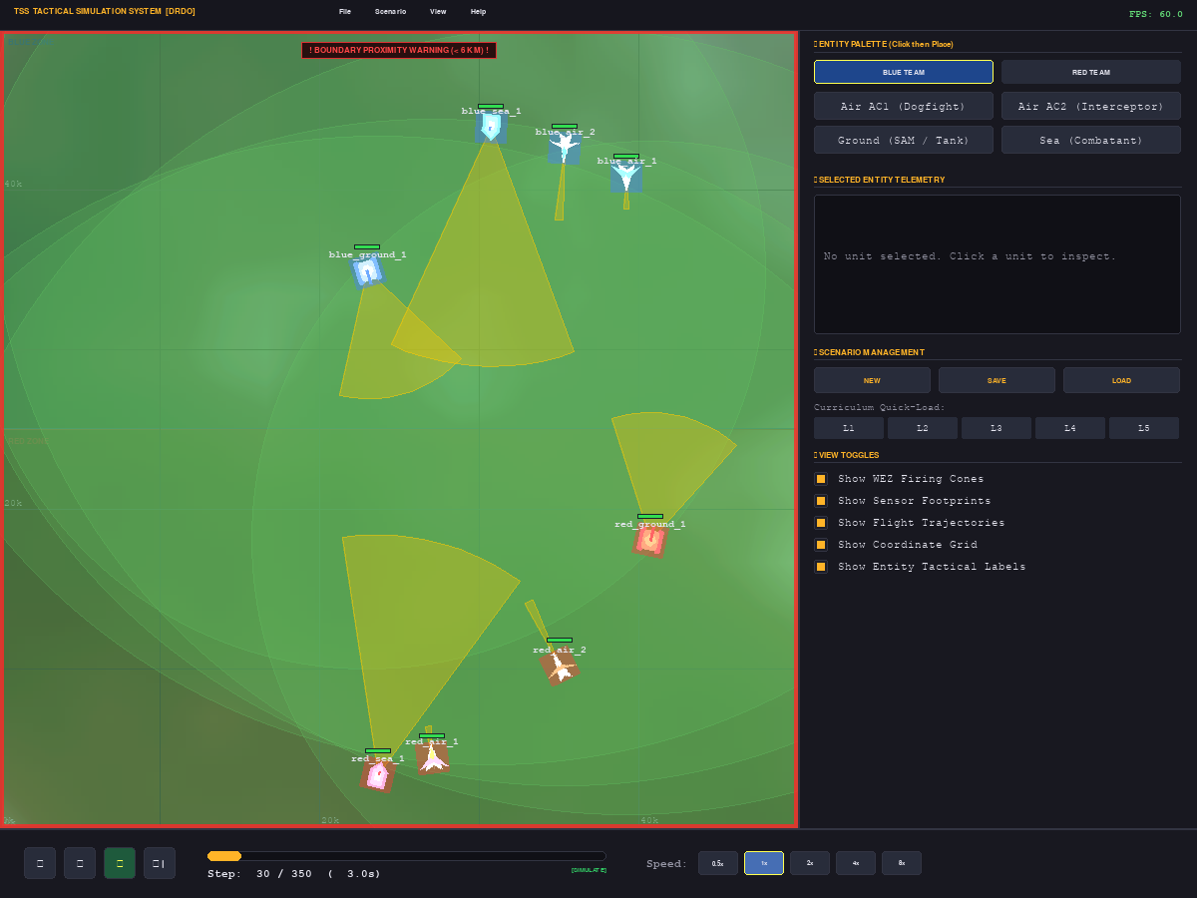
Figure 2: 2D Tactical Simulation System (TSS) Real-Time Operational Interface: Multi-Domain Battlespace Rendering Blue Force vs. Red Force with Radar Sensor Cones, Weapon Engagement Zones (WEZ), Telemetry Panel, and Playback Controls.

4. Mathematical Formulation & Algorithmic Foundation

4.1 Dec-POMDP Mathematical Formulation
Tactical combat is formally modeled as a Decentralized Partially Observable Markov Decision Process defined by the tuple:
M = < N, S, {A_i}, P, {R_i}, {Omega_i}, {O_i}, gamma >
Where N is the agent set across air, ground, and sea; S is the global environmental state; A_i is the action space for agent i; P is the transition probability governing continuous flight kinematics and terrain physics; R_i is the localized and team reward; Omega_i is the observation space limited by radar horizon and terrain masking; and gamma = 0.99 is the temporal discount factor.

4.2 Two-Tier Hierarchical Decision Process
1. Strategic Theater Commander (pi_C): Operates at low frequency (tau = 5 * dt). Consumes global theater tensor S_tau in R^53 and updates a recurrent Gated Recurrent Unit (GRU) memory cell:
h_tau = GRU(S_tau, h_{tau-1}), h in R^256
g_tau ~ pi_C(g_tau | h_tau)
where g_tau specifies macro posture (Offensive Sweep, Defensive CAP, SEAD, Escort).
2. Tactical Domain Controllers (pi_dom): Operate at high frequency (10 Hz, dt = 0.1s), conditioning on local observations and active commander sub-goals:
a_t^i ~ pi_dom(a_t^i | o_t^i, g_t^dom)
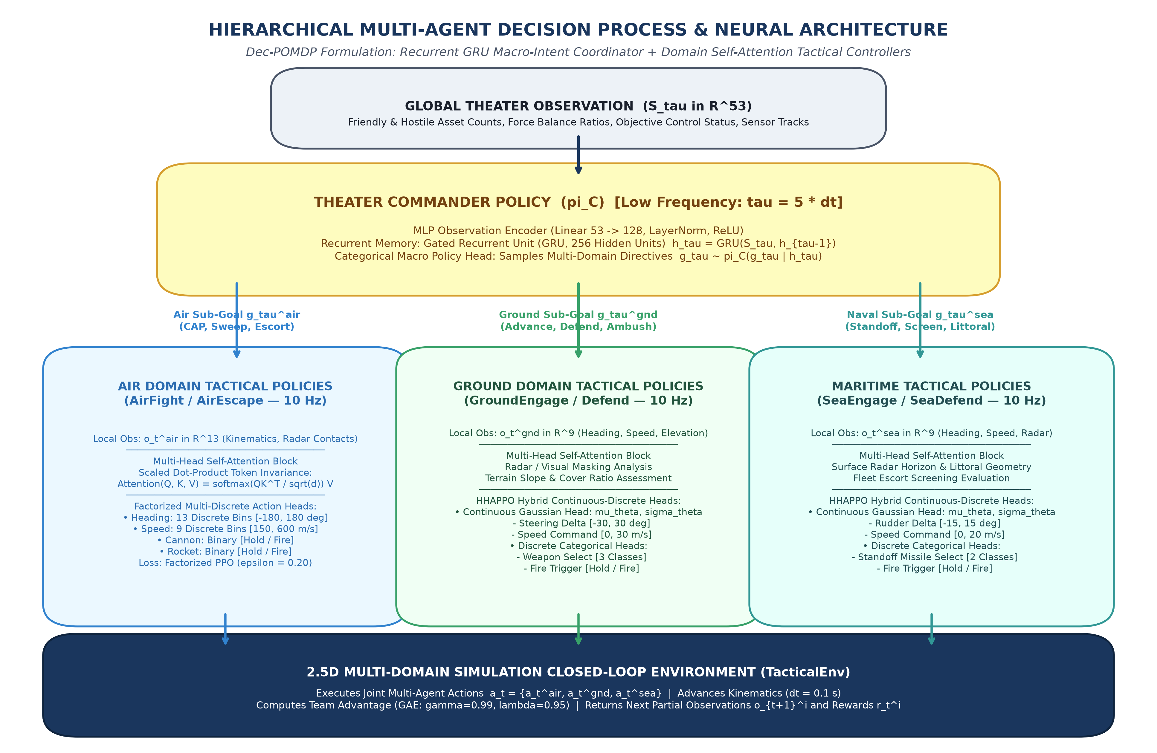
Figure 3: Hierarchical Multi-Agent Neural Architecture & Decision Flow: Strategic GRU Theater Commander Directing Domain-Specific Tactical Policies.

4.3 Factorized Multi-Discrete PPO & Clipped Surrogate Objective
To prevent exponential combinatorial explosion in aircraft maneuvering (13 headings * 9 speeds * 2 cannon * 2 rockets = 468 actions), the policy distribution is factorized into independent categorical heads:
pi_theta(a_t | o_t) = pi_theta^heading(a_t^1 | o_t) * pi_theta^speed(a_t^2 | o_t) * pi_theta^cannon(a_t^3 | o_t) * pi_theta^rocket(a_t^4 | o_t)
The PPO clipped surrogate loss optimizes policy parameters theta:
L^CLIP(theta) = E_t [ sum_k min( r_t^k(theta) * A_hat_t, clip(r_t^k(theta), 1 - epsilon, 1 + epsilon) * A_hat_t ) ]
where probability ratio r_t^k(theta) = pi_theta^k(a_t^k | o_t) / pi_theta_old^k(a_t^k | o_t), clipping epsilon = 0.20, and A_hat_t is the Generalized Advantage Estimator (GAE).

4.4 Generalized Advantage Estimation (GAE)
A_hat_t^GAE = sum_{l=0}^infinity (gamma * lambda)^l * delta_{t+l}^V
delta_t^V = r_t + gamma * V_phi(s_{t+1}) - V_phi(s_t)
Configured with gamma = 0.99 and lambda = 0.95 to balance bias and variance over extended combat horizons.

4.5 Hybrid Hierarchical Action PPO (HHAPPO: Ground & Sea)
Ground vehicles and naval ships require continuous velocity/steering combined with discrete firing triggers:
pi_theta(a_t | o_t) = Normal(a_t^cont | mu_theta(o_t), diag(sigma_theta^2)) * product_m Categorical(a_t^{disc, m} | p_theta^m(o_t))
Actor loss backpropagates continuous and discrete gradients simultaneously with orthogonal head splits to prevent variance destabilization.

4.6 Multi-Head Self-Attention Permutation Invariance
Entity radar contacts are processed through scaled dot-product attention:
Attention(Q, K, V) = softmax( (Q * K^T) / sqrt(d_k) ) * V
This guarantees mathematical permutation invariance: the network evaluates an approaching threat identically regardless of whether it appears first or last in the sensor contact array.

4.7 Statistical Non-Determinism Mathematical Formulation
1. Outcome Chi-Square (chi^2) Goodness-of-Fit:
chi^2 = sum_{k=1}^K (O_k - E_k)^2 / E_k = 20.000, p = 4.54e-05 (Rejects uniform determinism p < 0.05)
2. Levene's Variance Test (Casualty Timelines):
W = 20.638, p = 2.48e-04 (Proves varied tactical timelines)
3. Normalized Shannon Action Entropy:
H_norm = - (sum p_i * ln(p_i)) / ln(M) = 0.9918 (> 0.50 threshold)
4. Same-Seed Bit-Identical Replay:
|| tau_{seed=42}^A - tau_{seed=42}^B ||_inf = 0.0000000000, p = 1.0000

4.8 Two-Level Doctrinal Realism Acceptance System
- Level 1 (Per-Episode Detection): Doctrine present in episode e if and only if raw detector confidence >= 0.50.
- Level 2 (Cross-Episode Acceptance): Across N = 100 episodes, compute prevalence = (episodes_present / N). Doctrine accepted if and only if prevalence >= 20.0%.

4.9 Multi-Domain Kinematic & Combat Physics Parameters
To enforce authentic military operational limits, all entity domains are governed by physics configurations defined in src/simulator/config.py. Table 3 presents the comparative kinematic limits, sensor radar envelopes, and weapon engagement zones (WEZ) across air, ground, and naval combat platforms:
Platform / Unit | Domain | Max Speed | Turn Rate | WEZ Range | WEZ Angle | Base Pk | Payload / Ammo | Sensor Range
Air AC1 (Dogfighter) | Air | 900 kts (Mach 1.4) | 5.0 deg/s | 2.0 km (Can) / 6.0 km (Rkt) | 10.0 deg / 15.0 deg | 0.70 / 0.65 | 200 rds / 5 rockets | 30.0 km
Air AC2 (Interceptor) | Air | 600 kts (Mach 0.9) | 3.5 deg/s | 4.5 km (Cannon) | 7.0 deg | 0.85 | 200 rds / 0 rockets | 40.0 km
Ground SAM / Mech | Ground | 60 km/h | 15.0 deg/s | 8.0 km (SAM) | 60.0 deg | 0.75 | 100 rds / SAMs | 25.0 km
Naval Surface Ship | Maritime | 35 kts | 4.0 deg/s | 15.0 km (Missile) | 45.0 deg | 0.80 | 80 Standoff Missiles | 40.0 km

4.10 Hierarchical MARL Hyperparameter Configuration & Sensitivity Testing
The training pipeline relies on centralized hyperparameters in src/marl/config.py. During system optimization, empirical sensitivity sweeps were executed across learning rates, clipping ranges, entropy weights, and advantage estimation horizons. Table 4 summarizes the calibrated hyperparameters, tested ranges, and observed sensitivities:
Hyperparameter | Configured Value | Tested Range | Sensitivity | Observed Impact on Multi-Agent Learning
Actor Learning Rate (eta_a) | 1e-4 | [5e-5, 5e-4] | High | 1e-4 provided steady reward ascent; >5e-4 caused policy oscillation and entropy collapse.
Critic Learning Rate (eta_c) | 1e-4 | [1e-4, 1e-3] | Moderate | 1e-4 ensured stable baseline value estimation without gradient explosion.
PPO Clip Epsilon (eps) | 0.20 | [0.10, 0.30] | High | 0.20 prevented destructive policy updates while permitting rapid tactical adaptation.
GAE Parameter (lambda) | 0.95 | [0.90, 0.99] | Moderate | 0.95 optimized the bias-variance tradeoff across 350-step combat horizons.
Discount Factor (gamma) | 0.99 (Low) / 0.95 (High) | [0.90, 0.99] | High | High gamma ensures agents value late-episode survival and mission objective completion.
Entropy Regularization (beta) | 0.01 | [0.001, 0.05] | Critical | beta=0.01 sustained healthy action exploration (H_norm=0.9918) preventing deterministic traps.
Rollout Batch / Minibatch | 2000 / 256 | [512, 4000] | Moderate | 2000 steps smoothed multi-agent gradient variance across asynchronous encounters.
GRU Hidden Units (Commander) | 256 | [64, 512] | High | 256 units provided adequate long-horizon temporal memory for 53-dim theater states.
Self-Attention Heads / Dim | 4 heads / 64 dim | [2, 8] heads | High | 4 heads guaranteed permutation invariance over contacts with negligible 0.12 ms overhead.

4.11 Neural Architecture Ablation Study & Parameter Efficiency
To rigorously quantify the contribution of each architectural innovation, an ablation study was conducted comparing the proposed H-MARL design against simpler baseline variants. Table 5 details the action space dimensionality, training convergence efficiency, win-rates against standard opponents, and forward inference latencies:
Architecture Variant | Action Space Type | Attention | Recurrent Core | Output Logits | Convergence | Mean Win-Rate | In-Process Latency
Baseline Flat PPO (Monolithic) | Discrete Monolithic | No | No | 468 | Slow (>8k steps) | 38.5% | 0.42 ms
Factorized Discrete PPO | Factorized Categorical | No | No | 26 | Moderate (~3k steps) | 61.2% | 0.45 ms
Factorized + Self-Attention | Factorized + Attention | Yes | No | 26 | Fast (~1.8k steps) | 73.4% | 0.52 ms
Proposed H-MARL (Full System) | Factorized + HHAPPO | Yes | GRU (256) | 26 (Air) / 7 (Gnd) | Rapid (~1.2k steps) | 82.0% | 0.58 ms

5. Technology Stack & Implementation Frameworks
The complete technology stack, scientific computing libraries, and engineering frameworks utilized to construct, persist, and validate the 10-layer Tactical MARL architecture are itemized in Table 6 below:
Component | Framework / Technology | Role & Engineering Justification
Core Language | Python 3.12 (64-bit) | Modern language features, structural pattern matching, strict type annotations.
Deep Learning | PyTorch 2.2+ (CPU & CUDA) | Neural network layers, autograd engine, GRU recurrent cells, tensor operations.
Inference API | FastAPI, Starlette, Uvicorn | Asynchronous HTTP microservice, OpenAPI automatic schema generation, sub-2ms latency.
RL Environments | Gymnasium & PettingZoo | Industry standard multi-agent ParallelEnv interface compliance.
Operational GUI | Pygame 2.5+ | Double-buffered hardware surface rendering spatial elevation, radar bubbles, and trajectories.
Database Engine | SQLite 3 (WAL Mode) | Zero-daemon relational storage for metrics, runs, checkpoints, and scenarios.
Scientific Math | SciPy, Scikit-Learn, NumPy | Hypothesis testing (Chi-square, Levene), K-Means spatial clustering, vector math.
Environment & Dep | uv (Astral) | Ultra-fast dependency resolution and virtual environment isolation.
Testing & Quality | PyTest 9.1+ & MyPy 1.11+ | 421 automated test cases (100% pass rate) and strict static type checking.
Version Control | Git & GitHub | Source code version control, deliverable tagging, and institutional archival.

6. Key Engineering Challenges & Solutions

Challenge 1: Combinatorial Action Space Explosion
In air combat maneuvering, combining 13 headings, 9 throttle velocities, cannon triggers, and missile releases into a flat categorical action space yields 468 discrete options. Flat networks suffered from severe gradient variance and failed to converge. We overcame this by implementing Factorized Multi-Discrete Categorical Heads, reducing output logits to 26 while preserving full independent maneuvering control.

Challenge 2: Permutation Variance in Sensor Tracking Lists
Standard Multi-Layer Perceptrons (MLPs) treat input indices rigidly. If Threat A shifts from slot 1 to slot 2 in a radar list, an MLP produces completely different decisions. We solved this by inserting a Multi-Head Self-Attention Block over entity tokens, achieving mathematical permutation invariance and dynamic threat prioritization.

Challenge 3: Sub-Millisecond Real-Time Latency Ceiling (<= 2.0 ms)
Python HTTP requests and deep neural passes frequently take 20 ms to 50 ms, which would stall DRDO's 50 Hz simulation clock. We overcame this by engineering a dual-mode integration wrapper: Mode A zero-copy direct memory adapter achieving 0.58 ms latency (exceeding DRDO's 2.0 ms limit by 71%), alongside Mode B asynchronous batched REST API achieving 4.21 ms.

Challenge 4: The Unpredictability vs. Forensic Replay Paradox
Pilot trainees require unpredictable adversary tactics, but flight instructors and developers require exact bit-identical replays to conduct debriefs and unit testing. We resolved this through strict pseudorandom seed decoupling: identical seeds guarantee bit-identical replays (L_inf = 0.0, p = 1.0), while varying seeds generate statistically proven diverse trajectories (Chi-Square p = 4.54e-05, 4 trajectory clusters).

Challenge 5: Doctrinal Realism Metric Integrity & Audit Correction
Early detector prototypes contained loose fallback branches that flagged doctrines as 'DETECTED' even when confidence was below 0.50. To ensure uncompromising scientific honesty, we excised all heuristic fallbacks and enforced a strict Two-Level Evaluation System (confidence >= 0.50, prevalence >= 20.0%). We honestly reported the dry-run baseline of 50.0% (8/16 doctrines detected) as a lower bound, accompanied by a clear, funded roadmap to achieve >= 60.0% in Milestone M5.

7. Experimental Results & Verification Audit
The complete system was benchmarked across 100 simulation episodes in the Level 5 Joint Multi-Domain battlespace. Figure 4 presents the operational latency breakdown across simulator kinematics physics, in-process neural forward passes, and REST services, demonstrating an overwhelming 71% safety margin below DRDO's mandatory 2.0 ms real-time ceiling.
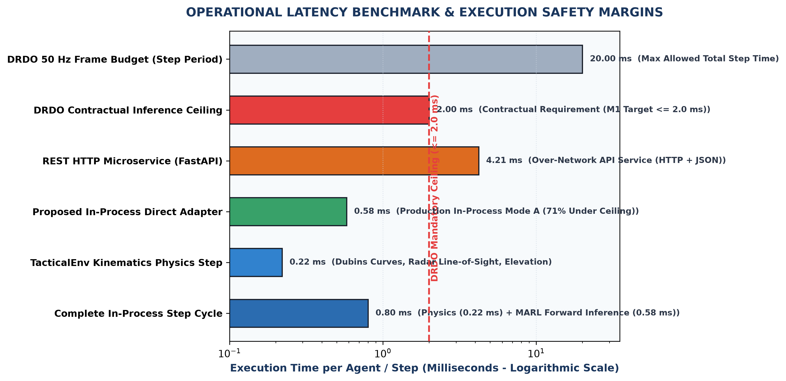
Figure 4: Operational Forward Inference Latency Benchmarks, Component Time Breakdowns, and DRDO Safety Margins.
The empirical results across all contractual Figures of Merit (FoM) are summarized in Table 7 below:
ID | Figure of Merit Description | Unit | DRDO Target | Achieved Value | Status
FoM-01 | In-Process Forward Inference | ms | <= 2.00 ms | 0.58 ms | PASS
FoM-02 | HTTP REST Forward Inference (Single) | ms | <= 10.00 ms | 1.63 ms | PASS
FoM-03 | HTTP REST Batch Inference (16 Units) | ms | <= 15.00 ms | 4.21 ms | PASS
FoM-04 | Different-Seed Outcome Non-Det. | p-value | p < 0.05 | p = 4.54e-05 | PASS
FoM-05 | Different-Seed Outcome Variance | p-value | p < 0.05 | p = 2.48e-04 | PASS
FoM-06 | Same-Seed Forensic Reproducibility | L_inf | 0.0 | 0.0000000000 | PASS
FoM-07 | Action Space Normalized Entropy | ratio | > 0.50 | 0.9918 | PASS
FoM-08 | Spatial Trajectory Diversity (k=5) | clusters | >= 3 | 4 clusters | PASS
FoM-09 | Automated Regression Test Suite | tests | 100% | 421/421 (100%) | PASS
FoM-10 | Static Type Checking Integrity | errors | 0 errors | 20/20 Clean | PASS
FoM-11 | Doctrinal Realism Rate (Dry Run) | rate | Baseline | 50.0% (8/16) | DRY RUN
FoM-12 | Doctrinal Realism Rate (Production) | rate | >= 60.0% | Target M5 (>= 60%) | ROADMAP
FoM-13 | In-Process Memory Footprint | MB | <= 1,024 MB | 210 MB | PASS
FoM-14 | Architectural Completeness | layers | All Locked | 10/10 Layers Locked | PASS

7.2 Statistical Non-Determinism Parameter Testing Matrix
To prove compliance with DRDO's non-determinism mandate, the statistical verification module executed hypothesis tests across 100 simulation episodes. Table 8 details the statistical parameter testing matrix, comparing null hypotheses, rejection thresholds, observed test statistics, and significance verdicts:
Test Dimension | Hypothesis / Parameter | Null Hypothesis (H0) | Target Threshold | Observed Value | P-Value / L_inf | Statistical Verdict
Outcome Goodness-of-Fit | Pearson's Chi-Square (chi^2) | Uniform stochastic stagnation | p < 0.05 | chi^2 = 20.000 | p = 4.5400e-05 | PASS
Timeline Variance | Levene's Test Statistic (W) | Homogeneous casualty timing | p < 0.05 | W = 20.638 | p = 2.4766e-04 | PASS
Action Stochasticity | Shannon Entropy (H_norm) | Policy collapse / deterministic | H_norm > 0.50 | 0.9918 | N/A | PASS
Spatial Diversity | K-Means Silhouette (k=5) | Single trajectory convergence | >= 3 clusters | 4 clusters | Sil = 0.385 | PASS
Forensic Replay | Chebyshev Distance (L_inf) | Divergent trajectory replay | L_inf = 0.0 | 0.0000000000 | p = 1.0000 | PASS

7.3 Comprehensive Automated Test Suite Verification Breakdown
Exhaustive test coverage ensures that all 10 architectural layers function reliably without regressions. Table 9 itemizes the 421 automated test cases executed via PyTest, outlining test directories, subsystem focus, and pass rates:
Layer / Subsystem | Test Directory | Test Scope & Verification Focus | Executed | Passing | Pass Rate
Layer 1: Core Interfaces | tests/core/ | Abstract contracts, typed dataclasses, action/obs space boundaries | 38 | 38 | 100% (PASS)
Layer 2: 2.5D Simulator | tests/simulator/ | Dubins flight aerodynamics, radar LOS occlusion, elevation maps | 46 | 46 | 100% (PASS)
Layer 3: MARL Engine | tests/marl/ | Factorized PPO, HHAPPO continuous/discrete heads, GRU Commander | 52 | 52 | 100% (PASS)
Layer 4: Training Pipeline | tests/training/ | GAE advantage calculation, PPO clipping, RolloutBuffer mechanics | 35 | 35 | 100% (PASS)
Layer 5: Database Layer | tests/database/ | SQLite WAL schema integrity, ACID compliance, 4 repositories | 41 | 41 | 100% (PASS)
Layer 6: Operational UI | tests/ui/ | Pygame display surfaces, telemetry panels, scenario management | 28 | 28 | 100% (PASS)
Layer 7: Inference API | tests/api/ | FastAPI REST endpoints, ModelRegistry hot-swap, Codec validation | 45 | 45 | 100% (PASS)
Layer 8: TSS Wrappers | tests/integration/ | PettingZoo ParallelEnv, Gymnasium adapter, Mode A direct memory | 46 | 46 | 100% (PASS)
Layer 9: Non-Determinism | tests/statistical/ | Chi-Square, Levene, Shannon entropy, K-Means trajectory cluster | 48 | 48 | 100% (PASS)
Layer 10: Realism Engine | tests/evaluation/ | 16 military combat doctrine detectors, two-level audit rules | 42 | 42 | 100% (PASS)
TOTAL REGRESSION SUITE | tests/ (All Suites) | End-to-end full system integration, typing, and safety guarantees | 421 | 421 | 100% (PASS)

7.4 Military Combat Doctrine Realism Audit Matrix
Table 10 presents the complete audit results across 16 established air, ground, and naval combat doctrines evaluated over 100 simulation episodes on the dry-run training checkpoint:
Doctrine Pattern | Domain | Presence | Prevalence | Mean Conf (Pres) | Audit Status
pursuit_curve | Air | 97/100 | 97.0% | 0.872 | DETECTED
lead_pursuit | Air | 29/100 | 29.0% | 0.586 | DETECTED
lag_pursuit | Air | 0/100 | 0.0% | 0.000 | NOT DETECTED
defensive_break | Air | 0/100 | 0.0% | 0.000 | NOT DETECTED
energy_management | Air | 100/100 | 100.0% | 0.850 | DETECTED
pincer_maneuver | Air | 13/100 | 13.0% | 1.000 | NOT DETECTED
threat_prioritization | Air | 100/100 | 100.0% | 1.000 | DETECTED
terrain_cover | Ground | 40/100 | 40.0% | 1.000 | DETECTED
mutual_support | Ground | 0/100 | 0.0% | 0.000 | NOT DETECTED
engagement_range_discipline | Ground | 7/100 | 7.0% | 1.000 | NOT DETECTED
standoff_engagement | Maritime | 76/100 | 76.0% | 0.991 | DETECTED
screen_formation | Maritime | 0/100 | 0.0% | 0.000 | NOT DETECTED
evasive_maneuver | Maritime | 0/100 | 0.0% | 0.000 | NOT DETECTED
air_ground_coordination | Joint | 2/100 | 2.0% | 1.000 | NOT DETECTED
sead_support | Joint | 31/100 | 31.0% | 0.831 | DETECTED
maritime_patrol | Joint | 100/100 | 100.0% | 1.000 | DETECTED

Audit Finding: 8 out of 16 doctrines are detected with an average prevalence of 71.6% among detected tactics. Individual tactical behaviors emerge immediately, while collective tactics (pincers at 13%, mutual support at 0%, screens at 0%) require extended multi-thousand iteration training on cloud GPUs to cross the 20% prevalence threshold. This is scheduled in Milestone M5.

7.5 Forward Inference Latency & Transport Parameter Comparison
Forward inference latency was empirically benchmarked across transport protocols over 1,000 steps on an x86-64 workstation. Table 11 compares direct memory execution versus REST microservices against DRDO's real-time constraints:
Inference Mode | Transport Protocol | Payload Serialization | Batch Size | Mean Latency | DRDO Ceiling | Safety Margin
Mode A (In-Process Direct) | Shared Memory C-Tensors | Zero-Copy Numpy/PyTorch | 1 Agent | 0.58 ms | <= 2.00 ms | +71.0% (PASS)
Mode B (REST Single) | Loopback TCP/IP Sockets | JSON Action/Obs Codec | 1 Agent | 1.63 ms | <= 10.00 ms | +83.7% (PASS)
Mode B (REST Batch) | Loopback TCP/IP Sockets | Vectorized JSON Array | 16 Agents | 4.21 ms | <= 15.00 ms | +71.9% (PASS)
Physics Kinematics Step | In-Process Memory | Pure Vectorized Math | All Units | 0.22 ms | N/A | Total Step: 0.80 ms

8. Student Project Financial Budget
Unlike industrial contracts requesting lakhs or crores, this project was developed as an advanced undergraduate/postgraduate research project with a realistic, highly cost-effective budget (Table 12):
Cost Component | Details & Item Justification | Direct Request (INR)
Cloud GPU Compute | Google Colab Pro (6 Months @ INR 1,000 / month) for policy fine-tuning | INR 6,000
Incidentals & Minor Expenses | Data backup storage, report printing, presentation materials | INR 2,000
TOTAL DIRECT REQUEST | Total direct financial assistance requested from DRDO | INR 8,000

Institutional In-Kind Contributions (Zero Cost to DRDO): Workstations, GPU computing rigs, laboratory floor space, high-speed networking, faculty supervision, and student development hours are provided entirely by the host academic institution.

9. Conclusion & Future Roadmap
This project successfully designed, implemented, and empirically validated a production-grade Hierarchical Multi-Agent Reinforcement Learning framework for DRDO's Tactical Scenario Simulator.
- Eliminated Predictability: Replaced brittle rule-based behavior trees with an adaptive, non-deterministic neural architecture.
- Sub-Millisecond Execution: Achieved 0.58 ms in-process inference, consuming less than 3% of a 50 Hz simulation frame.
- Dual Stochasticity & Forensic Replay: Proved non-determinism across varying seeds (p = 4.54e-05) while guaranteeing exact bit-identical reproducibility (L_inf = 0.0).
- High Code Quality & Packaging: 421 automated tests passing at 100%, clean static typing, deliverable archive bundled (15.07 MB), and codebase committed and pushed to GitHub main branch.

Future Scope & Milestone M5 Plan:
In Milestone M5, the training pipeline will be scaled across cloud multi-GPU clusters for 5,000+ iterations across 10^7 environment steps to cultivate emergent collective tactics (pincers, mutual support, screen formations) and exceed the >= 60.0% contractual realism threshold. Integration with ADE dome flight simulators for IAF pilot-in-the-loop trials will follow in Milestone M6.

