About the project:

Description:

The following project is development of an online book store which involves buying books online by first registering in it in order to access the facilities provided by this site.

**Requirements:**

The development of the project requires the knowledge of various web developing languages like java script, HTML/CSS, XML, Servlets, SQL.

**Design of the site:**

The basic design of the project involves a main page which has details regarding the description of the site, registration page that enables the user to access the cart to buy books, It also involves Latest updates regarding the discounts and offers that are provided on the books.

The basic design outlook is as follows:

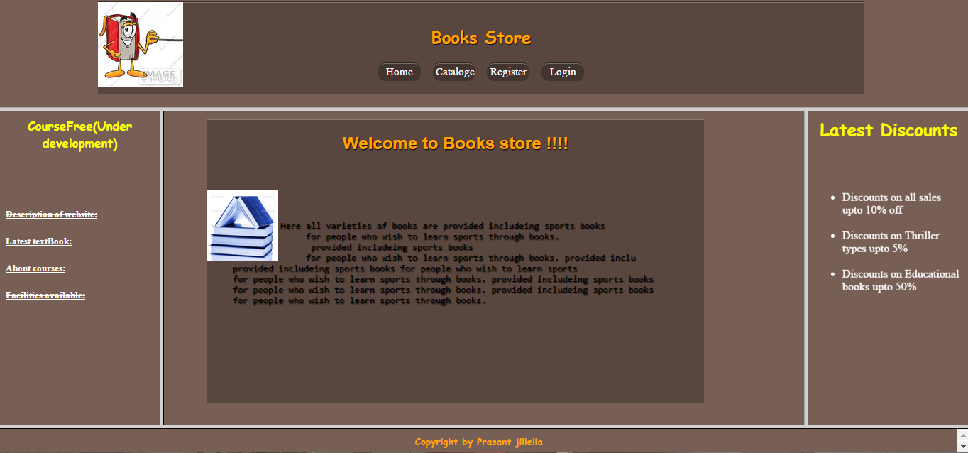

**Coding part of the project:**

**Features of the Online Book Store:**

--The entire web page is divided into frames using the following main code which in turn links to the other parts of the frame with the help of the names corresponding to these frames.

<html><head>

<title>Books_main</title>

<frameset rows="25%,70%,*">

<frame src="head1.html" name="heads"/>

<frameset cols="15%,60%,15%">

<frame src="left.html" name="left"/>

<frame src="center.html" name="center"/>

<frame src="right.html" name="right"/> </frameset>

<frame src="copy.html" name="copy"/> </frameset>

</head></html>

--Here as we can see the main frame contains 5 parts namely heads, left, right, centre, copy and the html pages that are linked to these frames are head1.html, left.html, right.html, center.html and copy.html respectively.

The view of the main page is as follows-

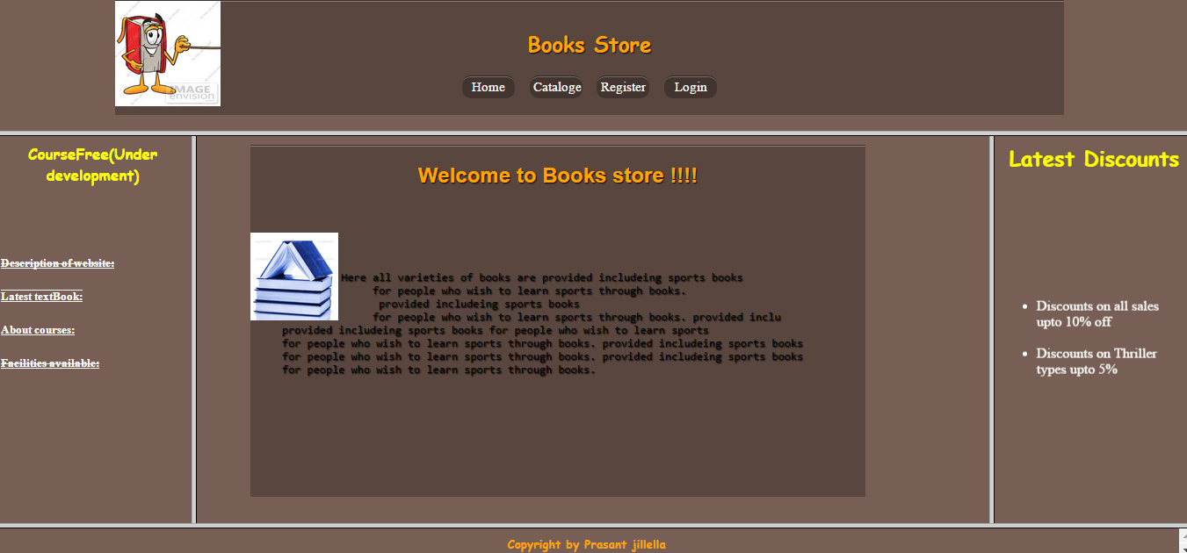

--Let us look into these html files one by one-

**Html Files Associated with Head and Center frame:**

**(i)head1.html-**

the code used is-

<html>

<head>

<style type="text/css">

body { background-image: url("center.jpg");}

h3{color:orange;font-size:25pt;}

a {color:yellow;}

</style></head>

<body>

<center><h3>Invalid username or password please try again!!!</h3></center>

<center><a href="login.html">Return to login page</a></center></body>

</html>

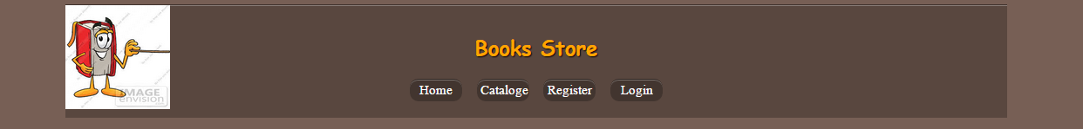

The head.html file contains the following buttons-

**a.)Home button**-the code used for it is

<html> <head>

<title>center</title>

<style type="text/css">

body { background-image:url("center.jpg"); }

div{ position:relative; margin:10px; left:43px; right:800px; height:400px; width:700px; font-family:Arial; text-shadow:1px 1px 1px black; border-top:1px solid rgba(0,0,0,0.3); background:rgba(0,0,0,0.25); box-shadow:inset 0 1px rgba(255,255,255,0.3); }

h2{ color:orange; }

</style> </head> <body><div>

<center><h2>Welcome to Books store !!!!</h2></br></center>

<pre> <img src="home.jpg" width="100" height="100" align="left"/>

<p>Here all varieties of books are provided includeing sports books

for people who wish to learn sports through books.

provided includeing sports books

for people who wish to learn sports through books. provided inclu

provided includeing sports books for people who wish to learn sports

for people who wish to learn sports through books. provided includeing sports books for people who wish to learn sports through books. provided includeing sports books

for people who wish to learn sports through books.

</p></pre> </div> </body></html>

it's preview is

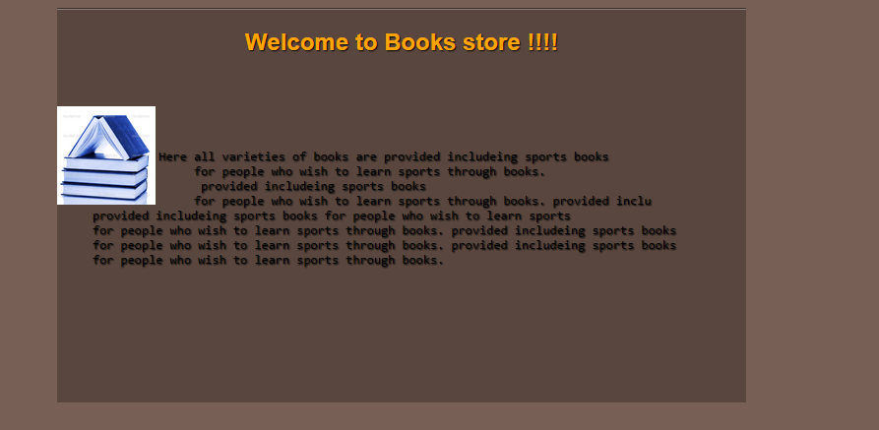

**b.)Catalogue Button**-

code used here is

<head><style type="text/css">

body{background-image: url("center.jpg");}

h2 { color:orange;font-family:Gabriola;font-size:20pt; }

th { color:green;font-family:Comic Sans MS;font-size:16pt }

input { color:pink;font-size:20pt;font-weight:bold; }

td { color:green;font-size:15pt;font-weight:bold }

.button { border-radius:10px; color:black; border:0px solid #4e6096; display:inline-block; cursor:pointer; background: #00CCCC; font-family:Italic; font-size:15px; width: 60; padding:4px 4px; border-top:1px solid rgba(0,0,0,0.3); background:rgba(0,0,0,0.25); box-shadow:inset 0 1px rgba(255,255,255,0.3);}

div{ position:relative; margin:30px; left:70px; right:100px; padding:0; height:1100px; width:75%; font-family:Arial; text-shadow:1px 1px 1px black; border:1px solid rgba(0,0,0,0.3); background:rgba(0,0,0,0.25); box-shadow:inset 0 1px rgba(255,255,255,0.3); }

</style></head><body >

<div> <h2 align="center"><u>Catalogue</u></h2> <form >

<table border="1" cellpadding="5" cellspacing="5s" align="center">

<tr> <th>Books</th> <th>Book Name</th> <th>Price</th> </tr>

<tr> <td><center><img src="WT.jpg" height=200 width=150></td></center> <td>Web Technologies BLACK BOOK</td> <td>Rs.300</td> </tr>

<tr> <td><img src="java.jpg" height=200 width=150></td> <td>Java 7 Programming BLACK BOOK</td> <td>Rs.400</td> </tr>

<tr> <td><img src="c.jpg" height=200 width=150></td> <td>The C Programming Language</td> <td>Rs.100</td> </tr><tr> <td><img src="cn.jpg" height=200 width=150></td> <td>Computer Networks</td> <td>Rs.350</td> </tr>

</table></form></div></body></html>

The output for this code is-

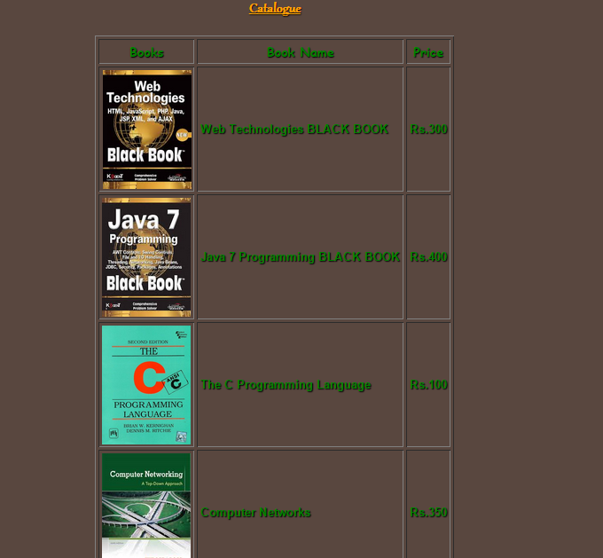

as you can see there is no add bbutton in this catalogue page as this is available only when you are logged in.

**c.)Register Button-**

This is used to register the user so that he can log in and access the facilities provided by the site.

The code used here is-

<html> <head> <title>Forms</title> <style type="text/css">

.l{font-size:14pt;color:orange;font-family:Gabriola;font-weight:bold}

.b{font-size:14pt;color:orange;font-family:Comic Sans MS}

body{background-image: url("center.jpg");}

.head{color:orange;font-family:Gabriola;font-size:20pt;}

input{font-size:15pt;color:black;font-family:Gabriola;font-weight:bold}

textarea{color:black;font-size:14pt}

div{ position:relative; margin:50px; left:150px; right:900px; height:1200px; width:500px; font-family:Arial; text-shadow:1px 1px 1px black; border-top:1px solid rgba(0,0,0,0.3); background:rgba(0,0,0,0.25); box-shadow:inset 0 1px rgba(255,255,255,0.3);}

.button { border-radius:10px; border:0px solid #4e6096; display:inline-block; cursor:pointer; background: #00CCCC; font-family:Italic; font-size:15px; width: 60; padding:4px 4px;}

</style><script type="text/javascript">

function validate() { var n = document.myform.fname; var e = document.myform.email; var pa = document.myform.pwd; var p = document.myform.pno;

if(!n.value.match(/[A-Z][a-z]{5}/))

{alert("please enter capital letter at begining and should be of length atleast 6"); return false;}

if(!e.value.match(/^[a-z]+[_.a-z0-9]*[@][a-z]+[.][a-z]{2,3}/)) { alert("Invalid email id"); return false;}

if(!pa.value.match(/[A-Za-z_]{6}/))

{ alert("Password should contain only charectersand should be of length atleast6"); return false;}

if(!p.value.match(/[0-9]{10}/)) { alert("Phone number invalid"); return false;}}

</script></head><body><div>

<p class="head" align="center"><u>Registration Form</u></p>

<form name="myform" method="post" action="http://localhost:8080/prasant/ad" onsubmit="return validate()">

<center><label class="b">Full Name:<input type="text" class="l" Name="fname" size="15" placeholder=" Both First & Last" maxlength="30"/></label></center><br><br>

<center><label class="b">Email Id:<input type="text" class="l" Name="email" size="15" placeholder=" abs@xyz.com" maxlength="30"/></label></center><br><br>

<center><label class="b">Password:<input type="password" class="l" Name="pwd" size="15" placeholder=" Unique password" maxlength="30"/></label></center><br><br>

<center><label class="b">Mobile no:<input type="text" class="l" Name="pno" size="15" placeholder=" 10 digit no." maxlength="10"/></label></center><br><br><br>

<center><label class="b">Select intrested areas:</label></center><br>

<center><label class="l"><input type="checkbox" name="intrest" value="Computers" unchecked="unchecked"/>Computers</label></center><br>

<center><label class="l"><input type="checkbox" name="intrest" value="Electrical" unchecked="unchecked"/>Electrical</label></center><br>

<center><label class="l"><input type="checkbox" name="intrest" value="Others"unchecked="unchecked"/>Others</label></center><br><br><br>

<center><label class="b">Select age:</label></center><br>

<center>

<label class="l"><input type="radio" name="age" value="under20" unchecked="unchecked"/>0-19</label>

</center><br>

<center>

<label class="l"><input type="radio" name="age" value="under40" unchecked="unchecked"/>20-40</label></center><br><br><br><center><label class="b">Enter Present Address:</label>

</center><br>

<center>

<textarea placeholder="Temporary address is preffered"></textarea></center><br><br><br><center><label class="b">Select Branch:</label>

</center><br>

<center>

<select class="l"><option>CSE</option><option>ECE</option><option>EEE</option><option>IT</option><option>Mech</option><option>Civil</option><option>Bio</option><option>Others</option></select>

</center>

<br><br><br><center><input type="submit" value="Submit"/><input type="reset" value="Clear"/><br></center>

</form></div>

</body>

</html>

The output for it is as follows

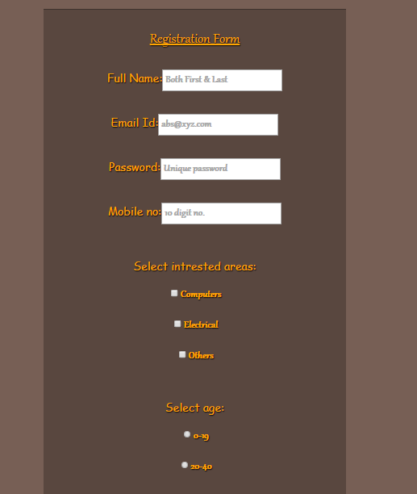 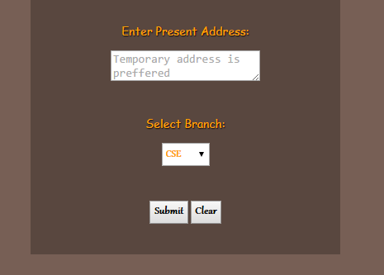

The submit button stores the information after verifying if the data is properly entered and the clear button removes all the entered data and provides a fresh form to enter the data.

**d.)Login button-**

This button points to the html file called Login.html which consists of the following code-

<html> <head> <style type="text/css">

.l{ font-size:15px;color:black; }

.b{ font-size:15px;color:white; font-family:Arial; }

body { background-image: url("center.jpg"); }

input { color:blue;font-size:18pt;font-weight:bold; }

p { color:green;font-size:25pt; }

.button { border-radius:10px; color:pink; border:0px solid #4e6096; display:inline-block; cursor:pointer; background: #00CCCC; font-family:Italic; font-size:15px; color:white; width: 60; padding:4px 4px; border-top:1px solid rgba(0,0,0,0.3); background:rgba(0,0,0,0.25); box-shadow:inset 0 1px rgba(255,255,255,0.3); }

div{ position:relative; margin:50px; left:200px; right:900px; height:70%; width:40%; font-family:Arial; text-shadow:1px 1px 1px black; border-top:1px solid rgba(0,0,0,0.3); background:rgba(0,0,0,0.25); box-shadow:inset 0 1px rgba(255,255,255,0.3); }

.h{ color:orange; }

</style>

</head> <body> <div align="centre"> <center><h4 class="h"><u>Login Form</u></h4></center> </br>

<form method="post" action="http://localhost:8080/prasant/val">

<center><pre><p class="b">Email id: <input type="text" class="l" Name="email" size="20" placeholder="abc@xyz.com" maxlength="30" class="b"/></p></pre></center>

<center><pre><p class="b">Password: <input type="password" class="l" Name="pwd" size="20" placeholder="password" maxlength="30" class="b"/></p></pre></center>

<br><center><pre><input class="button" type="submit" value="Submit"> <input class ="button" type="reset" value="Clear"/></center></pre>

</form></div> </body></html>

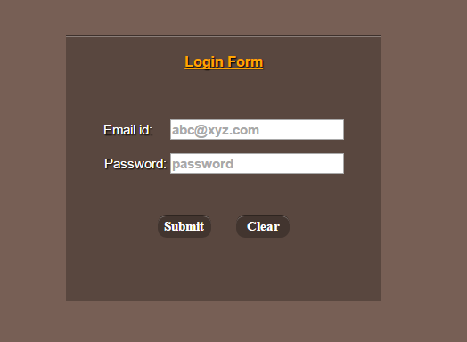

The login page takes in your email and password check's it with the registered data and provides permission to enter the official site.

Once logged in the head changes and the register button gets replaced with cart button and the login button replaced by log out button.

**Cart button**--it is used to store the information regarding the items selected and the total cost of these items and displays the same.

code used is-

import javax.servlet.*;

import javax.servlet.http.*;

import java.io.*;

import java.sql.*;

public class Show extends HttpServlet

{

public void service(HttpServletRequest req, HttpServletResponse res) throws ServletException,IOException {

PrintWriter out=res.getWriter();

res.setContentType("text/html");

String s = "center.jpg";String c = "blue";String f = "Gabriola";String g = "#85FF5C";String y = "yellow";String m = "Comic Sans MS";String l = "catalogue.html";int t = 0;

try{

Class.forName("sun.jdbc.odbc.JdbcOdbcDriver");

Connection con=DriverManager.getConnection("Jdbc:Odbc:git","","");

Statement st=con.createStatement();

ResultSet rs = st.executeQuery("Select * from Cart");

out.println("<html><body background='"+s+"'><center><font color='"+g+"' size='"+12+"' face='"+f+"'><b><u>Cart</u></b></fort></h1><table border='"+1+"' cellpadding='"+5+"' cellspacing='"+10+"'><tr><th><font color='"+y+"' size='"+5+"' face='"+m+"'>Books</font></th><th><font color='"+y+"' size='"+5+"' face='"+m+"'>Price</font></th></tr>");

while(rs.next()){String p = rs.getString(1);

String price = rs.getString(2); t+=Integer.valueOf(price); out.println("<tr><td><imgsrc='"+p+"'height='"+200+"' width='"+150+"'></td>"); out.println("</font></b></td><td><b><fontcolor='"+c+"'size='"+6+"'face='"+f+"'>Rs.");out.println(price);out.println("</font></b></td></tr>");} out.println("</table><fontcolor='"+c+"'size='"+12+"'face='"+f+"'><b>Totalpriceis:Rs."+t+"</b></fort><br><fontcolor='"+y+"'size='"+5+"'face='"+m+"'><b><ahref='"+l+"'>Keepshopping</a></b></fort></center></body></html>");st.close();con.close(); }

catch (Exception e){out.println(e);}}}

The output for the enteered code is-

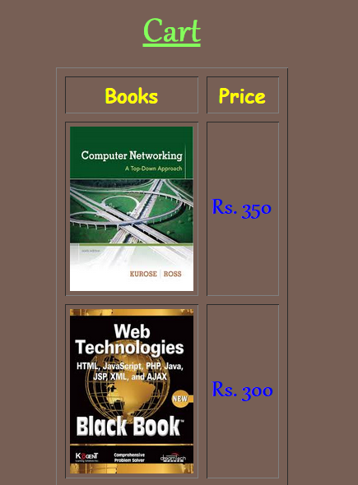

-logout button is used to return back to the home site.

**Html Files Associate with left frame and centre frame:**

The left frame is named as CourseFree which has links describing the features that will be present in the site CourseFree that is yet to be launched.

The links present are--

**(i)Description of Website:**

This link provides a brief description of the site.

The code used here is:

<html> <style type="text/css">

div{ position:relative; margin:10px; left:13px; right:800px; height:400px; width:850; padding:5; font-family:Comic Sans MS; text-shadow:1px 1px 1px black; border-top:1px solid rgba(0,0,0,0.3); background:rgba(0,0,0,0.25); box-shadow:inset 0 1px rgba(255,255,255,0.3); }

body { background-image:url("center.jpg") }

h3{ color:orange;}

pre{ color:white;}

</style> <body>

<div> <h3><center>Online Book Store</center></h3> <p><pre>

This site is developed with the objective of supplying Books online for a

reasonable cost to people accross the world, also many seasonal offers are

involved which involve giving discounts.

There are also plans to develop and bring forward the other fields of books

like--

---Action<br> ---Comic<br> ---Adventure<br> ---Fiction<br> ---Sports

</pre> </p>

</div>

</body>

</html>

Output for the above code is:

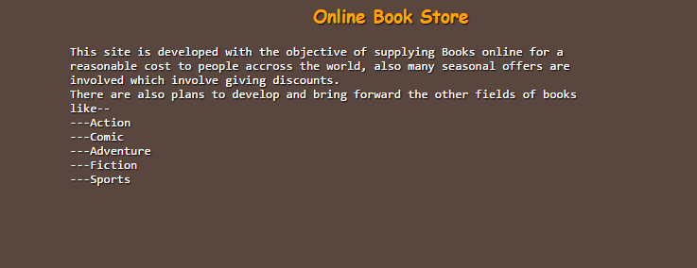

**(ii)Latest text Books:**

This link provides details about the text books that are yet to be released.

The code used here is:

<html><head> <title>List html</title> <style type="text/css">

li{color:#4642B4; font-family:"Helvetica"; font-style:Comic Sans MS; font-size:12pt}

p.fi{color:yellow;font-size:12pt;font-family:Comic Sans MS;background-image:url("bac1.png");}

p.second{color:white;font-family:Comic Sans MS;background-image:url("bac1.png");}

.re{color:#4642B4;font-size:14pt;font-family:Comic Sans MS;} .prasant{color:#008000;font-size:10pt;font-family:Comic Sans MS;} #l{color:orange;}

body { background-image:url("images.jpg"); }

div{ position:relative; margin:50px; left:35px; right:800px; height:2700px; padding:20px; width:80%; font-family:Comic Sans MS; text-shadow:1px 1px 1px black; border-top:1px solid rgba(0,0,0,0.3); background:rgba(0,0,0,0.25); box-shadow:inset 0 1px rgba(255,255,255,0.3); }

body{ background-image:url("center.jpg"); }

h1{ font-size:20px;}

</style></head>

<body bgcolor="#E1E1E1">

<div>

<h1 id="l" align="center">Brief intro of the new textbook(Computer parts)</h1>

<ol> <h3><li>I/p Devices</li></h3>

<ul>

<li id="l"><a class="prasant" href="#k">Key board</a></li>

<li id="l"><a class="prasant" href="#m">Mouse</a></li>

<li id="l"><a class="prasant" href="#c">CD-drive</a></li > </ul>

<h3><li>O/p devices</li></h3>

<ul>

<li id="l"><a class="prasant" href="#mo">Monitor</a></li>

<li id="l"><a class="prasant" href="#p">Printer</a></li>

<li id="l"><a class="prasant" href="#s">Speaker</a></li> </ul> </ol>`

<h1 class="re" id="k" ><u>Keyboard</u></h1>

<p class="fi">

In computing, a keyboard is a typewriter-style device, which uses an arrangement of buttons or keys, to act as mechanical levers or electronic switches. Following the decline of punch cards and paper tape, interaction via teleprinter-style keyboards became the main input device for computers. A keyboard typically has characters engraved or printed on the keys and each press of a key typically corresponds to a single written symbol. However, to produce some symbols requires pressing and holding several keys simultaneously or in sequence. While most keyboard keys produce letters, numbers or signs (characters), other keys or simultaneous key presses can produce actions or execute computer commands. </p>

<h1 class="re" id="m"><u>Mouse</u></h1>

<p class="second">

In computing, a mouse is a pointing device that detects two-dimensional motion relative to a surface. This motion is typically translated into the motion of a pointer on a display, which allows for fine control of a graphical user interface.Physically, a mouse consists of an object held in one's hand, with one or more buttons. Mice often also feature other elements, such as touch surfaces and "wheels", which enable additional control and dimensional input. </p>

<h1 class="re" id="c"><u>CD-drive</u></h1>

<p class="fi">

In computing, an optical disc drive (ODD) is a disk drive that uses laser light or electromagnetic waves within or near the visible light spectrum as part of the process of reading or writing data to or from optical discs. Some drives can only read from discs, but recent drives are commonly both readers and recorders, also called burners or writers. Compact discs, DVDs, and Blu-ray discs are common types of optical media which can be read and recorded by such drives. Optical drive is the generic name; drives are usually described as "CD" "DVD", or "Blu-ray", followed by "drive", "writer", etc. </p>

<h1 class="re" id="mo"><u>Monitor</u></h1>

<p class="second">

A monitor or a display is an electronic visual display for computers. The monitor comprises

the display device, circuitry and an enclosure. The display device in modern monitors is

typically a thin film transistor liquid crystal display (TFT-LCD) thin panel, while older

monitors used a cathode ray tube (CRT) about as deep as the screen size.

Originally, computer monitors were used for data processing while television receivers

were used for entertainment. From the 1980s onwards, computers (and their monitors) have

been used for both data processing and entertainment, while televisions have implemented

some computer functionality. The common aspect ratio of televisions, and then computer

monitors, has also changed from 4:3 to 16:9.

<h1 class="re" id="p"><u>Printer</u></h1>

<p class="fi">

In computing, a printer is a peripheral which makes a persistent human-readable representation

of graphics or text on paper or similar physical media. The two most common printer mechanisms . The first commercial printers generally used mechanisms from electric typewriters and Teletype machines, which operated in a similar fashion. The demand for higher speed led to the development of new systems specifically for computer use. Among the systems widely used through the 1980s were daisy wheel systems similar to typewriters, line printers that produced similar output but at much higher speed, and dot matrix systems that could mix text and graphics but produced relatively low-quality output. The plotter was used for those requiring high-quality line art like blueprints. </p>

<h1 class="re" id="s"><u>Speaker</u></h1>

<p class="second">

Computer speakers, or multimedia speakers, are speakers external to a computer, that disable the lower fidelity built-in speaker. They often have a low-power internal amplifier. The standard audio connection is a 3.5 mm (approximately 1/8 inch) stereo phone connector often color-coded lime green (following the PC 99 standard) for computer sound cards. A few use a RCA connector for input. There are also USB speakers which are powered from the 5 volts at 500 milliamps provided by the USB port, allowing about 2.5 watts of output power. Computer speakers were introduced by Altec Lansing in 1990.[1] Computer speakers range widely in quality and in price. The computer speakers typically packaged with computer systems are small, plastic, and have mediocre sound quality. Some computer speakers have equalization features such as bass and treble controls.

</p> </div></body></html>

The output for the above code is:

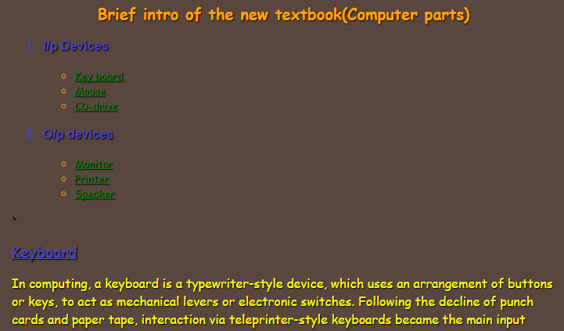

**(iii)About Courses:**

This link provides details regarding the courses that will be provided by the Course Free that is yet to be launched.

Code used here is:

<html> <head> <style type="text/css">

div{ position:relative; margin:10px; left:13px; right:800px; color:orange; height:400px; width:850; padding:5; font-family:Comic Sans MS; text-shadow:1px 1px 1px black; border-top:1px solid rgba(0,0,0,0.3); background:rgba(0,0,0,0.25); box-shadow:inset 0 1px rgba(255,255,255,0.3); }

body { background-image:url("center.jpg"); }

h3; { color:orange; font-size:15px; }

p{ color:white; font-size:15px; }

</style>

</head><body bgcolor="#008000"> <div> <center><h3>Teaching Cources For Free:</h3></center> <pre> <p>

We people have plans to launch a Teaching site called CourseFree in order

to encourage students and various other catigory of people to learn things

that are main topics of engineering.

This CourseFree site is teaching site that is going to be free for all

who apire to learn things.

You can see that the site askes for addetional information in the registration

page Like--

--Area of interest

--Branch for students

These are not necessary but are requested to be answered in order to have

an idea on what type of courses are to be introduced when we launch the site

CourseFree.

Sponcered by prasant jillelle...

</p> </pre> </div> </body></html>

Output for the above code is:

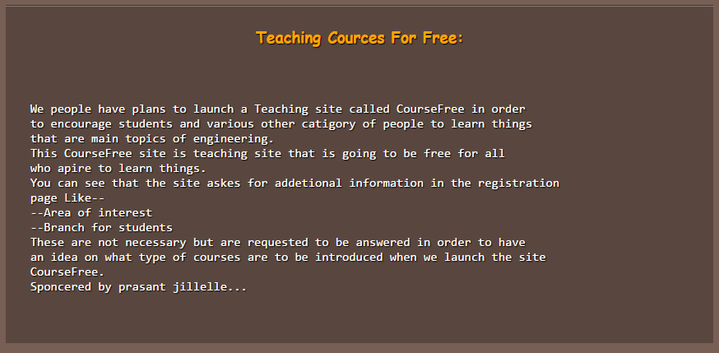

**Html files Associated with the right frame**:

This frame contains only one html file that provides description of the latest offers provided on the books available.

The code used is:

<html> <head> <title>right</title> <style type="text/css">

body { background-image:url("center.jpg"); }

h2{ font-family:Comic Sans MS; color:yellow; }

li { color:white; }

</style> </head>

<body> <center><h2>Latest Discounts</h2></center> </br> </br>

<marquee direction="up"> <ul>

<li>Discounts on all sales upto 10% off</li></br>

<li>Discounts on Thriller types upto 5%</li></br>

<li>Discounts on Educational books upto 50%</li></br>

</ul> </marquee> </body></html>

The output of code is:



**Html files associated with the copy frame:**

There is only one html file it is copy.html, It provides the details regarding the copy rights assigned for this site.

code used is:

<head><style type="text/css">

body{ background-image:url("center.jpg"); }

p{color:orange;font-family:Comic Sans MS;font-size:10pt;}

</style><html><body>

<b><p align="middle">Copyright by Prasant jillella</p></b></body></html>

Output for the code is:



**Implementation:**

Establishing the connections needed:

1.)Download and install Apache Tomcat 7.0 or any latest version on your system, you can see that tomcat starts automatically when installed.

2.)Make sure that there is no Oracle database installed or running on your system as this might hack the port that is accesses by Apache Tomcat.

3.)Starting tomcat can be done as follows-

> Go to "bin" folder in tomcat.

>Click on "Tomcat7w" and click on start.

image view-

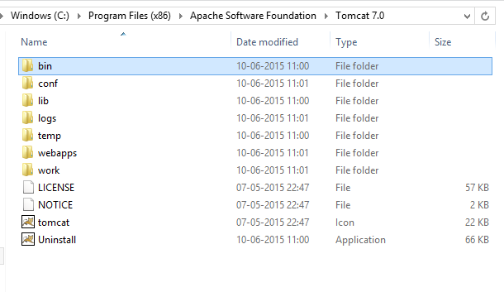 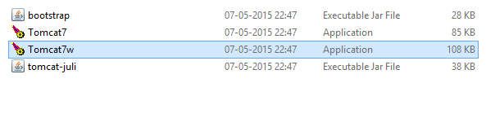 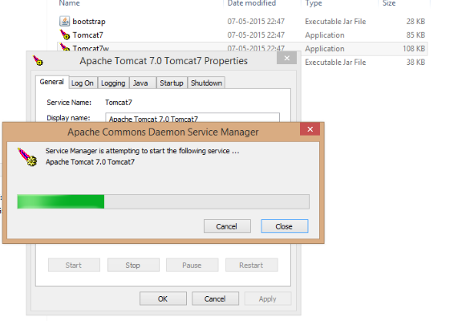

---alternative approach

>Go to hidden icons and start from there.

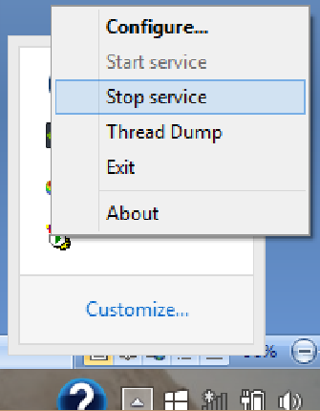

--Then place the entire code of the website in the webapps folder of Tomcat

this folder should contain the following data in the webapps folder(it includes all the html, java script files, Css files needed).

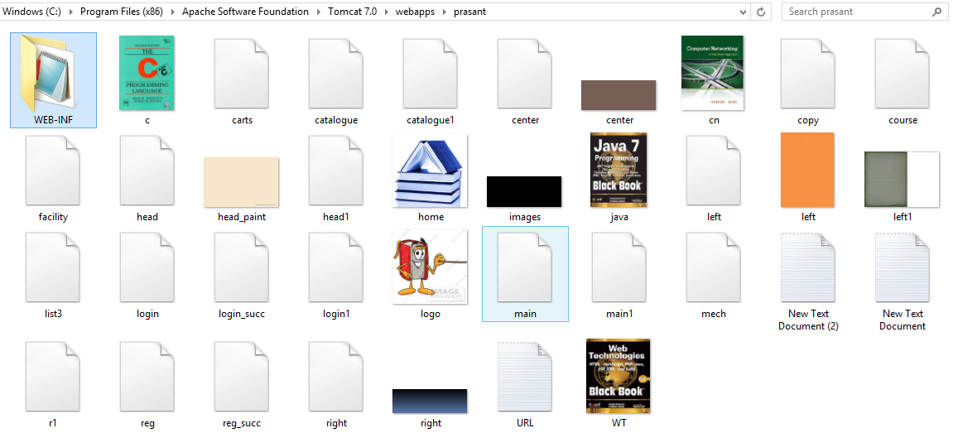

--Then the WEB-INF file contains the classes folder(which in turn contains the java files) and the xml file required.

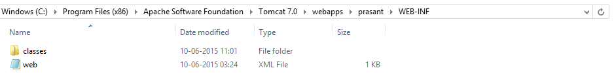

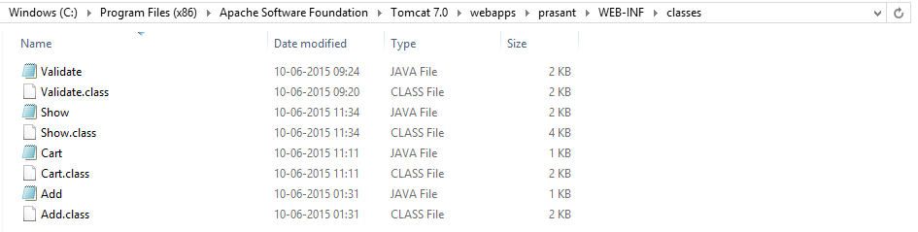

Creating Required tables in Microsoft Access:

1.)Open Microsoft Access and create cart and login tables, these tables are needed to store the information given by the user and are used in future for various purposes like validating etc.

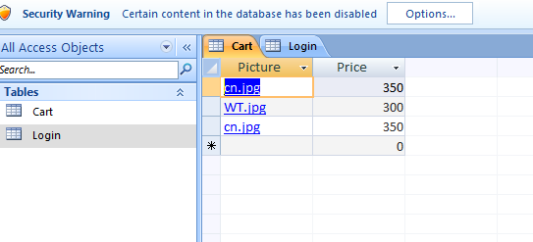

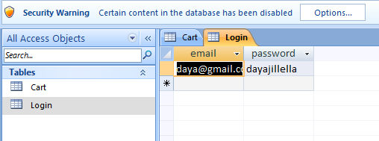

**Testing:**

Unit testing:

All the individual parts of the project have been tested for their correctness like the way in which the registration conditions are satisfied or not, the validation involved in the login site which involves in checking whether the user who wants to login is authorised or not.

System testing:

In addition to unit testing the project is tested in entirety for it's efficiency in working as a whole when all the files are linked and run together.

**Benefits:**

This online book store project has many benefits some of them are:

-personally it helped me gain knowledge and experience regarding the web development languages like java script, HTML/CSS, XML, servlets, SQL .

-It is beneficial to the library present in steel plant and people as it provides a source to buy books online.

**Future scope of the project:**

This project is currently used to buy books online and can be developed by adding many other features like--

-Providing a link that will take your ATM or any other cards and transfer money.

-It can also be provided with other varieties of books like comics, fiction, adventure etc rather than just education related books.

This site can also be included with free teaching site called CourseFree for free education online.