**Tic tac toe game development project**

**Abstract**

Our project is to make a multiplayer tic tac toe game purely based on digital circuit. We made the circuit designing in proteus software. We have used flip-flop, gates, connectors and LED.

We took the input by pressing the push buttons and this input is stored in flip flop which comes from input condition blocks AND gate. The input and output is shown by LED lights. Each player is assigned with a different colour and if any of the player wins then their respective colour LED will glow up and if the match is drawn then green colour LED will glow up.

**Component Used**

* Push Buttons
* NOT, AND (2 and 3 input), OR, NOR gate
* Resistances
* D flip flop
* Common cathode bi-colour led
* Led

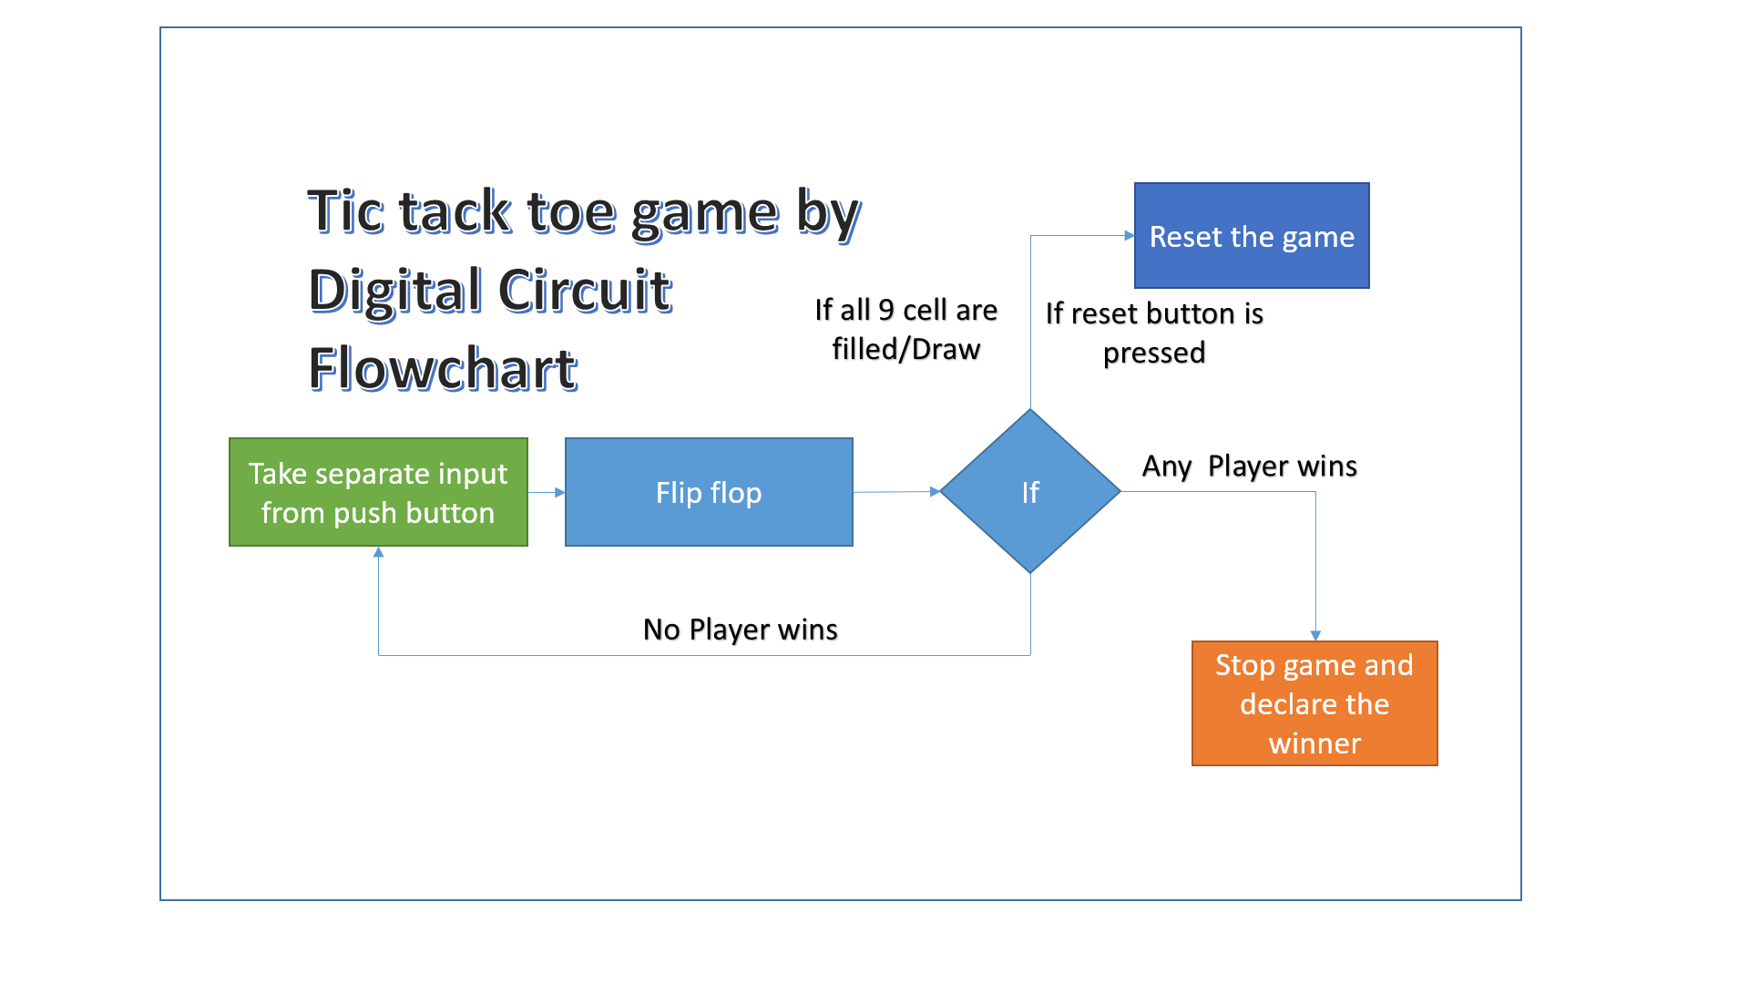

More information and detail explanation of project is give in another pdf attached along with this pdf.

Check out schematic PDF for more information.