JUNIT BASIC TESING EXERCISE HANDS-ON

Ex.1 : Setting up JUNIT

1. Created my java project in my Eclipse IDE
2. Added JUNIT-5 in my JUNIT dependency
3. Created my JUNIT test class in my project

Ex.2 : Writing Basic JUNIT Tests

1.Created a new java class with boolean method to test.

Sample:

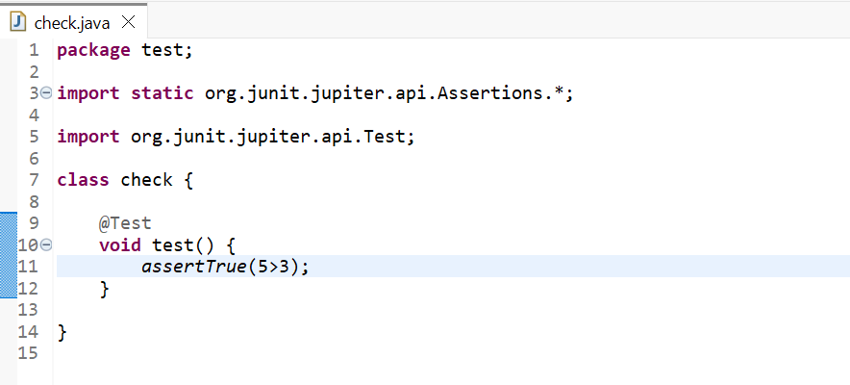

2.Successfully tested the JUNIT methods given below

Ex.3 : Assertion in JUNIT

Various Test method using JUNIT

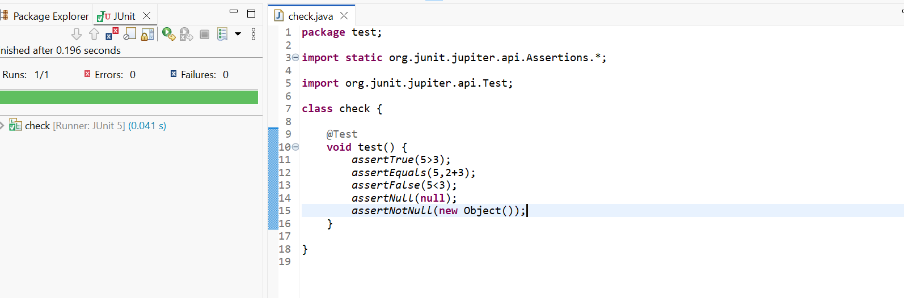

Ex.4: Arrange-Act and Assert pattern

A.Test using AAA patter :

describe("Array", function () {

describe("#indexOf()", function () {

("should return -1 when not present", function () {

// arrange

const inputArray = [1, 2, 3]

// act

const result = inputArray.indexOf(4)

// assert

expect(result).to.equal(1)

})

})

})

B. @Before and @After annotation for setup and teandowm method

Code:

**import** **org.junit.jupiter.api.AfterAll**;  
**import** **org.junit.jupiter.api.AfterEach**;  
**import** **org.junit.jupiter.api.BeforeAll**;  
**import** **org.junit.jupiter.api.BeforeEach**;  
**import** **org.junit.jupiter.api.Test**;  
**import static** **org.junit.jupiter.api.Assertions.assertEquals**;  
  
**public** **class** **MySingleTestClass** {  
  
 **private** int num1;  
 **private** int num2;  
  
   
 @BeforeAll  
 **static** void setupBeforeAll() {  
 System.out.println("Before all tests");  
 }  
  
   
 @AfterAll  
 **static** void cleanupAfterAll() {  
 System.out.println("After all tests");  
 }  
  
   
 @BeforeEach  
 void setupBeforeEach() {  
 System.out.println("Before each test");  
 num1 = 2;  
 num2 = 3;  
 }  
  
   
 @AfterEach  
 void cleanupAfterEach() {  
 System.out.println("After each test");  
 }