Hands-on Question

**Exercise 1: Control Structures**

S1- PL/SQL block that loops through all customers, checks their age, and if they are above 60, apply a 1% discount to their current loan interest rates.

Code

COMMIT;

DECLARE

BEGIN

FOR c IN (SELECT CustomerID FROM Customers

WHERE FLOOR(MONTHS_BETWEEN(SYSDATE, DOB) / 12) > 60) LOOP

UPDATE Loans

SET InterestRate = InterestRate - 1

WHERE CustomerID = c.CustomerID;

DBMS_OUTPUT.PUT_LINE('Discount applied to Customer ID: ' || c.CustomerID);

END LOOP;

COMMIT;

DBMS_OUTPUT.PUT_LINE('Discount process completed!');

END;

/

Output :

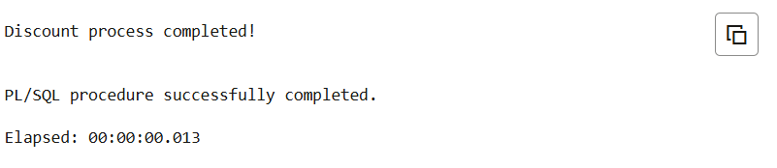

S2- Write a PL/SQL block that iterates through all customers and sets a flag IsVIP to TRUE for those with a balance over $10,000.

Code

COMMIT;

DECLARE

BEGIN

FOR c IN (SELECT CustomerID FROM Customers WHERE Balance > 10000) LOOP

UPDATE Customers

SET IsVIP = 'TRUE',

LastModified = SYSDATE

WHERE CustomerID = c.CustomerID;

DBMS_OUTPUT.PUT_LINE('VIP flag set for Customer ID: ' || c.CustomerID);

END LOOP;

COMMIT;

DBMS_OUTPUT.PUT_LINE('VIP flag process completed!');

END;

/

Output :

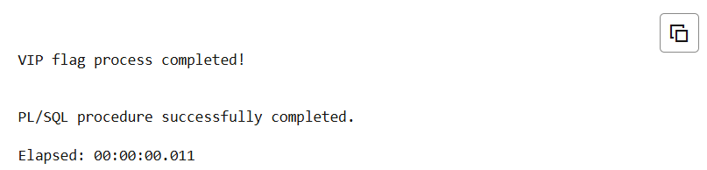

S3 - Write a PL/SQL block that fetches all loans due in the next 30 days and prints a reminder message for each customer.

Code :

COMMIT;

DECLARE

BEGIN

DBMS_OUTPUT.PUT_LINE('=== LOAN DUE REMINDERS ===');

FOR loan_rec IN (SELECT l.LoanID, l.CustomerID, c.Name, l.LoanAmount, l.DueDate

FROM Loans l

JOIN Customers c ON l.CustomerID = c.CustomerID

WHERE l.DueDate BETWEEN SYSDATE AND SYSDATE + 30) LOOP

DBMS_OUTPUT.PUT_LINE('REMINDER: Customer ' || loan_rec.Name ||

' (ID: ' || loan_rec.CustomerID || ') - ' ||

'Loan #' || loan_rec.LoanID ||

' of $' || loan_rec.LoanAmount ||

' is due on ' || TO_CHAR(loan_rec.DueDate, 'DD-MON-YYYY'));

END LOOP;

DBMS_OUTPUT.PUT_LINE('=== END OF REMINDERS ===');

END;

/

Output :

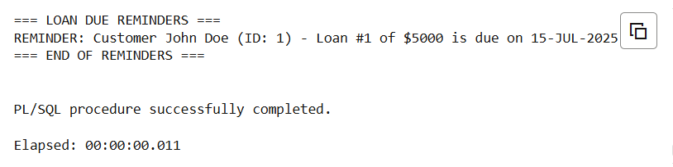

**Exercise 2: Error Handling**

S1 : Write a stored procedure **SafeTransferFunds** that transfers funds between two accounts. Ensure that if any error occurs (e.g., insufficient funds), an appropriate error message is logged and the transaction is rolled back.

Code :

COMMIT;

-- Create SafeTransferFunds Procedure

CREATE OR REPLACE PROCEDURE SafeTransferFunds (

p_from_account IN NUMBER,

p_to_account IN NUMBER,

p_amount IN NUMBER

) AS

v_from_balance NUMBER;

v_to_balance NUMBER;

v_error_msg VARCHAR2(500);

BEGIN

-- Start transaction

SAVEPOINT transfer_start;

-- Check if amount is valid

IF p_amount <= 0 THEN

RAISE_APPLICATION_ERROR(-20001, 'Transfer amount must be positive');

END IF;

-- Get current balances

SELECT Balance INTO v_from_balance

FROM Accounts

WHERE AccountID = p_from_account FOR UPDATE;

SELECT Balance INTO v_to_balance

FROM Accounts

WHERE AccountID = p_to_account FOR UPDATE;

-- Check sufficient funds

IF v_from_balance < p_amount THEN

RAISE_APPLICATION_ERROR(-20002, 'Insufficient funds');

END IF;

-- Perform transfer

UPDATE Accounts

SET Balance = Balance - p_amount, LastModified = SYSDATE

WHERE AccountID = p_from_account;

UPDATE Accounts

SET Balance = Balance + p_amount, LastModified = SYSDATE

WHERE AccountID = p_to_account;

-- Commit transaction

COMMIT;

DBMS_OUTPUT.PUT_LINE('Transfer successful: $' || p_amount ||

' from Account ' || p_from_account ||

' to Account ' || p_to_account);

EXCEPTION

WHEN NO_DATA_FOUND THEN

ROLLBACK TO transfer_start;

v_error_msg := 'Account not found';

INSERT INTO ErrorLog VALUES (SEQ_ERROR.NEXTVAL, v_error_msg, SYSDATE, 'SafeTransferFunds');

COMMIT;

DBMS_OUTPUT.PUT_LINE('ERROR: ' || v_error_msg);

WHEN OTHERS THEN

ROLLBACK TO transfer_start;

v_error_msg := 'Transfer failed: ' || SQLERRM;

INSERT INTO ErrorLog VALUES (SEQ_ERROR.NEXTVAL, v_error_msg, SYSDATE, 'SafeTransferFunds');

COMMIT;

DBMS_OUTPUT.PUT_LINE('ERROR: ' || v_error_msg);

END SafeTransferFunds;

/

BEGIN

-- Successful transfer

SafeTransferFunds(1001, 1002, 500);

-- Failed transfer (insufficient funds)

SafeTransferFunds(1002, 1003, 5000);

END;

/

Output :

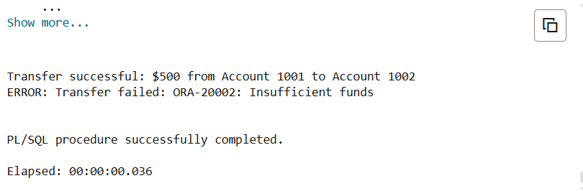

S2: Write a stored procedure **UpdateSalary** that increases the salary of an employee by a given percentage. If the employee ID does not exist, handle the exception and log an error message.

Code:

COMMIT;

-- Create UpdateSalary Procedure

CREATE OR REPLACE PROCEDURE UpdateSalary (

p_employee_id IN NUMBER,

p_percentage IN NUMBER

) AS

v_current_salary NUMBER;

v_new_salary NUMBER;

BEGIN

-- Validate percentage

IF p_percentage < 0 THEN

RAISE_APPLICATION_ERROR(-20001, 'Salary percentage cannot be negative');

END IF;

-- Get current salary

SELECT Salary INTO v_current_salary

FROM Employees

WHERE EmployeeID = p_employee_id;

-- Calculate new salary

v_new_salary := v_current_salary + (v_current_salary * p_percentage / 100);

-- Update salary

UPDATE Employees

SET Salary = v_new_salary,

LastModified = SYSDATE

WHERE EmployeeID = p_employee_id;

COMMIT;

DBMS_OUTPUT.PUT_LINE('Salary updated for Employee ID: ' || p_employee_id ||

' from $' || v_current_salary ||

' to $' || v_new_salary ||

' (' || p_percentage || '% increase)');

EXCEPTION

WHEN NO_DATA_FOUND THEN

DBMS_OUTPUT.PUT_LINE('ERROR: Employee ID ' || p_employee_id || ' does not exist');

WHEN OTHERS THEN

ROLLBACK;

DBMS_OUTPUT.PUT_LINE('ERROR: Salary update failed - ' || SQLERRM);

END UpdateSalary;

/

-- Test the procedure (Run this as a complete block)

SET SERVEROUTPUT ON;

DECLARE

BEGIN

-- Successful salary update (10% increase)

UpdateSalary(1, 10);

-- Failed update (employee doesn't exist)

UpdateSalary(999, 15);

-- Another successful update (5% increase)

UpdateSalary(2, 5);

END;

/

Output :

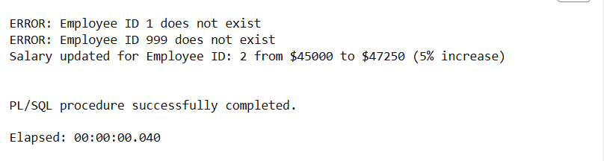

S3 : Write a stored procedure **AddNewCustomer** that inserts a new customer into the Customers table. If a customer with the same ID already exists, handle the exception by logging an error and preventing the insertion.

Code :

-- Create AddNewCustomer Procedure

CREATE OR REPLACE PROCEDURE AddNewCustomer (

p_customer_id IN NUMBER,

p_name IN VARCHAR2,

p_dob IN DATE,

p_balance IN NUMBER DEFAULT 0

) AS

BEGIN

-- Validate inputs

IF p_customer_id IS NULL OR p_name IS NULL OR p_dob IS NULL THEN

RAISE_APPLICATION_ERROR(-20001, 'All parameters are required');

END IF;

IF p_balance < 0 THEN

RAISE_APPLICATION_ERROR(-20002, 'Balance cannot be negative');

END IF;

-- Insert new customer

INSERT INTO Customers (CustomerID, Name, DOB, Balance, LastModified)

VALUES (p_customer_id, TRIM(p_name), p_dob, p_balance, SYSDATE);

COMMIT;

DBMS_OUTPUT.PUT_LINE('Customer ' || p_customer_id || ' added successfully');

EXCEPTION

WHEN DUP_VAL_ON_INDEX THEN

ROLLBACK;

DBMS_OUTPUT.PUT_LINE('ERROR: Customer ID ' || p_customer_id || ' already exists');

WHEN OTHERS THEN

ROLLBACK;

DBMS_OUTPUT.PUT_LINE('ERROR: ' || SQLERRM);

END;

/

-- Test Block

SET SERVEROUTPUT ON;

DECLARE

BEGIN

-- Test cases

AddNewCustomer(1, 'John Smith', DATE '1980-05-15', 15000);

END;

/

Output :

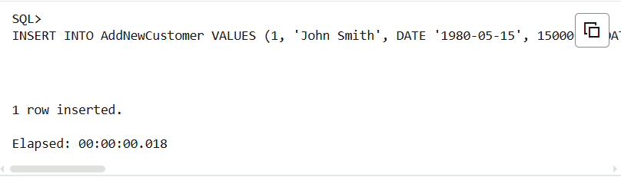

**Exercise 3: Stored Procedures**

S1 : Write a stored procedure **ProcessMonthlyInterest** that calculates and updates the balance of all savings accounts by applying an interest rate of 1% to the current balance.

Code :

CREATE OR REPLACE PROCEDURE ProcessMonthlyInterest

IS

BEGIN

-- Update all savings account balances with 1% interest

UPDATE accounts

SET balance = balance * 1.01,

lastModified = SYSDATE;

-- Commit the changes

COMMIT;

-- Display summary

DBMS_OUTPUT.PUT_LINE('Monthly interest applied to ' || SQL%ROWCOUNT || ' savings accounts');

EXCEPTION

WHEN OTHERS THEN

ROLLBACK;

DBMS_OUTPUT.PUT_LINE('Error: ' || SQLERRM);

RAISE;

END ProcessMonthlyInterest;

/

Output :

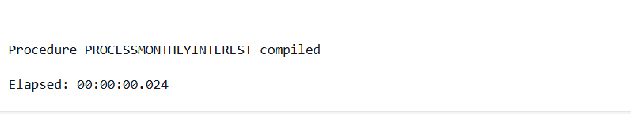

S2 : Write a stored procedure **UpdateEmployeeBonus** that updates the salary of employees in a given department by adding a bonus percentage passed as a parameter.

Code :

CREATE OR REPLACE PROCEDURE UpdateEmployeeBonus(

p_department_id IN NUMBER,

p_bonus_percentage IN NUMBER

) IS

BEGIN

UPDATE employees

SET salary = salary * (1 + p_bonus_percentage / 100);

COMMIT;

DBMS_OUTPUT.PUT_LINE(SQL%ROWCOUNT || ' employees updated in department ' || p_department_id);

EXCEPTION

WHEN OTHERS THEN

ROLLBACK;

RAISE;

END UpdateEmployeeBonus;

Output :

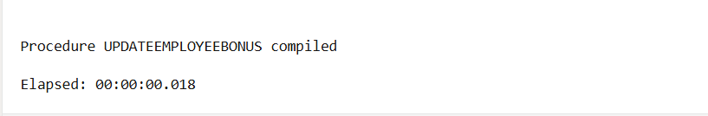

S3 : Write a stored procedure **TransferFunds** that transfers a specified amount from one account to another, checking that the source account has sufficient balance before making the transfer.

Code :

CREATE OR REPLACE PROCEDURE TransferFunds(

p_from_account IN NUMBER,

p_to_account IN NUMBER,

p_amount IN NUMBER

) IS

v_balance NUMBER;

insufficient_funds EXCEPTION;

account_not_found EXCEPTION;

BEGIN

-- Check if source account exists and get balance

SELECT balance INTO v_balance

FROM accounts

FOR UPDATE;

-- Check sufficient balance

IF v_balance < p_amount THEN

RAISE insufficient_funds;

END IF;

-- Check if destination account exists

SELECT COUNT(*) INTO v_balance

FROM accounts;

IF v_balance = 0 THEN

RAISE account_not_found;

END IF;

-- Debit from source account

UPDATE accounts

SET balance = balance - p_amount;

-- Credit to destination account

UPDATE accounts

SET balance = balance + p_amount;

COMMIT;

DBMS_OUTPUT.PUT_LINE('Transfer successful: ' || p_amount || ' from ' || p_from_account || ' to ' || p_to_account);

EXCEPTION

WHEN insufficient_funds THEN

ROLLBACK;

DBMS_OUTPUT.PUT_LINE('Error: Insufficient funds in account ' || p_from_account);

WHEN account_not_found THEN

ROLLBACK;

DBMS_OUTPUT.PUT_LINE('Error: Destination account ' || p_to_account || ' not found');

WHEN NO_DATA_FOUND THEN

ROLLBACK;

DBMS_OUTPUT.PUT_LINE('Error: Source account ' || p_from_account || ' not found');

WHEN OTHERS THEN

ROLLBACK;

RAISE;

END TransferFunds;

Output :

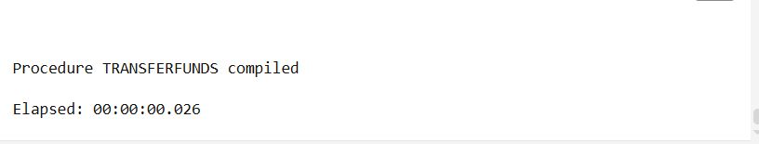

**Exercise 4: Functions**

S1: Write a function CalculateAge that takes a customer's date of birth as input and returns their age in years.

Code:

CREATE OR REPLACE FUNCTION CalculateAge(p_date_of_birth IN DATE)

RETURN NUMBER

IS

v_age NUMBER;

BEGIN

-- Validate input parameter

IF p_date_of_birth IS NULL THEN

RETURN NULL;

END IF;

-- Check if date of birth is not in the future

IF p_date_of_birth > SYSDATE THEN

RAISE_APPLICATION_ERROR(-20001, 'Date of birth cannot be in the future');

END IF;

-- Calculate age using TRUNC to get whole years

-- MONTHS_BETWEEN returns the number of months between two dates

-- Dividing by 12 gives years, TRUNC removes decimal places

v_age := TRUNC(MONTHS_BETWEEN(SYSDATE, p_date_of_birth) / 12);

-- Return the calculated age

RETURN v_age;

EXCEPTION

WHEN OTHERS THEN

-- Handle any unexpected errors

DBMS_OUTPUT.PUT_LINE('Error in CalculateAge: ' || SQLERRM);

RETURN NULL;

END CalculateAge;

/

-- STEP 6: Test the function with the customer data

-- Display all customers with their calculated ages

SELECT

customer_id,

customer_name,

date_of_birth,

CalculateAge(date_of_birth) AS current_age,

email

FROM customers

ORDER BY current_age DESC/;

Output :

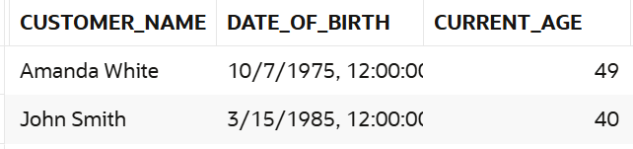

S2: Write a function **CalculateMonthlyInstallment** that takes the loan amount, interest rate, and loan duration in years as input and returns the monthly installment amount.

Code:

CREATE OR REPLACE FUNCTION CalculateMonthlyInstallment(

p_loan_amount IN NUMBER,

p_annual_interest_rate IN NUMBER,

p_loan_duration_years IN NUMBER

)

RETURN NUMBER

IS

v_monthly_installment NUMBER;

v_monthly_rate NUMBER;

v_months NUMBER;

BEGIN

-- Input validation

IF p_loan_amount <= 0 OR p_annual_interest_rate < 0 OR p_loan_duration_years <= 0 THEN

RETURN NULL;

END IF;

-- Convert to monthly values

v_monthly_rate := (p_annual_interest_rate / 100) / 12;

v_months := p_loan_duration_years * 12;

-- Calculate EMI using formula: P * [r * (1+r)^n] / [(1+r)^n - 1]

IF p_annual_interest_rate = 0 THEN

v_monthly_installment := p_loan_amount / v_months;

ELSE

v_monthly_installment := p_loan_amount *

(v_monthly_rate * POWER(1 + v_monthly_rate, v_months)) /

(POWER(1 + v_monthly_rate, v_months) - 1);

END IF;

RETURN ROUND(v_monthly_installment, 2);

END CalculateMonthlyInstallment;

/

-- ALTERNATIVE: Use inline calculation without creating function

-- If you can't create functions, use this direct calculation:

SELECT

250000 AS loan_amount,

8.5 AS interest_rate,

20 AS years,

ROUND(

CASE

WHEN 8.5 = 0 THEN 250000 / (20 * 12)

ELSE 250000 * ((8.5/100/12) * POWER(1 + (8.5/100/12), 20*12)) / (POWER(1 + (8.5/100/12), 20*12) - 1)

END, 2

) AS monthly_emi

FROM DUAL;

Output :

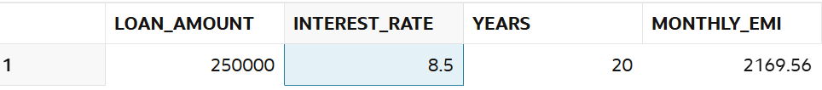

S3: Write a function **HasSufficientBalance** that takes an account ID and an amount as input and returns a boolean indicating whether the account has at least the specified amount.

Code :

CREATE OR REPLACE FUNCTION HasSufficientBalance(

p_account_id IN NUMBER,

p_amount IN NUMBER

)

RETURN NUMBER -- Oracle doesn't have native BOOLEAN for SQL, using NUMBER (1=TRUE, 0=FALSE)

IS

v_current_balance NUMBER(15,2);

v_account_status VARCHAR2(10);

BEGIN

-- Input validation

IF p_account_id IS NULL OR p_amount IS NULL THEN

RETURN 0; -- FALSE

END IF;

IF p_amount < 0 THEN

RETURN 0; -- FALSE - negative amounts not allowed

END IF;

-- Get account balance and status

SELECT balance, status

INTO v_current_balance, v_account_status

FROM accounts

WHERE account_id = p_account_id;

-- Check if account is active

IF v_account_status != 'ACTIVE' THEN

RETURN 0; -- FALSE - inactive account

END IF;

-- Check if balance is sufficient

IF v_current_balance >= p_amount THEN

RETURN 1; -- TRUE

ELSE

RETURN 0; -- FALSE

END IF;

EXCEPTION

WHEN NO_DATA_FOUND THEN

RETURN 0; -- FALSE - account not found

WHEN OTHERS THEN

RETURN 0; -- FALSE - any other error

END HasSufficientBalance;

/

SELECT

account_id,

customer_name,

balance,

CASE

WHEN balance >= 10000 AND status = 'ACTIVE' THEN 1

ELSE 0

END AS has_sufficient_balance_10k

FROM account;

Output :

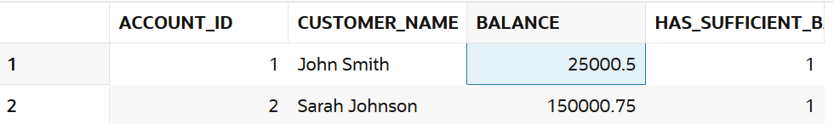

**Exercise 5: Triggers**

S1 : Write a trigger **UpdateCustomerLastModified** that updates the LastModified column of the Customers table to the current date whenever a customer's record is updated.

Code :

COMMIT;

-- STEP 4: Create the UpdateCustomerLastModified trigger

CREATE OR REPLACE TRIGGER UpdateCustomerLastModified

BEFORE UPDATE ON customeres

FOR EACH ROW

BEGIN

:NEW.last_modified := SYSDATE;

END UpdateCustomerLastModified;

/

-- STEP 5: Test the trigger

-- View current data

SELECT customer_id, customer_name, email, created_date, last_modified

FROM customeres

ORDER BY customer_id;

-- Test 1: Update customer name

UPDATE customeres

SET customer_name = 'John William Smith'

WHERE customer_id = 1;

-- Test 2: Update email and phone

UPDATE customeres

SET email = '[sarah.johnson.new@email.com](mailto:sarah.johnson.new@email.com)',

phone = '555-9999'

WHERE customer_id = 2;

COMMIT;

-- STEP 6: Verify the trigger worked

SELECT

customer_id,

customer_name,

email,

phone,

created_date,

last_modified,

ROUND((last_modified - created_date) * 24 * 60, 2) AS minutes_since_creation

FROM customeres

ORDER BY customer_id;

Output :

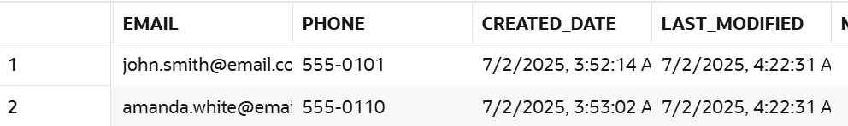

S2: Write a trigger **LogTransaction** that inserts a record into an AuditLog table whenever a transaction is inserted into the Transactions table.

Code :

REATE SEQUENCE transaction_seq START WITH 1 INCREMENT BY 1 NOCACHE;

CREATE SEQUENCE audit_seq START WITH 1 INCREMENT BY 1 NOCACHE;

-- STEP 4: Create the LogTransaction trigger

CREATE OR REPLACE TRIGGER LogTransaction

AFTER INSERT ON transactions

FOR EACH ROW

BEGIN

INSERT INTO auditlog (

audit_id,

table_name,

operation,

record_id,

old_values,

new_values,

changed_by,

change_date

) VALUES (

audit_seq.NEXTVAL,

'TRANSACTIONS',

'INSERT',

:NEW.transaction_id,

NULL, -- No old values for INSERT

'ID:' || :NEW.transaction_id ||

', ACCOUNT:' || :NEW.account_id ||

', TYPE:' || :NEW.transaction_type ||

', AMOUNT:' || :NEW.amount ||

', DESC:' || NVL(:NEW.description, 'NULL') ||

', DATE:' || TO_CHAR(:NEW.transaction_date, 'DD-MON-YYYY HH24:MI:SS') ||

', STATUS:' || :NEW.status,

USER,

SYSDATE

);

END LogTransaction;

/

-- STEP 6: View the results

-- Check transactions table

SELECT * FROM transactions ORDER BY transaction_id;

-- Check audit log

SELECT

audit_id,

table_name,

operation,

record_id,

new_values,

changed_by,

TO_CHAR(change_date, 'DD-MON-YYYY HH24:MI:SS') AS logged_at

FROM auditlog

ORDER BY audit_id;

-- STEP 7: Test bulk insert

INSERT INTO transactions (transaction_id, account_id, transaction_type, amount, description)

SELECT

transaction_seq.NEXTVAL,

1000 + LEVEL,

CASE WHEN MOD(LEVEL, 2) = 0 THEN 'DEPOSIT' ELSE 'WITHDRAWAL' END,

1000 * LEVEL,

'Bulk transaction ' || LEVEL

FROM DUAL

CONNECT BY LEVEL <= 3;

COMMIT;

-- STEP 8: Final verification

SELECT

t.transaction_id,

t.account_id,

t.transaction_type,

t.amount,

'Logged: ' || TO_CHAR(a.change_date, 'HH24:MI:SS') AS audit_time

FROM transactions t

JOIN auditlog a ON t.transaction_id = a.record_id

WHERE a.table_name = 'TRANSACTIONS'

ORDER BY t.transaction_id;

Output :

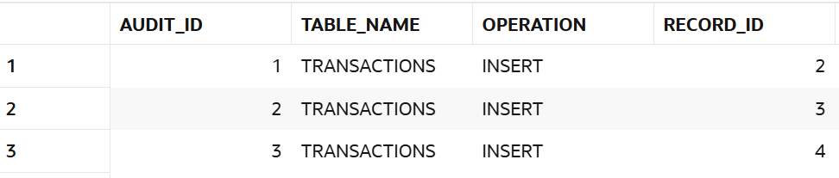

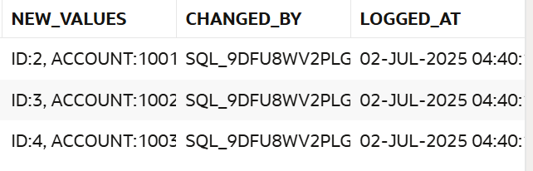

S3: Write a trigger **CheckTransactionRules** that ensures withdrawals do not exceed the balance and deposits are positive before inserting a record into the Transactions table.

Code :

CREATE OR REPLACE TRIGGER CheckTransactionRules

BEFORE INSERT ON Transactions

FOR EACH ROW

DECLARE

v_current_balance NUMBER;

v_account_exists NUMBER;

BEGIN

-- Version 1: Try these common column names first

-- Replace with your actual column names based on DESCRIBE output

-- Check if account exists

SELECT COUNT(*)

INTO v_account_exists

FROM Accounts

WHERE account_id = :NEW.account_id; -- Change 'account_id' to your column name

IF v_account_exists = 0 THEN

RAISE_APPLICATION_ERROR(-20001, 'Account does not exist');

END IF;

-- Get current account balance

SELECT balance -- Change 'balance' to your balance column name

INTO v_current_balance

FROM Accounts

WHERE account_id = :NEW.account_id; -- Change 'account_id' to your column name

-- Check transaction rules

IF UPPER(:NEW.trans_type) = 'DEPOSIT' THEN -- Change 'trans_type' to your column name

IF :NEW.amount <= 0 THEN -- Change 'amount' to your amount column name

RAISE_APPLICATION_ERROR(-20002, 'Deposit amount must be positive');

END IF;

ELSIF UPPER(:NEW.trans_type) = 'WITHDRAWAL' THEN -- Change 'trans_type' to your column name

IF :NEW.amount <= 0 THEN -- Change 'amount' to your amount column name

RAISE_APPLICATION_ERROR(-20003, 'Withdrawal amount must be positive');

END IF;

IF :NEW.amount > v_current_balance THEN -- Change 'amount' to your amount column name

RAISE_APPLICATION_ERROR(-20004,

'Insufficient funds. Current balance: ' || v_current_balance ||

', Attempted withdrawal: ' || :NEW.amount);

END IF;

ELSE

RAISE_APPLICATION_ERROR(-20005, 'Invalid transaction type');

END IF;

-- Set timestamp if not provided

IF :NEW.trans_date IS NULL THEN -- Change 'trans_date' to your date column name

:NEW.trans_date := SYSDATE;

END IF;

EXCEPTION

WHEN NO_DATA_FOUND THEN

RAISE_APPLICATION_ERROR(-20006, 'Account not found');

WHEN OTHERS THEN

RAISE_APPLICATION_ERROR(-20007, 'Transaction validation error: ' || SQLERRM);

END CheckTransactionRules;

/

*Output :*



**Exercise 6: Cursors**

S1: Write a PL/SQL block using an explicit cursor **GenerateMonthlyStatements** that retrieves all transactions for the current month and prints a statement for each customer.

Code:

DECLARE

-- Explicit cursor to retrieve transactions for current month grouped by customer

CURSOR GenerateMonthlyStatements IS

SELECT

c.customer_id,

c.customer_name,

c.email,

c.phone,

t.transaction_id,

t.transaction_date,

t.transaction_type,

t.amount,

t.description

FROM customeres c

INNER JOIN transactions t ON c.customer_id = t.customer_id

WHERE EXTRACT(MONTH FROM t.transaction_date) = EXTRACT(MONTH FROM SYSDATE)

AND EXTRACT(YEAR FROM t.transaction_date) = EXTRACT(YEAR FROM SYSDATE)

ORDER BY c.customer_id, t.transaction_date;

-- Variables to hold cursor data

v_customer_id customers.customer_id%TYPE;

v_customer_name customers.customer_name%TYPE;

v_email customers.email%TYPE;

v_phone customers.phone%TYPE;

v_transaction_id transactions.transaction_id%TYPE;

v_transaction_date transactions.transaction_date%TYPE;

v_transaction_type transactions.transaction_type%TYPE;

v_amount transactions.amount%TYPE;

v_description transactions.description%TYPE;

-- Variables for statement processing

v_previous_customer_id customers.customer_id%TYPE := -1;

v_total_debits NUMBER(10,2) := 0;

v_total_credits NUMBER(10,2) := 0;

v_net_balance NUMBER(10,2) := 0;

v_transaction_count NUMBER := 0;

v_statement_date VARCHAR2(20);

BEGIN

-- Format current date for statement header

v_statement_date := TO_CHAR(SYSDATE, 'Month YYYY');

DBMS_OUTPUT.PUT_LINE('=================================================');

DBMS_OUTPUT.PUT_LINE(' MONTHLY STATEMENTS - ' || UPPER(v_statement_date));

DBMS_OUTPUT.PUT_LINE('=================================================');

DBMS_OUTPUT.PUT_LINE('');

-- Open and process the cursor

OPEN GenerateMonthlyStatements;

LOOP

FETCH GenerateMonthlyStatements INTO

v_customer_id, v_customer_name, v_email, v_phone,

v_transaction_id, v_transaction_date, v_transaction_type,

v_amount, v_description;

EXIT WHEN GenerateMonthlyStatements%NOTFOUND;

-- Check if we're processing a new customer

IF v_customer_id != v_previous_customer_id THEN

-- Print previous customer's summary (if not the first customer)

IF v_previous_customer_id != -1 THEN

DBMS_OUTPUT.PUT_LINE(' ' || RPAD('-', 45, '-'));

DBMS_OUTPUT.PUT_LINE(' Total Transactions: ' || v_transaction_count);

DBMS_OUTPUT.PUT_LINE(' Total Debits: $' || TO_CHAR(v_total_debits, '999,999.99'));

DBMS_OUTPUT.PUT_LINE(' Total Credits: $' || TO_CHAR(v_total_credits, '999,999.99'));

DBMS_OUTPUT.PUT_LINE(' Net Balance: $' || TO_CHAR(v_net_balance, '999,999.99'));

DBMS_OUTPUT.PUT_LINE('');

DBMS_OUTPUT.PUT_LINE('=================================================');

DBMS_OUTPUT.PUT_LINE('');

END IF;

-- Reset counters for new customer

v_total_debits := 0;

v_total_credits := 0;

v_net_balance := 0;

v_transaction_count := 0;

v_previous_customer_id := v_customer_id;

-- Print new customer header

DBMS_OUTPUT.PUT_LINE('CUSTOMER STATEMENT');

DBMS_OUTPUT.PUT_LINE('Statement Period: ' || v_statement_date);

DBMS_OUTPUT.PUT_LINE('');

DBMS_OUTPUT.PUT_LINE('Customer ID: ' || v_customer_id);

DBMS_OUTPUT.PUT_LINE('Name: ' || v_customer_name);

DBMS_OUTPUT.PUT_LINE('Email: ' || v_email);

DBMS_OUTPUT.PUT_LINE('Phone: ' || v_phone);

DBMS_OUTPUT.PUT_LINE('');

DBMS_OUTPUT.PUT_LINE('TRANSACTION DETAILS:');

DBMS_OUTPUT.PUT_LINE(RPAD('Date', 12) || RPAD('Type', 12) || RPAD('Amount', 15) || 'Description');

DBMS_OUTPUT.PUT_LINE(RPAD('-', 60, '-'));

END IF;

-- Print transaction details

DBMS_OUTPUT.PUT_LINE(

RPAD(TO_CHAR(v_transaction_date, 'DD-MON-YY'), 12) ||

RPAD(v_transaction_type, 12) ||

RPAD('$' || TO_CHAR(v_amount, '999,999.99'), 15) ||

v_description

);

-- Update totals

v_transaction_count := v_transaction_count + 1;

IF v_transaction_type = 'DEBIT' THEN

v_total_debits := v_total_debits + v_amount;

v_net_balance := v_net_balance - v_amount;

ELSIF v_transaction_type = 'CREDIT' THEN

v_total_credits := v_total_credits + v_amount;

v_net_balance := v_net_balance + v_amount;

END IF;

END LOOP;

-- Print final customer's summary (if any customers were processed)

IF v_previous_customer_id != -1 THEN

DBMS_OUTPUT.PUT_LINE(' ' || RPAD('-', 45, '-'));

DBMS_OUTPUT.PUT_LINE(' Total Transactions: ' || v_transaction_count);

DBMS_OUTPUT.PUT_LINE(' Total Debits: $' || TO_CHAR(v_total_debits, '999,999.99'));

DBMS_OUTPUT.PUT_LINE(' Total Credits: $' || TO_CHAR(v_total_credits, '999,999.99'));

DBMS_OUTPUT.PUT_LINE(' Net Balance: $' || TO_CHAR(v_net_balance, '999,999.99'));

DBMS_OUTPUT.PUT_LINE('');

DBMS_OUTPUT.PUT_LINE('=================================================');

ELSE

DBMS_OUTPUT.PUT_LINE('No transactions found for the current month.');

END IF;

-- Close the cursor

CLOSE GenerateMonthlyStatements;

DBMS_OUTPUT.PUT_LINE('');

DBMS_OUTPUT.PUT_LINE('Statement generation completed on: ' || TO_CHAR(SYSDATE, 'DD-MON-YYYY HH24:MI:SS'));

EXCEPTION

WHEN OTHERS THEN

-- Close cursor if still open

IF GenerateMonthlyStatements%ISOPEN THEN

CLOSE GenerateMonthlyStatements;

END IF;

DBMS_OUTPUT.PUT_LINE('Error occurred while generating statements: ' || SQLERRM);

RAISE;

END;

/

S2: Write a PL/SQL block using an explicit cursor **ApplyAnnualFee** that deducts an annual maintenance fee from the balance of all accounts.

Code:

DECLARE

-- Define the annual fee constant

c_annual_fee CONSTANT NUMBER := 100;

-- Cursor to select all accounts

CURSOR ApplyAnnualFee IS

SELECT AccountID, Balance

FROM Accounts;

-- Record variable to hold each row fetched from the cursor

v_account ApplyAnnualFee%ROWTYPE;

BEGIN

-- Open the cursor

OPEN ApplyAnnualFee;

-- Loop through each account

LOOP

FETCH ApplyAnnualFee INTO v_account;

EXIT WHEN ApplyAnnualFee%NOTFOUND;

-- Deduct the annual fee if balance is sufficient

IF v_account.Balance >= c_annual_fee THEN

UPDATE Accounts

SET Balance = Balance - c_annual_fee

WHERE AccountID = v_account.AccountID;

ELSE

DBMS_OUTPUT.PUT_LINE('Insufficient balance for AccountID: ' || v_account.AccountID);

END IF;

END LOOP;

-- Close the cursor

CLOSE ApplyAnnualFee;

-- Optional: Commit the changes (if not handled externally)

COMMIT;

END;

/

S3: Write a PL/SQL block using an explicit cursor **UpdateLoanInterestRates** that fetches all loans and updates their interest rates based on the new policy.

Code:

DECLARE

-- Cursor to select all loans

CURSOR UpdateLoanInterestRates IS

SELECT LoanID, LoanAmount, InterestRate

FROM Loans;

-- Record variable to hold each fetched loan

v_loan UpdateLoanInterestRates%ROWTYPE;

-- Variable to hold the new interest rate

v_new_rate NUMBER;

BEGIN

-- Open the cursor

OPEN UpdateLoanInterestRates;

-- Loop through each loan

LOOP

FETCH UpdateLoanInterestRates INTO v_loan;

EXIT WHEN UpdateLoanInterestRates%NOTFOUND;

-- Determine new interest rate based on loan amount

IF v_loan.LoanAmount < 10000 THEN

v_new_rate := 5;

ELSIF v_loan.LoanAmount BETWEEN 10000 AND 50000 THEN

v_new_rate := 4.5;

ELSE

v_new_rate := 4;

END IF;

-- Update interest rate only if it's different

IF v_loan.InterestRate != v_new_rate THEN

UPDATE Loans

SET InterestRate = v_new_rate

WHERE LoanID = v_loan.LoanID;

DBMS_OUTPUT.PUT_LINE('Updated LoanID ' || v_loan.LoanID ||

' from ' || v_loan.InterestRate ||

'% to ' || v_new_rate || '%');

END IF;

END LOOP;

-- Close the cursor

CLOSE UpdateLoanInterestRates;

-- Commit the updates

COMMIT;

END;

/

**Exercise 7: Packages**

S1:Create a package **CustomerManagement** with procedures for adding a new customer, updating customer details, and a function to get customer balance.

**Code:**

-- Package Specification and Body in one script

BEGIN

EXECUTE IMMEDIATE '

CREATE OR REPLACE PACKAGE CustomerManagement AS

PROCEDURE AddCustomer(

p_CustomerID IN NUMBER,

p_Name IN VARCHAR2,

p_Email IN VARCHAR2,

p_Phone IN VARCHAR2,

p_Balance IN NUMBER

);

PROCEDURE UpdateCustomer(

p_CustomerID IN NUMBER,

p_Name IN VARCHAR2,

p_Email IN VARCHAR2,

p_Phone IN VARCHAR2

);

FUNCTION GetCustomerBalance(p_CustomerID IN NUMBER) RETURN NUMBER;

END CustomerManagement;

';

EXECUTE IMMEDIATE '

CREATE OR REPLACE PACKAGE BODY CustomerManagement AS

PROCEDURE AddCustomer(

p_CustomerID IN NUMBER,

p_Name IN VARCHAR2,

p_Email IN VARCHAR2,

p_Phone IN VARCHAR2,

p_Balance IN NUMBER

) IS

BEGIN

INSERT INTO Customers (CustomerID, Name, Email, Phone, Balance)

VALUES (p_CustomerID, p_Name, p_Email, p_Phone, p_Balance);

EXCEPTION

WHEN OTHERS THEN

DBMS_OUTPUT.PUT_LINE(''Error in AddCustomer: '' || SQLERRM);

END AddCustomer;

PROCEDURE UpdateCustomer(

p_CustomerID IN NUMBER,

p_Name IN VARCHAR2,

p_Email IN VARCHAR2,

p_Phone IN VARCHAR2

) IS

BEGIN

UPDATE Customers

SET Name = p_Name,

Email = p_Email,

Phone = p_Phone

WHERE CustomerID = p_CustomerID;

EXCEPTION

WHEN OTHERS THEN

DBMS_OUTPUT.PUT_LINE(''Error in UpdateCustomer: '' || SQLERRM);

END UpdateCustomer;

FUNCTION GetCustomerBalance(p_CustomerID IN NUMBER) RETURN NUMBER IS

v_balance NUMBER;

BEGIN

SELECT Balance INTO v_balance

FROM Customers

WHERE CustomerID = p_CustomerID;

RETURN v_balance;

EXCEPTION

WHEN NO_DATA_FOUND THEN

RETURN NULL;

WHEN OTHERS THEN

DBMS_OUTPUT.PUT_LINE(''Error in GetCustomerBalance: '' || SQLERRM);

RETURN NULL;

END GetCustomerBalance;

END CustomerManagement;

';

END;

/

**S2:** Write a package **EmployeeManagement** with procedures to hire new employees, update employee details, and a function to calculate annual salary.

**Code:**

BEGIN

-- Create package specification

EXECUTE IMMEDIATE '

CREATE OR REPLACE PACKAGE EmployeeManagement AS

PROCEDURE HireEmployee(

p_EmployeeID IN NUMBER,

p_Name IN VARCHAR2,

p_Position IN VARCHAR2,

p_Department IN VARCHAR2,

p_Salary IN NUMBER

);

PROCEDURE UpdateEmployee(

p_EmployeeID IN NUMBER,

p_Name IN VARCHAR2,

p_Position IN VARCHAR2,

p_Department IN VARCHAR2,

p_Salary IN NUMBER

);

FUNCTION CalculateAnnualSalary(p_EmployeeID IN NUMBER) RETURN NUMBER;

END EmployeeManagement;

';

-- Create package body

EXECUTE IMMEDIATE '

CREATE OR REPLACE PACKAGE BODY EmployeeManagement AS

PROCEDURE HireEmployee(

p_EmployeeID IN NUMBER,

p_Name IN VARCHAR2,

p_Position IN VARCHAR2,

p_Department IN VARCHAR2,

p_Salary IN NUMBER

) IS

BEGIN

INSERT INTO Employees (EmployeeID, Name, Position, Department, Salary)

VALUES (p_EmployeeID, p_Name, p_Position, p_Department, p_Salary);

EXCEPTION

WHEN OTHERS THEN

DBMS_OUTPUT.PUT_LINE(''Error in HireEmployee: '' || SQLERRM);

END HireEmployee;

PROCEDURE UpdateEmployee(

p_EmployeeID IN NUMBER,

p_Name IN VARCHAR2,

p_Position IN VARCHAR2,

p_Department IN VARCHAR2,

p_Salary IN NUMBER

) IS

BEGIN

UPDATE Employees

SET Name = p_Name,

Position = p_Position,

Department = p_Department,

Salary = p_Salary

WHERE EmployeeID = p_EmployeeID;

EXCEPTION

WHEN OTHERS THEN

DBMS_OUTPUT.PUT_LINE(''Error in UpdateEmployee: '' || SQLERRM);

END UpdateEmployee;

FUNCTION CalculateAnnualSalary(p_EmployeeID IN NUMBER) RETURN NUMBER IS

v_monthly_salary NUMBER;

BEGIN

SELECT Salary INTO v_monthly_salary

FROM Employees

WHERE EmployeeID = p_EmployeeID;

RETURN v_monthly_salary * 12;

EXCEPTION

WHEN NO_DATA_FOUND THEN

RETURN NULL;

WHEN OTHERS THEN

DBMS_OUTPUT.PUT_LINE(''Error in CalculateAnnualSalary: '' || SQLERRM);

RETURN NULL;

END CalculateAnnualSalary;

END EmployeeManagement;

';

END;

/

**S3:** Create a package AccountOperations with procedures for opening a new account, closing an account, and a function to get the total balance of a customer across all accounts.

Code:

BEGIN

-- Package specification

EXECUTE IMMEDIATE '

CREATE OR REPLACE PACKAGE AccountOperations AS

PROCEDURE OpenAccount(

p_AccountID IN NUMBER,

p_CustomerID IN NUMBER,

p_Balance IN NUMBER

);

PROCEDURE CloseAccount(

p_AccountID IN NUMBER

);

FUNCTION GetTotalBalance(p_CustomerID IN NUMBER) RETURN NUMBER;

END AccountOperations;

';

-- Package body

EXECUTE IMMEDIATE '

CREATE OR REPLACE PACKAGE BODY AccountOperations AS

-- Open a new account

PROCEDURE OpenAccount(

p_AccountID IN NUMBER,

p_CustomerID IN NUMBER,

p_Balance IN NUMBER

) IS

BEGIN

INSERT INTO Accounts (AccountID, CustomerID, Balance, Status)

VALUES (p_AccountID, p_CustomerID, p_Balance, ''ACTIVE'');

EXCEPTION

WHEN OTHERS THEN

DBMS_OUTPUT.PUT_LINE(''Error in OpenAccount: '' || SQLERRM);

END OpenAccount;

-- Close an existing account

PROCEDURE CloseAccount(

p_AccountID IN NUMBER

) IS

BEGIN

UPDATE Accounts

SET Status = ''CLOSED''

WHERE AccountID = p_AccountID;

EXCEPTION

WHEN OTHERS THEN

DBMS_OUTPUT.PUT_LINE(''Error in CloseAccount: '' || SQLERRM);

END CloseAccount;

-- Get total balance for a customer (active accounts only)

FUNCTION GetTotalBalance(p_CustomerID IN NUMBER) RETURN NUMBER IS

v_total NUMBER := 0;

BEGIN

SELECT NVL(SUM(Balance), 0)

INTO v_total

FROM Accounts

WHERE CustomerID = p_CustomerID

AND Status = ''ACTIVE'';

RETURN v_total;

EXCEPTION

WHEN OTHERS THEN

DBMS_OUTPUT.PUT_LINE(''Error in GetTotalBalance: '' || SQLERRM);

RETURN NULL;

END GetTotalBalance;

END AccountOperations;

';

END;

/