Spring DataJpa with Spring Boot and Hibernate Hands-on

Mandatory

Handson-1: Spring Data Jpa quick Example

A. Created Project with Spring Initializer

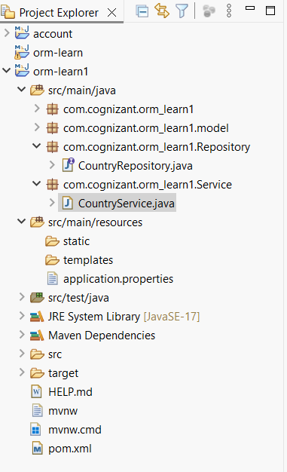

B. Adding mysql credential into Application Properties

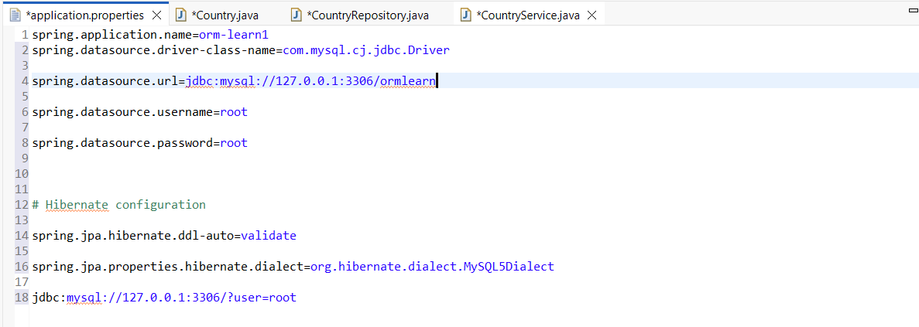

C. Creating Persistence Class which is Country.java

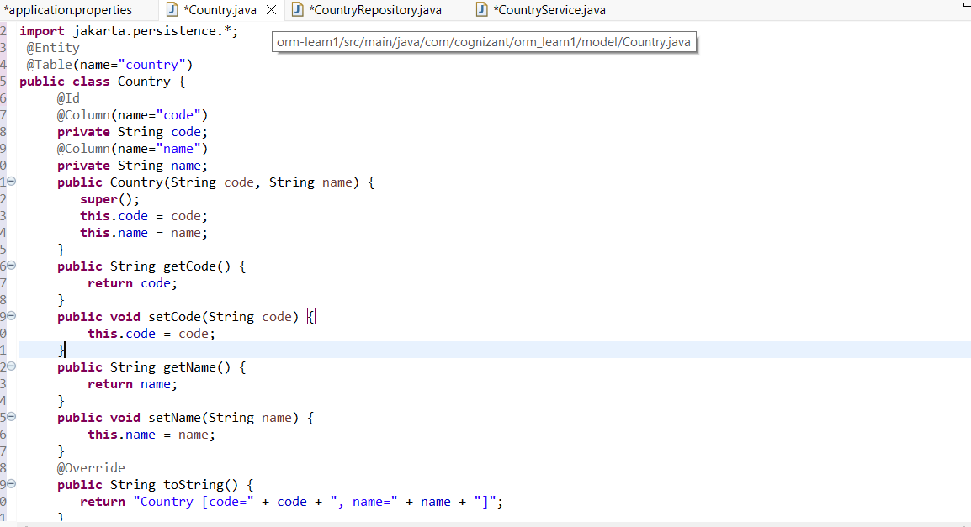

D. Creating Repository Class which is CountryRepository.java

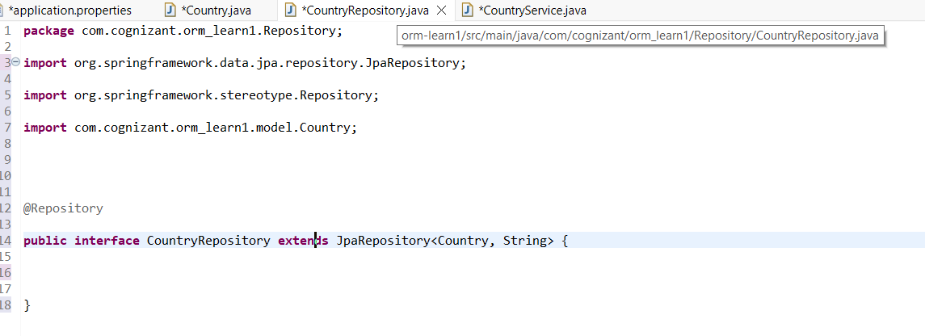

E. Creating Service Class which is CountryService.java

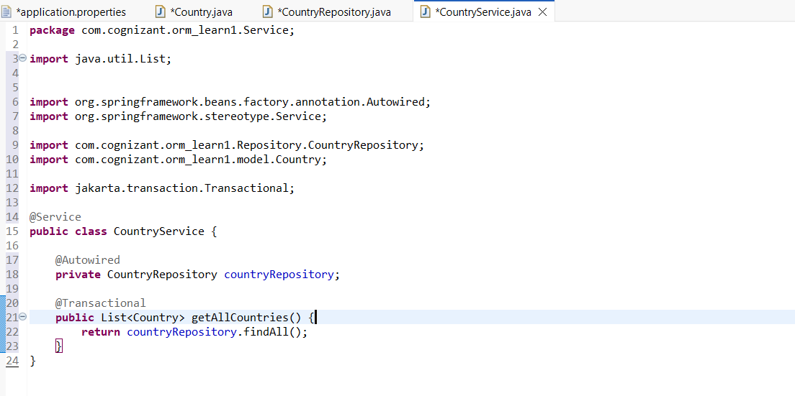

Output:

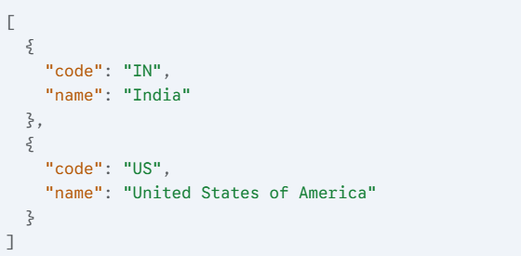

Handson-2: Difference between JPA,Hibernate and Spring DataJPA

A. Hibernate

/* Method to CREATE an employee in the database */

**public** Integer addEmployee(Employee employee){

Session session = factory.openSession();

Transaction tx = **null**;

Integer employeeID = **null**;

**Try** {

tx = session.beginTransaction();

employeeID = (Integer) session.save(employee);

tx.commit();

} **catch** (HibernateException e) {

**if** (tx != **null**) tx.rollback();

e.printStackTrace();

} **finally** {

session.close();

}

**return** employeeID;

}

B.EmployeeRepository.java

**public** **interface** EmployeeRepository **extends** JpaRepository<Employee, Integer> { }

C.EmployeeService.java

@Autowire

**private** EmployeeRepository employeeRepository;

@Transactional

**public** **void** addEmployee(Employee employee) {

employeeRepository.save(employee);

  }