Spring Rest using Spring Boot

1.Spring Rest Handson

1. Creating Spring Web Project using Maven

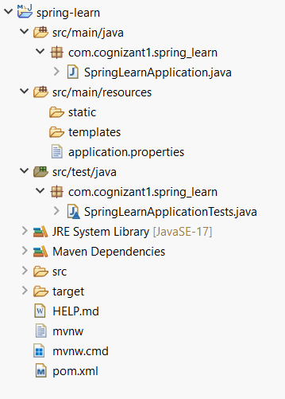

2. Spring core – Load country from spring configuration XML

Code:

Country.xml

<beans xmlns=*"http://www.springframework.org/schema/beans"*

xmlns:xsi=*"http://www.w3.org/2001/XMLSchema-instance"*

xsi:schemaLocation=*"http://www.springframework.org/schema/beans*

[*http://www.springframework.org/schema/beans/spring-beans.xsd*](http://www.springframework.org/schema/beans/spring-beans.xsd)*"*>

<!-- Bean configuration for Country -->

<bean id=*"country"* class=*"com.cognizant1.spring_learn.Country"*>

<property name=*"code"* value=*"IN"* />

<property name=*"name"* value=*"India"* />

</bean>

</beans>

Country.java

**package** com.cognizant1.spring_learn;

**public** **class** Country {

**private** String code;

**private** String name;

**public** Country() {

}

**public** String getCode() {

**return** code;

}

**public** **void** setCode(String code) {

**this**.code = code;

}

**public** String getName() {

**return** name;

}

**public** **void** setName(String name) {

**this**.name = name;

}

@Override

**public** String toString() {

**return** "Country [code=" + code + ", name=" + name + "]";

}

}

SpringLearnApplication.java

**package** com.cognizant1.spring_learn;

**import** org.slf4j.Logger;

**import** org.slf4j.LoggerFactory;

**import** org.springframework.context.ApplicationContext;

**import** org.springframework.context.support.ClassPathXmlApplicationContext;

**public** **class** SpringLearnApplication {

**private** **static** **final** Logger ***LOGGER*** = LoggerFactory.*getLogger*(SpringLearnApplication.**class**);

**public** **static** **void** displayCountry() {

ApplicationContext context = **new** ClassPathXmlApplicationContext("country.xml");

Country country = (Country) context.getBean("country", Country.**class**);

// Display country details

***LOGGER***.debug("Country : {}", country.toString());

System.***out***.println("Country Details:");

System.***out***.println("Code: " + country.getCode());

System.***out***.println("Name: " + country.getName());

System.***out***.println("Full Details: " + country.toString());

}

**public** **static** **void** main(String[] args) {

*displayCountry*();

}

}

Output: Retrived data from country.xml configuration

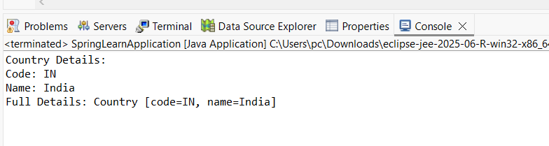

2.Spring Rest Handson

1.Hello World Restful WebService

HelloController.java

**package** com.cognizant1.spring_learn.controller;

**import** org.slf4j.Logger;

**import** org.slf4j.LoggerFactory;

**import** org.springframework.web.bind.annotation.GetMapping;

**import** org.springframework.web.bind.annotation.RestController;

@RestController

**public** **class** HelloController {

**private** **static** **final** Logger ***logger*** = LoggerFactory.*getLogger*(HelloController.**class**);

@GetMapping("/hello")

**public** String sayHello() {

String response = "Hello World!!";

**return** response;

}

}

SimpleLearnApplication.java

**package** com.cognizant1.spring_learn;

**import** org.springframework.boot.SpringApplication;

**import** org.springframework.boot.autoconfigure.SpringBootApplication;

@SpringBootApplication(exclude = {

org.springframework.boot.autoconfigure.jdbc.DataSourceAutoConfiguration.**class**,

org.springframework.boot.autoconfigure.orm.jpa.HibernateJpaAutoConfiguration.**class**

})

**public** **class** SpringLearnApplication {

**public** **static** **void** main(String[] args) {

SpringApplication.*run*(SpringLearnApplication.**class**, args);

System.***out***.println("Spring Learn application started successfully on port 8083!");

}

}

ApplicationProperty.java

spring.application.name=spring-learn

server.port=8083

# Application Configuration

spring.application.name=spring-learn

Output:

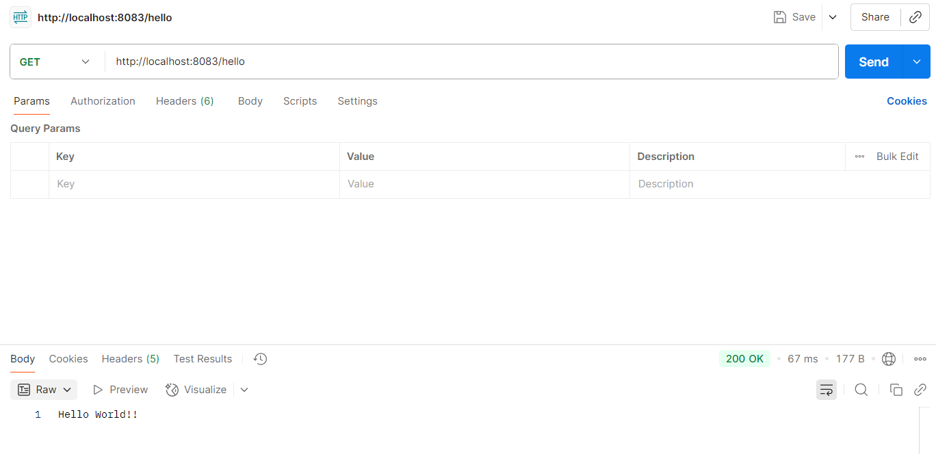

2.REST Country Web Service

Country.java

**package** com.cognizant1.spring_learn;

**public** **class** Country {

**private** String code;

**private** String name;

**public** Country() {}

**public** Country(String code, String name) {

**this**.code = code;

**this**.name = name;

}

// Getter and Setter methods

**public** String getCode() {

**return** code;

}

**public** **void** setCode(String code) {

**this**.code = code;

}

**public** String getName() {

**return** name;

}

**public** **void** setName(String name) {

**this**.name = name;

}

@Override

**public** String toString() {

**return** "Country{" +

"code='" + code + '\'' +

", name='" + name + '\'' +

'}';

}

}

CountryController.java

**package** com.cognizant1.spring_learn.Controller;

**import** org.springframework.beans.factory.annotation.Autowired;

**import** org.springframework.context.ApplicationContext;

**import** org.springframework.web.bind.annotation.RequestMapping;

**import** org.springframework.web.bind.annotation.RequestMethod;

**import** org.springframework.web.bind.annotation.RestController;

**import** com.cognizant1.spring_learn.Country;

@RestController

**public** **class** CountryController {

@Autowired

**private** ApplicationContext applicationContext;

@RequestMapping(value = "/country", method = RequestMethod.***GET***)

**public** Country getCountryIndia() {

// Load India bean from spring xml configuration

Country india = (Country) applicationContext.getBean("india");

**return** india;

}

}

ApplicationContext.xml

<?xml version=*"1.0"* encoding=*"UTF-8"*?>

<beans xmlns=*"http://www.springframework.org/schema/beans"*

xmlns:xsi=*"http://www.w3.org/2001/XMLSchema-instance"*

xmlns:context=*"http://www.springframework.org/schema/context"*

xsi:schemaLocation=*"*

[*http://www.springframework.org/schema/beans*](http://www.springframework.org/schema/beans)

[*http://www.springframework.org/schema/beans/spring-beans.xsd*](http://www.springframework.org/schema/beans/spring-beans.xsd)

[*http://www.springframework.org/schema/context*](http://www.springframework.org/schema/context)

[*http://www.springframework.org/schema/context/spring-context.xsd*](http://www.springframework.org/schema/context/spring-context.xsd)*"*>

<!-- Enable annotation-driven configuration -->

<context:annotation-config />

<context:component-scan base-package=*"com.cognizant1.spring_learn"* />

<!-- Define India bean -->

<bean id=*"india"* class=*"com.cognizant1.spring_learn.Country"*>

<property name=*"code"* value=*"IN"* />

<property name=*"name"* value=*"India"* />

</bean>

</beans>

SpringLearnApplication.java

**package** com.cognizant1.spring_learn;

**import** org.springframework.boot.SpringApplication;

**import** org.springframework.context.annotation.ImportResource;

@ImportResource("classpath:applicationContext.xml")

**public** **class** SpringLearnApplication {

**public** **static** **void** main(String[] args) {

SpringApplication.*run*(SpringLearnApplication.**class**, args);

}

}

Output:

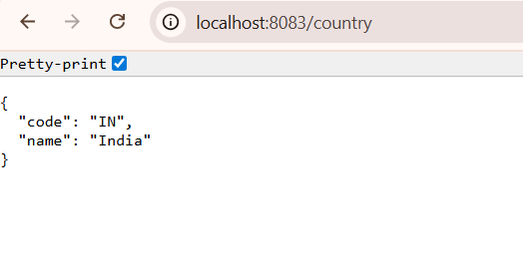

3.REST - Get Country Based on country code

Country.java

**package** com.cognizant1.spring_learn;

**public** **class** Country {

**private** String code;

**private** String name;

**public** Country() {}

**public** Country(String code, String name) {

**this**.code = code;

**this**.name = name;

}

// Getter and Setter methods

**public** String getCode() {

**return** code;

}

**public** **void** setCode(String code) {

**this**.code = code;

}

**public** String getName() {

**return** name;

}

**public** **void** setName(String name) {

**this**.name = name;

}

@Override

**public** String toString() {

**return** "Country{" +

"code='" + code + '\'' +

", name='" + name + '\'' +

'}';

}

}

CountryController.java

package com.cognizant.springlearn.controller;

import com.cognizant.springlearn.model.Country;

import com.cognizant.springlearn.service.CountryService;

import com.cognizant.springlearn.service.exception.CountryNotFoundException;

import org.springframework.beans.factory.annotation.Autowired;

import org.springframework.web.bind.annotation.GetMapping;

import org.springframework.web.bind.annotation.PathVariable;

import org.springframework.web.bind.annotation.RestController;

@RestController

public class CountryController {

@Autowired

private CountryService countryService;

@GetMapping("/country/in")

public Country getCountry(@PathVariable String code)

{

return countryService.getCountry(code);

}

}

CountryService.java

package com.cognizant.springlearn.service;

import com.cognizant.springlearn.model.Country;

import com.cognizant.springlearn.service.exception.CountryNotFoundException;

import org.springframework.beans.factory.annotation.Autowired;

import org.springframework.beans.factory.annotation.Qualifier;

import org.springframework.stereotype.Service;

import java.util.List;

@Service

public class CountryService {

@Autowired

@Qualifier("countryList")

private List<Country> countryList;

public Country getCountry(String code) throws CountryNotFoundException {

// Use a lambda expression to find the first country matching the code case-insensitively.

// If no country is found, orElseThrow will execute and throw the exception.

return countryList.stream()

.filter(country -> country.getCode().equalsIgnoreCase(code))

.findFirst()

.orElseThrow(() -> new CountryNotFoundException());

}

}

ApplicationContext.xml

<?xml version=*"1.0"* encoding=*"UTF-8"*?>

<beans xmlns=*"http://www.springframework.org/schema/beans"*

xmlns:xsi=*"http://www.w3.org/2001/XMLSchema-instance"*

xmlns:context=*"http://www.springframework.org/schema/context"*

xsi:schemaLocation=*"*

[*http://www.springframework.org/schema/beans*](http://www.springframework.org/schema/beans)

[*http://www.springframework.org/schema/beans/spring-beans.xsd*](http://www.springframework.org/schema/beans/spring-beans.xsd)

[*http://www.springframework.org/schema/context*](http://www.springframework.org/schema/context)

[*http://www.springframework.org/schema/context/spring-context.xsd*](http://www.springframework.org/schema/context/spring-context.xsd)*"*>

<!-- Enable annotation-driven configuration -->

<context:annotation-config />

<context:component-scan base-package=*"com.cognizant1.spring_learn"* />

<!-- Define India bean -->

<bean id=*"india"* class=*"com.cognizant1.spring_learn.Country"*>

<property name=*"code"* value=*"IN"* />

<property name=*"name"* value=*"India"* />

</bean>

</beans>

Output:

