MicroServices with API Gateway Hands-On

Mandatory Hands-on

1. Creating MicroServices for account

A. Created Repository for account

B. Accounts.java

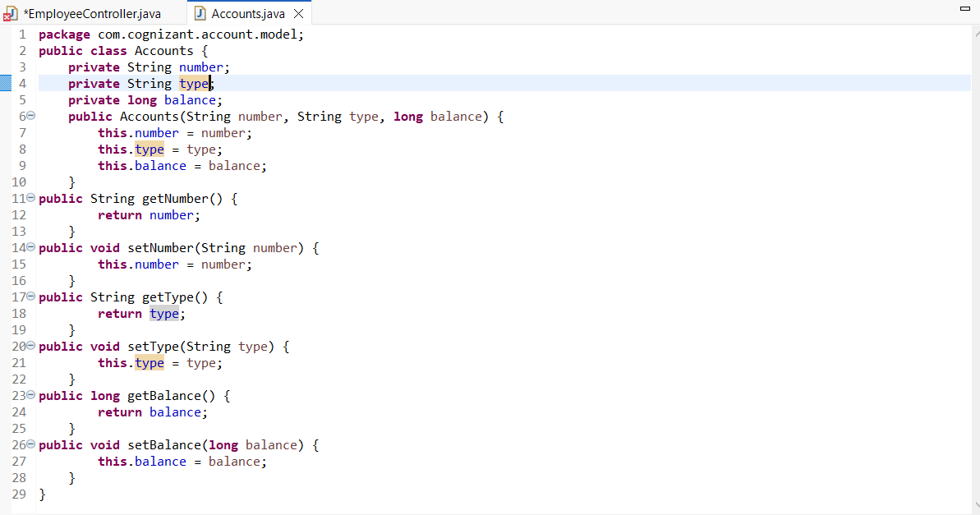

C.EmployeeController.java

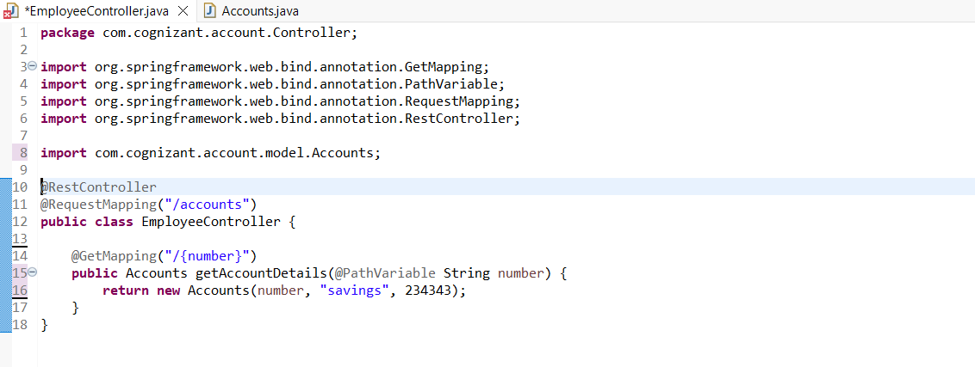

Output:

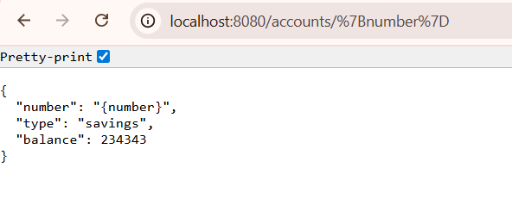

2.Created Microservices for loan

A.Created Repository

B.Loan.java

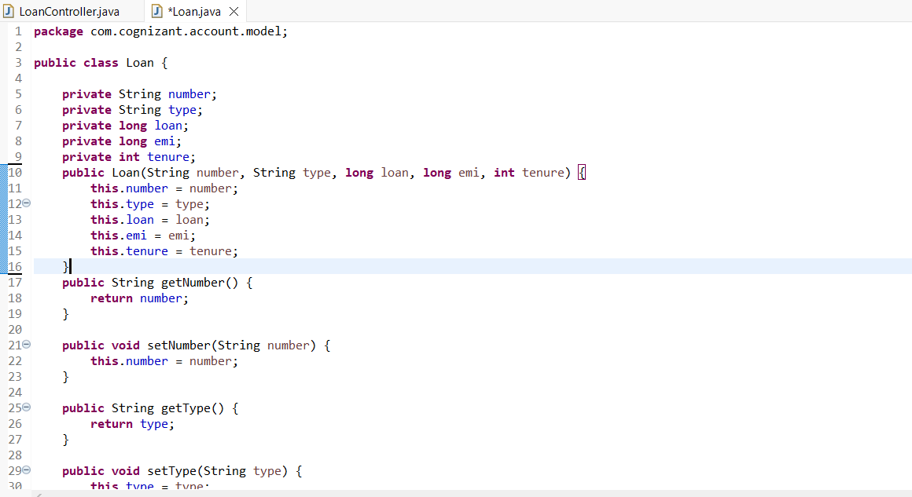

C.LoanController.java

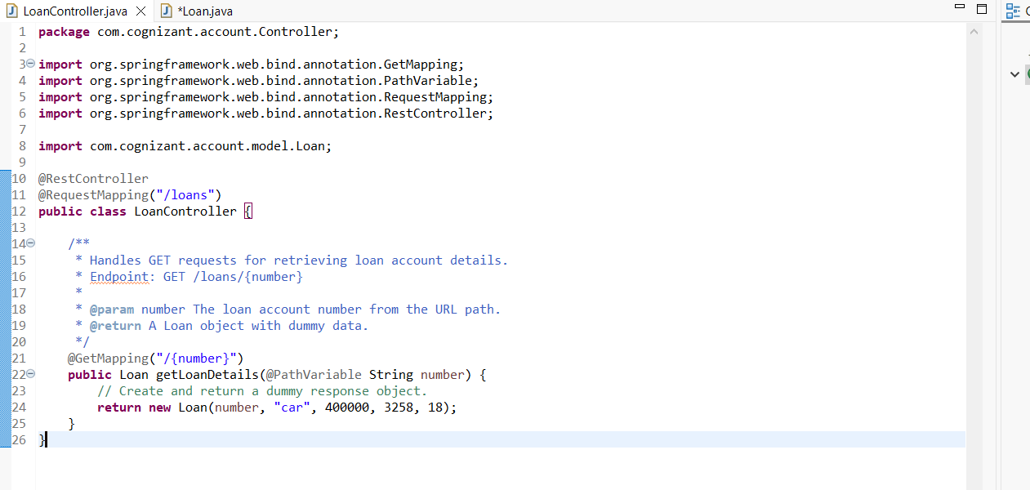

D.Output:

