React Hands-on

1. ReactJS-HOL

Code:

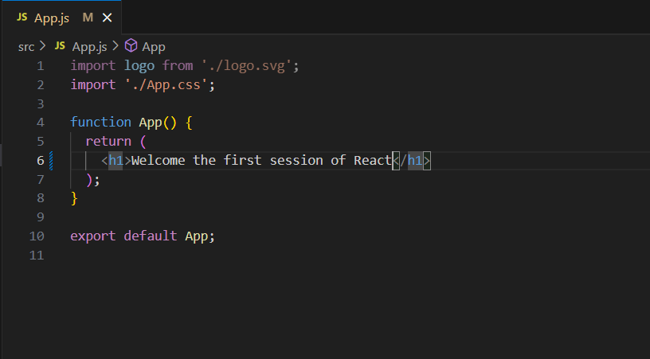

Output:

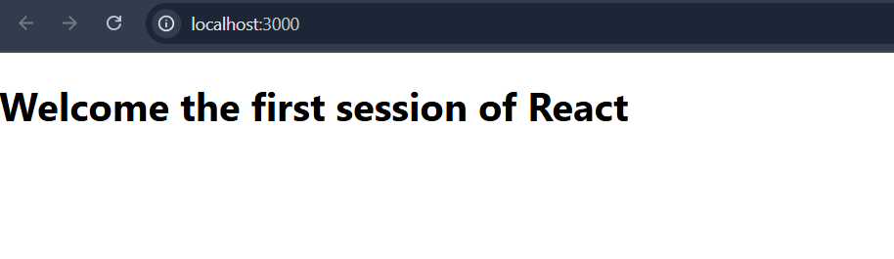

2. ReactJS-HOL

Code:

Home.js

import React, {Component} from "react";

class Home extends Component {

render() {

return (

<div>

<h3>Welcome to the Home Page of Student Management Portal</h3>

</div>

);

}

}

export default Home;

About.js

import React, {Component} from "react";

class About extends Component {

render() {

return (

<div>

<h3>Welcome to the About Page of Student Management Portal</h3>

</div>

);

}

}

export default About;

Contact.js

import React, {Component} from "react";

class Contact extends Component {

render() {

return (

<div>

<h3>Welcome to the Contact Page of Student Management Portal</h3>

</div>

);

}

}

export default Contact;

App.js

import logo from './logo.svg';

import './App.css';

import Home from './Components/Home';

import Contact from './Components/Contact';

import About from './Components/About';

function App() {

return (

<div className="App">

<Home/>

<Contact/>

<About/>

</div>

);

}

export default App;

Output:

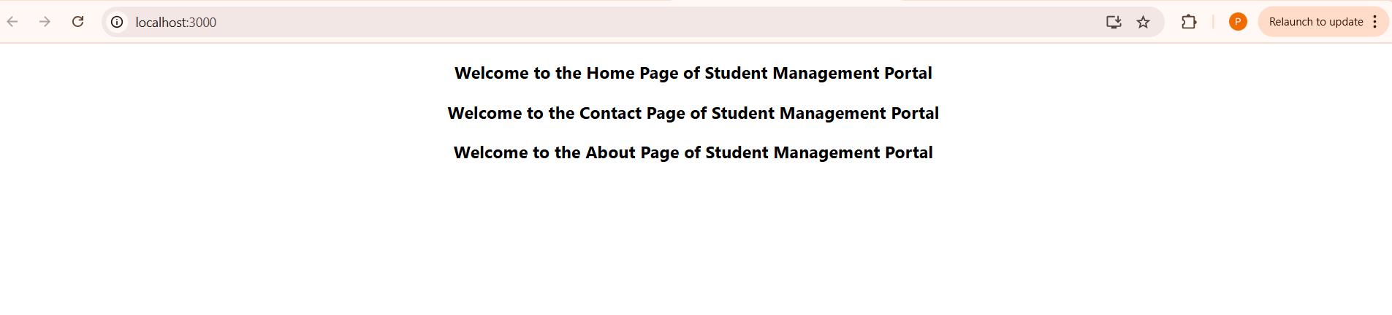

3.ReactJs-Hol

Code:

CalculateScore.js

import '../Stylesheets/mystyle.css';

const percenttoDecimal =(decimal)=>{

return (decimal.toFixed(2)+'%')

}

const calcScore = (total,goal) => {

return percenttoDecimal(total/goal)

}

export const CalculateScore = ({Name,School,total,goal}) => {

return (

<div className="formatstyle">

<h1><font color = 'Brown'>StudentDetails</font></h1>

<div className='Name'>

<b><span>Name:</span></b>

<span>{Name}</span>

</div>

<div className='School'>

<b><span>School:</span></b>

<span>{School}</span>

</div>

<div className='Total'>

<b><span>Total:</span></b>

<span>{total}</span>

<span>Marks</span>

</div>

<div className='Score'>

<b><span>Score:</span></b>

<span>{calcScore(total,goal)}</span>

</div>

</div>

);

}

Mystyle.css

.Name

{

font-weight: 300;

color:blue;

}

.School{

color:crimson

}

.Total{

color:darkmagenta

}

.formatstyle{

text-align:center;

font-size:large;

}

.Score{

color:forestgreen;

}

App.js

import logo from './logo.svg';

import './App.css';

import {CalculateScore} from '../src/Components/CalculateScore';

function App() {

return (

<div>

<CalculateScore Name={"Steeve"}

School = {"DNV Public School"}

total = {450}

goal = {500} />

</div>

);

}

export default App;

Output:

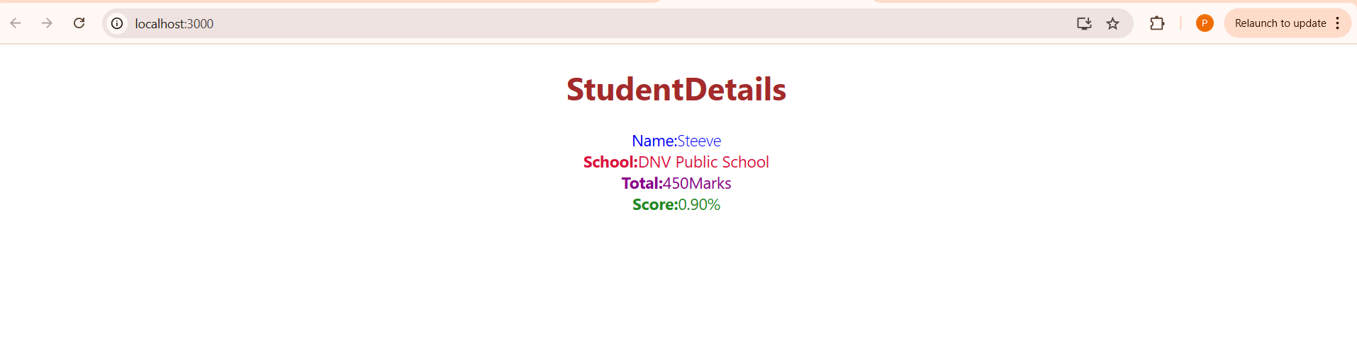

4.ReactJs.hol

Code:

Post.js

class Post {

constructor(id, title, body, userId) {

this.id = id;

this.title = title;

this.body = body;

this.userId = userId;

}

}

export default Post;

Posts.js

import React, { Component } from 'react';

import Post from './Post';

class Posts extends Component {

constructor(props) {

super(props);

this.state = {

posts: []

};

}

loadPosts() {

fetch('https://jsonplaceholder.typicode.com/posts')

.then(response => response.json())

.then(data => {

const posts = data.map(post =>

new Post(post.id, post.title, post.body, post.userId)

);

this.setState({ posts: posts });

})

}

componentDidMount() {

this.loadPosts();

}

componentDidCatch(error, errorInfo) {

alert('An error occurred in the Posts component: ' + error.message);

}

render() {

return (

<div className="posts-container">

<h1>Blog Posts</h1>

{this.state.posts.map(post => (

<div key={post.id} className="post">

<h2>{post.title}</h2>

<p>{post.body}</p>

<hr />

</div>

))}

</div>

);

}

}

export default Posts;

App.js

import logo from './logo.svg';

import './App.css';

import React from 'react';

import Posts from './Posts';

function App() {

return (

<div className="App">

<header className="App-header">

<Posts />

</header>

</div>

);

}

export default App;

Output:

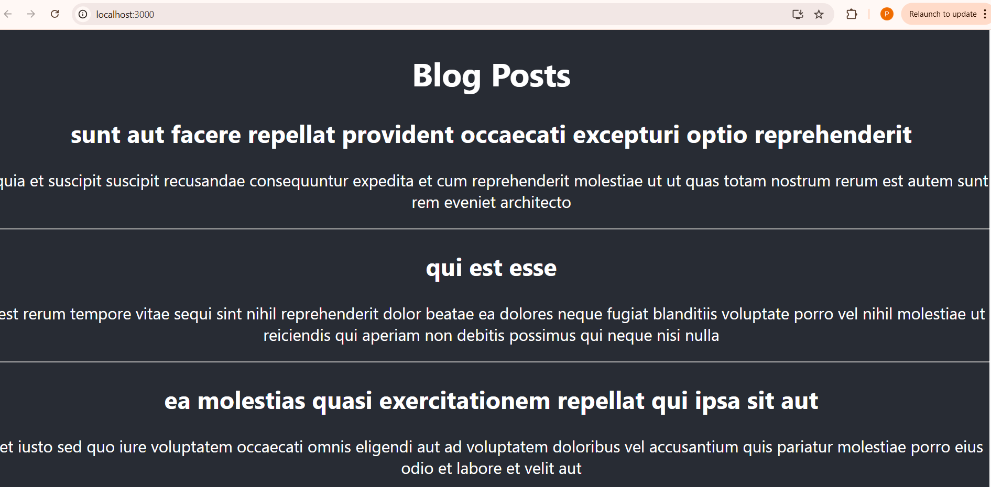

5.ReactJS-Hol

Code:

CohortDetails.js

import styles from './CohortDetails.module.css';

const CohortDetails = ({ cohort }) => {

// Determine h3 color based on status

const getStatusColor = (status) => {

return status?.toLowerCase() === 'ongoing' ? 'green' : 'blue';

};

return (

<div className={styles.box}>

<h3 style={{

color: getStatusColor(cohort.status),

margin: '0 0 10px 0',

fontSize: '16px',

fontWeight: 'bold'

}}>

{cohort.name}

</h3>

<dl>

<dt>Started On</dt>

<dd>{cohort.startDate}</dd>

<dt>Current Status</dt>

<dd>{cohort.status}</dd>

<dt>Coach</dt>

<dd>{cohort.coach}</dd>

<dt>Trainer</dt>

<dd>{cohort.trainer}</dd>

</dl>

</div>

);

};

export default CohortDetails;

App.js

import CohortDetails from './CohortDetails';

function App() {

const cohorts = [

{

id: 1,

name: "INTADMDF10 - .NET FSD",

startDate: "22-Feb-2022",

status: "Scheduled",

coach: "Aathma",

trainer: "Jojo Jose"

},

{

id: 2,

name: "ADM21JF014 - Java FSD",

startDate: "10-Sep-2021",

status: "Ongoing",

coach: "Apoorv",

trainer: "Elisa Smith"

},

{

id: 3,

name: "CDBJF21025 - Java FSD",

startDate: "24-Dec-2021",

status: "Ongoing",

coach: "Aathma",

trainer: "John Doe"

}

];

return (

<div className="App">

<div className="App-header">

<h1>Cohorts Details</h1>

<div className="cohorts-container">

{cohorts.map(cohort => (

<CohortDetails key={cohort.id} cohort={cohort} />

))}

</div>

</div>

</div>

);

}

export default App;

Output:

